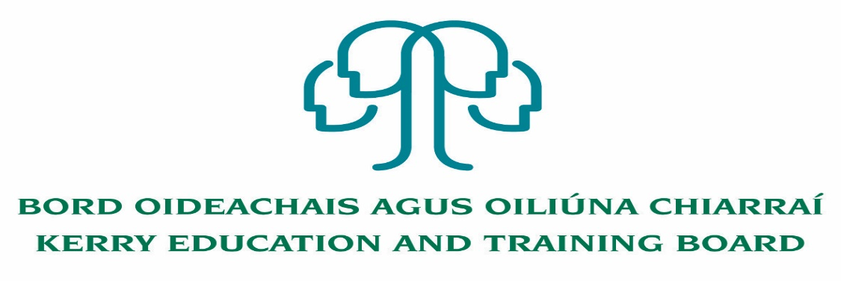
Job Description and Person Specification
Permanent Assistant Staff Officer Grade IV
Centre of first assignment: Corporate Capital and Technology Department,
Kerry Education and Training Board, Head Office
Location
Appointment is to the Scheme – Kerry ETB reserves the right to assign a staff member to any other location, as the service exigencies require.

Reporting/Accountability Relationship
Grade IV will report to the Head of CCT.

Post Summary/Purpose
The Assistant Staff Officer is a support/supervisory position within Kerry ETB and is assigned responsibility for the day to day operation of a work area, section or team.

The Assistant Staff Officer works as part of a team, supporting managers and colleagues to meet work goals and objectives and to deliver quality services to internal and external customers. The post holder will be responsible for the implementation of work programmes to achieve goals and targets.

The post holder will be required to be flexible, and undertake duties to support the work of the department as a whole.
The post holder will promote and maintain best practices throughout the CCT Department to ensure a quality service is delivered at all times
The appointee may be assigned to any of a very wide variety of areas or activities carried out in the Kerry ETB Scheme.

Duties

Garda Vetting Liaison Officer:
Oversee and manage the Garda Vetting of Students and Learners over 18 years of age in Kerry ETB who require Garda Vetting as part of the course they are attending or for work experience that they are completing. This will entail:

- Verifying all Garda Vetting Invite Forms (NVB1) completed by students and learners and submitting to the National Vetting Bureau.
- Assessing disclosure documents processed by the National Vetting Bureau
- Liaison between the National Vetting Bureau and Kerry ETB School Principals and Centre Managers
- Keeping Head of CCT up to date with any matters arising in the Garda Vetting Process

Insurance Administrator
Administration of Insurance – related matters in Kerry ETB, including;
- Recording of and effective archiving of all Personal Accident Reports/ General Incidents from all Schools & Centres , and assessing to establish possible Insurance Claims.
- Interface with Kerry ETB Schools/Centres to ensure necessary claims forms are completed, and log subsequent claims with Insurer Claims Team.
- Liaison with Insurer (Irish Public Bodies) Claims team on claims matters.
- Recording and updating all updates and changes to claims records, both live and historic.
- Liaising with Kerry ETB Schools/Centres on progressing of individual claims.
- Recording and archiving all written communications on all identified Claims.
- Liaising with Schools & Centres as required on new requirements/ identified risks.
- Effective Relationship management with Claimants/Parents/Schools Management/Centre Management/ Insurer Claims team.

Other:

- Analysing expenditure within the CCT Department on a monthly basis and submitting expenditure analysis report to Head of CCT and Kerry ETB compliance unit.
- Analysis and reporting of Prompt Payments within the CCT Department
- Processing of PO’s and Invoices on the creditors system
- Providing administrative assistance to Head of CCT Department
- Assistance with the preparation of audit files and assist with queries during the audit process.
- Assistance with the preparation of CCT Department requirements of the annual financial statements.
- Maintaining and updating log of 3rd party contracts within the CCT Department.
- Assistance with DSAR/FOI requests as required
- Undertake special/one-off tasks.
- To contribute to the development and implementation of appropriate Management Information Systems.
- Undertake relevant training and development activities and respond positively to new and alternative systems.
- Liaise with staff in other departments, the public and outside agencies in a confidential, courteous and professional manner.
- Ensure all information received within the Department remains confidential.
- Contribute to the setting of organisational tone through policies and the development and promotion of good internal controls in relevant areas of responsibility.
- Ensure the information delivered to managers, staff and other stakeholders is relevant, appropriate and timely, and in line with Kerry ETB policies and procedures.
- Attend, as required, working groups and committees of Kerry ETB.
- Represent the CCT Department of Kerry ETB at meetings, if required, with external agencies/bodies/groups that are necessary for the proper discharge of the post.
- Maintain a strong focus on self-development, seeking feedback and opportunities for growth.
- Research issues thoroughly, consult appropriately to gather all information needed on an issue.
- Plan and prioritise work in terms of importance, timescales and other resource constraints, re-prioritising in light of changing circumstances for self and relevant staff teams.
- Carry out lawful orders of the Chief Executive.
- Carry out any other duties appropriate to the grade which may be assigned from time to time.

Person Specification

Candidates for a Grade IV post must:

- Have the requisite knowledge, skills and competencies to carry out the role. Competencies will be informed by best practice Public Appointment Service competency frameworks for the Irish Public Service;
- be capable and competent of fulfilling the role to a high standard;
- have obtained at least Grade D3 in five subjects in the Leaving Certificate Examination (higher, ordinary, applied or vocational programmes) or equivalent or have passed an examination at the appropriate level within the QQI qualifications framework which can be assessed as being comparable to Leaving Certificate standard or equivalent or higher or have appropriate relevant experience which encompasses equivalent skills and expertise;

Desirable Criteria
- Achieved or be at an advanced stage of working towards a Level 6 qualification or higher on the National Framework of Qualifications
- Good working knowledge of circulars and compliance requirements
- Ability to analyse complex issues
- Excellent administrative and IT Skills
- Strong Communication Skills, both written and oral.
- Demonstrable initiative
- Strong attention to detail

Competences required
Kerry ETB Core Values of Respect, Quality, Equality, Inclusion and Learning are the guiding principles of the organisation and underpin the competencies required to fulfil this role.

The person appointed to the above post will be required to show evidence of the following competences:

People Management
- Leads others, monitoring performance and trying to get the best out of people
- Allocates work fairly and appropriately and ensures that everybody does their fair share
- Addresses any performance issues in a timely, appropriate and constructive manner
- Involves others in decisions that affect them, allocating work fairly and appropriately
- Demonstrates trust in others to deal with important tasks and acknowledges a job well done
- Helps team members to identify their own and their team’s learning and development needs in line with objectives
- Helps build effective relationships and resolve disagreements between team members
- Acts as an effective link between staff and other managers

Information Management and Decision Making
- Follows procedures and ensures they are implemented in own area, understanding the rationale behind them
- Reviews completed work regularly and acts on learning points
- Evaluates current work practices to identify changes that could be made to improve efficiencies
- Can work effectively on a number of tasks at the same time
- Is comfortable working with and manipulating a range of data, e.g. numerical, written etc.
- Makes sound appropriate decisions in a confident manner and can justify and stand by them

Delivery of Results
- Delivers results on time and to a high standard
- Takes responsibility for own work and the work of the team
- Plans and prioritises the work schedule, ensuing the efficient use of all of the resources available and delivering on objectives even with multiple or conflicting demands
- Evaluates the current work practices to identify changes that could be made to help them run more effectively
- Maintains accurate records and monitors work, ensuring any errors are identified and rectified
- Appreciates the need to delegate work appropriately rather than doing everything oneself

Interpersonal & Communication Skills
- Shows respect, tact and maintains composure when dealing with customers or staff members
- Demonstrates the ability to be assertive and negotiate when necessary, communicating in a clear and confident manner whilst remaining approachable and polite
- Listens to others and invites feedback, dealing with information in a constructive way
- Influences others by actively listening and clearly expressing their position
- Produces written letters /reports in a clear and concise manner

Specialist Knowledge, Expertise and Self Development
- Develops and maintains the skills and expertise required to perform in the role effectively, e.g. relevant technologies, IT systems, relevant policies etc
- Has a clear understanding of the role, objectives and targets and how they fit into the work of the unit and Department/ Organisation and communicates this to the team
- Leads by example, being committed to self-development and enhancing the knowledge and skills required to improve performance

Drive & Commitment to Public Service Values
- Consistently strives to perform at a high level, demonstrating flexibility and finding solutions to overcome obstacles
- Serves the Government and people of Ireland
- Can work independently without excessive guidance or support
- Demonstrates resilience in the face of significant demands and challenges
- Ensures that the customer is at the heart of all services provided
- Is personally honest and trustworthy
- Acts with integrity and supports this in others

