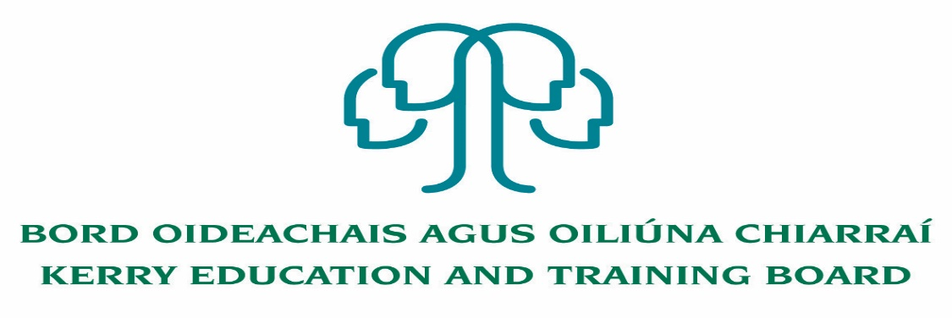
Job Description and Person Specification
Permanent Grade III – Clerical Officer
CCT Department

Location
Initial assignment will be to Kerry ETB Head Office, Centrepoint, Tralee. Appointment is to the Scheme – Kerry ETB reserves the right to assign a staff member to any other location, as the service exigencies require.

Reporting/Accountability Relationship
Grade III will report to the Head of CCT.

Post Summary/Purpose
The Clerical Officer is a support position within Kerry ETB with working in the front of house reception and for providing administrative support to the Kerry ETB CCT Department.

The Clerical Officer works as part of a team, supporting managers and colleagues to meet work goals and objectives and to deliver quality services to internal and external customers. The post holder will be responsible for the implementation of work programmes to achieve goals and targets.

The post holder will be required to be flexible, and undertake duties to support the work of the department as a whole.
The post holder will promote and maintain best practices throughout the CCT Department to ensure a quality service is delivered at all times
The post holder may be assigned to any of a very wide variety of areas or activities carried out in the Kerry ETB Scheme.

Duties

- Reception duties to act as the first point of contact for Kerry ETB- answering main telephone lines, directing enquiries, taking and distributing messages, processing emails and looking after incoming/outgoing post
- To ensure high quality customer service in dealing with the public and other stakeholders by responding to queries and providing information effectively and efficiently
- To draft relevant correspondence as required e.g. letters, memos etc

- Co-Ordinate planned events with relevant internal stakeholders and invited guests when required
- Assist in the procurement process for the purchase of goods, materials or equipment or other products or services as required utilising the Purchase to Pay system
- Filing of paperwork for audit purposes
- To assist in the recording, monitoring an transfer of fixed assets in Kerry ETB Head Office, Centrepoint, Tralee
- Provide administrative support to CCT department

Person Specification

Candidates for a Grade III post must:

- Have the requisite knowledge, skills and competencies to carry out the role. Competencies will be informed by best practice Public Appointment Service competency frameworks for the Irish Public Service;
- be capable and competent of fulfilling the role to a high standard;
- have obtained at least Grade D3 in five subjects in the Leaving Certificate Examination (higher, ordinary, applied or vocational programmes) or equivalent or have passed an examination at the appropriate level within the QQI qualifications framework which can be assessed as being comparable to Leaving Certificate standard or equivalent or higher or have appropriate relevant experience which encompasses equivalent skills and expertise;
Irish Language Fluency
- The post holder must be fluent in the Irish language

Desirable Criteria
- Excellent Customer Service skills
- Excellent administrative and IT Skills
- Strong Communication Skills, both written and oral.
- Strong attention to detail

Competences required
Kerry ETB Core Values of Respect, Quality, Equality, Inclusion and Learning are the guiding principles of the organisation and underpin the competencies required to fulfil this role.

The person appointed to the above post will be required to show evidence of the following competences:

People Management
- Leads others, monitoring performance and trying to get the best out of people
- Allocates work fairly and appropriately and ensures that everybody does their fair share
- Addresses any performance issues in a timely, appropriate and constructive manner
- Involves others in decisions that affect them, allocating work fairly and appropriately
- Demonstrates trust in others to deal with important tasks and acknowledges a job well done
- Helps team members to identify their own and their team’s learning and development needs in line with objectives
- Helps build effective relationships and resolve disagreements between team members
- Acts as an effective link between staff and other managers

Information Management and Decision Making
- Follows procedures and ensures they are implemented in own area, understanding the rationale behind them
- Reviews completed work regularly and acts on learning points
- Evaluates current work practices to identify changes that could be made to improve efficiencies
- Can work effectively on a number of tasks at the same time
- Is comfortable working with and manipulating a range of data, e.g. numerical, written etc.
- Makes sound appropriate decisions in a confident manner and can justify and stand by them

Delivery of Results
- Delivers results on time and to a high standard
- Takes responsibility for own work and the work of the team
- Plans and prioritises the work schedule, ensuing the efficient use of all of the resources available and delivering on objectives even with multiple or conflicting demands
- Evaluates the current work practices to identify changes that could be made to help them run more effectively
- Maintains accurate records and monitors work, ensuring any errors are identified and rectified
- Appreciates the need to delegate work appropriately rather than doing everything oneself

Interpersonal & Communication Skills
- Shows respect, tact and maintains composure when dealing with customers or staff members
- Demonstrates the ability to be assertive and negotiate when necessary, communicating in a clear and confident manner whilst remaining approachable and polite
- Listens to others and invites feedback, dealing with information in a constructive way
- Influences others by actively listening and clearly expressing their position
- Produces written letters /reports in a clear and concise manner

Specialist Knowledge, Expertise and Self Development
- Develops and maintains the skills and expertise required to perform in the role effectively, e.g. relevant technologies, IT systems, relevant policies etc
- Has a clear understanding of the role, objectives and targets and how they fit into the work of the unit and Department/ Organisation and communicates this to the team
- Leads by example, being committed to self-development and enhancing the knowledge and skills required to improve performance

Drive & Commitment to Public Service Values
- Consistently strives to perform at a high level, demonstrating flexibility and finding solutions to overcome obstacles
- Serves the Government and people of Ireland
- Can work independently without excessive guidance or support
- Demonstrates resilience in the face of significant demands and challenges
- Ensures that the customer is at the heart of all services provided
- Is personally honest and trustworthy
- Acts with integrity and supports this in others

