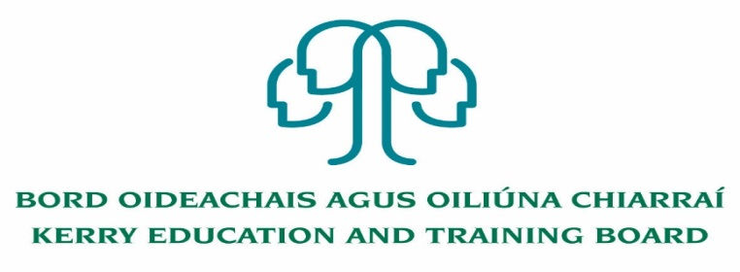

Kerry Education and Training Board (Kerry ETB) is a statutory education and training authority for County Kerry, established in accordance with the provisions of the Education and Training Boards Act 2013.

Kerry ETB is a provider of Primary, Post Primary and Further Education and Training services in Co. Kerry. The ETB has c. 1300, employees, an annual budget of c. €82 million, c.37 Centres of Education and Training with the organisations Head Office located in Tralee, Co. Kerry.

**Job Opportunities**

Kerry Education and Training Board invites applications from suitably qualified persons for the following positions. Appointment is to the scheme – centre of first assignment which may arise is identified for assistance of applicants

**An Tochar Further Education and Training Centre, Causeway**

Full time Permanent Grade III Clerical Officer

Full time Permanent Caretaker

**O’Connell Further Education and Training Centre, Cahersiveen**

Full time Permanent Grade III Clerical Officer

**Kenmare Further Education and Training Centre, Kenmare**

Full time Permanent Grade III Clerical Officer

**Dingle Further Education and Training Centre, Dingle**

Full time Permanent Grade III Clerical Officer

**Kerry College, Various Campus Locations**

Full timePermanent Grade III Clerical Officer x 2

Full time Fixed Term Grade III Clerical Officer x 1

**Kerry ETB Further Education and Training Unit, Centrepoint, John Joe Sheehy Road, Tralee**

Full time Permanent Grade III Clerical Officer

**Coláiste na Sceilge, Cahersiveen**

Permanent Grade III Clerical Officer – Half time post (17.5 hours per week)

Application form and further details i.e. Job Description and Person Specification are available from our website [www.kerryetb.ie/opportunities.html](http://www.kerryetb.ie/opportunities.html)

-------------------------------------------------------------------------------------------------------------------------------------------

**Please indicate clearly on application form which Centre/School you are applying for.**

Please complete an application form and **return by email only** to jobs@kerryetb.ie. No C.V.’s, only official application form will be accepted. Applications must be received not later than12 noon Friday 3rd March 2023.

*Colm Mc Evoy*

*Chief Executive*

**Kerry Education & Training Board services Gaeltacht areas.**

**Cuirfear fáilte roimh chomhfhreagras í nGaeilge.**

**Garda Vetting of successful candidates will take place prior to offer of employment.**

**Canvassing will automatically disqualify.**

**Short-listing will take place on the basis of the information provided in the application form. Depending on the qualifications and experience of applicants, short-listing thresholds may be higher than the minimum standards set out.**

###### Kerry Education & Training Board is an equal opportunities employer.

*“Creating a Learning Society in Kerry”*

