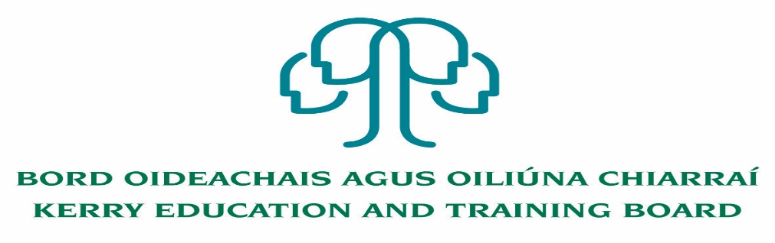

Applications are invited for the following post under the aegis of Kerry Education and Training Board.

Caretaker Post – Two Year Fixed Term Contract
Centre of initial assignment: Kenmare Further Education and Training Centre

-----------------------------------------------------------------------------------------------------------------
Application form, Job Description and Person Specification available on www.kerryetb.ie or from The Human Resources Department, Kerry Education and Training Board, Centrepoint, John Joe Sheehy Road, Tralee, Co. Kerry.

Please complete application form which can be downloaded from this website www.kerryetb.ie/opportunities and return by email only to jobs@kerryetb.ie. No CVs only official application form will be accepted.
Applications by email only must be received not later than 12 noon Friday 5th November 2021.
Colm Mc Evoy
Chief Executive Officer

Kerry Education & Training Board services Gaeltacht areas.
Cuirfear fáilte roimh chomhfhreagras i nGaeilge.
Garda Vetting of successful candidates will take place prior to offer of employment.
Canvassing will automatically disqualify.
Short-listing will take place on the basis of the information provided in the application form. Depending on the qualifications and experience of applicants, short-listing thresholds may be higher than the minimum standards set out.
Kerry Education & Training Board is an equal opportunities employer.
“Creating a Learning Society in Kerry”

