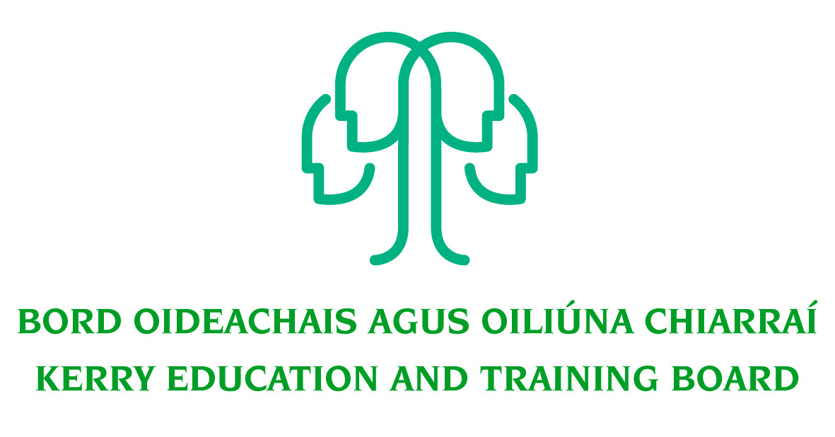
JOB DESCRIPTION
Title: Grade V Specific purpose to cover Maternity Leave
Grade: Grade V
Nature of post: Full time 37 hours per week
Reporting to: Further Education Standards Officer
Section: Kerry ETB Quality Assurance Unit
Post summary: To assist in the provision of a Curriculum / Assessment / Quality Assurance service as described in the Kerry ETB Quality Assurance System in respect of all education and training activities.

Duties and Responsibilities

- Assist the Further Education Standards Officer in the provision of relevant and timely advice, information and support to Management, Principals, Centre Managers, Programme Co-ordinators and Teachers/Tutors on matters relating to the assessment process, the processing of certification, educational materials and aids, educational methodologies and practices to meet the requirements of Quality and Qualifications Ireland (QQI) and other certifying bodies associated with the delivery of Further Education programmes in Kerry ETB.

- Assist the Further Education Standards Officer in researching the procurement of learning resource materials and assist in the dissemination of same to Principles/Centre Managers and Programme Coordinators.

- Support any improvements/actions required to the Quality Assurance System.

- Assist in the provision of assistance across further education provision in all quality assurance areas including the development and review of programmes, assessments and education plans for all certified Further Education programmes.

- Assist in the develop of quality assurance policies and procedures in line with QQI Guidelines and Kerry ETB policies.

- Co-operate with the provision of information and co-ordination for the Programme Evaluation Process.

- Assist in the identification of Staff Development needs for the introduction of new or revised modules/courses.

- Assist the Further Education Standards Officer in the administration of local IT systems and control the application of assessments and certification processes for Further Education Provision.

- Assist the Further Education Standards Officer in ensuring all matters in relation to the assessment and certification processes are conducted in a correct and proper manner in accordance with the processes and procedures set out in the Quality Assurance System and in accordance with the criteria outlined by the relevant certifying body. This includes, but not exclusively, the following;
  - Produce and maintain the Assessment Schedule
  - Disseminate Programme Descriptors and Programme Modules in accordance with the assessment regulations
  - Ensure the security of test questions, results and records in all cases
  - Co-ordinate the provision of reasonable accommodation, when required
  - Organise and prepare assessment packs and administer the relevant documentation for all assessment events when required
  - Recall Programme Descriptors and Programme Modules that have been withdrawn or are out of date
  - Monitor assessment and certification activity in accordance with Kerry ETB Quality Assurance System and in accordance with the criteria for certifying bodies
  - Administer/Organise and conduct the process for the External Verification of Assessment in Further Education
  - Monitor the processes for the Internal Verification of Assessment Results
  - Administer RPL requests
  - Report any breaches or suspected breaches relating to the Quality Assurance System or contracts to the AEO
  - Process any non-conformances in relation to the Kerry ETB Quality Assurance System through the Quality Assurance Unit

- Participate on the Local Results Approval Panel as an observer when requested

- Produce statistical reports relating to certification of all Further Education Programmes including the following;
  - Reports on programme results as requested
  - Reports on Internal Verification of Assessment Processes and Results
  - Reports on the Results Approval Process
  - Reports on Grade Analysis
  - Reports for the Kerry ETB Quality Council, Quality Governance Board and Programme Governance Board

- Assist the Further Education Standards Officer with follow up on any recommendations from the groups.

- Support the Further Education Standards Officer in the management of the learner appeal process with the relevant documentation for the Assessment Appeals Panel.

- Assist the Further Education Standards Officer in co-operating with and facilitating visits for external monitoring/verification processes from the Award Councils or 3rd party certification providers.

- Assist the Further Education Standards Officer in providing Kerry ETB Staff and Second providers of Further Education with briefings/training, as required, in relation to the Quality Assurance System, Curriculum Assessment instruments and procedures.

- Assist FET Centres/College Management Teams with Certificate Award Ceremonies.

- Undertake any other duties/projects as requested by the Further Education Standards Officer or the AEO.

Person Specification

As per Circular Letter 8/2017 and 46/2017 candidates must (by closing date for receipt of applications):

- have the requisite knowledge, skills and competencies to carry out the role. Competencies will be informed by best practice Public Appointment Service competency frameworks for the Irish Public Service;
- be capable and competent of fulfilling the role to a high standard;
- have obtained at least Grade D3 in five subjects in the Leaving Certificate Examination (higher, ordinary, applied or vocational programmes) or equivalent or have passed an examination at the appropriate level within the QQI qualifications framework which can be assessed as being of a comparable to Leaving Certificate standard or equivalent or higher or have appropriate relevant experience which encompasses equivalent skills and expertise;

Desirable:
- A third level qualification (Level 6 or higher on the National Framework of Qualifications)
- Experience in Certification and Quality Assurance systems and have networks into training and education.
- Experience in the development of policies and procedures
- Knowledge of ISO/QA systems.
- Knowledge of QQI, QBS System.
- Knowledge of Kerry ETB PLSS System.
- Access to transport and the ability to drive
- Excellent administrative and IT skills

Competences required
Kerry ETB Core Values of Respect, Quality, Equality, Inclusion and Learning are the guiding principles of the organisation and underpin the competencies required to fulfil this role.

The person appointed to the above post will be required to show evidence of the following competences:

Specialist Knowledge, Expertise and Self Development
- Clearly understands the role, objectives and targets and how they fit into the work of the Organisation.
- Develops the expertise necessary to carry out the role to a high standard and has a thorough understanding of the Code of Practice for the Governance of Education and Training Boards
- Is proactive in keeping up to date on issues and key developments that may impact on the Department and/or wider ETB service
- Consistently reviews own performance and sets self-challenging goals and targets
Leadership Potential
- Is flexible and willing to adapt, positively contributing to the implementation of change
- Contributes to the development of policies in the Department/Organisation
- Seeks to understand the implications of taking a particular position on issues and how interdependencies need to be addressed in a logical and consistent way
- Maximises the contribution of the team, encouraging ownership, providing support and working effectively with others
- Formulates a perspective on issues considered important and actively contributes across a range of settings

Analysis & Decision Making
- Is skilled in policy analysis and development, challenging the established wisdom and adopting an open-minded approach
- Quickly gets up to speed in a complex situation, rapidly absorbing all relevant information/data (written and oral)
- Uses numerical data skilfully to understand and evaluate service issues and adjudicating tenders.
- Identifies key themes and patterns in and across different sources of information, drawing sound and balanced conclusions
- Sees the logical implications of taking a particular position on an issue

Delivery of Results
- Assumes personal responsibility for and delivers on agreed objectives/goals
- Manages and progresses multiple projects and work activities successfully
- Accurately estimates time parameters for projects and manages own time efficiently, anticipating obstacles and making contingencies for overcoming these
- Maintains a strong focus on meeting the needs of customers at all times
- Ensures all outputs are delivered to a high standard and in an efficient manner
- Use resources effectively, at all times challenging processes to improve efficiencies

Interpersonal & Communication Skills
- Communicates in a fluent, logical, clear and convincing manner verbally and in writing
- Is able to listen effectively and develop a two-way dialogue quickly
- Maintains a strong focus on meeting the needs of internal and external customers
- Effectively influences others to take action
- Works to establish mutual understanding to allow for collaborative working

Drive & Commitment to Public Service Values
- Consistently strives to perform at a high level
- Maintains consistent effort under pressure and is resilient to criticism or setbacks at work
- Demonstrates high levels of initiative, taking ownership for projects and demonstrating self sufficiency
- Is personally trustworthy and can be relied upon
- Places the citizen at the heart of all process and systems

