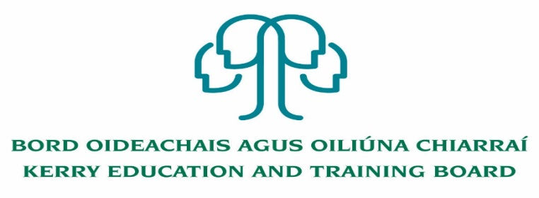

Kerry Education and Training Board (Kerry ETB) is a statutory education and training authority for County Kerry, established in accordance with the provisions of the Education and Training Boards Act 2013.
Kerry ETB is a provider of Primary, Post Primary and Further Education and Training services in Co. Kerry. The ETB has c. 1200, employees, an annual budget of c. €82 million, c.37 Centres of Education and Training with the organisations Head Office located in Tralee, Co. Kerry.

English for Speakers of other Languages (ESOL) Tutor Pool

Kerry Education and Training Board invites applications for inclusion on the above Tutor Pool which may arise (all appointments are to Kerry ETB).

Successful candidates will be placed in the Ukraine Response Tutor Pool.
Successful candidates may be assigned to schools, further education and training centres or other centres where tutoring may be required.
Candidates may be deployed within the school day, evenings, weekends and during the summer months where need arises.
An applicant’s inclusion on the pool is not an offer of employment. Hours will be assigned for tutor posts that may arise.

Garda Vetting will take place prior to inclusion on the Tutor Pool.

---------------------------------------------------------------------------------------------------------------------------------------
Further details and application forms can be downloaded from www.kerryetb.ie/opportunities or contact the H.R. Department, Kerry ETB, Centrepoint, John Joe Sheehy Road, Tralee, Co. Kerry. Tel. 066-7121488.

Please complete an application form and return by email only to jobs@kerryetb.ie. No C.V.’s, only official application form will be accepted.
Applications must be received not later than 12.00 noon Friday 27th May 2022.
Colm Mc Evoy
Chief Executive Officer

Kerry Education & Training Board services Gaeltacht areas.
Cuirfear fáilte roimh chomhfhreagras í nGaeilge.
Garda Vetting of successful candidates will take place prior to offer of employment.
Canvassing will automatically disqualify.
Short-listing will take place on the basis of the information provided in the application form. Depending on the qualifications and experience of applicants, short-listing thresholds may be higher than the minimum standards set out.
Kerry Education & Training Board is an equal opportunities employer.
“Creating a Learning Society in Kerry”

