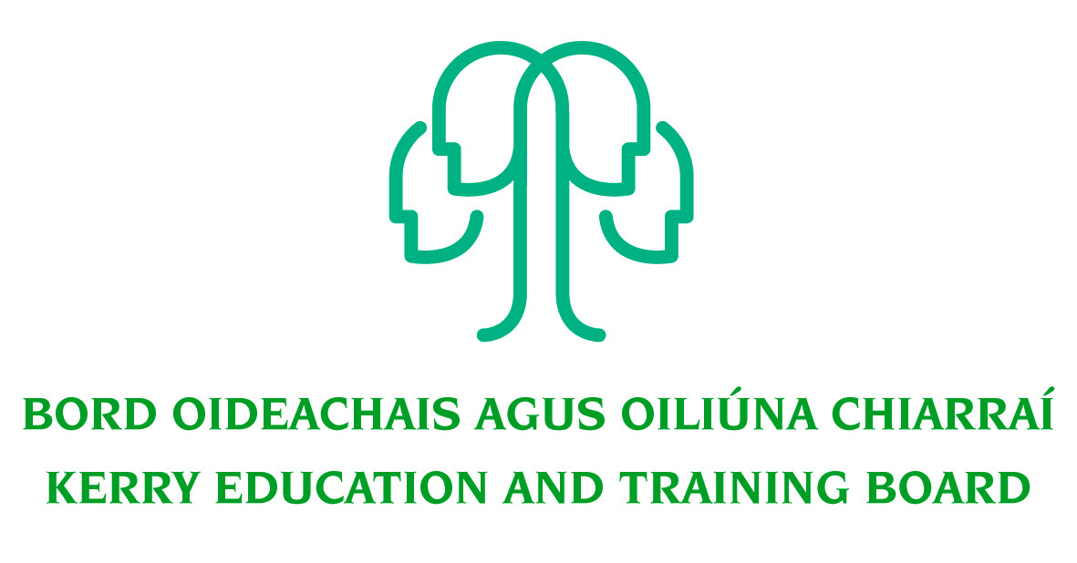
Electrical Apprenticeship Instructor Post
Kerry ETB Training Centre

Instructions for Completing this Form

Please Note: This is a FORM document and must be filled in as a form.

In order to successfully complete this form please do the following:

- Use the up and down arrows or TAB key to move through the grey fields. It is necessary to click in the grey box to insert text.

- On completing the form please save your changes as follows:
  - Go to the File drop down menu on the top toolbar.
  - Go to save as.
  - Name the document as your full name.
- Email the completed document to jobs@kerryetb.ie where one of our HR team will receive it.

Any queries regarding this form please email them to jobs@kerryetb.ie

Section 1

Name

Address

Phone Number
Mobile Number
E mail address

If you have any particular requirements to facilitate attendance at interview please inform Human Resources Department when confirming your interview appointment.

Kerry ETB is an Equal Opportunities Employer and applications from suitably qualified people with disabilities are actively encouraged.

Declaration
I declare that in submitting this application that all the information is, to the best of my knowledge, true in every detail. I understand that false statements may lead to disqualification, or if appointed, to termination of my employment.

Section 2

Education and Training/Development

Please list schools, colleges, universities etc. and qualifications obtained.

Name | From | To | Course Pursued | Qualification obtained | Corresponding Level on National Framework of Qualifications

Please give details of any further relevant training/development

College/Institute/ Centre/Organisation Provided | From | To | Type of Training & Qualification Obtained |  | Corresponding Level on National Framework of Qualifications

You may be required to produce evidence of qualifications and certificates of attendance.

Section 3

Employment Record: Please start with your current post and work backwards in chronological sequence:

From | To | Name & Address of Employer | Job Title | Main Responsibilities
Month/year | Month/year

You may use this page to supply any additional information on your Employment Record or Education and Training/Development.

Section 4

Work Experience & Personal Profile

In the following box, using no more than 150 words, briefly describe your career to date, detailing your number of years’ experience of operating in your particular field of expertise, your span of control and accountability, your key skills and achievements.

In the following box, please list your Interests and Achievements and the membership of clubs, institutions or societies, indicating any offices held.

In the following box, please describe briefly why have you applied for this post?

Section 5

Details of Referees

Please give the names and addresses of two referees from whom Kerry ETB can request references on your behalf prior to interview. One should be a recent employer. Both referees should have been in a position of responsibility within the employing organisation(s). They must not be related to you, or be known to you only as a friend. If you are unable to provide these please give details of someone who knows you in other than a personal capacity and who is prepared to provide a reference for you.
[Please note: your referees will be contacted without further communication with you and prior to interview if shortlisted for interview].

1st Referee |  |  | 2nd Referee
Name: |  |  | Name:
Organisation Name & Address: |  |  | Organisation Name & Address:
Telephone No./Ext & Email Address: |  |  | Telephone No./Ext & Email Address:
Position Held: |  |  | Position Held:
Your work connection with this referee: |  |  | Your work connection with this referee:
If you were known by another name when employed please specify: |  |  | If you were known by another name when employed please specify:
Dates of employment to/from (if applicable) |  |  | Dates of employment to/from (if applicable)

Signature | Date

Short-listing will take place on the basis of the information provided in the application form. Depending on the qualifications and experience of applicants, short-listing thresholds may be significantly higher than the minimum standards set out.

Kerry Education & Training Board is an equal opportunities employer.
“Creating a Learning Society in Kerry”

