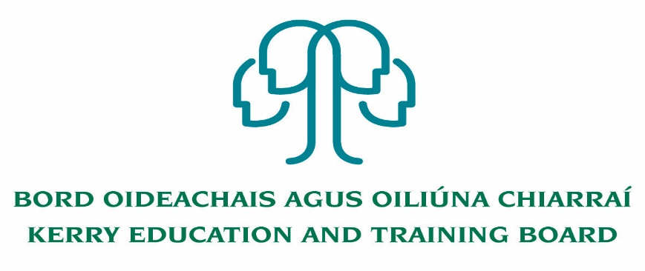
Deputy Principal Post Application Form
Kerry College

Completed application forms will only be accepted via email (jobs@kerryetb.ie),
No C.V.’s only official application form will be accepted.

Please note that all areas of the application form must be fully completed giving as much detail as possible of your skills, abilities experience relating to this post application as shortlisting will be based on the information gathered from this form

- Personal Details
Name: |  | Work No:
Address for |  | Mobile No:
Correspondence: |  | Home No:
 |  | Email:

Are you currently on career break?
Have you availed of the Incentivised Scheme for Early retirement (ISER)?
Are you in receipt of a state Pension?

- Current or Most Recent Appointment
Yes: No:
Are you currently employed by Kerry ETB?
If yes, complete section (a) below
If no, complete section (b) below

(a) Current staff members of Kerry ETB
Department/School/ Adult education centre/Programme | Title of Post
Current Annual Salary | Starting date

(b) External applicants - where you work now, or your last job
Employer’s name
Employer’s address
Starting date
Position held
Leaving date (if applicable)
Current Annual Salary
When could you be available for work, or what notice period is required by your current employer?
Reason for leaving if no longer employed?

Are there any restrictions on your right to work in Ireland

Yes: No:

If yes, please give details:__________________________________________________________
3. Previous Appointments
Please list all your previous appointments. This should also include voluntary and temporary work. Continue on a separate sheet if necessary.
Dates employed to/from | Name & address  of School/Centre | Position held PWT/ CID/TWT/PRCT/PT (Please state hours) | Nature of work including subjects & levels taught | Reason for  leaving

3A. What aspects of your recent experience, outlined above, have prepared you for the role of Deputy Principal?

Current and Previous Post of Responsibility experience (if applicable)
Director of  Adult Education |  | Permanent |  | Acting |  | Duration |  | Year of Appointment
Duties:

Programme  Co-ordinator |  | Permanent |  | Acting |  | Duration |  | Year of Appointment
Duties:

Assistant  Principal |  | Permanent |  | Acting |  | Duration |  | Year of Appointment
Duties:

Special Duties |  | Permanent |  | Acting |  | Duration |  | Year of Appointment
Duties:

3B. Outline briefly your three greatest achievements with respect to the above responsibilities:

- Details of Qualifications

Are you a registered teacher with the Teaching Council Yes No
If yes please attach a copy of your Confirmation of Registration Form. Registration No:__________
Please indicate what subjects have you been recognised to teach___________________________________________
If no, are you eligible for registration and willing to register? ___________________

Title of Degree:_____________________________
College: __________________________________
Year Obtained: _____________ Pass Honours
Subjects Taken
First Year | Result |  | Final Year |  |  | Result
Duration of Course of Study 2 yrs 3 yrs 4 yrs other (please specify)
Please specify whether full-time part-time study
Higher Diploma in Education (or equivalent):____________________________
College: ___________________________________
Year Obtained: _____________ Pass Honours

Other Qualifications held |  | Course Title |  | Year of Award | Pass or Honours |  | College

Any other information in regard to qualifications:

Inservice Courses
Dates |  | Title of Course | Name of Organisers | Nature of Award
From | To

- List, with outline dates, any extra-curricular activities in which you are or have been involved (start with the most recent and work backwards)

Have you completed the TUSLA Child First Training
Please Tick

Yes: No:

- The Role and Function of Deputy Principal

A number of key competencies have been identified as being essential for the effective performance of the role and function of Deputy Principal. Max. 150 words per competence

Leadership Skills
- Teaching and Learning
- College Development
- People and Teams

Organisational Management and Administrative Skills

Strategic Development and Management Skills

Self-Awareness and Self- Management

A clear vision for the development of Education in Kerry

Commitment to Professional Development.

Communication
.

Commitment to Kerry ETB Core Values

- Supporting Statement
This Section is for you to provide further information in support of your application. You should demonstrate why you have applied for the position and outline any other knowledge/expertise or attributes which you consider pertinent to the role of Deputy Principal.

- References
Please give the names and addresses of two referees from whom Kerry ETB can request references on your behalf prior to interview. One should be a recent employer. Both referees should have been in a position of responsibility within the employing organisation(s). They must not be related to you, or be known to you only as a friend. If you are unable to provide these please give details of someone who knows you in other than a personal capacity and who is prepared to provide a reference for you.
[Please note: your referees will be contacted without further communication with you and prior to interview if shortlisted for interview]
1st Referee |  |  | 2nd Referee
Name: |  |  | Name:
Organisation Name & Address |  |  | Organisation Name & Address
Telephone No./Ext & Email Address |  |  | Telephone No./Ext & Email Address
Position Held: |  |  | Position Held:
Your work connection with this referee |  |  | Your work connection with this referee
If you were known by another name when employed please specify: |  |  | If you were known by another name when employed please specify:
Dates of employment to/from (if applicable) |  |  | Dates of employment to/from (if applicable)
- Declaration
If this section is not completed, your application will not be considered for processing.

Have you been investigated by the Gardaí, HSE, or your employer in relation to substantiated complaints made concerning your treatment of children?

YES NO

Were you the subject of any allegation of criminal conduct or wrongdoing towards a minor?

YES NO

Are you aware of any material circumstance in respect of your own conduct which touched/touches on the welfare of a minor?

YES NO

Please note that it is a fundamental term of your employment that you make appropriate full disclosure in respect of the questions outlined above. You should also note that if Kerry ETB is satisfied, in the future, that you have made an incomplete or inaccurate disclosure, you may face disciplinary action, up to and including dismissal.

Kerry ETB undertakes that all responses furnished by you in respect of the above questions will be treated as confidential, subject to any reporting obligations which may be imposed on the school, pursuant to “Children First” published by the Department of Children and Youth Affairs, the Child Protection Procedures for Primary and Post-Primary Schools published by the Department of Education and Skills or pursuant to any legal obligation imposed on the school to facilitate the effective investigation of crime.

In the event of your being recommended for appointment to this position Kerry ETB is obliged to comply with the terms of current DES Circular Letters.
Kerry ETB’s policy is that all newly appointed teachers and support staff will be vetted via An Garda Siochana and that the outcome of the vetting will be considered in the light of the Kerry ETB’s vetting policy. This applies in respect of appointments to teaching posts, principal and deputy principal positions where the person is not currently an employee of the College and applies irrespective of whether the individual has been previously vetted or not.

10. DECLARATION AND SIGNATURE
- You are required to sign the declaration below certifying that all information you have provided is accurate.
- The Selection Committee may wish to check any of the details you have provided.
- Providing incorrect information or deliberately concealing any relevant facts may result in disqualification from the selection process or, where discovery is made after an appointment, in summary dismissal.

I declare that the information supplied in this application form is accurate and true.

Before signing this form, please ensure that you have replied fully to all questions asked.

Signed ___________________________ Date _____________

Please indicate where you saw this advert: ___________________________________________

Garda Vetting of successful candidates will take place prior to offer of employment.
Canvassing will automatically disqualify. Shortlisting of applicants may take place.

Kerry Education & Training Board is an equal opportunities employer

For Employer Use Only:
Application received by closing date Yes No
Teaching Council Registration Yes No
Post-Primary Teacher Qualification(s) as per DES Guidelines Yes No
Minimum of 5 year’s whole-time satisfactory teaching service or its equivalent Yes No
A Qualification in Post Primary Teacher Education or equivalent Yes No

COMPLETING A COMPETENCY BASED APPLICATION FORM
A Competency Based Application Form requires you, the candidate, to describe some of your personal achievements to-date that demonstrate certain competencies (necessary skills and qualities) required for the position you are applying for (e.g. Leader of Teaching and Learning, Leader of School Development, Communication Skills etc.). All question areas must be completed.
A definition of a skill or quality is given for each competency. You are then asked to describe a situation, from your own experience, which you think is the best example of what YOU have done which demonstrates this skill or quality. It is essential that you describe how you demonstrated the skill or quality in question.
You are advised to structure what you write so that you give specific information about what you have done - for example, do not simply say that “X was successful”, describe exactly what you did and how you demonstrated the skill or quality in question.
For each example please include the following:
(a) the nature of the task, problem or objective;
(b) what you actually did and how you demonstrated the skill or quality (and, where appropriate, the date you demonstrated it)
(c) the outcome or result of the situation and your estimate of the proportion of credit you can claim for the outcome.
Please do not use the same example to illustrate your answer to more than two skill areas.
Please note that, should you be called to interview, the board may look for additional examples of where you demonstrated the skills required for this post so you should think of a number of examples of where you demonstrated each of the skills.

