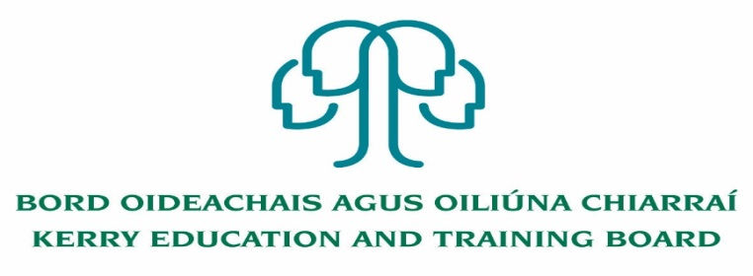

Deputy Principal (PWT)
Kerry College
Roll number: 76494H Category XVI

Kerry Education & Training Board (Kerry ETB) invites applications for the post of Deputy Principal for Kerry College.

Kerry College is a fully integrated College of Further Education and Training. The College offers a full range of Further Education and Training opportunities for learners/students with courses for progression, employment and apprenticeships. Kerry College provides a dynamic and inclusive environment for learners/students to complete their chosen further education and training course. The overall role of the Deputy Principal is to assist the Principal in the Management of the College.

County Kerry is our Campus.
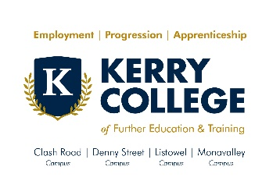

Kerry College currently has four campus locations across the county:
- Clash Road, Tralee
- Denny St., Tralee
- Monavalley, Tralee
- Listowel
For further details please visit www.kerrycollege.ie

To qualify for appointment to this post candidates must have:
- A recognised post-primary teaching qualification
- A minimum of 5 years’ satisfactory teaching experience or equivalent
- Registration in accordance with Section 30 of the Teaching Council Act 2001
- Satisfactory experience of leadership, management and administration at a sufficiently high level.

---------------------------------------------------------------------------------------------------------------------
Conditions of Service, Terms of Appointment, Qualifications, Salary Scales and Allowances are in accordance with the regulations of the relevant Department.

Application form and full details may be obtained from www.kerryetb.ie/opportunities or contact the H.R. Department, Kerry ETB, Centrepoint, John Joe Sheehy Road, Tralee, Co. Kerry. Tel. 066-7121488

Please complete an application form and return by email only to jobs@kerryetb.ie. No C.V.’s, only official application form will be accepted. Applications must be received not later than 1 p.m. Monday 14th September 2020.

Colm Mc Evoy
Chief Executive Officer

Kerry Education & Training Board services Gaeltacht areas.
Cuirfear fáilte roimh chomhfhreagras i nGaeilge.
Garda Vetting of successful candidates will take place prior to offer of employment.
Canvassing will automatically disqualify. Shortlisting of applicants may take place.

Kerry Education & Training Board is an equal opportunities employer.
“Creating a Learning Society in Kerry”
