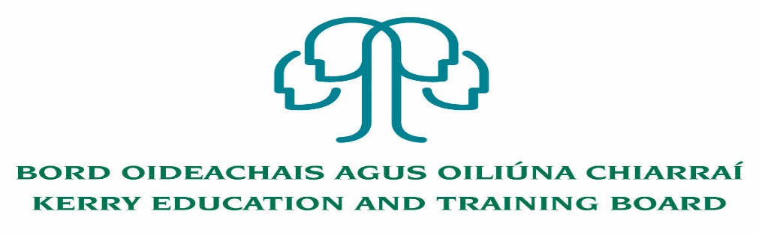

**Cover Instructor Pool**

**Centre of first assignment: Kerry College, Monavalley Campus**

Kerry Education and Training Board invite suitably qualified applicants for inclusion in a pool of temporary cover instructors to provide short-term cover on Phase 2 apprenticeships and on full time programmes listed below.

**Apprenticeship Programmes**

Electrical, Plumbing, Carpentry & Joinery, Fitting, Metal Fabrication, Stonecutting, Motor Mechanic, Drawing for Engineering, Maths for Engineering, Commis Chef

**Full Time Programmes**

Accounting Technician, IT Support, First Aid, Supervisory Management, Customer Care, Communications, Hairdressing, Project Management, Manual and Computerised Payroll, Manual and Computerised bookkeeping, Social Studies, Software Development, Train the Trainer, Sport and Leisure/Personal Training, Nutrition, Beauty Therapy, Tableau Software/office 365, ICT, Turning/Milling, Door Security/ Guarding skills, Healthcare, Digital Media, Cybersecurity

Qualifications relevant to both Programmes are outlined in the Person Specification.

Garda Vetting of successful applicants will take place prior to inclusion on the pool.

Colm McEvoy

Chief Executive Officer

----------------------------------------------------------------------------------------------------------------

*Please complete application form which can be downloaded from our website www.kerryetb.ie/opportunities and return by email only to* [*jobs@kerryetb.ie*](mailto:jobs@kerryetb.ie)*. No C.V.’s, only official application form will be accepted.*

**Kerry Education & Training Board services Gaeltacht areas.  
Cuirfear fáilte roimh chomhfhreagras i nGaeilge.  
Garda Vetting of successful candidates will take place prior to offer of employment.  
Canvassing will automatically disqualify.   
Short-listing will take place on the basis of the information provided in the application form. Depending on the qualifications and experience of applicants, short-listing thresholds may be higher than the minimum standards set out.**

###### Kerry Education & Training Board is an equal opportunities employer.

*“Creating a Learning Society in Kerry”*

