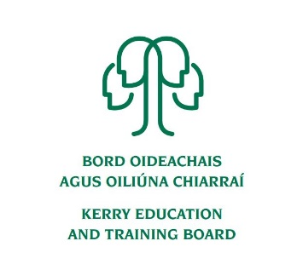

Kerry Education and Training Board (Kerry ETB) is a statutory education and training authority for County Kerry, established in accordance with the provisions of the Education and Training Boards Act 2013.

Kerry ETB is a provider of Primary, Post Primary and Further Education and Training services in Co. Kerry. The ETB has c. 1200, employees, an annual budget of c. €82 million, c.37 Centres of Education and Training with the organisations Head Office located in Tralee, Co. Kerry.

**Tutor Pool – Community Education – Kerry ETB**

Kerry Education and Training Board invites applications, from suitably qualified persons, for inclusion on the above Tutor Pool which may arise. We are seeking applications from individuals who have qualifications/skills in a variety of disciplines:

* Art Painting (Oil and Acrylic)
* Keep fit, Yoga, Pilates
* Creativity, Crafts, Music, Dance, Movement
* Beauty, Health, Wellbeing, Holistic Therapies
* Parenting
* Cooking and Nutrition
* History, Culture, Heritage, Languages
* Personal Development, Empowerment, Advocacy
* ICT for all levels
* Sustainable Living, Biodiversity, Nature & the Environment
* Farming, Fishing

An applicant’s inclusion on the pool is not an offer of employment. Hours will be assigned for casual part-time tutor posts that may arise. Experience in working with groups and/or ability to deliver in Irish is desirable. Garda Vetting will take place prior to inclusion on the Tutor Pool.

---------------------------------------------------------------------------------------------------------------------------------------

Further details are available from our webpage [www.kerryetb.ie/opportunities or contact the H.R](http://www.kerryetb.ie/opportunities%20or%20contact%20the%20H.R). Department, Kerry ETB, Centrepoint, John Joe Sheehy Road, Tralee, Co. Kerry. Tel. 066-7121488.

Please complete an application form and return by email only to jobs@kerryetb.ie. No C.V.’s, only official application form will be accepted. Applications must be received not later than **12.00 noon Thursday 30th June, 2022.**

***Colm Mc Evoy***

***Chief Executive Officer***

Kerry Education & Training Board services Gaeltacht areas.  
Cuirfear fáilte roimh chomhfhreagras í nGaeilge.  
Garda Vetting of successful candidates will take place prior to offer of employment.  
Canvassing will automatically disqualify.   
Short-listing will take place on the basis of the information provided in the application form. Depending on the qualifications and experience of applicants, short-listing thresholds may be higher than the minimum standards set out.

Kerry Education & Training Board is an equal opportunities employer.

*“Creating a Learning Society in Kerry”*

