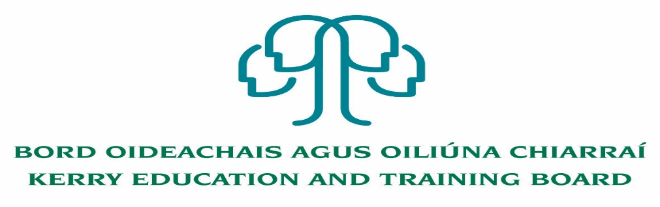

**Cleaning Posts**

Applications are invited for the following Part time Specific Purpose cleaning posts, under the aegis of Kerry Education & Training Board which may arise (all appointments are to Kerry ETB - centre of first assignment is indicated here for the assistance of applicants). All posts are of 34 weeks duration in line with school academic year.

**Killarney Community College – 21 hours per week**

**Gaelcholáiste Chiarraí - 22 hours per week**

Colm Mc Evoy

Chief Executive Officer

---------------------------------------------------------------------------------------------------------------------------------

Application form, Job Description and Person Specification available on [www.kerryetb.ie](http://www.kerryetb.ie) or from The Human Resources Department, Kerry Education and Training Board, Centrepoint, John Joe Sheehy Road, Tralee, Co. Kerry.

Please complete application form which can be downloaded from Kerry ETB website [www.kerryetb.ie/opportunities](http://www.kerryetb.ie/opportunities) and return by email only to [*jobs@kerryetb.ie*](mailto:jobs@kerryetb.ie). No CVs only official application form will be accepted.

Applications by **email only** must be received not later than 12 noon Friday 11th September 2020.

**Kerry Education & Training Board services Gaeltacht areas.**

**Cuirfear fáilte roimh chomhfhreagras i nGaeilge.**

**Garda Vetting of successful candidates will take place prior to offer of employment.**

**Canvassing will automatically disqualify.**

**Short-listing will take place on the basis of the information provided in the application form. Depending on the qualifications and experience of applicants, short-listing thresholds may be higher than the minimum standards set out.**

**Kerry Education & Training Board is an equal opportunities employer.**

**“Creating a Learning Society in Kerry”**

