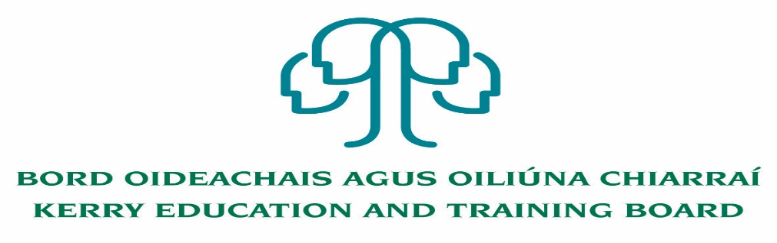

Cleaning Post

Applications are invited for the following Permanent Cleaning post which may arise:

Initial assignment to Coláiste na Ríochta & Kerry College, Listowel Campus
23 hours per week from mid-August to end of June

Appointment is to the Scheme – Kerry ETB reserves the right to assign a staff member to any other location, as the service exigencies require.

Essential Requirements:
- Proven experience of undertaking cleaning duties
- Experience of using buffing and vacuuming equipment
- Working knowledge and familiarity with commercial cleaning techniques
- Good organisational and time management skills
- Flexible with the ability to deal with unexpected events and changing work activities
- Willingness to work outside normal hours as required
- Experience and understanding of Health and Safety

Desirable Requirements:
- Ability to work effectively and supportively as a member of the school/college team
- Good interpersonal and communication skills
- Ability to act on own initiative
- Punctual, reliable and trustworthy

Please see Job Description and Person Specification available on www.kerryetb.ie or from The Human Resources Department, Kerry Education and Training Board, Centrepoint, John Joe Sheehy Road, Tralee, Co. Kerry.

Please complete application form which can be downloaded from Kerry ETB website www.kerryetb.ie/opportunities and return by email only to jobs@kerryetb.ie. No CVs only official application form will be accepted.
Applications by email only must be received not later than 12 noon Monday 13th July 2020.
Colm Mc Evoy
Chief Executive Officer

Kerry Education & Training Board services Gaeltacht areas.
Cuirfear fáilte roimh chomhfhreagras i nGaeilge.
Garda Vetting of successful candidates will take place prior to offer of employment.
Canvassing will automatically disqualify.
Short-listing will take place on the basis of the information provided in the application form. Depending on the qualifications and experience of applicants, short-listing thresholds may be higher than the minimum standards set out.
Kerry Education & Training Board is an equal opportunities employer.
“Creating a Learning Society in Kerry”

