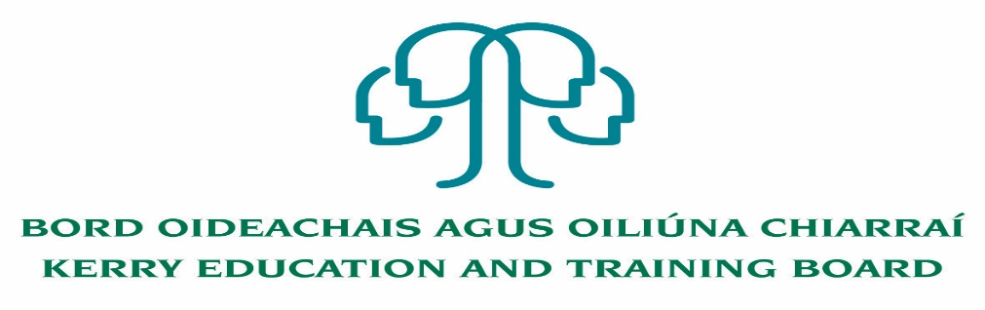
Job Description and Person Specification

Cleaner

Nature of Post
Fixed Term Cleaner Post

Location
Appointment is to the Scheme – Kerry ETB reserves the right to assign a staff member to any other location, as the service exigencies require.

Centre of first assignment
Kerry College, Clash Campus

Hours
25 hours per week

Reporting/Accountability Relationship
Cleaner will report to Principal/Deputy Principal

Salary
Salary Scale and Conditions of Service will be in accordance with the regulations of the Department of Education and Skills.

Duties

The duties include the day to day cleaning of a diverse school/college to include vacuuming, polishing, dusting, mopping and use of commercial cleaning equipment.

- Thorough cleaning of surfaces and floors in allocated classrooms, corridors, offices etc. paying particular attention to corners of rooms and under furniture and fittings.
- Specialised cleaning in practical rooms to include, kitchens, engineering labs, woodwork room etc.
- Allocated rooms, stairs and corridor walls to be dusted.
- Furniture in allocated areas to be polished.
- Cleaning and maintenance of reception area as allocated.
- Cleaning, wiping and sweeping in canteen area and staff room at times allocated.
- Cleaning of other buildings within the school/college grounds e.g. Sports Hall, if applicable
- Mopping and making safe any water or spills on floors.
- Safe removal of waste and litter to allocated disposal points, taking particular care with liquids, broken glass or other substances which may be unsafe to staff and students.
- Emptying vacuum cleaners and buffer vacuum bags.
- All toilets, urinals, sinks, wash hand basins etc. must be cleaned and disinfected at appropriate intervals.
- An adequate supply of toilet paper, paper towels and soap to be maintained.
- Windows in allocated areas to be cleaned regularly
- Reporting any damage or hazard.
- Ensuring all containers of cleaning agents are correctly labelled before use and are used safely and in compliance with manufacturers written instructions and all chemicals are stored safely when not in use.
- Ensure mops, cloths etc. are washed and left to dry as appropriate.
- Carrying out a review of all areas for cleaning and upkeep to identify and plan cleaning on a scheduled basis.
- Responsibility for maintaining floor areas and surfaces to the highest standards of cleanliness and hygienic condition
- Undertake cyclical deep cleaning which encompasses a range of activities including but not limited to
      - Woodwork and walls to be washed down
      - Light shades to be washed
      - Furniture to be washed and polished
- Preparation of Examination Centres as necessary and any cleaning required after exams
- Preparation of school/college for special occasions to include any cleaning requirement necessary during and after occasions
- The school/college may run Night Classes that may need cleaning support as required
- Flexible attendance patterns may be necessary i.e. attendance during evenings/weekends if classes/events are in progress
- Liaise with Principal/Deputy Principal in ordering cleaning materials/replacement of cleaning equipment in line with the correct ETB purchasing methods
- Additional class rooms etc. may be added to the school/college in the future and will come under the remit of cleaning duties
- Supporting the school/college’s Green Policy of Recycling and Waste Disposal
- Undertake training in use of methods, materials and equipment as required
- Compliance with the Health and Safety practices of the school/college
- To perform other such duties as may be required and generally carry out such instructions as may from time to time be given by Kerry ETB and/or the Principal/Deputy Principal

Person Specification

Cleaner Specification:

Essential Requirements:
- Proven experience of undertaking cleaning duties
- Experience of using buffing and vacuuming equipment
- Working knowledge and familiarity with commercial cleaning techniques
- Good organisational and time management skills
- Flexible with the ability to deal with unexpected events and changing work activities
- Willingness to work outside normal hours as required
- Experience and understanding of Health and Safety
- Punctual, reliable and trustworthy

Desirable Requirements:
- Ability to work effectively and supportively as a member of the school/college team
- Good interpersonal and communication skills
- Ability to act on own initiative

Short listing will take place on the basis of evidence provided in the application form.

The person appointed will be required to show evidence of the following:

Specialist Knowledge & Expertise:
- Is committed to self-development including further training if required and continuously seeks to improve personal performance
- Proven experience of undertaking cleaning duties.
- Experience of using buffing and vacuuming equipment
- Working knowledge and familiarity with commercial cleaning techniques
- Ability to follow manufacturers’ instructions with regard to cleaning equipment and chemical usage

Knowledge of Health and Safety:
- Experience and understanding of relevant Health and Safety issues

Team Work:
- Show respect for colleagues and co-workers
- Ability to work effectively and supportively as a member of the school team
- Offers own ideas and perspectives
- Understands own role in the team, making every effort to play his/her part

Customer Service and Communication Skills:
- Actively listens to others understanding their perspectives/requirements/needs
- Communicates clearly and concisely when speaking and in writing
- Ability to follow instructions on equipment, materials etc.
- Good interpersonal and communication skills

Delivery of Results:
- Completes work in a timely manner
- Adapts quickly to new ways of doing things
- Checks all work thoroughly to ensure it is completed to a high standard
- Identifies and appreciates the urgency and importance of different tasks
- Punctual, reliable and trustworthy

Drive & Commitment to Public Service Values:
- Consistently strives to perform at a high level and deliver a quality service
- Is thorough and conscientious, even if work is routine
- Demonstrates resilience in the face of significant demands and challenges
- Ensures that the learner is at the heart of all services provided
- Is personally honest and trustworthy
- Acts with integrity and supports this in others

Kerry ETB Core Values: Respect, Quality, Equality, Inclusion and Learning are the guiding principles of the organisation and underpin the competencies required to fulfil this role.

