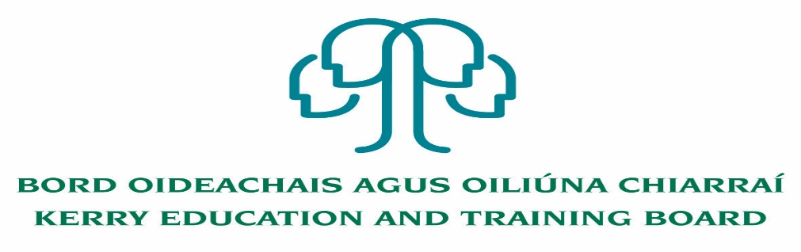

Job Description and Person Specification
Caretaker post

Nature of Post
Permanent 39 hours per week

Location
Appointment is to the Scheme – Kerry ETB reserves the right to assign a staff member to any other location, as the service exigencies require. Kerry College, Denny St. Campus

Reporting/Accountability Relationship
Caretaker will report to the Principal

Salary
Salary Scale and Conditions of Service will be in accordance with the regulations of the Department of Education and Skills.

Duties

To open the school/centre each morning and at other times as required prior to commencement of classes or meetings and to be similarly available at key times during the school/centre day. This may require flexible working hours. To have all classrooms ready for the meeting of classes at least half an hour before the official time of commencing.

To close the school/centre each day and night on termination of school/centre activities and to ensure that the school/centre are safely secured for the night and that all doors, windows etc., are closed. To ensure all electrical power and lighting is switched off throughout the school/centre. That all controls on central heating systems, radiators, storage heaters are set to come into timely operation in the morning as required.

To open and close the school/centre for functions outside of the normal hours when necessary.

Ensure that school/centre buildings are safe and secure at the conclusion of classes examinations or functions.

To co-operate in the introduction and operation of new plant and equipment.

To perform such duties in accordance with quality initiatives and standards.

To take delivery of all materials received and to record those deliveries as directed. Transfer of such materials to stores or other appropriate place.

To help maintain and care for the school/centre premises and contents and to prevent as far as possible, any damage to the structure, furniture, fittings or equipment on the part of students or others.

To keep the school/centre premises, furniture and fittings clean and in a well-maintained condition including glass doors and windows.

To take up training and continuous professional development as required to enhance ability to do the job

To provide such cleaning services as may be required. To liaise and co-operate with cleaning staff/contractors to ensure that the cleaning of the entire school/centre is done in a satisfactory manner and that all areas of building are kept in a clean and hygienic condition. To operate a clean as you go policy. To list promptly all requisitions for repairs to cleaning equipment or for replenishing of materials. To write up such records relating to their work and the work of cleaning staff as are required. To keep a preventative maintenance register. To be alert to Health & Safety reporting procedures.

To look after the fuel boiler and to check and report on fuel stocks regularly. To check and report on gas stocks where required for practical subjects. To help in the exercise of economy in the use of fuel and light throughout the building, and to help prevent all unauthorised use of same.

To keep in safe custody, the keys of all rooms in the building and to ensure that no unauthorised person has access to any part of the building. Follow the Kerry ETB Key Holding Policy.

To ensure that all refuse bins are emptied into the appropriate wheelie bins and to prepare for the weekly collection of these bins. Liaise with cleaning staff, Green Schools Club and Principal about the school focussed approach to refuse collection and dispersal.

To ensure proper maintenance of all school/centre grounds undertaking weeding, mowing and planting, as required, including the maintenance of the gardens and demonstration plots. To ensure that the grounds are free of litter and are always neat and presentable and to prevent trespass thereon.

To co-operate in efforts to heighten awareness of health and safety in the workplace through new procedures. To conform to Health, Safety and Welfare procedures in all aspects of his/her work. To ensure co-operation with ongoing legislative changes.

To be responsible throughout the year for maintenance of the building in line with Kerry ETB maintenance guidelines under the supervision of the Principal/Centre Manager. Including undertaking minor repairs to premises, fixtures and fittings and paintwork as directed.

To test all drains occasionally and ensure that they are kept clean and functioning properly at all times.

To undertake, during vacation periods, when the school/centre is closed, a thorough cleaning and polishing of such parts of the building as may be assigned to him/her and of the furniture therein; to carry our minor repairs and paintwork as directed.

In relation to emergency on call services best practise/needs of school/centre – by agreement applies.

To bring to the notice of the appropriate authorities ie, Principal/Centre Manager any acts of misconduct observed.

To give such assistance as may be required in connection with the organisation of exhibitions of students work whether within or without the precincts of the school/centre.

To carry out his/her duties at such times and for such periods each day as may be determined by the Principal/Centre Manager.

To maintain ethical behaviour and fairness in the carrying out of duties, and, to adhere to the Kerry ETB Code of Conduct at all times in the performance of such duties.

To work as part of a team with the ancillary staff, Principal/Centre Manager in keeping the school/centre fit for purpose.

To co-operate with efforts to improve value for money and general efficiency in the provision of services.

Only where directed by the Principal/Centre Manager or other designated person to liaise with external qualified contractors.

To contribute to the development of effective teams.

To liaise and work with staff and students in relation to the Kerry ETB Sustainability policy

To ensure compliance with organisational policies, goals, procedures and legislation.

Evening Functions (If Required)

When Evening Training, examinations or School/Centre functions are being held, be on duty a minimum of a half an hour before the start of such classes or functions and have rooms in readiness for classes and functions. Duties as assigned by the Principal/Centre Manager to be carried out during evening/night attendance. Kerry ETB policy should be adhered to when dealing with third parties using a Kerry ETB school/centre/premises.

To arrange that all classrooms are adequately heated before classes commence. To see to the heating requirements of the building and safeguard the heating and water pipes during the cold period of the year.

The above is not an exhaustive list as each School/Centre will have particular
requirements. On this basis there is a requirement to carry out such other appropriate
duties as may be required and generally carry out such instructions as may, from time to
time, be given Principal/Centre Manager/Chief Executive Officer.

Person Specification
Caretaker

Essential Requirements:
- Proven experience to undertake caretaking duties
- Experience in grounds keeping e.g. garden maintenance
- Understanding/experience in electrics, plumbing and carpentry
- Experience of taking responsibility for the security of buildings
- Experience and understanding of Health and Safety
- Full Clean Driving Licence

Desirable Requirements:
- Ability to work effectively and supportively as a member of the school team
- Good interpersonal and communication skills
- Ability to act on own initiative, dealing with any unexpected problems that may arise
- Punctual, reliable and trustworthy

Short listing will take place on the basis of evidence provided in the application form.

The person appointed will be required to show evidence of the following:
Specialist Knowledge & Expertise:
- Is committed to self-development and continuously seeks to improve personal performance
- Proven experience to undertake caretaking duties.
- Experience in grounds keeping e.g. garden maintenance
- Understanding/experience in electrics, plumbing and carpentry
- Experience of taking responsibility for the security of buildings

Knowledge of Health and Safety:
- Experience and understanding of Health and Safety issues

Team Work:

- Show respect for colleagues and co-workers
- Ability to work effectively and supportively as a member of the school team
- Offers own ideas and perspectives
- Understands own role in the team, making every effort to play his/her part

Customer Service and Communication Skills:
- Actively listens to others understanding their perspectives/requirements/needs
- Communicates clearly and concisely when speaking and in writing
- Ability to follow instructions on equipment, materials etc.
- Good interpersonal and communication skills

Delivery of Results:
- Completes work in a timely manner
- Adapts quickly to new ways of doing things
- Checks all work thoroughly to ensure it is completed to a high standard
- Identifies and appreciates the urgency and importance of different tasks
- Punctual, reliable and trustworthy

Drive & Commitment to Public Service Values:
- Consistently strives to perform at a high level and deliver a quality service
- Is thorough and conscientious, even if work is routine
- Demonstrates resilience in the face of significant demands and challenges
- Ensures that the customer is at the heart of all services provided
- Is personally honest and trustworthy
- Acts with integrity and supports this in others

Kerry ETB Core Values: Respect, Quality, Equality, Inclusion and Learning are the guiding principles of the organisation and underpin the competencies required to fulfil this role.

