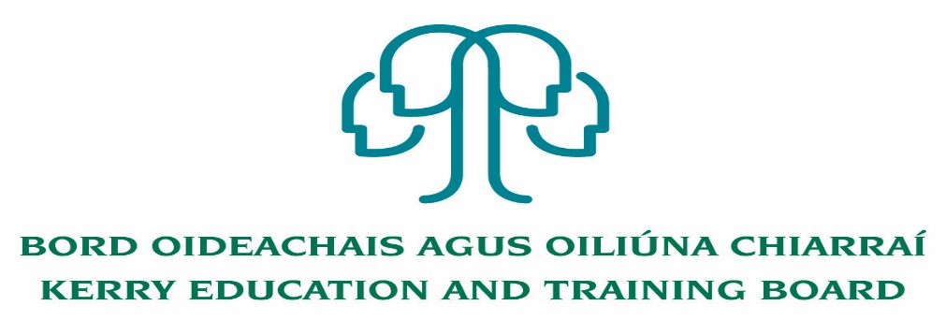

Application for inclusion in Creative Youth Tutor Pool
Completed application forms will be accepted via email only to (jobs@kerryetb.ie)

Please note that all areas of the application form must be fully completed giving as much detail as possible of your skills, abilities and experience.

Professional Sector (please choose one or more):
Creative Arts:
Digital Creativity:
Creative Industries (varied):
Specific discipline/category (please choose one or more) please use ‘Other’ if your discipline is not listed:
Arts
Architecture
Design (Built Environment/Construction/Engineering/Interior/Garden/Space/Fashion/Textiles):
Design:(Business/Graphic/Entrepreneurship/Product/Process/ICT/Innovation/Robotics/
Systems/Coding/:
Craft:
Visual Arts:
Traditional Arts:
Creative Performing Arts (theatre/drama):
Creative Performing Arts (Stage Craft/Make-Up/Special Effects):
Creative Literary Arts:
Film/Animation/Cinematography/Special Effects:
Design, Craft or arts appreciation or theory (all categories):
Personal Styling inclu. hair, nail art and make-up:

Other (Please state):____________________________

1. Personal Details
Your last name/family name Firstname
Permanent home address
Home telephone no. Work telephone no.
Mobile no. Email address

2. Current or Most Recent Appointment
Are you currently employed by Kerry ETB?
If yes, complete section (a) below
If no, complete section (b) below

(a) Current employees of Kerry ETB
Department/School/ Further Education and Training Centre
Title of post
Current Annual Salary Starting date
(b) External applicants - where you work now, or your last job
Employer’s name.
Employer’s address
Starting date Leaving date (if applicable)
Position held

3. Previous Appointments
What jobs have you had in the past?
Please list all your previous appointments. This should also include voluntary, temporary work, short-term assignments. Continue on a separate sheet if necessary.
Dates employed Name & address Position held & Reason for
to/from of employer nature of work leaving
4. Professional Qualifications

Award | Institution | Areas of study | Year | Level of Award
You may be required to provide evidence of any academic qualifications stated.

5. Any further information of relevance (Achievements, Interests, Organisations, etc)

7. Supporting Statement

How you meet the selection criteria
Drawing upon your experience, skills, abilities and qualifications explain how you meet the requirements of the Creative Tutor Pool. Please try and limit your response to no more than 500 words.

8 Details Of Referees
Please give the names and addresses of two referees from whom references can be requested prior to selection to the LCYP Creative Tutor Pool. One should be your present employer/a service provider/organisation working with young people, or your most recent employer if you are currently unemployed. Both referees should have been in a position of responsibility within the employing organisation(s). They must not be related to you, or be known to you only as a friend. If you are unable to provide these please give details of someone who knows you in other than a personal capacity and who is prepared to provide a reference for you.
1st Referee 2nd Referee
Name Name
Organisation name and address Organisation name and address
Telephone no./ext and email address Telephone no./ext and email address)

Position held Position held
Your work connection with this referee Your work connection with this referee
If you were known by another name If you were known by another name
when employed please specify: when employed please specify:
Dates of employment to/from (if applicable) Dates of employment to/from (if applicable)
9. Important Information

Please read before signing this application form
The accuracy of information provided may be checked with other organisations. Provision of false or misleading information may amount to a criminal offence. Kerry ETB may obtain from or provide information to third parties for the purposes of the detection and prevention of crime.
The organisation may data match information it holds about its employees for the prevention and detection of crime.

Declaration
I declare that the information I have provided is true and accurate and that I have not omitted any material facts. I accept that the offer of assignments from the pool and/or contractual employment is conditional on the provision by me of true, accurate information with no material omissions.
I give my consent to Kerry ETB making such reasonable enquiries as it sees fit in respect of my application.
I accept that once I have commenced an assignment/employment, Kerry ETB will be entitled to terminate my contract without notice if information in this application is untrue or inaccurate or if there are material omissions from it.
Signature Date

Please submit completed application form by email to jobs@kerryetb.ie and mark in the subject line: LCYP Creative Youth.

No C.V.’s only official application form will be accepted.

Garda Vetting will take place.

Canvassing will automatically disqualify. Shortlisting of applicants may take place.

Kerry Education & Training Board is an equal opportunities employer.

