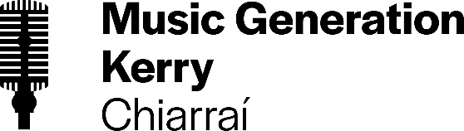 | 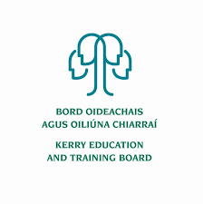

Kerry Education and Training Board (Kerry ETB) is a statutory education and training authority for County Kerry, established in accordance with the provisions of the Education and Training Boards Act 2013.

Music Generation Kerry is part of Music Generation, Ireland’s national music education programme initiated by Music Network, co-funded by U2, The Ireland Funds, the Department of Education and Skills and Local Music Education Partnerships.

Part time Musician Educator Pool
Music Generation Kerry

Kerry Education and Training Board invites applications from suitably qualified persons to be placed in a pool for part-time Musician Educators for the following Music Generation Kerry Programmes:

- Early Years Music Programmes
- Group Percussion/Drums (Primary and Post-Primary Schools)
- Group Guitar/Ukulele (Primary and Post-Primary Schools)
- Classical Ensemble (Strings/Woodwind/Brass)
- Traditional Irish Instrumental and Group Programmes

Musician Educators will work with children and young people in group contexts online and in person and may work on one or more programmes at any given time. The ability to deliver tuition at more than one location throughout County Kerry will be advantageous. Applications are particularly welcomed from musicians who can teach through the medium of Irish.
--------------------------------------------------------------------------------------------------------------------------
Please complete application form which can be downloaded from our website www.kerryetb.ie/opportunities and return by email only to jobs@kerryetb.ie. No C.V.’s, only official application form will be accepted.

Applications by email only must be received not later than 12 noon Thursday !!!!!
Please complete application form, including reference form, for the post(s) you are applying for

Colm Mc Evoy
Chief Executive Officer

Kerry Education & Training Board services Gaeltacht areas.
Cuirfear fáilte roimh chomhfhreagras i nGaeilge.
Garda Vetting of successful candidates will take place prior to offer of employment.
Canvassing will automatically disqualify. Short-listing will take place on the basis of the information provided in the application form. Depending on the qualifications and experience of applicants, short-listing thresholds may be higher than the minimum standards set out.

Kerry Education & Training Board is an equal opportunities employer.
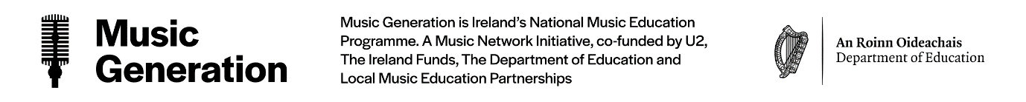
“Creating a Learning Society in Kerry”

