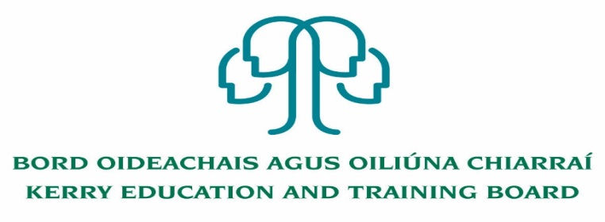

Adult Education Officer Post (Permanent)
Initial Duties: Management of Kerry College Outdoor
Education and Training Campus

Job Description

Nature of Post: Permanent Full Time - 37 hours per week

Location: Appointment is to the Scheme – Kerry Education and Training Board Kerry ETB reserves the right to assign a staff member to any other location, as the service exigencies require. Your centre of first assignment will be Kerry College Outdoor Education and Training Campus.

Salary: €53,323 – €83,847

Reporting/Accountability Relationship: Director of Further Education and Training or delegated officer

Post Summary:
This position involves responsibility for the leadership and management of the Kerry College, Outdoor Education and Training Campus. Due to the nature of the post, a willingness to work outside of normal working hours if required

Key areas of responsibility:
This role will include, but is not be limited to, the following:
- Lead the Campus staff to agree and implement a work plan for the further development and delivery of Kerry College, Outdoor Education and Training Campus aligned to the mission and vision of Kerry College.
- Development, delivery and monitoring of the Campus programme of outdoor education and training provision to meet current, new and emerging needs in ensuring the Campus is recognised as a leader in outdoor education and training skills acquisition and development.
- Maintain records of educational and training programme planning as per Kerry ETB policy, SOLAS, Department requirements, QQI guidelines etc.
- Develop, implement, review and evaluate and update procedures and systems for the operation and functioning of the Campus ensuring compliance with relevant legislation (including Education, Employment, Child Protection, Adult Safeguarding etc.), relevant policies and regulations.
- Work in consultation with Kerry College Management in fully integrating the Campus (including the staff) into the wider Kerry College as a Campus of excellence for the design, development and delivery of Outdoor Education and Training programmes and services.
- Lead the centre in the review, design, development and delivery of outdoor education and training and environmental programmes.
- In consultation with the Kerry College and ETB Senior Management team, develop, plan and evaluate education and training programmes under various types of provision i.e. skills development for outdoor education and training professionals, environmental awareness and sustainability, programmes.
- Assessment and monitoring of learner progress and achievement.
- Establish and promote high standards and expectations for all learners and staff for learning and engagement.
- Foster a culture of self-assessment and reflective thinking among learners.
- Ensure that the education and training provided in the Campus is constantly supervised and evaluated.
- Actively promote own continuous professional development and that of staff and ensures that it is in line with the overall goals, plans and targets of the Campus.
- Lead and support the design, development and delivery of blended learning programmes, as required.
- Foster and maintain excellent professional working relationships with all staff in the Campus, ensuring effective delegation and support.
- Lead, motivate and manage all staff in the Campus to achieve excellence in their work; through the use of Kerry ETB HR Policies, systems, planning and evaluation, team work/support, clearly defined organisation structures, established roles and responsibilities and effective communications.
- Ensure adherence to health and safety, child protection, and welfare for students, adult safeguarding policy etc.
- Lead and implement workforce planning in addressing the ever evolving needs of the Campus.
- Completion of appropriate administration duties, including the establishment and maintenance of appropriate procedures for record keeping and regular reporting to Kerry ETB, SOLAS and the Department of Further and Higher Education Research, Innovation and Science as appropriate.
- Budgeting and financial management within the financial framework of Kerry ETB System.
- Monitoring, management and data inputting for all learners and courses on the Kerry ETB PLSS system for the Kerry College Outdoor and Education and Training Campus.
- Daily operational management of Campus including all facility maintenance and upkeep.
- Management of premises, including implementation of Health and Safety requirements, , monitoring of compliance and associated record keeping.
- Implement the policies of Kerry ETB, the relevant Government Department, QQI and SOLAS in an efficient and productive manner.
- Engage and communicate in a professional manner with all stakeholders, setting an appropriate standard and code in terms of tone, response, methods etc.
- Ensure effective and positive public relations for the Campus with the wider community.
- Implement modern methods of communication for internal and external audiences e.g. information technology systems, on line platforms etc.

- Proactively participate in professional development, networking etc. to extend knowledge and skill set and keep up to date with current educational and training thinking and practice.
- Other duties appropriate to the grade, may be assigned from time to time by the Director of FET or delegated officer.

The above list of accountabilities may be varied having regard to the changing needs of the Scheme and the terms of the post can include delivery of responses to unpredictable work demands as they arise.

Person Specification
The successful candidate will:
(a) Have management experience at an appropriate senior level, including leading teams and managing resources;
(b) Have relevant experience in the following:
- Leadership of teaching or learning or training in adult education or further education or training or community or voluntary sectors;
- Governance and management;
- Performance management.
(c) Demonstrate the capacity to work as part of a management team, contribute to the implementation of strategic plans, organisational policies and procedures;
(d) Demonstrate the ability to manage and lead change and to fulfil reform requirements within the ETB;
(e) Have strong interpersonal and collaborative skills including the ability to work effectively with a range of stakeholders and to represent the ETB as required;
(f) Carry out the lawful orders of the Director of Further Education.

Qualifications
Third Level qualification(s) in relevant discipline(s) commensurate with the role would be a decided advantage

Competencies Required
- Leadership: Supporting, developing, leading and managing FET staff.
- Analysis and Decision Making: Programme planning, monitoring and implementation.
- Management and delivery of results: Reviewing, reporting and evaluating FET programme and service delivery.
- Interpersonal and communication skills: Promote, establish and maintain effective communications across all FET provision and with relevant voluntary and statutory bodies.
- Specialist Knowledge, Expertise and Self-development: Possess a clear understanding of the role and how it fits into the work of the ETB and maintain a focus on self-development, seeking feedback and opportunities for growth to help carry out the specific role requirements.
- Drive and Commitment to Public Service Values: Develop, manage and implement an ETB-wide framework approach to the delivery of further education and training provision and service.

Kerry Education and Training Board services Gaeltacht areas.
Cuirfear fáilte roimh chomhfhreagras í nGaeilge.
Garda Vetting of successful candidates will take place prior to offer of employment.
Canvassing will automatically disqualify.
Short-listing will take place on the basis of the information provided in the application form. Depending on the qualifications and experience of applicants, short-listing thresholds may be higher than the minimum standards set out.

