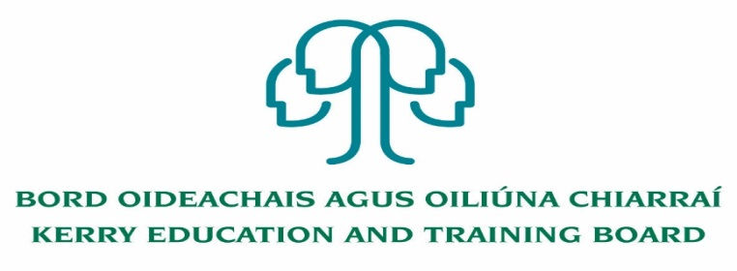

Kerry Education and Training Board (Kerry ETB) is a statutory education and training authority for County Kerry, established in accordance with the provisions of the Education and Training Boards Act 2013.

Kerry ETB is a provider of Primary, Post Primary and Further Education and Training services in Co. Kerry. The ETB has over 1,100 employees, an annual budget of circa €52 million, 33 Centres of Education and Training with the organisations Head Office located in Tralee, Co. Kerry.

**Permanent Grade VI - Senior Staff Officer**

**Human Resources Department, Kerry ETB Head Office**

**Confined Competition**

**(as per C. L. 0008/2017 and 46/2017)**

**Post Summary**:

This post is a supervisory position within Kerry ETB and will be assigned responsibility for the day to day operation and supervision of work areas, section or team.

The post holder will manage employee documentation, including contracts, recruitment/selection processes, staff allocation/utilisation and employee relations documentation.

Application forms and full details may be obtained from [www.kerryetb.ie/opportunities or contact the H.R](http://www.kerryetb.ie/opportunities%20or%20contact%20the%20H.R). Department, Kerry ETB, Centrepoint, John Joe Sheehy Road, Tralee, Co. Kerry. Tel. 066-7121488

Please complete an application form and **return by email only** to jobs@kerryetb.ie. No C.V.’s, only official application form will be accepted. Applications must be received not later than 12 noon Monday, 7th December, 2020

**Proposed date for interview will be Thursday, 10th December, 2020**

*Colm Mc Evoy*

*Chief Executive*

**Kerry Education & Training Board services Gaeltacht areas.**

**Cuirfear fáilte roimh chomhfhreagras í nGaeilge.**

**Garda Vetting of successful candidates will take place prior to offer of employment.**

**Canvassing will automatically disqualify.**

**Short-listing will take place on the basis of the information provided in the application form. Depending on the qualifications and experience of applicants, short-listing thresholds may be higher than the minimum standards set out.**

###### Kerry Education & Training Board is an equal opportunities employer.

*“Creating a Learning Society in Kerry”*

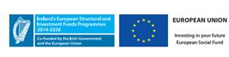Education_MARK_MASTER_Std_Colour