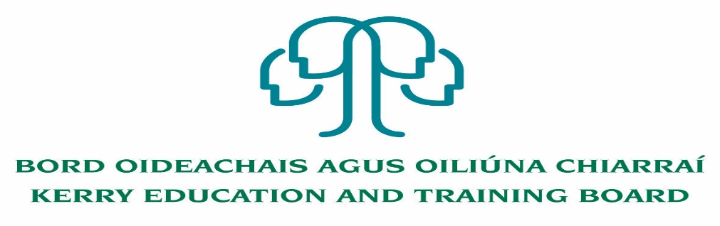

Kerry Education & Training Board wishes to recruit committed, enthusiastic and talented educators to its team of teachers and educational leaders. We provide a quality comprehensive education & training service in eight second level schools, two Further Education colleges, Kerry ETB Training Centre, five adult education and training centres and through a wide range of community-based adult and further education and training programmes.

**Teaching Posts**

Applications are invited for the following Fixed Term/Specific Purpose teaching post (s), under the aegis of Kerry Education & Training Board which may arise in the school year 2021/2022 (all appointments are to Kerry ETB – centre of first assignment is indicated here for the assistance of applicants). All vacancies are subject to the Directors of Redeployment agreeing to the posts being filled, following completion of the 2021 Scheme. A panel may be formed from these competitions from which appointments may be made in 2021/2022

**Hours**

**Coláiste Gleann Lí**

CGL 21.22.1 Art (Carers Leave) 16

CGL 21.22.2 Biology (Maternity Leave Cover) 22

CGL 21.22.3English and History (Maternity Leave Cover) 16

CGL 21.22.4 Geography (Experience of teaching ICT is an advantage) 14

CGL 21.22.5 Irish 14

CGL 21.22.6 Religion (Experience of teaching Wellbeing is an advantage) 16

**Killarney Community College**

KAS 21.22.7 Home Economics (Experience of teaching Irish is an advantage) 11

**Causeway Comprehensive School**

CWS 21.22.8 Construction Studies 16

CWS 21.22.9 Maths (Experience of teaching Chemistry is an advantage) 19

CWS 21.22.10 Physical Education and Geography 22

CWS 21.22.11 Spanish 11

**Castleisland Community College**

CIS 21.22.12 Agricultural Science (Experience in teaching ICT is an advantage) 5

CIS 21.22.13 French 8

CIS 21.22.14 Construction Studies (Experience of teaching Graphics is an advantage) 11

CIS 21.22.15 History 10

CIS 21.22.16 Irish and PE (Job share cover) 11

**Gaelcholáiste Chiarraí**

GCS 21.22.17 Béarla (Saoire mháithreachais) 18

GCS 21.22.18Béarla 18

**Coláiste na Sceilge**

CNS 21.22.19 German and English 22

CNS 21.22.20 Spanish (Experience of teaching English is an advantage) (Career break cover) 22

**Coláiste na Ríochta**

CNR 21.22.21 Construction Studies 19

CNR 21.22.22 PE (Experience of teaching Geography is an advantage) 20

CNR 21.22.23 .English (Experience of teaching Learning Support is an advantage) 12

CNR 21.22.24 Chemistry 12

CNR 21.22.25 History (Experience of teaching CSPE and English is an advantage) 17

**A Teacher Education qualification is a requirement.**

Candidates proposed for appointment with Kerry Education & Training Board must be registered in accordance with Section 31 of the Teaching Council Act, 2001.

***Applicants are requested to submit Confirmation of Teaching Council Registration outlining subjects qualified to teach and proof of current registration with their application form.***

---------------------------------------------------------------------------------------------------------------------------------

*Please complete application form which can be downloaded from our website www.kerryetb.ie/opportunities and return by email only to* [*jobs@kerryetb.ie*](mailto:jobs@kerryetb.ie)*. No C.V.’s, only official application form will be accepted.*

*Applications by* ***email only*** *must be received not later than 12 noon Friday 28th May 2021.*

*Please complete application form, including reference form, for the post(s) you are applying for.*

***Colm Mc Evoy***

***Chief Executive Officer***

**Kerry Education & Training Board services Gaeltacht areas.**

**Cuirfear fáilte roimh chomhfhreagras i nGaeilge.**

**Garda Vetting of successful candidates will take place prior to offer of employment.**

**Canvassing will automatically disqualify.**

**Short-listing will take place on the basis of the information provided in the application form. Depending on the qualifications and experience of applicants, short-listing thresholds may be higher than the minimum standards set out.**

###### Kerry Education & Training Board is an equal opportunities employer.

*“Creating a Learning Society in Kerry”*

