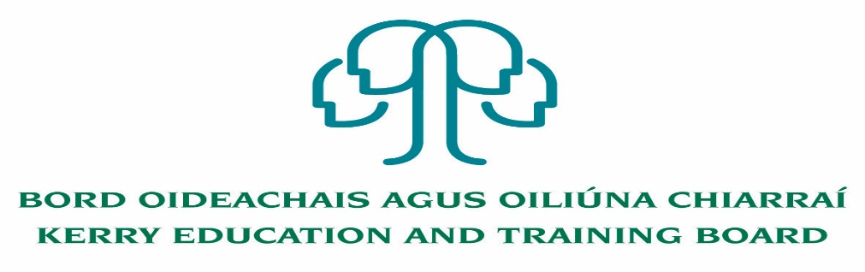

Kerry Education and Training Board (Kerry ETB) is a statutory education and training authority for County Kerry, established in accordance with the provisions of the Education and Training Boards Act 2013.

Kerry ETB is a provider of Primary, Post Primary and Further Education and Training services in Co. Kerry. The ETB has c. 1200, employees, an annual budget of c. €82 million, c.37 Centres of Education and Training with the organisations Head Office located in Tralee, Co. Kerry.

**Teaching Posts**

Applications are invited for the following Fixed Term/Specific Purpose teaching post (s), under the aegis of Kerry Education & Training Board which may arise in the school year 2022/2023 (all appointments are to Kerry ETB – centre of first assignment is indicated here for the assistance of applicants). All vacancies are subject to the Directors of Redeployment agreeing to the posts being filled, following completion of the 2022 Scheme. A panel may be formed from these competitions from which appointments may be made in 2022/2023.

**Hours**

**Coláiste Gleann Lí**

CGL 22.23.1 Irish 17

CGL 22.23.2 Construction Studies 17

CGL 22.23.3 Home Economics (Experience of teaching SEN is an advantage) 16

CGL 22.23.4 Guidance Counsellor (Job Share cover) 10

CGL 22.23.5 History (Experience of teaching English, SEN and EAL is an advantage) 16

CGL 22.23.6 Art (to cover Carers leave) 16

CGL 22.23.7 Religious Education 22

**Killorglin Community College**

KOS 22.23.8 Irish (Experience of teaching PE is an advantage) 16.66

KOS 22.23.9 Business (Experience of teaching Special Education is an advantage) 17

Maternity Leave Cover

KOS 22.23.10 Maths and PE (Career break Cover) 22

KOS 22.23.11 Special Education 14

KOS 22.23.12 History 12

**Causeway Comprehensive School**

CWS 22.23.13 Business (Career Break Cover) 11

CWS 22.23.14 Spanish 19

CWS 22.23.15 Maths (Experience of teaching Geography is an advantage) 18

CWS 22.23.16 Business (Maternity Leave Cover) 22

CWS 22.23.17 English 14

**Castleisland Community College**

CIS 22.23.18 Construction Studies 14.67

CIS 22.23.19 History and Religion 15

CIS 22.23.20 Engineering (Career Break Cover) 18

CIS 22.23.21 Special Education 22

CIS 22.23.22 History and PE 14

**Coláiste na Ríochta**

CNR 22.23.23 English 22

CNR 22.23.24 Construction Studies 17

CNR 22.23.25 Chemistry 12

CNR 22.23.26 History 17

CNR 22.23.27 Special Education (Maternity Leave Cover) 22

**Killarney Community College**

KAS 22.23.28 Special Education 22

KAS 22.23.29 French 14

KAS 22.23.30 Irish 11

**Gaelcholáiste Chiarraí**

GCS 22.23.31Eacnamaíocht Bhaile (Taithí as bheith ag múineadh Oideachas 14

Reiligiúnach ina bhuntáiste)

**Coláiste na Sceilge**

CNS 22.23.32 Business (Job share Cover) 11

CNS 22.23.33 Biology (Experience of teaching Maths and Science to JC is an advantage) 22

(Parental Leave Cover)

CNS 22.23.34 Irish (Career Break Cover) 22

CNS 22.23.35 Maths 22

CNS 22.23.36 Business (Parental Leave Cover upto February 2023) 22

**A Teacher Education qualification is a requirement.**

Candidates proposed for appointment with Kerry Education & Training Board must be registered in accordance with Section 31 of the Teaching Council Act, 2001.

***Applicants are requested to submit Confirmation of Teaching Council Registration outlining subjects qualified to teach and proof of current registration with their application form.***

---------------------------------------------------------------------------------------------------------------------------------

***Please complete application form which can be downloaded from our website www.kerryetb.ie/opportunities and return by email only to*** [***jobs@kerryetb.ie***](mailto:jobs@kerryetb.ie)***. No C.V.’s, only official application form will be accepted.***

***Applications by email only must be received not later than 4pm Monday 13th June 2022.***

***Please complete application form, including reference form, for the post(s) you are applying for.***

**Provisional date for interviews week of 20th June and week of 27th June 2022.**

***Colm Mc Evoy***

***Chief Executive Officer***

**Kerry Education & Training Board services Gaeltacht areas.**

**Cuirfear fáilte roimh chomhfhreagras i nGaeilge.**

**Garda Vetting of successful candidates will take place prior to offer of employment.**

**Canvassing will automatically disqualify.**

**Short-listing will take place on the basis of the information provided in the application form. Depending on the qualifications and experience of applicants, short-listing thresholds may be higher than the minimum standards set out.**

###### Kerry Education & Training Board is an equal opportunities employer.

*“Creating a Learning Society in Kerry”*

