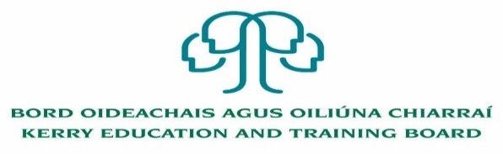

Applications are invited from suitably qualified persons for the following position which may arise
Permanent Mainstream Teacher
Kerry ETB Two Mile Community National School
Killarney, Co. Kerry
Roll Number- 17365L

Panel of Applicants
An internal panel of suitable applicants may be set up to fill vacancies which may occur within a specific time period (four months for teacher posts and the duration of the school year for SNA posts) from the date on which the Board approves the successful candidate

Candidates proposed for appointment with Kerry Education & Training Board must be registered in accordance with Section 31 of the Teaching Council Act, 2001.

Please complete application form which can be downloaded from our website www.kerryetb.ie/opportunities and return by email only to jobs@kerryetb.ie.
No C.V.’s, only official application form will be accepted.

Applications by email only must be received not later than 12 noon, 18th October, 2022

Colm Mc Evoy
Chief Executive Officer

Kerry Education & Training Board services Gaeltacht areas.
Cuirfear fáilte roimh chomhfhreagras i nGaeilge.
Garda Vetting of successful candidates will take place prior to offer of employment.
Canvassing will automatically disqualify.
Short-listing will take place on the basis of the information provided in the application form. Depending on the qualifications and experience of applicants, short-listing thresholds may be significantly higher than the minimum standards set out.
Kerry Education & Training Board is an equal opportunities employer.
“Creating a Learning Society in Kerry”

