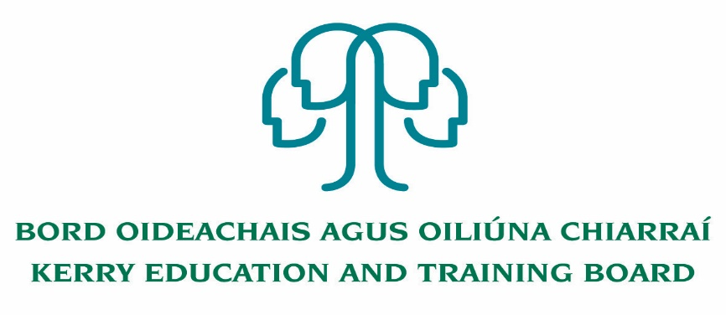

Kerry Education & Training Board wishes to recruit committed, enthusiastic and talented educators to its team of teachers and educational leaders. We provide a quality comprehensive education & training service in Kerry College (a fully integrated College of Further Education and Training which offers a full range of Further Education and Training opportunities for learners/students with courses for progression, employment and apprenticeships across four Campus locations), five adult education and training centres and through a wide range of community-based adult and further education and training programmes.

**Fixed Term Tattoo Artistry Tutor Post**

**Kerry College, Clash Campus**

Applications are invited for the above post under the aegis of Kerry Education & Training Board, which may arise. All appointments are to Kerry ETB – centre of first assignment is indicated here for the assistance of applicants.

**Kerry College, Clash Campus**

**Tattoo Artistry Tutor Post**

**Hours: 60 hours up to 4th June 2021**

**Essential Criteria**

Apprenticeship training/qualification in this area

·Minimum of 2 years’ experience in relevant discipline

·Experience of working with groups

·Excellent organisational and administration skills

·Experience of QQI assessment protocols and procedure

-------------------------------------------------------------------------------------------------------------------------------------------

Please complete application form which can be downloaded from our website www.kerryetb.ie/opportunities and return by email only to [jobs@kerryetb.ie](mailto:jobs@kerryetb.ie). No C.V.’s, only official application form will be accepted.

Applications by email only must be received not later than 12 noon Friday 2nd April 2021.

Colm Mc Evoy

Chief Executive Officer

**Kerry Education & Training Board services Gaeltacht areas.**

**Cuirfear fáilte roimh chomhfhreagras i nGaeilge.**

**Garda Vetting of successful candidates will take place prior to offer of employment.**

**Canvassing will automatically disqualify.**

**Short-listing will take place on the basis of the information provided in the application form. Depending on the qualifications and experience of applicants, short-listing thresholds may be significantly higher than the minimum standards set out.**

###### Kerry Education & Training Board is an equal opportunities employer.

*“Creating a Learning Society in Kerry”*

