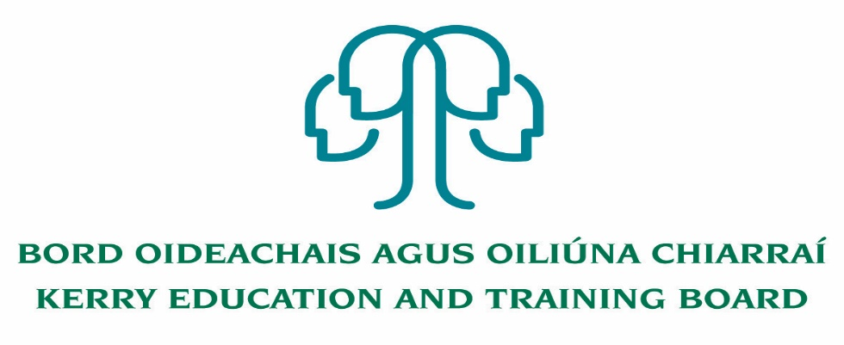

Kerry Education and Training Board (Kerry ETB) is a statutory education and training authority for County Kerry, established in accordance with the provisions of the Education and Training Boards Act 2013.

Kerry ETB is a provider of Primary, Post Primary and Further Education and Training services in Co. Kerry. The ETB has c. 1200, employees, an annual budget of c. €82 million, c.37 Centres of Education and Training with the organisations Head Office located in Tralee, Co. Kerry.

**Special Needs Assistant Panel**

**Various Kerry ETB Schools**

Applications are invited for Special Needs Assistant Panel, under the aegis of Kerry Education & Training Board for posts which may arise in the school year 2022/2023 (all appointments are to Kerry ETB).

To qualify for appointment, candidates must have:

* Practical work experience in Second level system/Further Education/Primary School

Candidates should possess:

* Organisational, good communication and interpersonal skills
* Familiarity with Second level curriculum.
* Ability to support and enhance educational experience for children with Special Educational Needs (SEN) who present in Kerry Education and Training Board Schools.
* A commitment to creating a safe supported environment for students with SEN needs
* A good understanding of recent developments in SEN in Ireland particularly the legislation as it pertains to the Education for persons with SEN Act 2004.
* Competency in the Irish Language will be a requirement in relevant schools.
* TUSLA Child First Training – Certificate of completion
* Current First Aid Responder Certification
* Current Manual Handling Certification

Desirable

* Completed QQI Level 5 Full Award or equivalent in childcare or equivalent Special Needs qualification
* Medical/Healthcare experience
* Excellent ICT Skills
* Competency in the use and understanding of Sign Language

Colm Mc Evoy

CEO

Conditions of Service, Terms of Appointment, details regarding Qualifications and Salary Scale are in accordance with the regulations of the Department of Education & Skills.

Please complete application form which can be downloaded from this website www.kerryetb.ie/opportunities and return by email only to [jobs@kerryetb.ie](mailto:jobs@kerryetb.ie). No C.V.’s, only official application form will be accepted.

Applications by email only must be received not later than **12 noon Monday 16th May 2022.**

**Kerry Education & Training Board services Gaeltacht areas.**

**Cuirfear fáilte roimh chomhfhreagras i nGaeilge.**

**Garda Vetting of successful candidates will take place prior to offer of employment.**

**Canvassing will automatically disqualify.**

**Short-listing will take place on the basis of the information provided in the application form. Depending on the qualifications and experience of applicants, short-listing thresholds may be higher than the minimum standards set out.**

###### Kerry Education & Training Board is an equal opportunities employer.

*“Creating a Learning Society in Kerry”*

