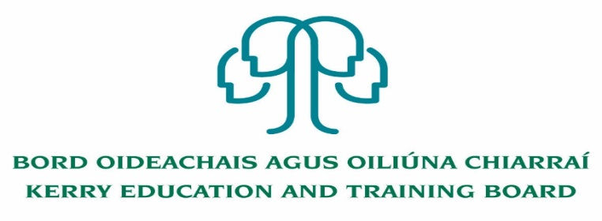

Kerry Education and Training Board (Kerry ETB) is a statutory education and training authority for County Kerry, established in accordance with the provisions of the Education and Training Boards Act 2013.

Kerry ETB is a provider of Primary, Post Primary and Further Education and Training services in Co. Kerry. The ETB has c. 1200, employees, an annual budget of c. €82 million, c.37 Centres of Education and Training with the organisations Head Office located in Tralee, Co. Kerry.

**Job Opportunities**

Applications are invited for the following post(s) under the aegis of Kerry Education & Training Board which may arise. All appointments are to Kerry ETB – centre of first assignment is indicated here for the assistance of applicants.

* **Fixed Term Resource Person post - Learning Support**

Full time 35 hours per week

Centre of first assignment: Tralee Youthreach, Liber House, Monavalley, Tralee

* **Specific Purpose Resource Person post – Leaving Cert Applied Maternity Leave cover**

Full time 35 hours per week

Centre of first assignment: Tralee LCA Youthreach, Aras an Phobail, Criolar na Mishleach, Tralee

* **Fixed Term Resource Person post – Learning Support**

Full time 35 hours per week

Centre of first assignment: Killarney Youthreach, 50 High St., Killarney

* **Youthreach Resource Person post**

Part time 17.5 hours per week (7 hours Specific Purpose arrangement cover and 10.5 Specific Purpose to cover leave up to 28/03/2023)

Centre of first assignment: Killarney Youthreach, 50 High St., Killarney

* **Resource Person Pool**

Kerry ETB Youthreach Programmes Tralee, Killarney, Listowel and Tralee LCA.

Application form and further details i.e. Job Description and Person Specification are available from our website [www.kerryetb.ie/opportunities.html](http://www.kerryetb.ie/opportunities.html)

-------------------------------------------------------------------------------------------------------------------------------------------

Please complete an application form and **return by email only** to jobs@kerryetb.ie. No C.V.’s, only official application form will be accepted. Applications must be received not later than Friday 29th July 2022.

*Colm Mc Evoy*

*Chief Executive*

**Kerry Education & Training Board services Gaeltacht areas.**

**Cuirfear fáilte roimh chomhfhreagras í nGaeilge.**

**Garda Vetting of successful candidates will take place prior to offer of employment.**

**Canvassing will automatically disqualify.**

**Short-listing will take place on the basis of the information provided in the application form. Depending on the qualifications and experience of applicants, short-listing thresholds may be higher than the minimum standards set out.**

###### Kerry Education & Training Board is an equal opportunities employer.

*“Creating a Learning Society in Kerry”*

