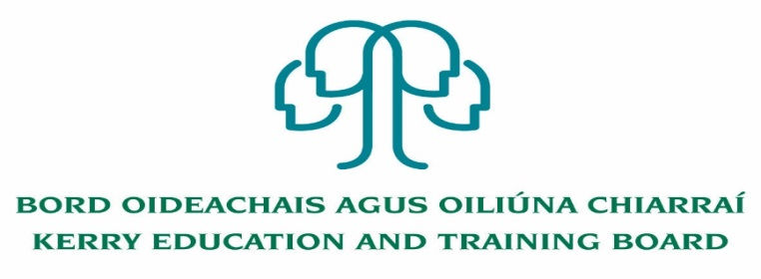

Kerry Education and Training Board (Kerry ETB) is a statutory education and training authority for County Kerry, established in accordance with the provisions of the Education and Training Boards Act 2013.

Kerry ETB is a provider of Primary, Post Primary and Further Education and Training services in Co. Kerry. The ETB has c. 1300 employees, an annual budget of c. €82 million, c.37 Centres of Education and Training with the organisations Head Office located in Tralee, Co. Kerry.

**Job Opportunity**

Applications are invited for the following post(s) under the aegis of Kerry Education & Training Board which may arise. All appointments are to Kerry ETB – centre of first assignment is indicated here for the assistance of applicants

**Regional Education and Language Teams (REALT) Coordinator Post**

**Grade VII**

**1 Year Fixed Term Contract**

**Centre of initial assignment: Kerry ETB, Liber House, Monavalley, Tralee**

**Essential Skills Requirements:**  
The successful candidate will:

• Experience of working in the Irish Education System  
• Excellent communication, interpersonal and ICT skills  
In addition  
• Quality and Qualifications Ireland (QQI) Level 7 (or higher) major academic award (or  
equivalent qualification recognised and accredited in Ireland) in health, education, arts,  
humanities, psychology, social science, youth and community areas or a relevant business  
qualification  
Or  
• Have appropriate relevant experience which encompasses equivalent skills and expertise

-------------------------------------------------------------------------------------------------------------------------------------------

***Further details for the above are available on*** [***www.kerryetb.ie/opportunities.html***](http://www.kerryetb.ie/opportunities.html)***.***

***Applications must be received by email only to jobs@kerryetb.ie not later than 12.00 noon Monday 9th January 2023.***

*Colm Mc Evoy*

*Chief Executive*

**Kerry Education & Training Board services Gaeltacht areas.**

**Cuirfear fáilte roimh chomhfhreagras í nGaeilge.**

**Garda Vetting of successful candidates will take place prior to offer of employment.**

**Canvassing will automatically disqualify.**

**Short-listing will take place on the basis of the information provided in the application form. Depending on the qualifications and experience of applicants, short-listing thresholds may be higher than the minimum standards set out.**

###### Kerry Education & Training Board is an equal opportunities employer.

*“Creating a Learning Society in Kerry”*

