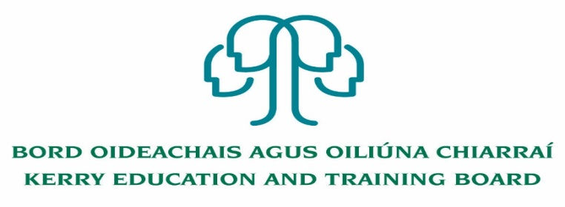

Kerry Education and Training Board (Kerry ETB) is a statutory education and training authority for County Kerry, established in accordance with the provisions of the Education and Training Boards Act 2013.

Kerry ETB is a provider of Primary, Post Primary and Further Education and Training services in Co. Kerry. The ETB has c. 1,300 employees, an annual budget of c. €82 million, c.37 Centres of Education and Training with the organisations Head Office located in Tralee, Co. Kerry.

**Job Opportunities**

Applications are invited for the following post(s) under the aegis of Kerry Education & Training Board which may arise. All appointments are to Kerry ETB – centre of first assignment is indicated here for the assistance of applicants.

* **Permanent Full time Adult Literacy Organiser (ALO) – South & Mid Kerry**

Centre of the first assignment: Kerry Education and Training Board, Adult Literacy and Basic Education Centre, Tralee, Co. Kerry

**Provisional date for interview 19th October 2022.**

**And**

* **Resource Person Post** - **Specific Purpose Contract to cover a staff member on leave**Centre of first Assignment: Kerry Education and Training Board Adult Literacy and Basic Education Centre, Tralee, Co Kerry.

Application form and further details for the above posts i.e. Job Description and Person Specification are available from our website www.kerryetb.ie/opportunities.html.

-------------------------------------------------------------------------------------------------------------------------------------------

Please complete an application form and **return by email only** to jobs@kerryetb.ie. No C.V.’s, only official application form will be accepted. Applications must be received not later than 12.00 noon **Wednesday 12th October 2022.**

*Colm Mc Evoy*

*Chief Executive*

**Kerry Education & Training Board services Gaeltacht areas.**

**Cuirfear fáilte roimh chomhfhreagras í nGaeilge.**

**Garda Vetting of successful candidates will take place prior to offer of employment.**

**Canvassing will automatically disqualify.**

**Short-listing will take place on the basis of the information provided in the application form. Depending on the qualifications and experience of applicants, short-listing thresholds may be higher than the minimum standards set out.**

###### Kerry Education & Training Board is an equal opportunities employer.

*“Creating a Learning Society in Kerry”*

