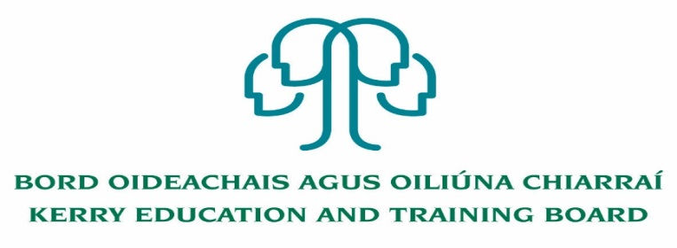

Kerry Education and Training Board (Kerry ETB) is a statutory education and training authority for County Kerry, established in accordance with the provisions of the Education and Training Boards Act 2013.

Kerry ETB is a provider of Primary, Post Primary and Further Education and Training services in Co. Kerry. The ETB has over 1,000 employees, an annual budget of circa €52 million, 36 Centres of Education and Training with the organisations Head Office located in Tralee, Co. Kerry.

Applications are invited for the following Permanent post, under the aegis of Kerry Education & Training

Board which may arise (all appointments are to Kerry ETB – centre of first assignment is to Kerry

College, Monavalley Campus).

**Permanent Healthcare Support Instructor post – Full time 37 hours per week**

-------------------------------------------------------------------------------------------------------------------------------------------

Application forms and full details may be obtained from [www.kerryetb.ie/opportunities or contact the H.R](http://www.kerryetb.ie/opportunities%20or%20contact%20the%20H.R). Department, Kerry ETB, Centrepoint, John Joe Sheehy Road, Tralee, Co. Kerry. Tel. 066-7121488

Please complete an application form and **return by email only** to jobs@kerryetb.ie. No C.V.’s, only official application form will be accepted. Applications must be received not later than 12 noon Friday 11th September 2020.

*Colm Mc Evoy*

*Chief Executive*

**Kerry Education & Training Board services Gaeltacht areas.**

**Cuirfear fáilte roimh chomhfhreagras í nGaeilge.**

**Garda Vetting of successful candidates will take place prior to offer of employment.**

**Canvassing will automatically disqualify.**

**Short-listing will take place on the basis of the information provided in the application form. Depending on the qualifications and experience of applicants, short-listing thresholds may be higher than the minimum standards set out.**

###### Kerry Education & Training Board is an equal opportunities employer.

*“Creating a Learning Society in Kerry”*

