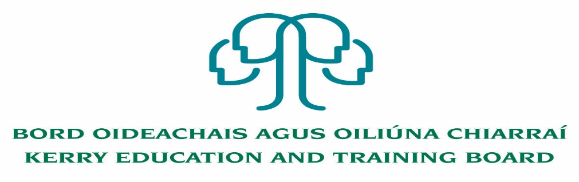

**Cleaning Post**

Applications are invited for the following post, which **may arise**.

Initial assignment to Kerry College, Clash Campus

**Permanent Cleaning Post**

25 hours per week

Appointment is to the Scheme – Kerry ETB reserves the right to assign a staff member to any other location, as the service exigencies require.

Colm Mc Evoy

Chief Executive Officer

---------------------------------------------------------------------------------------------------------------------------------

Please complete application form which can be downloaded from Kerry ETB website [www.kerryetb.ie/opportunities](http://www.kerryetb.ie/opportunities) and return by email only to [*jobs@kerryetb.ie*](mailto:jobs@kerryetb.ie). No CVs only official application form will be accepted.

Applications by **email only** must be received not later than 12 noon 3rd February 2022.

**Kerry Education & Training Board services Gaeltacht areas.**

**Cuirfear fáilte roimh chomhfhreagras i nGaeilge.**

**Garda Vetting of successful candidates will take place prior to offer of employment.**

**Canvassing will automatically disqualify.**

**Short-listing will take place on the basis of the information provided in the application form. Depending on the qualifications and experience of applicants, short-listing thresholds may be higher than the minimum standards set out.**

**Kerry Education & Training Board is an equal opportunities employer.**

**“Creating a Learning Society in Kerry”**

