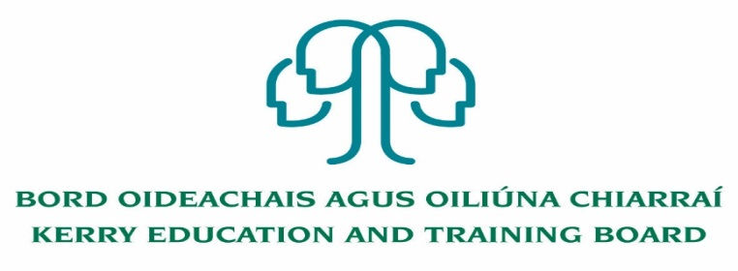

Kerry Education and Training Board (Kerry ETB) is a statutory education and training authority for County Kerry, established in accordance with the provisions of the Education and Training Boards Act 2013.

Kerry ETB is a provider of Primary, Post Primary and Further Education and Training services in Co. Kerry. The ETB has c. 1300, employees, an annual budget of c. €82 million, c.37 Centres of Education and Training with the organisations Head Office located in Tralee, Co. Kerry.

**Job Opportunity**

Applications are invited for the following post(s) under the aegis of Kerry Education & Training Board which may arise. All appointments are to Kerry ETB – centre of first assignment is indicated here for the assistance of applicants.

**Applications are invited for the following post which may arise:**

**Community Education Facilitator**

**with initial responsibility for Management of O’Connell FET Centre, Cahersiveen**

-------------------------------------------------------------------------------------------------------------------------------------------

Please complete an application form and **return by email only** to jobs@kerryetb.ie. No C.V.’s, only official application form will be accepted. Applications must be received not later than 12.00 noon Wednesday 21st December 2022.

*Colm Mc Evoy*

*Chief Executive*

**Kerry Education & Training Board services Gaeltacht areas.**

**Cuirfear fáilte roimh chomhfhreagras í nGaeilge.**

**Garda Vetting of successful candidates will take place prior to offer of employment.**

**Canvassing will automatically disqualify.**

**Short-listing will take place on the basis of the information provided in the application form. Depending on the qualifications and experience of applicants, short-listing thresholds may be higher than the minimum standards set out.**

###### Kerry Education & Training Board is an equal opportunities employer.

*“Creating a Learning Society in Kerry”*

