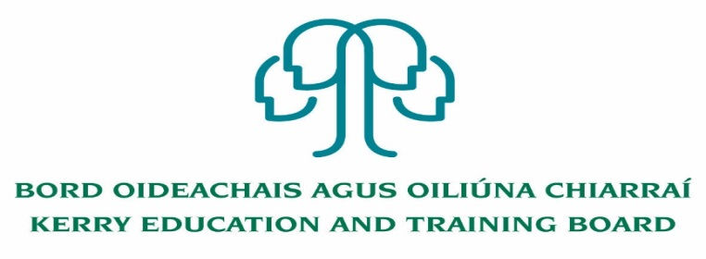
Kerry Education & Training Board (Kerry ETB) invites applications for the post of Community Education Facilitator which may arise.

Community Education Facilitator post
with initial responsibility for Management of O’Connell FET Centre, Cahersiveen
(Career Break Cover to 31st August 2021)

Functions of the post:
- Responsible for all aspects of the day to day organization and facility management of the FET centre
- The effective management of staff performance, financial and other resources.
- Responsibility for scheduling and timetabling
- The efficient and effective delivery of agreed and appropriate services and programmes as required by customers and stakeholders
- Delivery of targets through the annual business planning process
- Responsible for risk management register for the FET centre

---------------------------------------------------------------------------------------------------------------------
Application form and full details may be obtained from www.kerryetb.ie/opportunities or contact the H.R. Department, Kerry ETB, Centrepoint, John Joe Sheehy Road, Tralee, Co. Kerry. Tel. 066-7121488

Please complete an application form and return by email only to jobs@kerryetb.ie. No C.V.’s, only official application form will be accepted. Applications must be received not later than 12 noon Monday, 14th September, 2020.

Kerry Education & Training Board services Gaeltacht areas.
Cuirfear fáilte roimh chomhfhreagras i nGaeilge.
Garda Vetting of successful candidates will take place prior to offer of employment.
Canvassing will automatically disqualify. Shortlisting of applicants may take place.

Kerry Education & Training Board is an equal opportunities employer.
“Creating a Learning Society in Kerry”
Colm Mc Evoy
Chief Executive Officer

