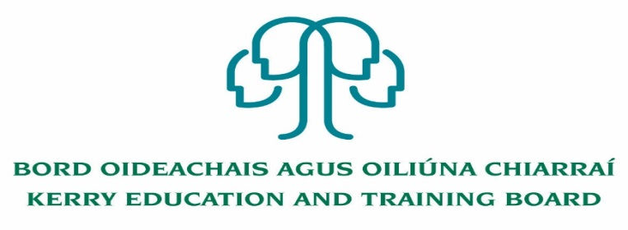

Kerry Education and Training Board (Kerry ETB) is a statutory education and training authority for County Kerry, established in accordance with the provisions of the Education and Training Boards Act 2013.

Kerry ETB is a provider of Primary, Post Primary and Further Education and Training services in Co. Kerry. The ETB has c. 1300, employees, an annual budget of c. €82 million, c.37 Centres of Education and Training with the organisations Head Office located in Tralee, Co. Kerry.

**Applications are invited for the following post which may arise:**

**Adult Literacy Organiser (Initial Responsibility for Coordinating Regional Literacy)**

**– (5-year fixed-purpose contract)**

The national network of the Education and Training Boards (ETB) are recruiting anAdult Literacy Organiser to support the implementation of the Adult Literacy for Life strategy. The Strategy aims to ensure that every adult has the necessary literacy, numeracy and digital literacy to fully engage in society and realise their potential.

The Adult Literacy Organiserwill be located across the national network of the ETBs, with one Adult Literacy Organiser located in each of the 16 ETBs.

Reporting to an ETB Adult Education Officer, theAdult Literacy Organiser will play a pivotal role in the strategic development of the Adult Literacy for Life Strategy. The successful candidate will have specific responsibility for providing overall proactive leadership and direction for the Adult Literacy for Life Strategy, coordinating awareness campaigns, supporting the delivery of the ALL strategy and facilitating cross-organization and cross-service coordination with Government departments and other relevant stakeholders.

Successful applicants will hold a relevant qualification and have post-qualification experience to include designing and managing advances relating to unmet literacy needs, numeracy and digital skills.

**Applying for the Post**

* Applicants should download the application form below – please click on link below
* Read application guide before completing application form (details on the front page of the application form).
* Please complete**all sections**of the form.
* If you are applying for more than one position, please complete a separate application form for **each**position.
* Once the form is completed, the applicant must email the application form directly to the appropriate ETB. Please see [here](https://www.etbi.ie/regional-literacy-coordinator/) for relevant e-mail addresses.

[https://www.etbi.ie/regional-literacy-coordinator/](https://eur03.safelinks.protection.outlook.com/?url=https%3A%2F%2Fwww.etbi.ie%2Fregional-literacy-coordinator%2F&data=05%7C01%7Crachel.byrne%40etbi.ie%7C0d4e1924029d4c5c14f708da5e63b3f5%7Cf5366bb4048545448baac80ddc368234%7C0%7C0%7C637926079671126843%7CUnknown%7CTWFpbGZsb3d8eyJWIjoiMC4wLjAwMDAiLCJQIjoiV2luMzIiLCJBTiI6Ik1haWwiLCJXVCI6Mn0%3D%7C3000%7C%7C%7C&sdata=z%2F87Rte11zzS4FUFr6PCYRHuhAvHfelS%2B%2Btkv8Y55iU%3D&reserved=0)

**Please note:**

* Application forms received after the closing date and time will not be accepted.
* Application forms that are incomplete or not completed correctly will not be accepted.
* Please ensure that the declaration is signed by you prior to submission of the application.

------------------------------------------------------------------------------------------------------------------------------------------

Please complete an application form and **return by email only** to jobs@kerryetb.ie. No C.V.’s, only official application form will be accepted. Applications must be received not later than 5 p.m. Friday 29th July 2022.

*Colm Mc Evoy*

*Chief Executive*

**Kerry Education & Training Board services Gaeltacht areas.**

**Cuirfear fáilte roimh chomhfhreagras í nGaeilge.**

**Garda Vetting of successful candidates will take place prior to offer of employment.**

**Canvassing will automatically disqualify.**

**Short-listing will take place on the basis of the information provided in the application form. Depending on the qualifications and experience of applicants, short-listing thresholds may be higher than the minimum standards set out.**

###### Kerry Education & Training Board is an equal opportunities employer.

*“Creating a Learning Society in Kerry”*

