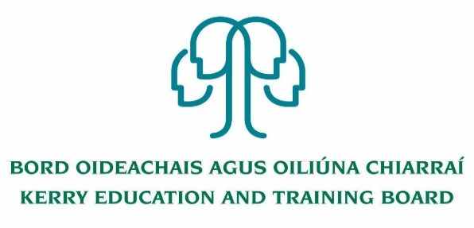

Applications are invited from suitably qualified persons for the following position which may arise

Fixed Term Main Stream Class Teacher – to cover leave
Initial duties as a mainstream multi grade class teacher.
Kerry ETB Tahilla Community National School
Tahilla, Co. Kerry
Roll Number- 05348S

Panel of Applicants
An internal panel of suitable applicants may be set up to fill vacancies which may occur within a specific time period (four months for teacher posts and the duration of the school year for SNA posts) from the date on which the Board approves the successful candidate

Additional information
The successful candidate will be appointed to a mainstream position initially, however duties may be subject to change. Experience teaching in a DEIS school setting, familiarity with DEIS initiatives, leading classroom based initiatives and team teaching desirable.

Experience in Music, Sport and ICT advantageous

Candidates proposed for appointment with Kerry Education & Training Board must be registered in accordance with Section 31 of the Teaching Council Act, 2001.

Please complete application form which can be downloaded from our website www.kerryetb.ie/opportunities and return by email only to jobs@kerryetb.ie.
No C.V.’s, only official application form will be accepted.

Applications by email only must be received not later than 12 noon on Monday 11th July 2022.

Colm Mc Evoy
Chief Executive Officer

Kerry Education & Training Board services Gaeltacht areas.
Cuirfear fáilte roimh chomhfhreagras i nGaeilge.
Garda Vetting of successful candidates will take place prior to offer of employment.
Canvassing will automatically disqualify.
Short-listing will take place on the basis of the information provided in the application form. Depending on the qualifications and experience of applicants, short-listing thresholds may be significantly higher than the minimum standards set out.
Kerry Education & Training Board is an equal opportunities employer.
“Creating a Learning Society in Kerry”

