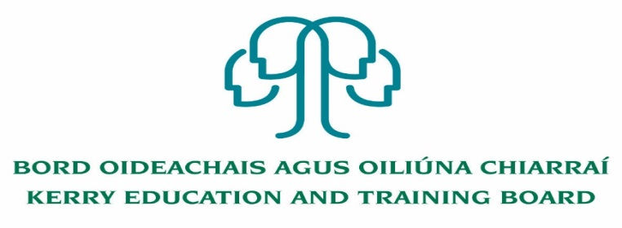

Kerry Education and Training Board (Kerry ETB) is a statutory education and training authority for County Kerry, established in accordance with the provisions of the Education and Training Boards Act 2013.

Kerry ETB is a provider of Primary, Post Primary and Further Education and Training services in Co. Kerry. The ETB has over 1,100 employees, an annual budget of circa €52 million, 36 Centres of Education and Training with the organisations Head Office located in Tralee, Co. Kerry.

**Applications are invited from suitably qualified persons for the following post which may arise:**

**2 Years Fixed Term Grade VII**

**Initial assignment: CCT Department, Kerry Education and Training Board, Centre point,**

**John Joe, Sheehy Rd., Tralee, Co. Kerry**

**Post Summary/Purpose**

Under general supervision of the head of CCT the successful candidate will perform a wide variety of buildings estate management including the management of Buildings, Property and projects. They will play a strategic role in supporting and developing the buildings functions within Kerry ETB. The successful applicant may have a large, multilevel staff and will be expected to take responsibility for decision making in the area. The person appointed will be required to be flexible in this position and must be prepared to undertake such other duties as assigned to them by the Head of CCT or senior management team. Such duties can be outside the normal area of work.

-------------------------------------------------------------------------------------------------------------------------------------------

Application forms and full details for this post may be obtained from [www.kerryetb.ie/opportunities or contact the H.R](http://www.kerryetb.ie/opportunities%20or%20contact%20the%20H.R). Department, Kerry ETB, Centrepoint, John Joe Sheehy Road, Tralee, Co. Kerry. Tel. 066-7121488

Please complete an application form and **return by email only** to jobs@kerryetb.ie. No C.V.’s, only official application form will be accepted. Applications must be received not later than 12.00 noon Wednesday 24th November 2021.

*Colm Mc Evoy*

*Chief Executive*

**Kerry Education & Training Board services Gaeltacht areas.**

**Cuirfear fáilte roimh chomhfhreagras í nGaeilge.**

**Garda Vetting of successful candidates will take place prior to offer of employment.**

**Canvassing will automatically disqualify.**

**Short-listing will take place on the basis of the information provided in the application form. Depending on the qualifications and experience of applicants, short-listing thresholds may be higher than the minimum standards set out.**

###### Kerry Education & Training Board is an equal opportunities employer.

*“Creating a Learning Society in Kerry”*

