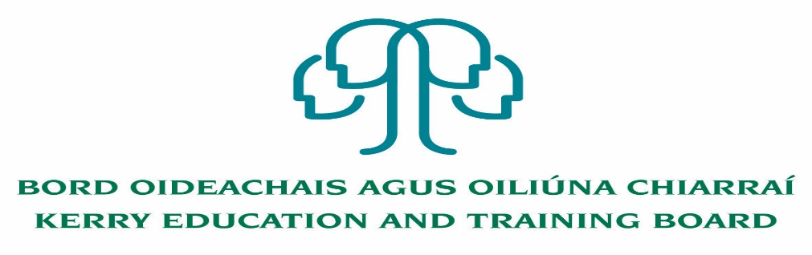

Job Description and Person Specification
Caretaker

Nature of Post
Two Year Fixed Term Caretaker Post.

Hours: Full time 39 hours per week.

Location
Appointment is to the Scheme – Kerry ETB reserves the right to assign a staff member to any other location, as the service exigencies require. Centre of first assignment is Kenmare Further Education and Training Centre.

Reporting/Accountability Relationship
Caretaker will report to Centre Manager

Salary
Salary Scale and Conditions of Service will be in accordance with the regulations of the Department of Education and Skills.

DUTIES/RESPONSIBILITIES:

- Cleanliness and general tidiness of the Centre and its environs.
- Cleanliness and servicing of storerooms, wash-up facilities and toilets.
- Supervise the operation of central heating plant and ensure efficient and economic operation.
- Ensure that all drains, water traps etc. are cleaned regularly.
- Control all general lighting to ensure economy.
- Ensure that the yards and loading bays are clean and tidy.
- Supervise and control use of all cleaning equipment.
- Clean and control the dust extractor and fume extractor equipment.
- Ensure that all windows in work area are secured before lock-up time.
- Ensure that all lights, water taps, fans, extractor plants etc are turned off before lock- up time.
- Report any defects or unusual occurrences to Manager.
- Willing co-operation in undertaking tasks allocated to him/her.
- Undergo Health and Safety training as required.

Any other duties which may be specified by management from time to time.

FUNCTION OF THE JOB:

- The general cleanliness and tidiness of the Centre and its environs, including cleaning tasks in classrooms, workshops, corridors, toilets, canteen, yards, stores, ground maintenance work, waste management and any other area identified.
- The efficient and economical operation of the heating, lighting, water and sewage systems
- Ensuring the security of the Centre and Grounds by securing exits/entrances, windows, doors etc at appropriate times, and
- Assisting generally in the efficient operation of the Centre.

Person Specification

Essential Requirements:
- Have obtained at least Grade D3 in five subjects in the Leaving Certificate Examination (higher, ordinary, applied or vocational programmes) or equivalent or have passed an examination at the appropriate level within the QQI qualifications framework which can be assessed as being of a comparable to Leaving Certificate standard or equivalent or higher or have appropriate relevant experience which encompasses equivalent skills and expertise.

- Relevant experience as a caretaker with associated responsibilities

- Good numeracy/literacy skills

Desirable Requirements:
- Qualification in the area of Health and Safety
- Experience in General Maintenance of Buildings/Centres e.g. Plumbing, Carpentry, Painting, Decorating and Gardening, within the demonstrated capacity Caretaker.

This job description is not intended to be a comprehensive list of all duties involved and consequently, the post holder may be required to perform other duties as appropriate to the post which may be assigned to him / her from time to time by the Centre Manager and to contribute to the development of the post while in the role.

The person appointed will be required to show evidence of the following:

Specialist Knowledge & Expertise:
- Is committed to self-development and continuously seeks to improve personal performance
- Proven experience to undertake caretaking duties.
- Experience in grounds keeping e.g. garden maintenance
- Understanding/experience in electrics, plumbing and carpentry
- Experience of taking responsibility for the security of buildings

Knowledge of Health and Safety:
- Experience and understanding of Health and Safety issues

Team Work:

- Show respect for colleagues and co-workers
- Ability to work effectively and supportively as a member of the Centre team
- Offers own ideas and perspectives
- Understands own role in the team, making every effort to play his/her part

Customer Service and Communication Skills:
- Actively listens to others understanding their perspectives/requirements/needs
- Communicates clearly and concisely when speaking and in writing
- Ability to follow instructions on equipment, materials etc.
- Good interpersonal and communication skills

Delivery of Results:
- Completes work in a timely manner
- Adapts quickly to new ways of doing things
- Checks all work thoroughly to ensure it is completed to a high standard
- Identifies and appreciates the urgency and importance of different tasks
- Punctual, reliable and trustworthy

Drive & Commitment to Public Service Values:
- Consistently strives to perform at a high level and deliver a quality service
- Is thorough and conscientious, even if work is routine
- Demonstrates resilience in the face of significant demands and challenges
- Ensures that the customer is at the heart of all services provided
- Is personally honest and trustworthy
- Acts with integrity and supports this in others

Kerry ETB Core Values: Respect, Quality, Equality, Inclusion and Learning

