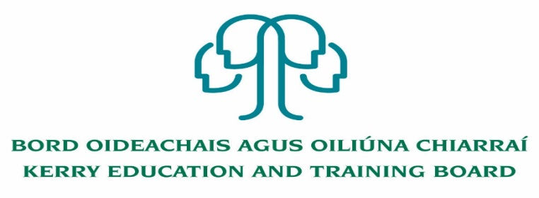

Kerry Education and Training Board (Kerry ETB) is a statutory education and training authority for County Kerry, established in accordance with the provisions of the Education and Training Boards Act 2013.

Kerry ETB is a provider of Primary, Post Primary and Further Education and Training services in Co. Kerry. The ETB has c. 1300, employees, an annual budget of c. €82 million, c.37 Centres of Education and Training with the organisations Head Office located in Tralee, Co. Kerry.

**Job Opportunities**

Applications are invited for the following post(s) under the aegis of Kerry Education & Training Board which may arise. All appointments are to Kerry ETB – centre of first assignment is indicated here for the assistance of applicants.

**Permanent Cleaner Post -** 7 hours per week

Initial assignment to Scoil an Ghleanna, Scoil Náisiúnta Phobail

Appointment is to the Scheme – Kerry ETB reserves the right to assign a staff member to any other location, as the service exigencies require.

Colm Mc Evoy

Chief Executive Officer

---------------------------------------------------------------------------------------------------------------------------------

Please complete application form which can be downloaded from Kerry ETB website [www.kerryetb.ie/opportunities](http://www.kerryetb.ie/opportunities) and return by email only to [*jobs@kerryetb.ie*](mailto:jobs@kerryetb.ie). No CVs only official application form will be accepted.

Applications by **email only** must be received not later than 12 noon 5th October 2022.

**Kerry Education & Training Board services Gaeltacht areas.**

**Cuirfear fáilte roimh chomhfhreagras i nGaeilge.**

**Garda Vetting of successful candidates will take place prior to offer of employment.**

**Canvassing will automatically disqualify.**

**Short-listing will take place on the basis of the information provided in the application form. Depending on the qualifications and experience of applicants, short-listing thresholds may be higher than the minimum standards set out.**

**Kerry Education & Training Board is an equal opportunities employer.**

**“Creating a Learning Society in Kerry”**

