External Application Form for REACH Funding
Note: Projects to be completed by 2023 year-end. Completed application forms and required supplementary documentation must be returned by Friday, 21st April 2023 to Michelle Anne Houlihan mhoulihan@kerryetb.ie

Section 1. Community Group/Project Information
- Part 1 - to be completed by all applicants
- Part 2 - if applicable, where the ETB does not have the up-to-date details relating to Tax Clearance and Bank Account.

Section 1 – Part 1 – Community group/project
Name of Community Group:
Title of project proposed:
Contact details
Contact Person |  |  |  |  | Role within organisation
Community Group Address
email |  |  |  |  |  | Phone number
Funding
Have you received REACH funding from another source? |  |  |  |  |  |  |  |  | Yes/No
If yes, please answer the following questions
Source(s) of this funding |  |  |  | Intended purpose of this funding

Section 1 – Part 2 – Complete if applicable
Tax Clearance (Please attach details of your current Tax Clearance Access with this application)
Tax registration number:
Proof of assurance
Tax clearance certificate number:
CHY number (if applicable)
Bank details
Name of bank
Address of bank
Sort code |  |  |  |  |  |  | Account number
IBAN

Section 2 – project costs/funding
Cost of project | €
Grant request (the grant amount sought in this application) |  |  | €
If the total cost of the project is greater than the amount of the grant sought, please outline where and how the balance of funding will be secured:
Project costs for each of the following, where applicable (grant amount sought for each)
Learner Assistance Fund | Innovative Green Projects | Project Focused on Increasing Participation |  | Campaigns that Contribute to Equality Policy & Legislation
€ | € | € |  | €
Supporting Marginalised and Disadvantaged Groups | Support for Refugee Groups
€ | €

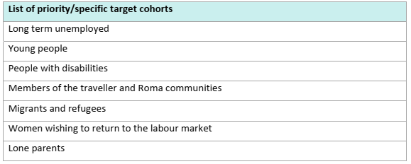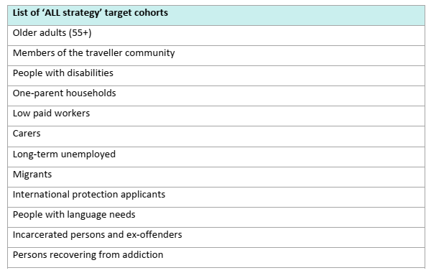
Section 3 – Project details
Project proposed
Please provide a synopsis of the project proposed under the specific funding criteria that the grant is sought for:
Funding Criteria | Target Group(s) | Funding Purpose
Learner Assistance Fund, inclusive of Out Reach/Mentoring projects
Innovative Green Projects
Projects focused on increasing participation in learning with target cohorts
Events/Awareness Campaigns that contribute to Equality policy and legislation
Community groups in pre-development phase to support the most marginalised and disadvantaged groups
Support for refugee groups to support education and training delivery and promote/support cultural and social inclusion including research and/or needs analysis
Please include any additional information regarding the target group(s) you wish to add to support this application:
Please provide information demonstrating how this funding intends to mitigate against educational disadvantage for the cohort you are working with:
Please outline how the funding can complement and/or enhance the current provision of similar education in the area.
Please clarify how this funding will support your learners to achieve positive outcomes as a result of this support:
How will the benefits of this funding be measured?
Please provide information on how this project represents value for money and indicate what steps the project has taken to ensure avoiding duplication with existing services in the area:

Section 4 – Submission Details
I declare on behalf of insert organisation name
That I have the appropriate authority to make this submission for funding. This application for funding form is fully completed and the information provided is a full and accurate account of how the funding (if allocated) will be used in 2023.
Signature |  |  | Print name
Position in organisation |  |  | Date

Applications to be submitted to your local ETB: mhoulihan@kerryetb.ie
Closing date for receipt of applications: Friday, 21st April 2023

CERTIFICATE OF ASSURANCE
(To accompany the financial and performance reports)
Management of and Accountability for Grants - DPER CL.13/14

Source of Grant Funding:

Name of Grantee:

Purpose of Grantee:

I can confirm the following Assurance Requirements have been met (please tick):
Income and Expenditure accounts relaitng to Grants provided by Kerry ETB have been submitted to Kerry ETB without delay after the end of the financial year
I have been informed by Kerry ETB that I have an obligation to make books and accounts available to the Comptroller and Auditor General where 50% or more of our income is sourced from Exchequer Funds
Records are available for inspection by Kerry ETB, if required
Agreed Services/Outputs have been delivered in line with the agreed Terms and Conditions
I can confirm that the service is fully compliant with Kerry ETB Procurement (Purchases) guidelines on using public funds received under grant from Kerry ETB - Guide for Grant Recipients
I can confirm that there was no Conflict of Interest in Procurement
Public money granted was used in accordance with the Terms and Conditions of the grant

Public Money Granted was used for the following:

Signed: Signed:

Responsible Person Responsible Person
(Management/Board/Committee level) (Management/Board/Committee level)

Date: Date:
(In small organisations, with a single manager, a single management signature is acceptable, also relevant for groups that don’t have paid staff)

KERRY EDUCATION AND TRAINING BOARD
Third Party Financial Statements Assurance – Community Education
Third Parties in receipt of Grant Funding from Kerry ETB are required to annually complete the following Assurance Statement.
Please read each requirement set out below carefully and confirm whether or not the requirement was complied with during the period under review.
Reference: DPER Circular Letter 13/2014 outlines the public financial management principles, procedures and additional reporting requirements to be followed in the management of grant funding from public money as well as the reclassification of grants and grants in aid. The overall principle is that there should be transparency and accountability in the management of public money, in line with economy, efficiency and effectiveness.
Third Party Organisation:
Third Party CEO/Centre Manager:
Date:
Retention of end-year balances
- Pre-funding may lead to unexpended balances of grant money at year’s end. With grantor approval (on foot of DPER sanction), these balances, or a portion thereof, may be retained by the grantee if deemed necessary to meet outstanding financial requirements. Such balances should be kept to a minimum and taken into account when considering the following year’s grant.
Please provide details of year-end balances retained
Was formal approval sought from the ETB to retain any end of year balances. Please provide details of same.
Administrative and Control Requirements
- The grantor should be satisfied that the accounting system and organisational arrangements of the grantee are adequate, taking account of the level of the grant payment, to ensure the proper administration of the money
Please provide details of your accounting system and organisational arrangements to ensure the proper administration of funding.
Onward payments of grants
- If it is the intention of the Third Party Organisation (grantee) to make onward grants from the funding received from the ETB, details of these onward grants and their recipients/proposed recipients must be provided to the ETB, along with details of the terms and conditions applying to these onward payments
In the year under review were there any onward grants to other recipients from funds received from the ETB. Please provide details of same.
Were these payments fully comprehended withing the signed SLA/Grant-SLA with Kerry ETB including the terms and conditions attaching to these onward payments of grants.
Was formal approval obtained from the ETB prior to the onward payment of grants and was this process is well documented and readily available for the purpose of audit/inspection.
The ETB maintains a record of those grantees that provide onward payment of the grant received.
Protecting State Investment
- Third Party Organisations (Grantees) should not dispose of publicly funded assets without the prior approval of the relevant ETB
Were any publicly funded assets disposed of in the year under review?
Was the ETB notified of the intention to dispose of, or disposal of, publicly funded assets?
Please provide details of prior sanction from the ETB to to dispose of publicly funded assets.
Please provide detail of how the proceeds were reimbursed to the Exchequer.
Grantee Responsibilities
- Financial Statements: Third Parties (Grantees) must submit their audited accounts to the ETB (grantor) without delay after the end of the financial year. Where the Chief Executive is satisfied, suitable financial statements are acceptable as an alternative (e.g. where audited accounts are not prepared). The Third Party (Grantee) must, in this case, prepare a statement outlining their level of expenditure, the rationale for not auditing accounts and submit to the ETB.
Financial Records were submitted to the ETB without delay at the end of the financial year. Setting out:
1. Name of Grantor: Kerry ETB named as a Grantor
2. Name of Grant: The actual name of the grant programme included
3. Purpose of the Grant: The purpose for which the funds are applied under the following headings:
a) Pay and general administration
b) Service provision/charitable activity
c) Specified others, including such expenditure as advertising consultancy
Accounting for Grants:
(i) The amount and term of the total grant awarded;
(ii) The amount of the grant taken to income in the current financial statements;

(iii) Where (ii) above differs from the cash received in the relevant financial period, a table showing:
(a) The grant taken to income in the period
(b) The cash received in the period, and
(c) Any grant amounts deferred or due at the period end.

Bank balances held
Capital Grants:
The amount of money provided and the conditions/milestones being used concerning the current and future instalments.
An undertaking was provided that the State’s investment is protected and will not be used as security for any other activity without prior consultation with the parent Department and sanction of DPER.
Employees: In a table accompanying the report in the Financial Statements, the number of employees whose total employee benefits (excluding employer pension costs) for the reporting period fell within each band of €10,000 from €60,000 upwards and an overall figure for total employer pension contributions. (This applies even if salaries are not being funded by the Exchequer).
Restrictions: Whether and how the use of the grant is restricted (i.e. is it for a particular project or the delivery of a service).
Tax Clearance: Whether compliant with relevant Circulars, including Circular 44/2006 “Tax Clearance Procedures Grants, Subsidies and Similar Type Payments”.
The grantee is fully tax compliant and has provided a Tax Clearance Access Number with the Tax Reference number and Charity Number, where appropriate. These documents are held on file and available for audit/inspection.
Vouched Expenditure: Vouched Expenditure Grantees making claims for grant funding on the basis of vouched expenditure are required to state formally to their funders that
Invoices used to support claims relate to activities and services appropriate to the grant scheme objectives
Amounts invoiced have been paid
Invoices have not and will not be used in support of another claim for reimbursement from any other funder(s) (except as provided for in agreed joint-funding arrangements)
Financial Control Grantees
I confirm that Appendix 2 of CL 13/14 - Statement of Principles for Grantees has been brought to our attention
I confirm that adequate financial control systems are in place to manage granted funds.

Please Print Name of Grantee:
Signature of Grantee:
Position on Committee:
Date:

DPER Circular: 13/2014 Management of and Accountability for Grants from Exchequer Funds - Overall Principles
Management of and Accountability for Grants from Exchequer Funds (circulars.gov.ie)



