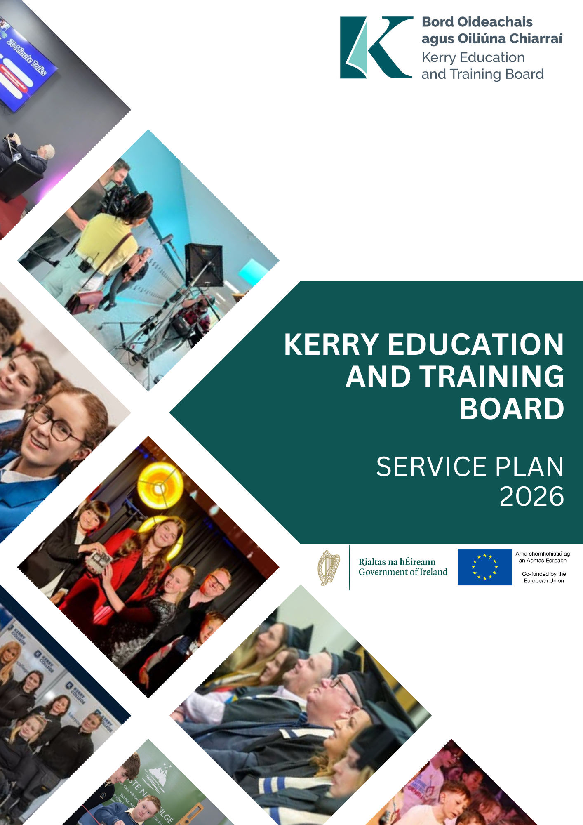

Service Plan 2026
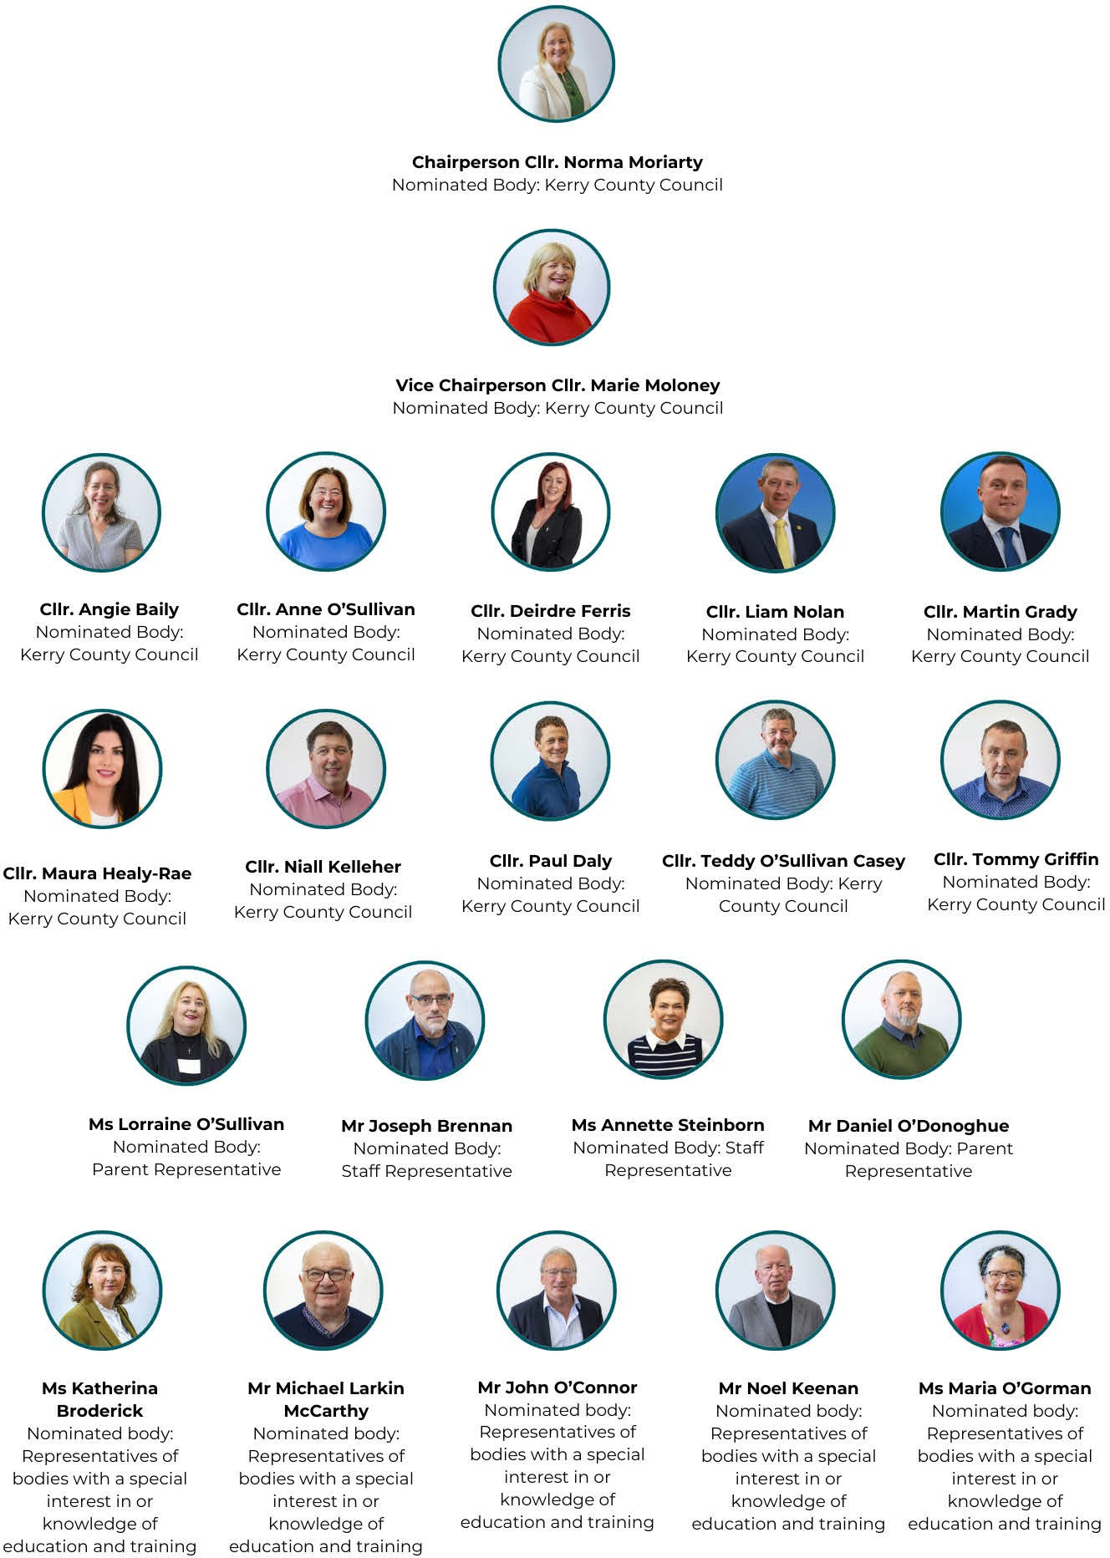
Kerry ETB Board 2026

Kerry ETB Executive 2026

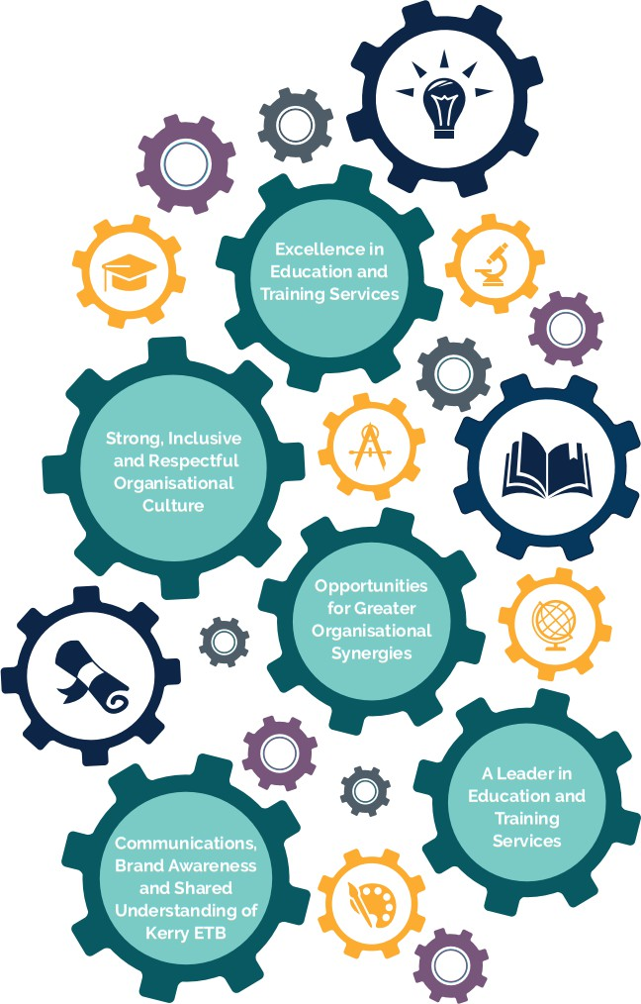
Ms. Ann O'Dwyer
Mr. Con Moynihan
Ms. Maria Brennan
Mr. Owen O'Donnell
Chief Executive (Acting)
Director of Schools, Youth and Music
Director of Organisation Support and Development
Director of Further Education and Training

Contents

Joint Foreword from An Cathaoirleach and Chief Executive 5
Organisation Profile 6
Locations 7
Organisational Structure 8
Our Vision, Mission and Core Values 9
Department of Education and Youth Performance Delivery Agreement 11
Further Education and Training Service Provision 2026 16
Kerry ETB Strategic Goals and Priorities 28
Goal 1: Excellence in Education and Training Services 29
Goal 2: Strong, Inclusive and Respectful Organisational Culture 37
Goal 3: Opportunities for Greater Organisational Synergies 41
Goal 4: A Leader in Education and Training Provision 45
Goal 5: Communications, Brand Awareness and Shared Understanding of Kerry ETB 50
Appendix I: Projected Receipts and Expenditure 53
Appendix 2 – Public Sector Duty Action Plan 2026 56
Appendix 3 – Communications Plan 63
Appendix 4 – Corporate Procurement Plan 2025 - 2027 71
Appendix 5 – Training and Development Plan 2026 -2027 73
Appendix 6 – Customer Charter Action Plan 2026 - 2027 79
Appendix 7 – ICT Strategy 2023 - 2027 81
Appendix 8 – Sustainability Strategy 2024 - 2026 90

Joint Foreword from An Cathaoirleach and Chief Executive

It is a pleasure to present the Kerry ETB Service Plan for the year ahead. This plan sets out our priorities and actions for 2026 as we continue to deliver high-quality education and training services for learners, students, communities, and employers across County Kerry.

This Service Plan provides a clear and practical framework for progressing the commitments set out in our Strategy Statement 2023–2027. It reflects our shared ambition to ensure that Kerry ETB remains inclusive, learner-centered, and responsive to the evolving needs of individuals, communities, and the world of work.

The year ahead offers both opportunities and challenges as we continue to strengthen how we plan, deliver, and evaluate our services. Strong leadership, committed staff, effective governance, and collaboration across the organisation will support us in delivering positive outcomes and ensuring that our services remain accessible, high quality, and focused on impact.

The priorities outlined in this plan focus on enhancing learner and student experiences, expanding access to education and training opportunities, supporting our staff, and embedding excellence across all areas of service delivery. They reflect our core values of inclusion, respect, equality, quality, and lifelong learning, and our commitment to continuous improvement.

Delivering this plan will rely on strong partnerships and a shared sense of purpose. We look forward to working closely with our learners, students, parents and guardians, staff, employers, communities and our key statutory and voluntary stakeholders.

We are deeply grateful for the continued support, guidance, and leadership of the Department of Education and Youth, the Department of Further and Higher Education, Research, Innovation and Skills, and SOLAS as we work together to advance our shared mission and vision.

As we move forward, we remain confident in the power of education and training to change lives, strengthen communities, and support a sustainable future for Kerry

Ms. Ann O’Dwyer Councillor Norma Moriarty
Chief Executive (Acting) An Cathaoirleach

Organisation Profile

Kerry ETB is the statutory authority responsible for delivering high-quality education and training services across County Kerry.

Established in 2013 under the Education and Training Boards Act, Kerry ETB is committed to fostering lifelong learning. Each year, the organisation engages students and learners, including c.131 primary students, c.3,172 post-primary students and in Further Education and Training, c. 11,208 Beneficiaries and c.1,702 apprentices.

Kerry ETB operates with a workforce of c.1,060 staff members across 38 locations, with an annual budget of c.€99,000,000, excluding capital funding.

Kerry ETB is structured within a corporate governance framework comprising a democratically appointed Board and an executive management team.

The organisation delivers a diverse range of education, training, and support services, including primary, post-primary education, further education and training, and Youth Work support ensuring that learning opportunities are available at every stage of life.

Kerry ETB continues to expand and enhance its services to meet the evolving needs of students, learners, parents/guardians, employers, and communities.
Kerry ETB has designated charitable status (registered charity number: 20083243)

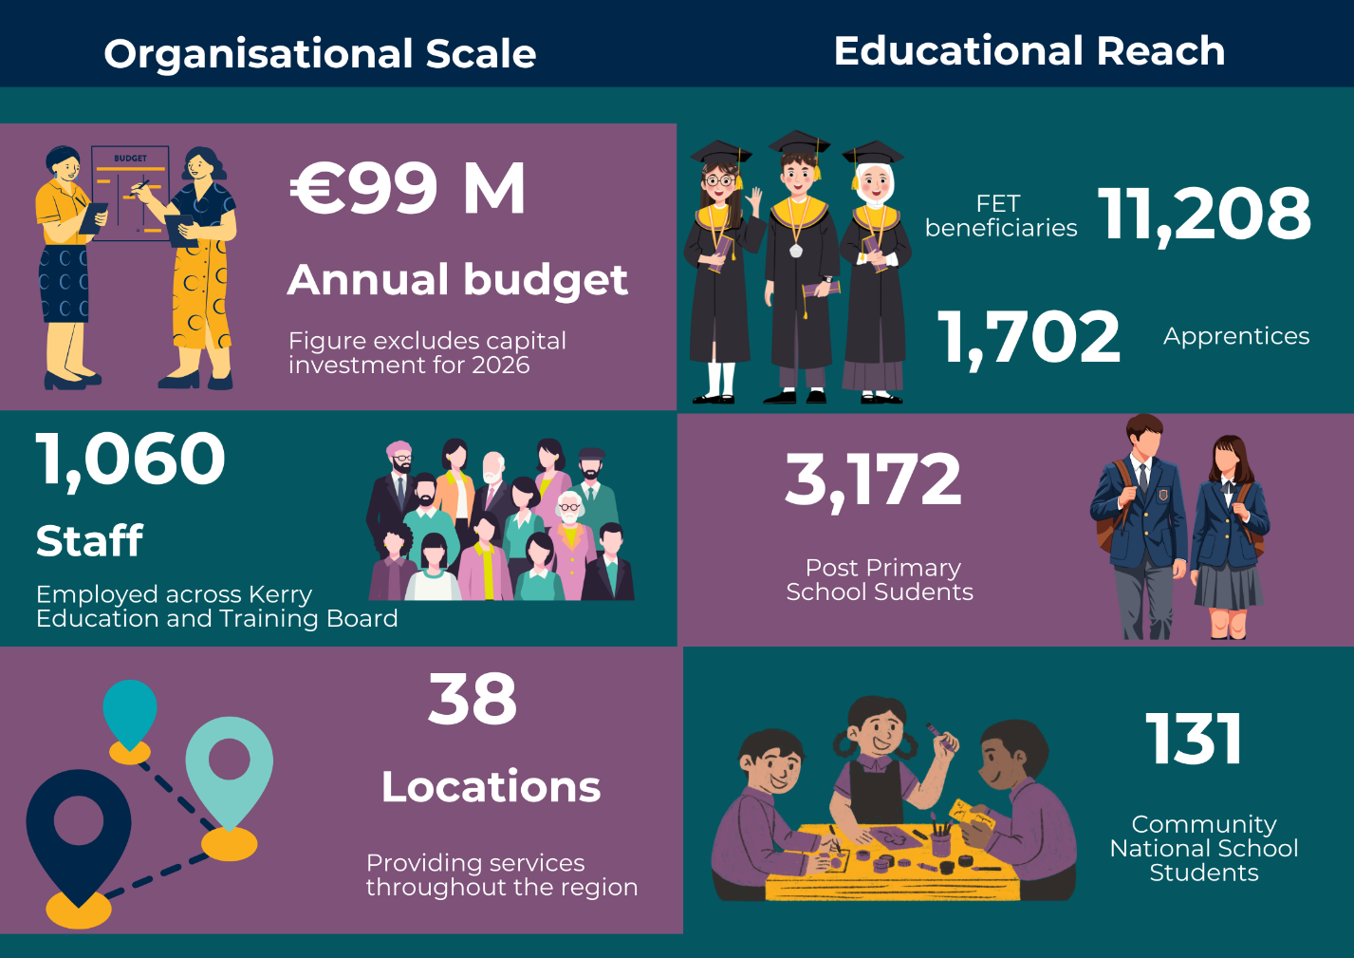

Locations

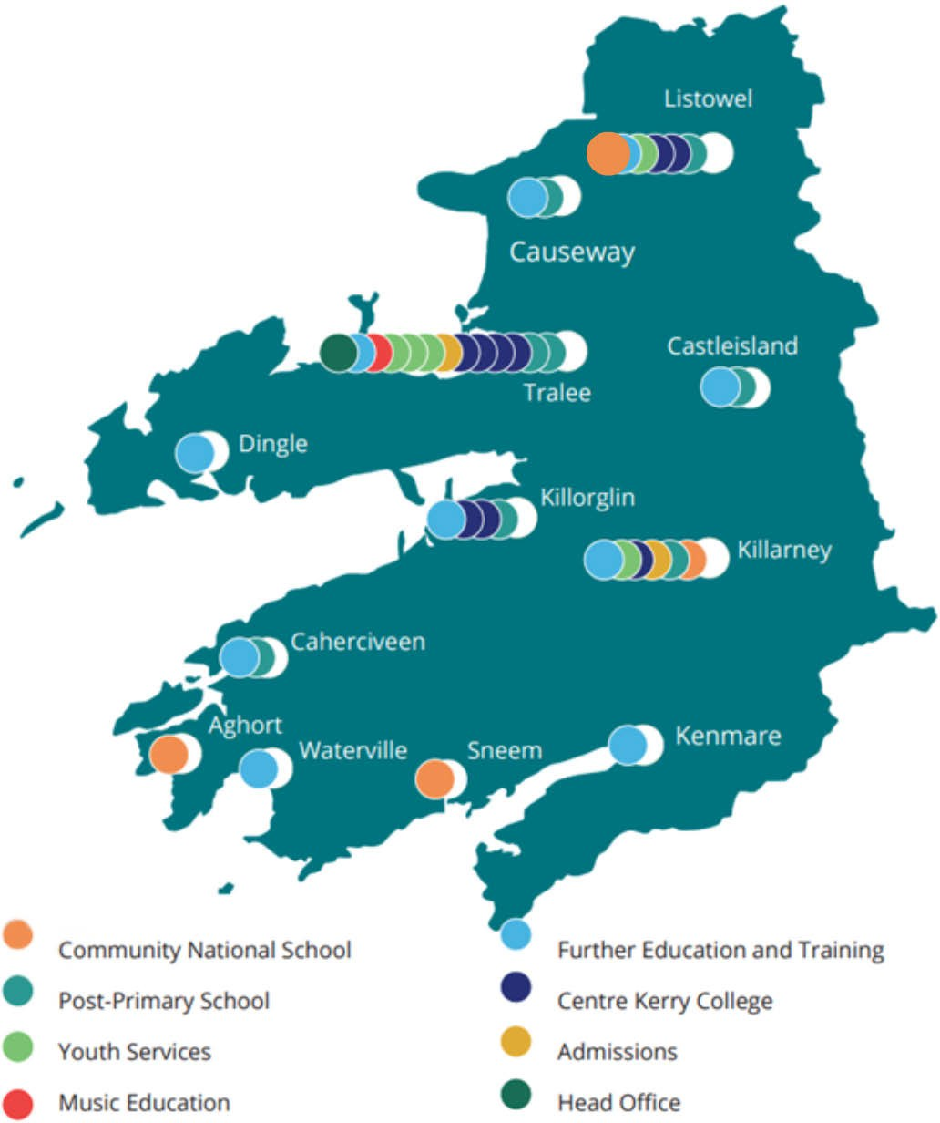

Organisational Structure

The Chief Executive is responsible for the executive management of Kerry ETB and is supported in this role by three Directors, namely:

Director of Schools, Youth and Music
Director of Organisation Support and Development
Director of Further Education and Training

The three Director roles reflect the three pillars of service delivery, with each Director formally delegated authority in their role as per Section 16 of the Education and Training Boards Act, 2013.

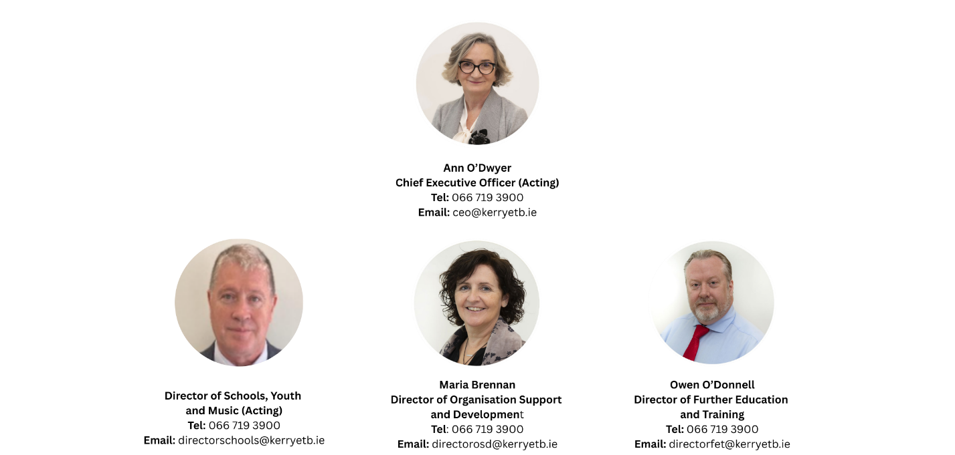

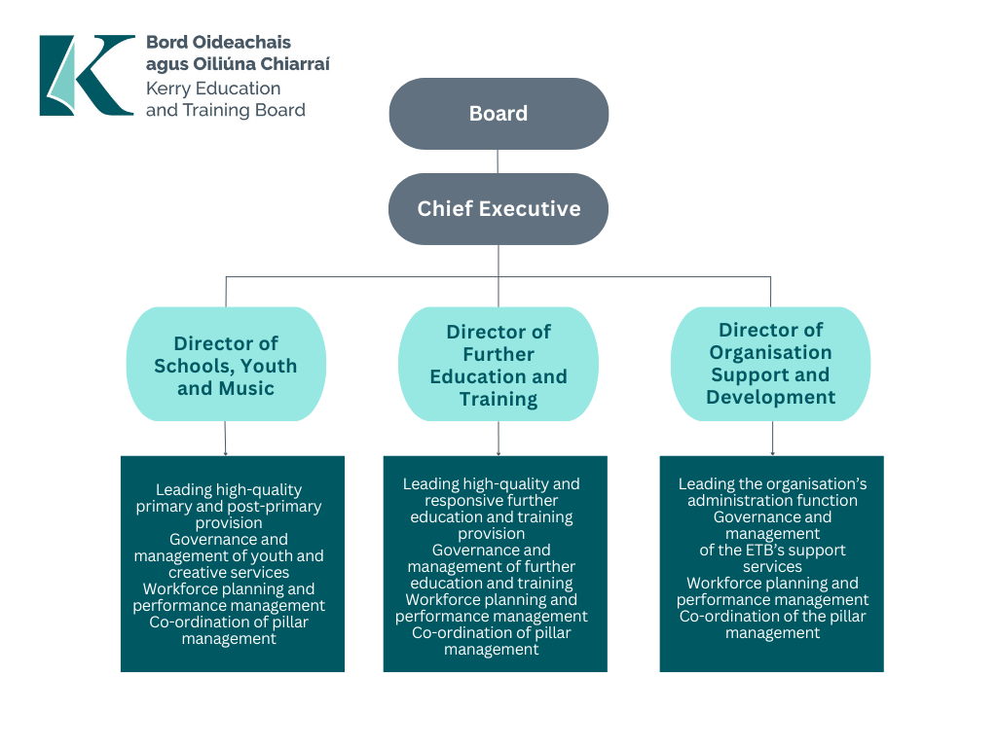

Our Vision, Mission and Core Values

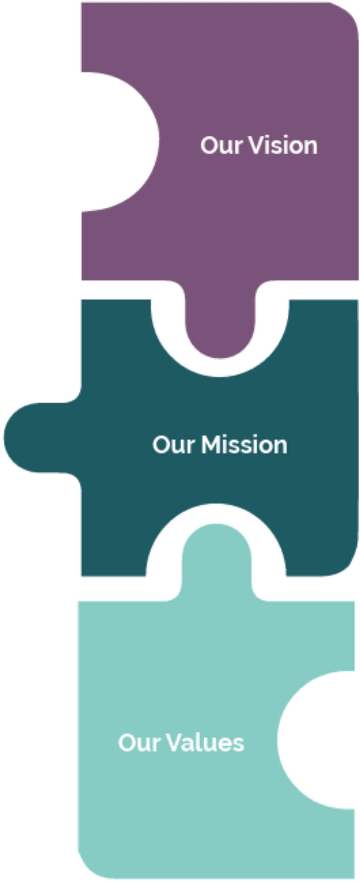

Vision
Our shared vision is that Kerry ETB will be an
innovative leader in the design and delivery of
quality- assured and sustainably delivered
education and training opportunities in Kerry.

To achieve our vision, we put a strong emphasis
on working closely with our internal and external
stakeholders, particularly marginalised groups.

Mission
We will continue to promote development.
of a lifelong and life-wide learning society in
Kerry so that all persons have equal access to
education and training opportunities.

Core Values
Our core values, Inclusion, Respect, Equality,
Quality, and Excellence in Learning, underpin
our actions and behaviours.

These values are centered on the belief that every
person should have the right to access education
and training opportunities to help them realise their
potential and meet their personal, social, civic, cultural
and economic needs.

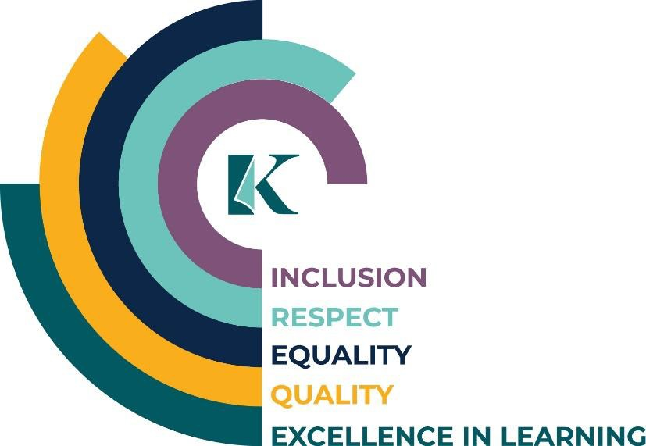

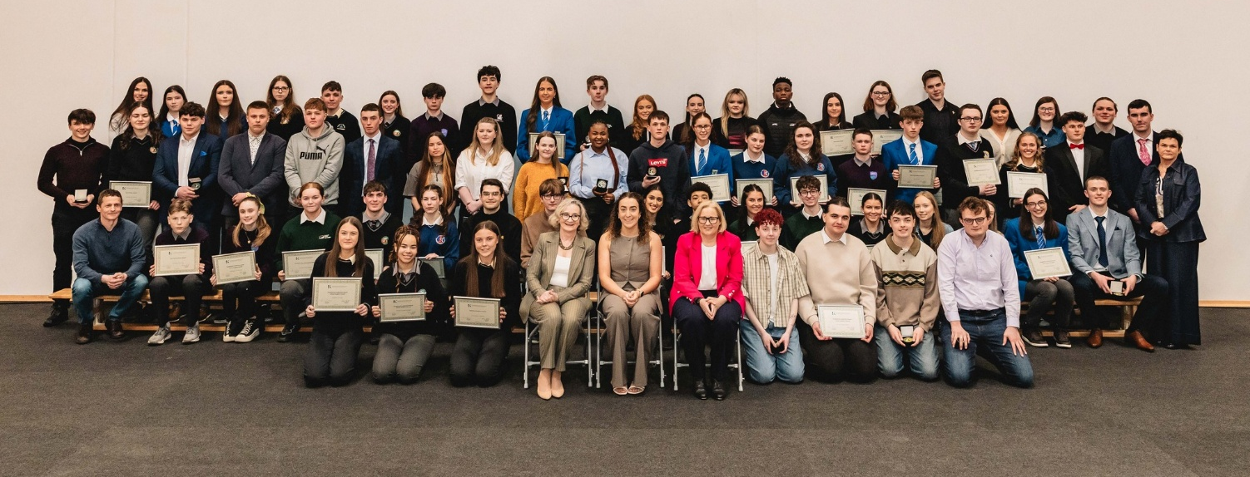
Student Awards 2025

Statement of Services

Department of Education and Youth Performance Delivery Agreement

In accordance with Section 8.7 of the Code of Practice for the Governance of ETBs (Circular Letter 83/2024) ETBs are required to agree a Performance Delivery Agreement with the Department of Education and Youth and report to that Department of Education and Youth on progress against targets. These agreements act as a performance contract between the Department of Education and Youth and Kerry ETB in which an agreed level of performance/service is formalised.
Under the terms of the Performance Delivery Agreement between the Department of Education and Youth and Kerry ETB, the following goals and priorities were identified. The specific actions, together with the performance indicators and targets to be delivered are as follows:

Optimise Student/Learner Experience

Priority | Action | Performance Indicator | Target
Provide a positive learning experience for all learners, including learners from marginalised groups | Develop strategic plan with SCP, Kerry Traveller Development CDP, HSCL and Youth Services to address Traveller retention in post primary school in Q1. Continue to address and support equality of outcomes for our learners, particularly those from marginalised groups in DEIS and non DEIS schools. | Continued implementation of the Public Sector Equality and Human Rights Duty Plan. | Increased retention of Travellers in the Post Primary School sector and progression to senior cycle. Commence research in collaboration with Mary Immaculate College into the effectiveness of the Kerry ETB Universal Design for Learning Programme Q4.
 | Continue Traveler education support programme/role for Schools, increasing leaving certificate completion rates. | Attendance, participation and retention of Traveler students in Post-Primary Schools. | 10% improvement in attendance, participation and retention of Traveler students
Support learners at risk of educational disadvantage in line with current national policy | Work with the HSCL Coordinators and Adult Literacy Coordinator to support marginalised parents, to support their children’s education. Leverage DEIS grants to prevent marginalisation and reduce the Risk of educational disadvantage. | An increase in participation, retention and progression in DEIS Schools. | Continued monitoring at Principals Meetings to ensure that individual School DEIS targets achieved.  Principals in turn present their DEIS updates at the monthly Principal meetings, which allows updates on their plans and learning for others.
 | Support the transition of the two Kerry School Completion projects to Kerry ETB. | Ongoing communication with TESS, School Completion Programme  Co-ordinators and Local Management Committees. | Until the full transfer to Kerry ETB the Department of Education and Youth School Completion Assurance document will be implemented.  Participate in, and input to, Department of Education and Youth/TESS/ETBI engagement structures on SCP transition and workforce arrangements, ensuring Kerry ETB submissions/feedback are provided within required timeframes.  Section 56 commissioned service model (governance, contracting/commissioning implications, finance and audit, reporting, data protection, risk), with an agreed action plan by end of Q3 2026.  Develop and agree an ETB approach to SCP governance and oversight aligned to national requirements (e.g., reporting templates, assurance steps, escalation routes), with implementation steps initiated by end of Q4 2026 (subject to national guidance).  Agree local communications strategy.
Ensure all necessary child safeguarding measures are in place in accordance with the Child Protection Procedures for Primary and Post-Primary Schools  Ensure all schools have adopted the Child Protection Procedure for Schools 2025 by the end of 2026 | Training and Child Protection for BOM in all Schools Q1 2026. All schools, Youthreach, LCYP, and Music Generation Programmes complete one day training for staff on new Child Protection Procedures. All Schools, Youthreach, LCYP, Music Generation Programmes to use new child protection checklist by December 2026.  Seek assurance of Child Protection P Training for staff and volunteers at Youth Services funded by Kerry ETB. | Kerry ETB Child Protection Oversight Meetings will be held biannually to ensure compliance with the new Procedures. Training provided for all Section 44 Committees. | Achieve full compliance in the 2025/2026 Kerry ETB Child Protection and Safeguarding Annual Report to the ETB Board in Q2.  All schools will have adopted the Child Protection Procedure for Schools 2025 by the end of 2026.
Ensure full compliance with the Child Protection Procedures for Primary and Post-Primary Schools

Confirm that the appropriate procedures for child protection and safeguarding are in place in line with the Child Protection Procedures for Schools 2025.

Protection Programmes

Priority | Action | Performance Indicator | Target
Assist the DEY, as needed, to meet the needs arising from the Irish Refugee Protection Programme and provision for international protection applicants | Organise REALT Update and Review Meetings every 6 weeks. Organise Irish Refugee Protection Programme and International Protection Meetings (Kerry ETB Structure) every 2 months. | REALT will proritise those most in need to ensure that students/learners are enrolled in Schools and Further Education and Training where appropriate. | Provide a timely response and consistent support for applicants and their families.

Governance

Priority | Action | Performance Indicator | Target
Attendance rates at Board meetings | Individual Boards should re-emphasise the requirement for attendance at all Board meetings as per the Code of Practice for Governance of ETBs. | Board members demonstrate full compliance with the attendance requirements of the Code of Practice for the Governance of ETBs. | All Board members are formally reminded of their obligation to attend all Board meetings, and attendance expectations are reaffirmed by the Board Chair in accordance with the Code of Practice. Biannual attendance reports will be provided to the chair and she will follow up with members where there are attendance issues.
Board self-assessments | All Boards should carry out self-assessments using the questionnaire included in the Code of Practice for the Governance of ETBs to identify areas where improvements are required. | Completion and consideration by the Board of a self-assessment using the questionnaire set out in the Code of Practice for the Governance of ETBs. | Each Board carries out a self-assessment using the Code of Practice questionnaire and considers the findings to identify areas for governance improvement.  The Executive will prepare a response to any issues/ recommendations emerging from the Board Self-Assessment.
Financial expertise on Audit and Risk, and Finance Committees | Appointments to Audit and Risk, and Finance Committees, should be made by the Board in consultation with Committee chairs. External members of Committees should bring the required Audit and financial skills and experience to the role. | The Audit and Risk and the Finance Committees include members with appropriate financial expertise to effectively discharge their responsibilities. | The Board ensures that the Audit and Risk and the Finance Committees are constituted so that members with suitable financial knowledge and experience are in place, in accordance with the Code of Practice for the Governance of ETBs.
Board appraisal of work carried out by Audit and Risk, and Finance Committees | The Chair should ensure that Board members are provided with written reports on the work carried out by the Audit and Risk, and Finance Committees as required under the Code of Practice. | The Board formally considers and appraises the effectiveness of the work carried out by the Finance Committee and the Audit and Risk Committee. | The Board undertakes a structured appraisal of the Finance Committee and the Audit and Risk Committee and considers whether their work has effectively supported the Board’s governance and oversight responsibilities.
Self-assessment by Audit and Risk, and Finance Committees | The chairs of both the Audit and Risk and Finance Committees should ensure that a self- assessment exercise is completed annually as required under the Code of Practice. | The Finance Committee and the Audit and Risk Committee carry out self-assessments of their effectiveness in discharging their roles and responsibilities. | The Finance Committee and the Audit and Risk Committee complete a self-assessment and consider the outcomes to identify any areas for improvement in line with their terms of reference and the Code of Practice.
Staff development | The Chief Executive should ensure that:  a member of staff is appointed as the training manager  training needs analysis in financial management is carried out on an annual basis  a training programme on financial management is developed and implemented | Staff member within the HR Department assigned to training/development.  Further training needs analysis including financial management will be carried out in 2026.  Draft Training and Development Plan 2026 - 2027 to be finalised and put forward to the Board for approval in Q1 2026. | Training and Development Plan 2026 – 2027 approved by the Board by Q2 2026 and actions implemented.
Departmental returns and reporting deadlines | Returns to the Department of Education and Youth must be accurate, and reporting deadlines adhered to. | Returns submitted to the Department of Education and Youth are complete, accurate and prepared in accordance with Departmental requirements. | All required returns are submitted to the Department of Education and Youth accurately and within the prescribed reporting deadlines
Risk management policy | The Board should ensure that there is an ongoing process designed to identify and address significant Risks involved in achieving an entity’s outcomes. The Audit and Risk Committee should support the Board in this role. | The Board maintains an ongoing process to identify, assess and address significant Risks to the achievement of the ETB’s objectives, supported by the Audit and Risk Committee. | The Board has and operates an established Risk management process, with the Audit and Risk Committee supporting the Board through regular consideration of significant Risks and related controls.
Internal controls | The Board should ensure that it receives adequate assurances that specified controls are operating as intended. | The Board receives and considers appropriate assurances that key controls are operating effectively as intended in Q1. | The Board is provided with adequate assurances, through management reporting and the work of the Audit and Risk Committee, that specified controls are in place and operating as intended.

Music Generation at Student Awards 2025

Further Education and Training Service Provision

2026
Overview of Further Education and Training (FET)
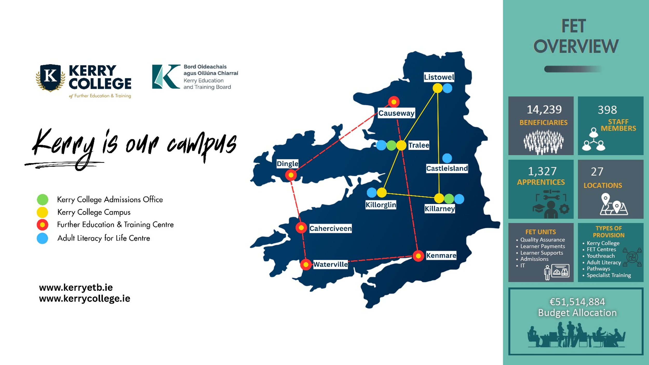
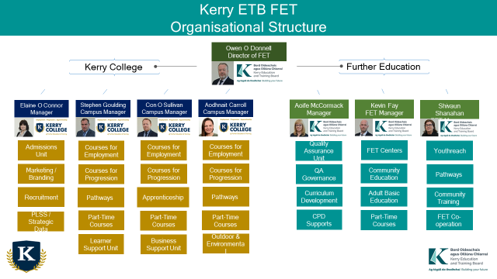
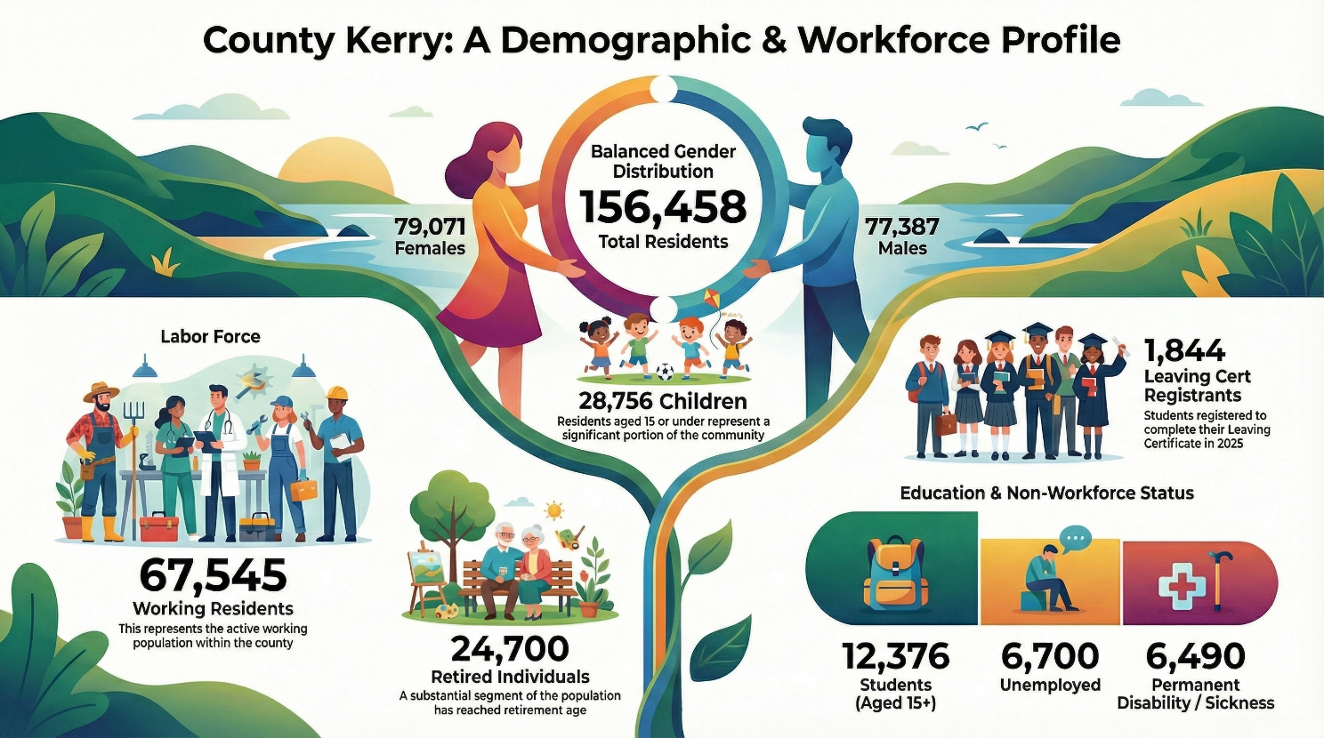
- All figures CSO Kerry Census of Population 2022

County Kerry covers an area of over 4,807km² and is the second largest county in Munster, the 5th largest in the country in terms of land area and the 15th largest in terms of population Census 2022 demonstrates that population of the county is 156,458, this represents 5.9% increase in the county’s population when compared to the 2016 census data . As a consequence of this the County of Kerry has seen the 12th largest population growth in the country. In terms of net Migration, the county of Kerry has experienced the 10th largest level growth in the country. While both of these data sets should be viewed as a positive indication of growth in the region, it realises an increased level of demand in terms of skills training, professional development, access to education, and lifelong learning for the county’s inhabitants.

The county’s population is accommodated in a network of towns and villages with many operating to a high degree of self-containment. These towns and villages act as a significant local employment and service centres for large rural hinterlands. The wider regional population, including Limerick & Cork is 950,150 while the towns of Tralee & Killarney have a 60-minute commuting population of over 320,000. The County of Kerry is a vital supporting partner to Counties Cork and Limerick in the development of a strong Southern region in Ireland. County Kerry forms part of the Atlantic Economic Corridor, a corridor running along the Western seaboard.

County Kerry faces significant population-related challenges characterised by uneven growth, where rapid development in urban hubs contrasts with severe rural depopulation, particularly in the south of the county. Despite an overall population increase of 6% to 156,458 in the 2022 Census, the county is struggling with an aging demographic, high vacancy rates, and a decrease of population in rural, peripheral areas. Kerry has a higher proportion of people over 60 (23%) compared to the national average (18%).

Kerry Household income
Based on 2022 data from the Central Statistics Office (CSO) released in April 2025, Kerry had the lowest median gross household income in Munster, with an average of €48,320 per year and was the fourth lowest nationally. The majority of households in Kerry (22.3pc) earned between €20,000 and €39,999. Less than 18pc earned between €40,000 and €59,999 and 13pc earned between €60,000 and €79,999. 16pc earned less than €20,000 while 6.5pc had no administrative income. Close to two and a half per cent earned more than €180,00. Listowel MD had the highest proportion of households (37.8pc) where the majority of income came from social transfers like pension, illness, disability, caring and working age income supports
Income by Local Electoral Area (LEA)
- Killarney: €56,099 (Highest in the county)
- Castleisland: €53,984
- Corca Dhuibhne: €46,355
- Tralee: €45,934
- Listowel: €45,630
- Kenmare: €44,470

Educational Attainment based on the CSO Census 2022 results released in December 2023, the educational attainment for the population aged 15 and over in County Kerry is as follows
- Third Level Qualification: 41% (approx. 44,200 people)
- Upper Secondary Level: 27% (approx. 29,300 people)
- Lower Secondary Level: 15% (approx. 15,800 people)
- Primary Education/No Formal Education: 11% (over 11,500 people)
- Not Stated/Other: Remainder of the population.
Based on the Census 2022 results, educational attainment in County Kerry has shown significant improvement, with 41% of the population aged 15 and over holding a third-level qualification, up from 38% in 2016. However, this remains below the national average of 45%. 11% of the population in Kerry had only completed primary level or had no formal education, slightly higher than the national rate of 10%. While Kerry had one of the lowest proportions of students (10% of the population aged 15+), 49% of 25-69 year olds in the South West region (including Kerry) participated in lifelong education, with strong engagement in engineering, computer science, and business subjects.

The Rural Development Policy 2021 – 2025 discusses the importance of accessible community-based training programmes and upskilling opportunities for those living in rural and marginalized communities. The Southwest Regional Enterprise Plan to 2024, under action 6.4 calls for the development of Regional Skills Clusters as a key enabler to promote Lifelong Learning, ETB’s are identified as an action partner in this instance.

Industry Analysis
The top employment sectors in County Kerry are
- Wholesale and retail
- Health and social care
- Tourism (accommodation and food services)
- Manufacturing
- Public Service

County Kerry’s economy is predominantly service-led, with tourism and hospitality forming the primary driver of employment and local economic activity, supported by a strong agri-food base, a small number of high-impact manufacturing employers, and growing activity across marine, enterprise, and skills-led sectors. Agriculture and food production remain central to the rural economy and associated supply chains, while established international manufacturers continue to play a significant role in regional employment. Kerry’s extensive natural and coastal assets also support opportunities in marine, seafood, outdoor, and nature-based activities, with increasing alignment between enterprise development, sustainability, and skills provision. Local policy direction, particularly through the Kerry Local Economic and Community Plan 2025–2030, emphasises sustainable and inclusive growth, workforce development, and community resilience. Labour market and demographic trends highlight both opportunities for targeted education and training interventions and ongoing challenges linked to participation rates, seasonality, and geographic dispersion. Overall, Kerry presents a diverse but tourism-dependent economy, underscoring the importance of responsive further education and training provision to support skills development, economic resilience, and progression pathways across the county.
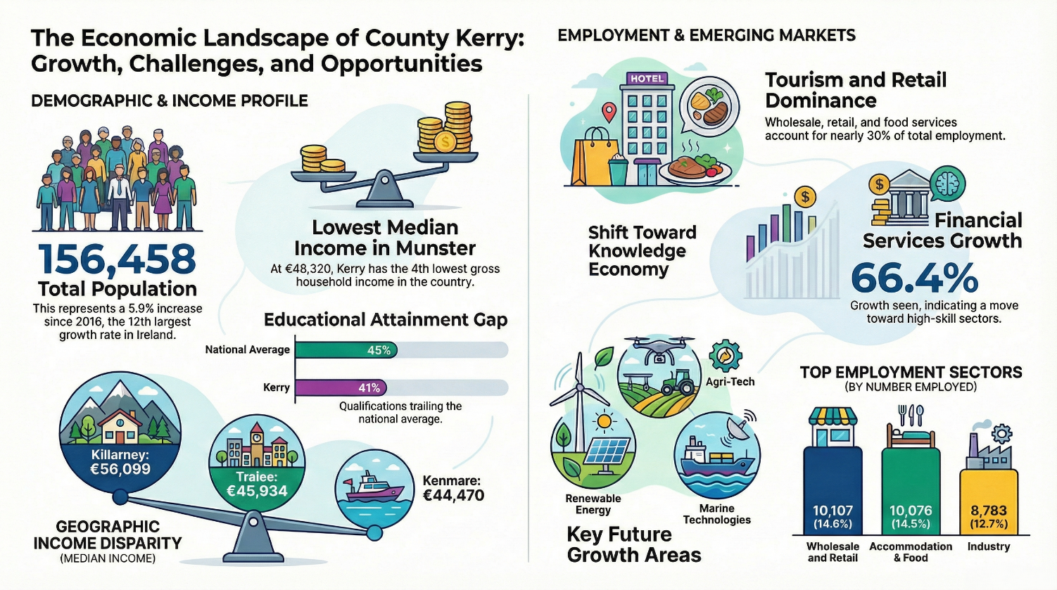

The top employers by sector in County Kerry:
- Food and Agri-business
- Manufacturing and Engineering
- Pharma, Tech, and Bio-Tech
- Tourism, Hospitality, and Retail
- Health, Education, and Public Sector

Main Employment by Sector
According to data extracted from the CSO Labour Force Survey (Q4 2019), the breakdown of employment by sector in Kerry is as follows:
Sector | Number Employed | Percentage of Total
Wholesale and retail trade | 10,107 | 14.6%
Accommodation and food service activities | 10,076 | 14.5%
Industry | 8,783 | 12.7%
Health and social work | 8,563 | 12.4%
Agriculture, forestry and fishing | 5,729 | 8.3%
Education | 4,790 | 6.9%
Construction | 4,431 | 6.4%
Administrative and support service activities | 3,137 | 4.5%
Other NACE (arts, entertainment, recreation) | 3,076 | 4.4%
Professional, scientific, technical activities | 2,747 | 4.0%
Public administration and defence | 2,590 | 3.7%
Transportation and storage | 1,908 | 2.8%
Financial and insurance activities | 1,769 | 2.6%
Information and communication | 1,622 | 2.3%
Total (All NACE economic sectors) | 69,328 | 100%

Emerging Sectors
Renewable Energy / Sustainability
Agri-Tech
Marine Technologies / Agri
Key employment trends show a strong shift towards the knowledge economy, with high growth in financial services (+66.4%) and food/beverage (+23.5%)

Kerry ETB Further Education and Training (FET)
Kerry ETB offer an extensive array of full-time and part-time courses across multiple programmes and in Campuses and Centres strategically located throughout the County. Kerry ETB Further Education and Training offer Certification at QQI levels 1 to 6 and a range of Industry and Vendor Certification across a wide range of areas. Kerry ETB FET provides courses for all learners over 16 years of age including Apprentices, School Leavers, Unemployed and Employed and those seeking re-engagement with education and training.

Kerry ETB FET Campuses / Centres
Kerry College has five Campuses, two Pathways Centres and two Admissions Offices.
Kerry College delivers Levels 3 to 6 QQI and Other Awarding Bodies through Full Time and Part Time courses in Apprenticeship, Courses for progression, Courses for Employment, Pathway Courses, Learning in Employment (STA) and Evening Training.

Youth Provision – Four Youthreach Centres & one Community Training Centre.
General Learning Level 3 / 4 QQI, Leaving Cert Applied, level 3 & 4 skills training in construction, hairdressing and catering.

FET Centres – Five FET Centres County Wide
All Adult FET Provision, Certified / Non-Certified, Full time, Part Time, Contracted Training. Adult Literacy for life, Community Education, BTEI.
Outreach Provision – County wide locations
Adult Literacy for Life, Community Education, Learning in Employment (STA), Contracted Training, Specialist Training Provision.

Kerry College
Kerry College Campuses at Clash, Denny Street, Listowel & Killarney offer full-time day & evening training and development courses at QQI levels 3-6. The Kerry College School of Beauty provides ITEC, CIBTAC & CIDESCO accreditation to 32 learners.
Kerry College campus offers courses for employment, progression, and pathway course options. Kerry College Campuses have a long and very successful tradition as the leading provider of further education in Kerry. As part of Kerry Education & Training Board (KETB), all campuses are committed to providing a quality education service with equal opportunity for people of all ages and abilities.

Kerry College Killorglin Campus provides specialist Further Education and Training in outdoor education, ecology, youth work, wellbeing, and emerging marine skills. Delivery is rooted in experiential, field-based learning and operates across a network of five linked locations in Killorglin, Killarney, Tralee, and Cahersiveen. Provision supports learners from entry-level Pathways through to advanced professional certification aligned with employment and progression opportunities.

Kerry College Monavalley Campus
Kerry College Monavalley Campus is the largest provider of skills-based training, upskilling & apprenticeship provision in the county. Kerry College Monavalley Campus offers an ecosystem of full-time day, evening, and flexible training & development courses to build confidence, knowledge and work-ready skills.

Kerry College Business Support Unit (BSU)
The BSU aims to equip employees with the skills to progress in their current job, or to take advantage of new job opportunities, while also supporting business to develop an agile pipeline of talent. The Business Support Unit through engagement with various bodies have developed specific programmes for a wide range of sectors. These programmes are delivered under the Skills to Advance Initiative. This extensive breath of provision is supported with by the campuses 66 staff.
A business cases have been submitted regarding Employer Engagement Officers to further develop learning in employment provision in Kerry and employer engagement through Skills to Advance
Kerry College Admissions Unit has two main street offices located in Tralee and Killarney and supports structured entry to full and part‑time programmes at Kerry College of Further Education and Training, enabling progression to employment, further study and Higher Education. The Admissions Office ensures a consistent, transparent and quality assured admissions process across all Kerry College campuses and centres, in line with the Kerry College Admissions Policy and Kerry ETB quality assurance frameworks. Admissions support learners from initial enquiry through application, eligibility assessment, offer and registration and plays a key role in ensuring learners are appropriately placed on programmes that best meet their needs and progression goals. Admissions also manage PLSS and compiles/monitors all learner data related to registrations.

Kerry ETB FET

Quality Assurance Unit supports all FET Provisions including Centres and Kerry College Campuses to maintain high quality services through its support of the ETB’s academic governance structures, by reviewing/ developing QA policies and procedures and developing new programmes and curriculum. The QA Unit also supports assessment processes and continuous improvement, monitoring and review through quality improvement planning processes. The QA Unit is the first point of contact for awarding bodies such as QQI.

Further Education Administration is located in FET Head Office. This team oversees all aspects of contracts administration, CID management, and course scheduling for the five FET centres, Adult Literacy for Life, Community Education and Outreach Provision. They are responsible for retaining and managing all necessary documentation and grant funding to ensure audit readiness and regulatory compliance. Additionally, the team addresses all public and tutor-related inquiries via telephone and email concerning the programmes under their administration.

Youth Provision have a 25-learner place centre in Killarney, a 25-learner place centre in Listowel and a 50-learner place centre Tralee which offers general level 3 & 4 and Leaving Certificate Applied. There is also a 40-learner place Community Training Centre which offers skills training at level 3 & 4 which also provides pre-apprenticeship courses.

FET Centres in An Tochar, Dingle, Kenmare, Caherciveen and Waterville Campus. There are nine external FET Centres in total, 5 FET Centres and Adult Literacy for Life Centres. These centres are strategically located delivering Further Education and Training (FET) to rural communities throughout the county. In 2025, they served 7,173 beneficiaries. They offer courses from Level 1 to Level 6 QQI, traineeships and a range of community education programs covering diverse topics. Approximately 85% of learners attending these centres reside within 10 kilometres of the facility, with most courses on offer in the part-time minor award space.

The Specialist Training Provision in Kerry is contracted to the National Learning Network (NLN) in Tralee to deliver 108 training places for Kerry. The Contracted Provision is monitored and managed from FET Head Office.

FET Priorities in 2026 (new FET strategy objectives)

South Campus - Acquisition of the facility and the transfer of Clash Road Campus provision to the MTU South Campus by September 2026.

Kerry College Killarney Campus – Acquisition of site for the development of the Kerry College Killarney Campus and the development of the business planning for the Hospitality Education and Training Centre located in the new development.

Moyderwell Youthreach Centre – Completion of the refurbishment and building upgrade of the Moyderwell Centre in Tralee including the transfer of Tralee ABE and Community Education to a segregated area of the Moyderwell facility by Q3/4 2026.

New Apprenticeship Development – Development of New Apprenticeships for Hotel Duty Manager and Hotel Accommodation Manger in collaboration with the Irish Hotel Federation.

Commercial Dive Centre – Development of the Diving Training Centre in Caherciveen Marina and the launch of the Commercial Diving courses by Q3 2026

Outdoor & Environmental Education and Training – - Development of the Blennerville Marine Education Centre to support accredited outdoor and environmental programmes, including the Marine Ecology course, alongside the delivery of Rewilding and Conservation programmes focused on biodiversity, habitat protection, and sustainable land and marine management through applied, field-based learning.

Tertiary Degree Courses – Continued development of Tertiary Degree courses with the Southwest Regional Tertiary collaborative group of Kerry ETB, Cork ETB, UCC and MTU.

Future-Ready Knowledge & Skills
Further consolidation of Kerry College as the FET college of the future, investing in the acquisition of the MTU South Campus and the SIUP projects in Listowel and Monavalley. Providing quality-assured, relevant, responsive and future-focused FET curriculum Embedding core, transversal, employability and green skills into all FET provision. The growth of micro – credentials to support employment in County Kerry. Focusing on the professional development of Kerry College Staff in AI, Teaching & learning and building Professional Communities of practice.
The Admissions office works closely with FET managers and Kerry ETB Quality Assurance to ensure applicants receive accurate and consistent information on course requirements, progression pathways, employability outcomes and Further and Higher Education opportunities.

Inclusion for Prosperity & Cohesion
In Kerry College, through our Admissions office, the aim is to widen access to FET. Kerry College & Kerry ETB have made an organisational commitment to strengthen our inclusive practices and policies. This also leads to valuing and recognising learning in all its forms and for all its purposes. UDL is at the heart of programme planning and our communities of practice. Providing consistent learner support throughout the learner journey. This is provided through our open learning centres, guidance services, and external counselling supports. Kerry College has developed the Learner Voice through its learner forums on campuses and working with Aontas. Also, Kerry College is developing digital inclusion through its laptop loan scheme
Widening access to FET is a core function of the Admissions Office. Admissions practices are grounded in equality, transparency and Universal Design for Learning principles and support participation from priority cohorts, including mature learners, learners with disabilities, migrants, early school leavers and those returning to education. Admissions works collaboratively with internal and external partners to reduce barriers to entry and to support informed course choice and successful learner participation.

Quality with Innovation
The development of new Tertiary programmes to align with the national strategy. Kerry College is developing its MOU with MTU and UCC in a regional context to develop new programmes and pathways for learners in Higher Education. Also Kerry ETB/Kerry College has a focus on working with third-level stakeholders like Mary Immaculate College to develop sustainable Professional development opportunities for its staff. UDL principles are embedded in Kerry College across Teaching & Learning, Quality Assurance & FET infrastructure. We measure this in Kerry College through our governance structures and quality improvement plans.
Kerry College is developing new awards and specialist programmes that respond to regional skills needs and emerging sectors, including the Night Sky Guide award, Commercial SCUBA, and Commercial Surface Supplied Diving. These programmes are designed in close collaboration with industry and regulatory partners to ensure they meet professional, safety, and employment standards while supporting clear pathways into work and further training. The programme portfolio reflects Kerry College’s strength in applied, place-based learning, building on distinctive regional assets such as the Kerry International Dark Sky Reserve and the strong demand for commercial diving skills across marine and construction sectors. Programme development and delivery are underpinned by established quality assurance processes and inclusive design practices, with effectiveness monitored through governance structures and continuous quality improvement planning.

Collaborating for Impact
Kerry ETB has in place strategic partnerships with MTU, UCC and MIC. Kerry ETB has a Southwest strategic partnerships and MOU with Cork ETB, MTU and UCC for the development and delivery of Tertiary Programmes in several agreed areas. Kerry ETB has strategic engagement with Employers' forums across the county and regionally. Kerry ETB is collaborating with Kerry County Council and a number of stakeholders on a range of provision areas from Sustainable Biodiversity, Marine Ecology and Marine Technologies such as commercial diving and marine maintenance.
The Admissions Office works collaboratively with internal and external stakeholders, including secondary schools, community organisations and Higher Education partners.

Funding Allocation for 2026
Kerry ETB receives funding for the provision of FET Services annually from the Department of Further and Higher Education, Research, Innovation and Science via SOLAS.
Table 1: Funding Allocation for Kerry ETB
Allocation for XXX ETB | 2025 Final Allocation | 2026 Allocation
 | Total | Pay | Non-Pay | Allowances | Total
Core Funding for a Strategic & Effective ETB | €12,972,343 | €7,505,617 | €5,725,337 | €0 | €13,230,954
Workforce Skills Development & Transformation | €13,526,011 | €7,087,097 | €2,337,459 | €4,381,239 | €13,805,795
FET Pathways | €11,567,406 | €5,105,466 | €2,565,675 | €3,369,803 | €11,040,944
Apprenticeship | €13,427,378 | €2,560,989 | €1,815,209 | €12,409,093 | €16,785,291
Strategic Investment | €21,746 | €0 | €21,737 | €0 | €21,737
Overall Allocation | €51,514,884 | €22,209,169 | €12,435,417 | €20,150,135 | €54,884,721

2026 Planned Beneficiaries
Programme Category | 2026 Planned
Employment - Workforce Skills Development & Transformation | 1596
Progression - Workforce Skills Development & Transformation | 1025
Pathways - FET Pathways | 228
Part-time - FET Pathways | 2805
Youth Provision - FET Pathways | 270
Community Education - FET Pathways | 2390
Adult literacy for Life - FET Pathways | 2374
Learning in Employment - Workforce Skills Development & Transformation | 520
2016+ & Craft Apprenticeship | 1702
TOTALS | 12,910

There is an overall decrease in planned beneficiaries from 2025. A significant increase in Phase 4 and Phase 6 Beneficiaries at a significantly greater cost per learner has seen a large increase in Apprenticeship Funding. An anticipated decrease in demand for ESOL has seen a reduction in planned beneficiaries in Adult Literacy for Life.
In 2026, Kerry ETB will utilise this funding to deliver
Core Funding for a Strategic & Effective ETB
SOLAS Budget - €13,230,954

Kerry ETB Core Funding is utilised across a range of Head Office and specific FET Functions/Units with a total of €7,505,617 funding 398 Staff

FET Contribution to Kerry ETB Head Office is circa €1,400,000

FET Head Office with the FET administration unit has a staff of non-pay budget of circa. €275,000

Kerry ETB FET QA Unit with11 Staff and non-pay budget of circa. €120,000

Kerry College Admissions Office with 13 Staff and a non-pay budget of circa. €390,000

Kerry ETB FET has a total 27 owned and leased locations in Kerry. The annual rent for Kerry ETB FET leased buildings is circa. €1,600,000. The repairs and Maintenance budget for Kerry ETB FET buildings is circa. €700,000 with a electric / heating cost of circa. €640,000.

The Kerry ETB FET ICT Unit has three full-time Staff which supports ICT for the delivery of programmes and commencement of learners & apprentices across all Kerry ETB FET provision. The Kerry ETB FET ICT Unit predominantly supports Level 1 & Level 2 support calls.

Kerry ETB FET Learner Payment Unit has two full-time Staff which Process Learners and Apprentices Payments. This unit oversees the payment of training, accommodation, and travel allowances to learners across the entirety of Kerry College, Youthreach, Community Training, and Specialist Training Provision.

Funding for FET Provision for Workforce Skills Development & Transformation
(Employment Progression, Learning in Employment)
SOLAS Budget - €13,805,795

Courses at QQI Levels 5 & 6 – Courses for Progression, Employment and Tertiary. The total forecasted beneficiaries for 2026 are 2621.
Courses for employment – 1596
Courses for Progression – 917
Tertiary Courses – 108
Learning in Employment planned Beneficiaries are 520

These Courses are delivered primarily in Kerry College with some provision in FET Centres.

Courses for Employment are primarily Level 5 & 6 equivalent courses with a strong focus on an employment outcome. The course focuses on imparting competencies through skills training. These courses have strong links with employers and long duration work placement of over 12 weeks in duration.
Courses for Progression are primarily Level 5 & 6 equivalent courses with a strong focus on progressing to Further Education and Training or Higher-Level Education. These courses are designed to impart the competencies required for success at third level.

Learning in Employment are certified course delivered to Industry Employers or Employees in the workforce delivering upskilling and job-related skills and competencies. These courses are predominantly organised and run by the Kerry ETB Business Engagement Unit through the Skills to Advance program.

Funding for FET Pathways
(Pathways, Youth Provision, Community Education, Adult Literacy for Life)
SOLAS Budget - €11,040,944

Kerry ETB FET Pathway courses are full time level 3 & 4 with a range of Part-Time Provision. The total projected Beneficiaries for 2026 are 8067.
Pathway Courses – 228
Youth Provision – 270
Part-Time Evening & BTEI – 2115
FET Pathways from School – 690
Adult Literacy for Life – 2374
Community Education – 2390
Specialist Training provision – 176

FET Pathways Provision takes place in four Kerry College Locations - Clash Campus Listowel Campus, Killorglin town Campus, Killarney Pathways.
The forecasted Beneficiaries for 2026 across 4 programmes is 228. These are programmes delivered at QQI level 3 & 4 for adults. The aim this year is to closely integrate Pathways with other vocational areas and develop awards. Mapping learners at Level 4 to career pathways –Business, Hospitality, Engineering, Carpentry

Youth Provision is delivered in four locations through five programmes in Kerry ETB, Four Youthreach Centres and One Community Training Centre. The Planned Beneficiaries for Youth Provision is 270. Two of the Youthreach provisions in Tralee have been relocated to a new Kerry ETB owned facility in Moyderwell with large investment to develop a high-quality purpose-built youth provision education and training facility. The addition of a fully equipped Home Economics classroom/training kitchen has added value to the programme because as well as providing meals for the learners, prepared by themselves it is preparing them for both employment and progression to Kerry College. Learners are trained in Barista and Food Preparation which has given them the opportunity to take up part time employment. It has also allowed the LCA programme to deliver electives in Tourism Hospitality and Catering. The upgrade of a Woodwork and Carpentry Workshop and the addition of a STEM/Engineering Workshop will give learners the opportunity to avail of practical classes which will greatly enhance the programme currently on offer.

Evening Training & BTEI- takes place in several locations including Kerry College Campuses and FET Centres The forecasted Beneficiaries for 2026 are 1,210. Evening Training in Kerry are provided at no fee for learners in receipt of Social Welfare payments. These courses are provided at multiple levels on the National Framework of Qualifications to provide for both progression and employment and also include vendor qualifications targeted at industry. New areas for provision have been identified for Evening training in Kerry College Killorglin town Campus and Kenmare FET Centre with further expansion in Kerry College Listowel Campus and Killarney.

The Specialist Training Provision in Kerry is contracted to the National Learning Network (NLN) in Tralee for a fee of circa. €1,773,360 to deliver 108 training places for Kerry. The Contracted Provision is monitored and managed from FET Head Office.

FET Schools Pathways is delivered across Kerry College Campuses and some FET Centres.
A total of 690 Beneficiaries is planned for 2026 which will be provided across several Kerry College Campuses. A range of FET Schools Pathway programmes will be delivered in Clash, Denny St and Listowel Campuses focusing on Healthcare, Hairdressing & Beauty, Sports & Coaching
Kerry College Monavalley Campus to deliver dedicated FET Schools Pathway programmes in the areas of Engineering, Construction, ICT, Hospitality & Media to 210 post primary students. Kerry College Killorglin Campus will deliver a range of FET Schools Pathway programmes with a focus on Outdoor and Environmental Education. FET Centres will deliver FET Schools Pathway training for areas in Kerry where location makes travel to a Kerry College Campus impractical and where expertise such as arts and design is available. Funding for FET Pathways supports early engagement and progression into Further Education through structured pathways from post primary education and community-based programmes. In 2026, FET Schools Pathways will continue to provide progression opportunities for learners, with 11 post primary schools in Kerry participating in FET pathways programmes. In addition, Kerry ETB will continue to develop and embed an internal progression initiative supporting learner transition from Youthreach, Pathways, Community Education and Adult Basic Education (ABE) into full and part‑time courses at Kerry College of Further Education and Training, enabling clear, supported progression routes and sustained learner participation.

Adult Literacy for Life is delivered countywide, in eight centres, with planned beneficiaries for 2026 coming to 2374. Kerry ETB will continue to deliver to the Adult Literacy for Life Strategy with a focus on Family Literacy for 2026. The renewal of the Collaboration and Innovation fund will see further ALL projects receive funding. The ALL team will also continue to work with the apprenticeship programs for literacy and numeracy assessment. The continuation of our ESOL intensive programs will also run in four locations for summer 2026.

Community Education is delivered in five FET Centres county-wide and in multiple outreach locations, with planned beneficiaries of 2390 in 2026. This is a vital program to tackle issues of rural isolation and social inclusion across the county. Initiatives such as Arts in Hospital will continue to help those most in need. The core philosophy of the community education programme centres on empowerment; by fostering a supportive and informal environment, Kerry ETB will continue to build the confidence and skills necessary in our community education learners to pursue further education, enhance their employability, or simply play a more active role in their local community.

Apprenticeship Funding
(Craft and Consortia led)
SOLAS Budget - €16,785,291

All Apprenticeship in Kerry ETB FET is delivered and managed by Kerry College Monavalley Campus.
A total of 1,702 apprentice Beneficiaries is planned to be achieved in 2026 and delivered across multiple sites in Tralee and one in Kenmare. These are across 2016+ Apprenticeships which Kerry ETB is the National lead provider in 2 apprenticeships, the Commis Chef and Wind Turbine Maintenance, and delivers four other 2016+ apprenticeship which Kerry ETB delivers in Kerry as a collaborating provider. Kerry ETB delivers Phase 2 apprenticeship training in 7 Apprenticeship areas and 1 apprenticeship, the Stone Cutting & Stone Masonry, at Phase 2, 4 and 6. Kerry College Monavalley also funds, monitors and records all Phase 4, 6 and 7 Craft Apprenticeship in Kerry on behalf of SOLAS.

Apprenticeship Type | Planned Beneficiaries
2016+ | 140
Phase 2 | 494
Phase 4 | 538
Phase 6 | 440
Phase 7 | 90

Kerry College Monavalley Campus to coordinate and oversee the continued delivery of the National Commis Chef Apprenticeship and the National Wind Turbine Maintenance Technician Apprenticeship. Kerry College Monavalley Campus also to work in partnership with industry (IHF) in the development of new Consortia led apprenticeships with particular emphases in the hospitality sector.

Kerry College Monavalley Campus to work in partnership with SOLAS in the rollout of Version 6 curriculum for craft apprenticeships. Kerry College Monavalley Campus to continue its work in the realisation of a new apprenticeship building at the Monavalley Campus Site. This project is advancing under the SIUF application.

Strategic Investment Funding
(Reach Funding, Specialist Skills Development, Skills to Advance Innovation Projects, ETB Strategic Initiatives,
Climate Action Initiatives, Self-Financing Courses)
SOLAS Budget - €21,737

Kerry ETB Community Education will continue to manage the budget to allocate funding to local community groups through the REACH fund, with a focus on supporting those most disadvantaged. This funding will also facilitate access to equipment such as ICT resources and provide workshops aimed at upskilling staff and learners.

Kerry ETB’s requirement funding for REACH is in excess of €50,000.

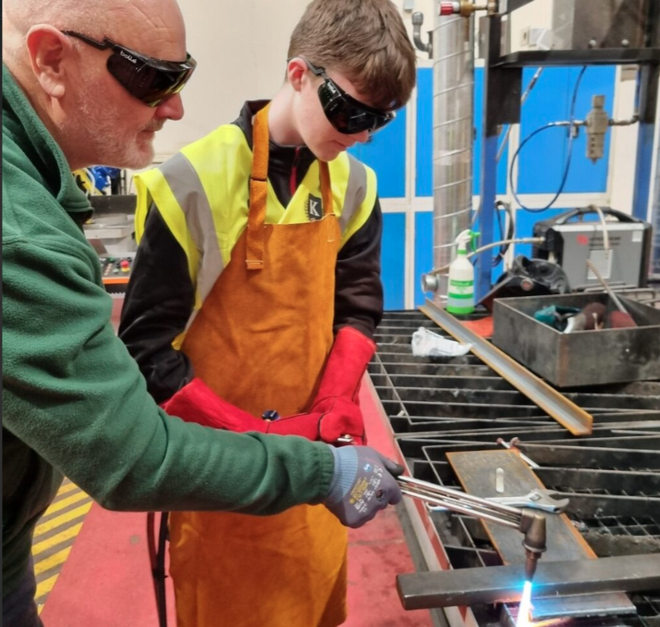

Transition Year/Further Education and Training Initiative-Monavalley Campus

Kerry ETB Strategic Goals and Priorities

Building on the goals, priorities, and actions agreed with the Department of Education and Youth, and the Department of Further and Higher Education, Research, Innovation and Science, Kerry ETB will advance key strategic priorities from our Strategy Statement 2023–2027 throughout 2026. Guided by our core values, these initiatives are designed to promote quality, inclusivity and equity, with a particular focus on supporting those most marginalised in our community. Through the implementation of these strategic priorities, we aim to enhance access to education and create meaningful opportunities for all.

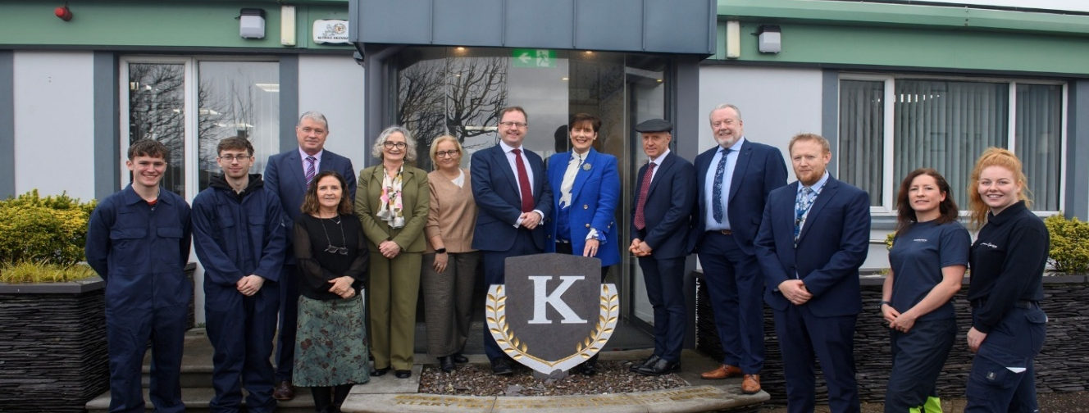

Minister for Further and Higher Education, Research, Innovation and Science James Lawless highlights innovation and investment at Kerry College, Monavalley Campus

Summary
The 2026 Kerry ETB Service Plan reflects a shift from framework development to implementation and embedding, with a strong emphasis on delivery maturity and organisational capability across Kerry ETB’s three organisational pillars: Schools, Youth and Music (SYM), Further Education and Training (FET); and Organisation Support and Development (OSD). Key priorities for 2026 reflect a strengthened emphasis on development, governance, compliance and organisational capacity.

In SYM priorities for 2026 focus on quality, inclusion and learner experience across the full education continuum. In schools, new and enhanced priorities include the implementation of the revised Senior Cycle, rollout of student devices to support senior cycle implementation, and the development and introduction of an AI Policy for schools, alongside continued implementation of the revised DEY Child Protection Procedures, Identity, Multi-Belief and Values Education (IMBV), the Belong To Q Mark, and Realising Inclusive Special Education Programme (RISE). In the Youth and Music areas, 2026 marks the delivery phase of the five-year Local Creative Youth Partnership (LCYP) Strategy, with targeted creativity programmes supporting early years settings, Traveller communities, international protection communities, and young adults with additional needs. Music Generation provision is further strengthened through expanded instrument loan schemes, enhanced progression pathways, and focused professional development for music educators, supporting equitable access and participation.

FET priorities for 2026 align closely with the draft Creating Futures Education and Training Strategy 2026-2030 and regional workforce needs. Key developments include the expansion of apprenticeship provision, the development of new apprenticeship programmes, and the planned launch of a Commercial Diving course in Quarter 3 2026, linked to the development of specialist marine training capacity. Significant capital and infrastructure priorities include the development of both the Killarney Sara Lee site, the acquisition of the MTU South Campus, as part of the development of the Kerry ETB FET College of the Future. There is also planned continued investment in green capital across FET campuses and further investment in Youthreach provision. The FET pillar also prioritises digital inclusion, Universal Design for Learning, and staff development in AI and digital pedagogies, alongside strengthened tertiary partnerships and programmes, employer and industry engagement, and the expansion of flexible, future-focused learning pathways.

Key priorities in OSD include enhanced Information Security Management System (ISMS), resourcing and compliance, improved fixed asset management, and the continued implementation of Public Sector Duty requirements through the Equality, Diversity and Inclusion (EDI) programme. 2026 also sees a renewed focus on organisational risk management, the review and enhancement of Internal Control Questionnaires (ICQs), the strengthening of the policy development framework, and the establishment of a structured training and development function to support staff capability and continuous improvement.

Collectively, these measures support a more coordinated, cohesive, evidence-informed and operationally focused approach to service delivery across Kerry ETB in 2026.

Goal 1: Excellence in Education and Training Services
We aim to ensure the continued review, design, delivery and support of quality-assured education and training opportunities to meet all learners’ evolving lifelong and life-wide learning needs.
Priority | Action | Target
1 (a) Create a high- quality, holistic education and training environment informed by learners' voice and actively addressing access for all. | Continue to support and develop parent/guardian, student/learner/youth and staff voice participation to ensure provision continues to meet needs and expectations. | Continue to address and support equality of outcomes for our students, particularly those from marginalised groups.
Staff are being provided with Padlet, Kahoot and Nearpod licences to support teaching and learning in Q1 2026.

Cross-Campus teaching and learning teams meet in each Quarter.

Learner voice will be gathered locally through learner forums and nominated learner representatives across Kerry ETB FET Quality Boards, Campuses and Centres. Feedback will be used to fine-tune delivery, supports and timetabling through programme team discussions.
Host Aontas/ Kerry ETB Learner Forum.

Survey Further Education and Training learners and prepare a report based on survey results for Further Education and Training Quality Council.

Seek Learner Voice at Further Education and Training Quality Council meetings and at QA procedure reviews.

Killorglin Campus will support strong participation in the QA-led learner survey and will review Campus-level themes with programme teams. Agreed actions will be tracked through normal QA review points and communicated back to learners so they can see what changed.
1 (a) Create a high- quality, holistic education and training environment informed by learners' voice and actively addressing access for all. | Continue to develop child protection oversight and adult safeguarding structures. | Training and Child Protection for BOM in all Schools and Youthreach in Q1 2026.  All Schools and Youthreach to complete Oide one day training for staff on new child protection guidelines.  All Schools and Youthreach to use new child protection checklist by December 2026.  All schools will have adopted the Child Protection Procedure for Schools 2025 by the end of 2026.  Training for staff at Youth Centres, Youth Work services.
Aontas training provided in Q1 2026.
Maintain strong child protection and adult safeguarding oversight at Killorglin Campus through implementation of the updated policy, annual refresher training and completion of Tusla child protection e-learning, with clear local reporting pathways and up to date contact lists.
Complete scheduled checks against Kerry ETB templates and checklists, ensure safeguarding statements and procedures are visible and covered at learner induction, and keep secure records of any concerns, actions and referrals in line with policy.
Review practice through programme team meetings and QA review points, including learning support and vulnerable adult considerations for relevant cohorts.

Schedule training for Youthreach staff in the role of DLP and DDLP to ensure additional staff are trained and available in the absence of a DLP or DDLP in Q 1.
1 (a) Create a high- quality, holistic education and training environment informed by learners' voice and actively addressing access for all. | Kerry ETB will have due regard to the Department of Education and Youth’s developing policy framework for the future development and delivery of the School Completion Programme (SCP), including ongoing strategic engagement with TESS, ETBI and the Department of Education and Youth, and will progress local enabling measures to support the proposed transition of SCP delivery to a Section 56 commissioned service model and the establishment of a new employment framework for the SCP workforce. | Participate in, and input to, Department of Education and Youth/TESS/ETBI engagement structures on SCP transition and workforce arrangements, ensuring Kerry ETB submissions/feedback are provided within required timeframes.  Section 56 commissioned service model (governance, contracting/commissioning implications, finance and audit, reporting, data protection, risk), with an agreed action plan by end of Q3 2026.  Develop and agree an ETB approach to SCP governance and oversight aligned to national requirements (e.g., reporting templates, assurance steps, escalation routes), with implementation steps initiated by end of Q4 2026 (subject to national guidance).  Agree local communications strategy.
1 (a) Create a high-quality, holistic education and training environment informed by learners' voice and actively addressing access for all. | Develop and implement an organisational management/staff mentoring system or support structure | See Training and Development Plan 2026 -2027  Please refer to Appendix 5 for details on this plan.
1 (a) Create a high-quality, holistic education and training environment informed by learners' voice and actively addressing access for all. | Review sport stock and facilities across all Schools, set minimum standards and develop a plan to address for the future. | Clár funding secured to improve play areas in Causeway Comprehensive and Tahilla Community National Schools.
1 (a) Create a high-quality, holistic education and training environment informed by learners' voice and actively addressing access for all. | Review practical subject facilities, sports facilities and resources and develop a plan to achieve high standards. | Continue to monitor opportunities for funding to improve home economics and art facilities.
1 (a) Create a high-quality, holistic education and training environment informed by learners' voice and actively addressing access for all. | Provide opportunities for learners to engage in clubs and societies. | Promote and administer Local Youth Club Grant Scheme Q 1 and Q 2.  Support capacity-building in clubs through delivery of training to volunteers in Q4.  Promote club/group provision through Radio Kerry Sound and Vision Project.  Increase in Tertiary places available for Nursing in 2026-27.  Working with National Tertiary Office to further develop a Tertiary programme in Community Development and Business with logistics.  Youthreach Access Day in all Campuses in Q1 2026.  Support learner participation in clubs and enrichment activities by establishing at least two low-cost, learner-led options linked to provision (e.g., outdoor walking group, ecology field group, indoor climbing club), and by linking with local community clubs to create participation and volunteering opportunities across Killorglin Campus delivery locations.  Established in 2025 - Learner voice forum in each Campus.  Aontas training will be provided in Q1 2026.  Kerry College Teams will enter Higher Education and Further Education and Training competitions in soccer/GAA.  Support cross-Campus clubs and team participation by coordinating regular sessions and at least one inter-Campus activity/fixture during 2026 (sport or outdoor activity) and facilitating learner entry where appropriate to local/regional HE and Further Education and Training competitions and events, using existing programme teams and community partners to keep it accessible and sustainable.
1 (b) Provide comprehensive guidance to all learners, offering academic, employment and personal support. | Expand Further Education and Training to HE pathways for learner progression with MTU and UCC – unified tertiary education. | New Tertiary programmes agreed through Programme Governance Board and the Further Education and Training Quality Council. Interviews for the new cohort for 2026-27 will be planned for Q1 2026.  Increase in Tertiary places available for Nursing in 2026-27.  Working with NTO to further develop a Tertiary programme in Community Development and Business with Logistics.  Use the planned Youth Work provision from Kerry College, Killorglin Town Campus as a pilot opportunity to explore and expand tertiary pathways within Kerry College, including progression mapping from QQI Level 5 into relevant QQI Level 6 and onward degree routes, and engagement with potential Higher Educations partners to support access, credit recognition and progression agreements.
1 (b) Provide comprehensive guidance to all learners, offering academic, employment and personal support. | Strengthen internal  progression routes through  the NQF (National  Qualifications Framework)  Levels. | Continue to strengthen internal progression by fully embedding progression pathways for Community Education and ABE, using the progression data to monitor, analyse and respond to learner trends.  Map and actively support internal progression across Killorglin provision, particularly from QQI Levels 3–4 programmes at Kerry College, Killorglin Town Campus into Level 5 options (including Youth Work), using joint taster sessions, planned referral points with Guidance, and consistent capture of progression outcomes for review by programme teams.  Also highlight opportunities across Kerry College Campuses such as ELC.
1 (b) Provide comprehensive guidance to all learners, offering academic, employment and personal support. | Achieve devolved responsibility/delegated authority status from QQI. | Participate in January 2026 meeting for sectoral view on devolved responsibility.  Gain understanding of steps involved.  Engage in the QQI steps for devolved responsibility for Youthreach Experience days.  Working with CTC on the introduction of Beauty Therapy.
1 (c) Provide widely accessible education and training opportunities in a range of areas, including creativity and music | Develop a county wide strategy  for music education and performance (establish a Kerry ETB School of Music Performance). | Continue expansion of after-School music provision to 20% of overall programming.  Enhance ensemble opportunities by supporting progression pathways for primary School and post-primary participants.  Increase participation and accessibility in underserved areas countywide.  15% growth in participant and location numbers.  Increased diversity of outreach (after-School) instrumental specialisms and ensembles.  Major performance to celebrate the achievements of MG Kerry School programmes Q2 2026.  15% increase in participation and two new programme locations by end of 2026.  Publication of Music Generation Kerry Strategic plan in 2026.  Collaborate with local stakeholders to align programme growth with education strategy.
1 (c) Provide widely accessible education and training opportunities in a range of areas, including creativity and music. | Roll out of the 5-year Kerry LCYP Strategy across all Schools and more broadly across Kerry. | Support professional creative practitioners through CPD in Q2.  Continue to ensure that all programmes are defined based on the needs and interests of children, young people and young adults, while prioritising lesser heard voices.
1 (d) Provide excellent responsive delivery to support the local and national economy taking account of local and national labour shortages and delivering programmes to best meet this skills gap. | Continue to ensure proactive and strategic forward planning (i.e. staff management, resource allocation, policies and communication channels) to support all future service delivery/provision. | Build on work commenced in 2025 in relation to the development, communication and training on policies to ensure policies are finalised, approved, communicated to staff and supported by appropriate training by through 2026.
1 (d) Provide excellent responsive delivery to support the local and national economy, taking account of local and national labour shortages and delivering programmes to best meet this skills gap. | Re-structure and expand Part- Time evening provision across the county providing an extensive and flexible programme. | Increase the provision of Part-Time Evening Training in Killarney across all three terms.  Continue the existing evening program in An Tóchar and expand the offering in Cahersiveen and Kenmare.  Further expand Evening Training provision by appointing an Evening Training Manager to coordinate scheduling, tutor resourcing, marketing and community engagement, building on the growth already established within Killorglin provision. Deliver a planned suite of Part-Time evening courses across four terms, aligned to local demand and progression opportunities.
1 (d) Provide excellent responsive delivery to support the local and national economy, taking account of local and national labour shortages and delivering programmes to best meet this skills gap. | Progress programme development standardisation through communities of practice | Conclude the Course Specification process for Full-Time programmes.  Commence the Course Specification process for Part-Time programmes.  Participate in the national QQI review of the Healthcare award standards.  Continue engagement in national sectoral process related to programme development e.g. Youthwork; Revise Programme Development Operating Guidelines (QA Unit),  Progress programme standardisation through active participation in Kerry College communities of practice, including completing/updating Course Specifications for Killorglin Part-Time evening provision across the five delivery locations.  Maintain consistent assessment and QA practice through shared templates and a fully digital assessment workflow (submission, marking, IV and EA), and contribute learning from the new Youth Work provision at Kerry College, Killorglin Town Campus into wider programme development discussions.
1 (e) Adapt and develop our  education and training as new learning approaches and technologies emerge. | Implement Universal Design for Learning Proposal/Plan. | Universal Design for Learning training events for teachers took place throughout 2026 to support equality of outcomes for learners.  As part of our Memorandum of Understanding with Mary Immaculate College Limerick our Post Primary Schools will be engaging in a Universal Design for Learning research initiative with the working title of Universal Design for Learning and the continuum of support - examining Schools’ practices
1 (e) Adapt and develop our  education and training as new learning approaches and technologies emerge. | Integrate and embed new software systems across the organisation. | See ICT Strategy 2023 – 2027.  Please refer to Appendix 7 for details on this strategy.
1 (e) Adapt and develop our  education and training as new learning approaches and technologies emerge. | Develop an integrated technology enhanced learning strategy. | AI Guidelines developed for Schools, after consultations with staff.  AI training provided to both staff and students.  Target one additional School for one-to-one devices in Q 4 2026.  Establish a Further Education and Training AI Working Group to develop policy and guidelines for Further Education and Training for use of AI in teaching, learning and assessment for both learners and staff.  Include any updates in the Kerry ETB Learner Handbook.  Implement agreed guidance locally through staff CPD.  Update learner induction, and consistent wording in assessment briefs to support responsible AI use while protecting assessment integrity.
1 (e) Adapt and develop our education and training as new learning approaches and technologies emerge. | Establish in-house resources for levels 1, 2, 3 and 4 ICT support for the organisation. | See ICT Strategy 2023 – 2027.  Please refer to Appendix 7 for details on this strategy.
1 (f) Design and deliver a career development programme for staff. | Design and implement a Training and Development Strategy. | See Training and Development Plan 2026 -2027.  Please refer to Appendix 5 for details on this plan.
1 (f) Design and deliver a career development programme for staff. | Promote the completion of Special Education Needs (SEN) professional qualifications. | Support Kerry ETB staff to complete SEN-focused qualifications and targeted CPD aligned to learner need, including Adapted Physical Activity training to strengthen inclusive participation across programmes.
1 (f) Design and deliver a career development programme for staff. | CPD for communities of practice and Universal Design for Learning. | Anticipated that research work in 2026 will give a roadmap for development of CPD.  Kerry College communities of practice developed where relevant and support the establishment of a Sport and Recreation Community of Practice to share planning, delivery approaches, resources and Quality Assurance standards across programmes and sites.
1 (f) Design and deliver a career development programme for staff. | Roll out of a comprehensive adaptive leadership programme for all leadership teams and staff. | See Training and Development Plan 2026 -2027.  Please refer to Appendix 5 for details on this plan.
1 (f) Design and deliver a career development programme for staff. | Develop and implement CPD  opportunities for primary, post-primary and Further Education and Training teachers/instructors to support the enhancement and embedding of outdoor learning practices into teaching and learning strategies. | PE teachers at post primary level will continue to run rich task events to enhance outdoor learning practices.  Our CNS sector will continue to embed outdoor ecology events as part of their curriculum.  Develop Killorglin Campus as a CPD provider, using the Adapted Physical Activity (APA) programme as the first established example of structured CPD delivery.  Continue to build delivery capacity for APA as professional development for primary, post-primary and Further Education and Training educators, focused on inclusive outdoor learning practice and practical teaching and learning strategies.  Use this as a platform to identify and develop additional CPD opportunities for educators, instructors and programme teams across disciplines, aligned to emerging need and Kerry College priorities.
1 (g) Research and implement future educational reforms in line with government policy and international best practices. | Deliver on targets set out in the Strategic Performance Agreement with SOLAS 2022- 2024 and 2025-2027. | Continued compliance with the specified targets and objectives agreed under the DEY Performance Delivery Agreement and with SOLAS under the SPA.
1 (h) Ensure that the capital and buildings programme is delivered and that all new projects are designed to comply with Department guidelines and the highest standards for energy efficiency. | Develop and progress capital projects including emergency and summer works programmes, SAR, SIUF etc. | Continue to implement a structured capital delivery programme that ensures all new building projects progress through design, procurement and construction stages in full alignment with Department of Education and Youth/ DFHERIS guidelines, including Technical Guidance Documents (TGDs) on energy efficiency, sustainability, and nearly‑zero energy building (NZEB) standards (where relevant)  Deliver the four sanctioned Climate Action Summer Works projects across Kerry ETB Schools, ensuring works are managed in line with approved specifications and Department of Education and Youth requirements.  Progress the installation of the bio‑mass boiler at Kerry College Monavalley Campus as part of Kerry ETB’s transition to more sustainable heating solutions.  Utilise the Devolved Green Capital Grant to plan and advance sustainability and climate action initiatives across Kerry ETB Further Education and Training buildings.  Continue to engage with both the SOLAS Further Education and Training Capital and Department of Education and Youth's Devolved Projects Section to ensure all capital projects undertaken are in compliance with guidelines.  Progress the commencement of new capital works at Tralee Regional Sports and Leisure Centre following the finalisation of the insurance settlement.  Progress the acquisition of MTU South Campus, Tralee by Kerry ETB.  Advance the proposed development in Killarney under the Further Education and Training College of the Future (CoTF) Major Projects Fund
1 (h) Ensure that the capital and buildings programme is delivered and that all new projects are designed to comply with Department guidelines and the highest standards for energy efficiency. | Progress plans to move Further Education and Training  provision in Tralee from  leased to permanent  accommodation. | Acquisition of the MTU South Campus and the phased movement from Clash Campus. Technical group and mapping set up. Staff and learners to be on site in Q3. Rebranding of the South Campus to Kerry College. Commenced.
1 (h) Ensure that the capital and buildings programme is delivered and that all new projects are designed to comply with Department guidelines and the highest standards for energy efficiency. | Address facility upgrades in line with the energy action plan set out in the Kerry ETB Sustainability Strategy 2023- 2025 (i.e. building fabric, thermal energy heating,  renewable energy and energy. | See Sustainability Strategy 2024 -2026.  Please refer to Appendix 8 for details on this strategy.

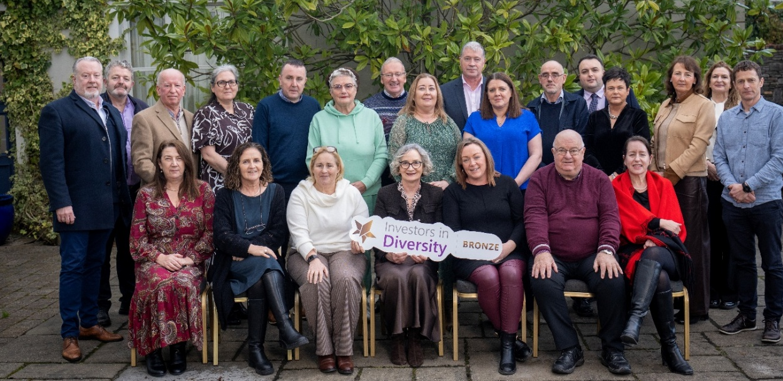

Kerry ETB achieves Investors in Diversity Bronze Accreditation

Goal 2: Strong, Inclusive and Respectful Organisational Culture
We aim to ensure our structures, processes, and behaviours underpin an environment that is safe, supportive and inclusive of all people, regardless of identity, background or circumstance.
Priority | Action | Target
2 (a) Complete an organisation-wide culture Audit and address recommendations. | Complete an organisation-wide culture Audit. The Audit should cover all aspects of the organisation's operations, including its mission, values, leadership, management practices, communication, and overall staff experience. | Culture Audit to be undertaken as part of the Equity, Diversity and Inclusion project commenced in Q1 2025.
2 (b) Promote a culture that is inclusive, non-discriminatory and respectful of human and civic rights. | Continue Traveller education support programme/role for Schools, increasing leaving certificate completion rates. | The Traveller Education Worker will secure support around Traveller mental health and career guidance for Travellers in education.  The Community Link Worker will work closely with Primary Schools to ensure Traveller students transfer from Primary to Post Primary School in September 2026.  Traveller Education Worker will link with the Traveller peer mentors to improve educational outcomes for Travellers. In addition, we will work closely with the community link workers who have been employed as part of the Travellers and Roma Education Strategy 2024 - 2030.  The introduction of a transition programme designed specifically for incoming first-year Traveller students in 2023/2024 was continued into 2025/2026.  A referral programme, initiated in 2023/2024, to encourage Traveller parents/guardians of post-primary students to participate in our Adult Literacy and Basic Education programme to continue in 2025/2026.
2 (b) Promote a culture that is inclusive, non-discriminatory and respectful of human and civic rights. | All Kerry ETB Schools to achieve yellow flag for inclusion and Belong to Q Mark. | The 8 Post Primary Schools have all applied and are at different stages of implementing the Belong to Q Mark.  Two Schools have achieved the LGBTQ+ Q Mark.
2 (b) Promote a culture that is inclusive, non-discriminatory and respectful of human and civic rights. | Implement the Public Sector Equality and Human Rights Duty (Section 42 of the Irish Human Rights and Equality Commission Act 2014). | Public Sector Equality and Human Rights to be incorporated as part of the Equity, Diversity and Inclusion project commenced in 2025.
2 (b) Promote a culture that is inclusive, non-discriminatory and respectful of human and civic rights. | Transition to a fully integrated Further Education and Training provision that helps to promote inclusivity and support learners with disabilities to achieve their full potential (move away from the legacy approaches). | Staff Training in Restorative practice, Introducing CBT and Supporting anxious learners in Further Education and Training completed by Kerry College staff in Clash/Denny Street and Listowel.  Staff Training in Disclosure Training, Vulnerable Adult Oversight, Critical incident planning, Staff first aid and AI in Q1/Q2 in 2026
2 (c) Ensure our core values guide the organisation’s behaviours and are the lived experience for all our  stakeholders. | Implementation of the Communications Plan. | See Communications Plan 2025 – 2027.  Please refer to Appendix 3 for details on this plan.
2 (c) Ensure our core values guide the organisation’s behaviours and are the lived experience for all our  stakeholders. | Roll out the ETBI Patrons' Framework on Ethos across all Kerry ETB Schools. | Two further Post Primary Schools commenced implementing the IMBV in Q3 2026.  Educational Policy and Development Officer with ETBI is invited to attend a Principal meeting in 2026, to support the implementation of IMBV.
2 (c) Ensure our core values guide the organisation’s behaviours and are the lived experience for all our stakeholders. | Roll out of the patrons' curriculum across all Kerry ETB Schools. | ETBI Patrons day, 12th Feb 2026, will be attended by Senior Staff of Kerry ETB along with our SEN and Ethos Coordinator, to further support this roll out.
2 (c) Ensure our core values guide the organisation’s behaviours and are the lived experience for all our  stakeholders. | Address organisational culture as part of staff induction processes. | See Training and Development Plan 2026 – 2027.  Please refer to Appendix 5 for details on this plan.  Kerry ETB aiming to achieve Silver Accreditation from the Irish Centre for Diversity in 2026.
2 (d) Support our learners and staff by strengthening access to and raising awareness of support  services. | Establish an access and disability support function. | Fully inclusive Admissions policies across schools and FET  SOLAS funds for disabilities for both Personal Assistant and general learning support access.  The development of a learning support policy and the creation of a learning Support Unit for Kerry College.by Q4  Build on Equity, Diversity and Inclusion project commenced in 2025.
2 (e) Ensure our structures actively promote inclusion and provide accessible and appropriate support for people with disabilities. | Implement the Public Sector  Equality and Human Rights  Duty (Section 42 of the Irish  Human Rights and Equality  Commission Act 2014). | See Public Sector Duty Plan.  Please refer to Appendix 2 for details on this plan
2 (f) Build stronger relationships with other regional agencies to proactively address barriers to inclusion for marginalised individuals or groups. | Expand Further Education and Training to HE pathways for learner progression with MTU and UCC – unified tertiary education.  Continue the implementation of the ETBI Provision Mapping Programme in Kerry ETB  Post Primary Schools.  Continue the rollout of the Belong To Q Mark in Post Primary Schools with Belong To Ireland.  Continue the rollout of the Yellow Flag for Inclusion in Post Primary Schools with the National Yellow Flag  Programme. | All Kerry ETB Post Primary Schools are engaged in the RISE programme (Realising Inclusive Special Education) which has incorporated Provision Mapping.  The RISE programme in Kerry is being supported by ETBI.  Growth of Tertiary in Community Development with MTU and Business with logistics. Final Sign off on the MOU between MTU Kerry and Kerry ETB.  The establishment of an MOU with Kerry County Council for work placements.  Build Further Education and Training to HE progression routes linked to Killorglin specialist pathways (outdoor, ecology and emerging marine provision), including structured progression mapping and engagement with MTU and UCC on potential entry routes, credit recognition and onward study options. This will include exploration of a potential Youth Work progression route between Kerry College and UCC.
2 (f) Build stronger relationships with other regional agencies to proactively address barriers to inclusion for marginalised individuals or groups. | Rollout Dignity in the Workplace training across the organisation. | See Training and Development Plan 2026 -2027.  Please refer to Appendix 5 for details on this plan.
2 (f) Build stronger relationships with other regional agencies to proactively address barriers to inclusion for marginalised individuals or groups. | Rollout targeted training including disability, unconscious bias, equality, intercultural, anti-harassment/bullying etc. training across the organisation. | See Training and Development Plan 2026 -2027.  Please refer to Appendix 5 for details on this plan.
2 (g) Work to meet the needs arising from the Irish Refugee Protection Programme and provision for international protection applicants | Continue the REALT Programme and the Ukrainian and International  Protection Co-ordination Team structures. | All international protection and Ukrainian students will have school places and access to transport where required.
2 (h) Create opportunities for students/learners and staff to access equality, diversity and inclusion education and training  opportunities. | Develop a revised Charter of Dignity. | See Customer Charter Action Plan  Please refer to Appendix 6 for details on this plan.  See Public Sector Duty Plan  Please refer to Appendix 2 for details on this plan.
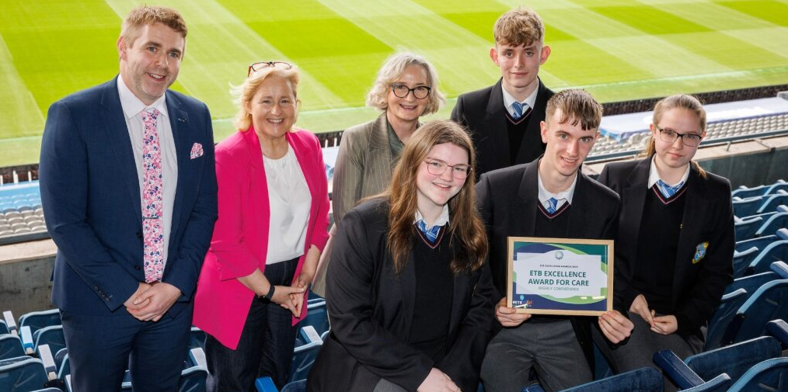
ETBI Awards in Croke Park

Goal 3: Opportunities for Greater Organisational Synergies
We aim to strengthen integration across our three pillars in a planned and strategic manner, adopting more cohesive and unified approaches.
Priority | Action | Target
3 (a) Develop a structure to facilitate shared understanding across the organisation's three pillars. | Continued embedding of the organisation's communication framework to ensure consistent, transparent and effective  communication across all teams. | See Communications Plan 2025 – 2027.  Please refer to Appendix 3 for details on this plan
3 (a) Develop a structure to facilitate shared understanding across the organisation's three pillars. | Establish a cross-Directorate leadership team with a focus on building synergies with agreed annual work plans and to communicate new policies and how they apply etc. | Continue twice-yearly Leadership Event which aims at strengthening collaboration across pillars, building synergies, and driving aligned, organisation wide objectives. -yearly Leadership Event which aims at strengthening collaboration across pillars, building synergies, and driving aligned, organisation wide objectives and policies-wide objectives.
3 (b) Create opportunities for closer cross-pillar collaboration to strengthen synergies and promote shared objectives. | Address in a structured manner Schools to Further Education and Training pathways. | Continue to expand TY to Further Education and Training provision to additional non-ETB post-primary schools.  As this is the first year in which the initial TY participants will have completed their Leaving Certificate, carry out a full mapping exercise to identify how many progressed to Further Education and Training and in which Further Education and Training Programme areas, evaluating whether their progression aligns with their original TY taster experience. Introduction of the New IVET module to Transition Years. Expand our TY provision to 10 Schools in 2026.
3 (b) Create opportunities for closer cross-pillar collaboration to strengthen synergies and promote shared objectives. | Roll out a Transition Year Further Education and Training opportunities programme. | The Further Education and Training / TY oversight group will continue to offer a wide range of TY programmes at Kerry College Monavalley Campus and through the Kerry College Outreach Programme.
3 (b) Create opportunities for closer cross-pillar collaboration to strengthen synergies and promote shared objectives. | Establish a cross-staff forum to meet annually to inform organisation direction, policy and priorities (c. 30 staff). | OSD - Review the work of the Cross Pillar Forum in Q1 2026 and establish if continuation with the current format is the way forward or if re-structuring is required in Q2.
3 (b) Create opportunities for closer cross-pillar collaboration to strengthen synergies and promote shared objectives. | Implement the benefits of organisational management information and data management systems/business intelligence engine in terms of greater organisational synergies, i.e. greater a whole of organisation approach. | To strengthen organisation wide cohesion and reduce siloed working, the Communications Group, EDI Working Group, Cross Pillar Forum and the biannual Leadership Event will continue to support a coordinated, collaborative approach across all pillars.  These structures ensure consistent policy development, shared learning and aligned implementation in key strategic areas including AI readiness, communications, EDI and leadership development.  By maintaining cross pillar representation, each group enables stronger integration, improved information flow, and enhanced synergies across the organisation. Collectively, this work supports a more unified, future focused and strategically coordinated operating model.
3 (c) Ensure greater integration of management and staff teams across the organisation. | Establish cross departmental implementation groups to support the roll out and integration of key organisational plans including Public Sector Duty plan, Communications plan etc. | The Communications Group, EDI Working Group, Cross Pillar Forum and the biannual Leadership Event collectively strengthen organisation wide cohesion and reduce siloed working.  Through shared learning, aligned policy development and cross pillar representation, they enhance integration and support a unified, strategically coordinated operating model.
3 (c) Ensure greater integration of management and staff teams across the organisation. | Organise twice yearly senior leadership in-service events, based on adaptive leadership approach. | These structures ensure consistent policy development, shared learning, and aligned implementation in key strategic areas including AI readiness, communications, EDI, and leadership development.  By maintaining cross pillar representation, each group enables stronger integration, improved information flow, and enhanced synergies across the organisation. Collectively, this work supports a more unified, future focused and strategically coordinated operating model.
3 (c) Ensure greater integration of  management and staff teams across the organisation. | Organise biannual staff days to support opportunities for whole of organisation “thinking and planning”. | See Training and Development Plan 2026 -2027.  Please refer to Appendix 5 for details on this plan
3 (d) Achieve excellence in the delivery of support services fully aligned to legislation. | Develop and implement the Kerry ETB 2025/2027 Corporate Procurement Plan. | See Corporate Procurement Plan 2025 - 2027.  Please refer to Appendix 4 for details on this plan
3 (d) Achieve excellence in the delivery of support services fully aligned to legislation | Develop plans for the strategic expansion of ETB support services outside the ETB. | Progress Kerry ETB Estates Strategy in Q 3 2026.  Continued development of Devolved Projects on behalf of the Deparment of Education and Youth.
3 (e) Establish a dedicated evidence-based research and development function to support decision making. | Work collaboratively with Mary Immaculate College Limerick and University College Cork (UCC) to develop an approach to action research on agreed themes. | As part of our MOU with Mary Immaculate College Limerick our Post Primary Schools will be engaging in a Universal Design for Learning research initiative with the working title of Universal Design for Learning and the continuum of support - examining Schools’ practices.
3 (f) Establish more linkages for the integration of youth services with Schools and Further Education and Training. | Cross pillar collaborations plan for Schools, Further Education and Training, and Youth Work creating opportunities for deeper connections between the formal and informal provision. | Successful development and implementation of the Youth Work Development Plan 2023-2027 (KPIs outlined in Youth Work Plan) including support of Further Education and Training Youthwork Traineeship.  The Kerry ETB Youthreach Programme in collaboration with Music Generation Programme will ensure that learners in Youthreach receive music lessons on a regular basis. An increased number of both Kerry ETB and Non-ETB Schools participated in 2025 in the Further Education and Training -Post Primary/Transition Yead programme. The Youthreach taster/experience day will take place in all Campuses in Q1 of 2026 and Pathways Officers will visit the Centres in Q 2.
3 (f) Establish more linkages for the integration of youth services with Schools and Further Education and Training. | Plan strategically for the provision of youth services in Kerry (Youth Work Development Plan 2023-2027 publication). | Successful development and implementation of the Youth Work Development Plan 2023-2027 (KPIs outlined in Youth Work Plan).
3 (g) Create more opportunities to  engage with all our stakeholders to better understand their needs  and address specific requirements and expectations. | Implementation of the  Customer Charter Action  Plan. | See Customer Charter Action Plan 2026 – 2027.  Please refer to Appendix 6 for details on this plan

Success for Kerry College Learners at the IMRO Radio Award 2025

Goal 4: A Leader in Education and Training Provision
We aim to establish ourselves as a leader in the development of education and training at both regional and national levels.
Priority | Action | Target
4 (a) Proactively expand the accessibility of the ETB’s support services to non-Kerry ETB Schools and Centres. | Expand Community National Schools  across the county. | The result of the DEY parent’s survey on choice of patronage of primary School will be published Q2 2026. Kerry ETB will support any Schools that wish to change patronage to a CNS in 2026.  We will continue to run our media campaign to inform parents of the CNS system.
4 (a) Proactively expand the accessibility of the ETB’s support services to non-Kerry ETB Schools and Centres. | Review the OSD function structure to position strategically for future expansion of its remit. | Kerry ETB will continue to support non-ETB Schools and Centres, in line with Section 22 of the Education and Training Boards Act 2013, by undertaking building works and capital project delivery for Department of Education and Youth non-ETB devolved projects - three new Schools and two School extensions.
4 (b) Promote Kerry ETB as a key regional employer to prospective job applicants. | Establish permanent Kerry ETB head office in Tralee | Kerry ETB to continue to engage with all stakeholders regarding the establishment of a permanent Kerry ETB Head Office in Tralee Town Centre.  By Q3 2026, Kerry ETB will:  1. Identify and appraise suitable options for a permanent Head Office in Tralee (purchase or long-term lease to buy),  2. Complete a business case, including cost, location, and accommodation requirements to submit to the DEY and DFHERIS.  3. Progress the necessary governance approvals to proceed with the identified preferred option.
4 (b) Promote Kerry ETB as a key regional employer to prospective job applicants. | Develop a workforce planning and support function for the organisation. | Kerry ETB HR Department will continue to co-ordinate workforce planning with Senior Managers and Directors in line with relevant Department guidelines.  Kerry ETB HR Department commence review and planning of Onboarding Programme in Q2.
4 (b) Promote Kerry ETB as a key regional employer to prospective job applicants. | Design and implement  recruitment campaigns  aimed at underrepresented  areas to broaden the  applicant pool and promote  greater inclusivity. | Kerry ETB will continue engagement in the DSP Workplace Experience Programme. Joint session is to be provided by Kerry ETB HR, DSP and potentially Local Authority to provide information to underrepresented groups on recruitment opportunities.
4 (c) Demonstrate innovative leadership in identifying and delivering future local and national development skills in response to local and national labour trends. | Re-structure and expand Part-Time evening provision across the county providing an extensive and flexible programme. | Commence the Course Specification process for Part-Time programmes.  Expansion of Evening Training programmes in Listowel and Killarney - three terms planned for 2026.  Further expand Evening Training provision by appointing an Evening Training Manager to co-ordinate scheduling, tutor resourcing, marketing and community engagement, building on the growth already established within Killorglin provision.  Deliver a planned suite of Part-Time evening courses across four terms, aligned to local demand and progression opportunities.
4 (c) Demonstrate innovative leadership in identifying and delivering future local and national development skills in response to local and national labour trends. | Develop and deliver professional qualifications to external stakeholders, including teachers and Youth Work professionals as relevant, to empower delivery of outdoor education and activities. | Deliver targeted short courses that directly strengthen safe, inclusive outdoor practice across the region, including Mountain Skills and River Safety Further Education and Training and Rescue to support competent delivery of outdoor activities.  Continue to develop Night Sky Guide as an evening-focused offering that aligns strongly with Youth Work practice, and use Adapted Physical Activity (APA) as a key CPD strand for teachers and instructors, building practical skill in adapting activities so participation is inclusive for all learners.
4 (c) Demonstrate innovative leadership in identifying and delivering future local and national development skills in response to local and national labour trends. | Establish marine training Campus in Caherciveen to meet local, regional and national training needs. | Progress the development of specialist marine training provision by advancing the Commercial Inshore Diving and Scuba Diving programmes following approval at validation panel.  Conditions arising from the panel are currently addressed with actions underway to finalise documentation, QA controls and delivery readiness so the programmes can move to implementation once conditions are fully met.
4 (c) Demonstrate innovative leadership in identifying and delivering future local and national development skills in response to local and national labour trends. | Exploring and creating rewilding, conservation, and ecology programmes to restore natural rainforest habitat. | Appoint an instructor in Q2 2026 with a primary remit to explore and develop new rewilding, conservation and ecology programmes that support restoration of native rainforest habitat.  This role will lead programme scoping, partner engagement and curriculum development, and will identify progression and employment links to ensure the provision is viable and aligned to regional environmental priorities.
4 (d) Build stronger relationships with employers in the region through the establishment of a Kerry ETB Employers Forum. | Host annual employer’s forum for Kerry. | Kerry College Business Support Unit (BSU) to work with local Chambers and industry representative bodies throughout the county.  The BSU will work in collaboration with the ETB's Senior Training Advisors in the promotion of both apprenticeships and Skills to Advance initiatives. The BSU will work in partnership - devising and supporting delivery of professional training programmes in response to existing and identified skills gaps. The BSU to launch a series of online briefing sessions further expanding the reach of the unit. Kerry College to further expand awareness of apprenticeships in the county. This will be achieved through briefing sessions, School visits, attendance at trade related events and through the Campuses Apprenticeship Open Night.
4 (d) Build stronger relationships with employers in the region through the establishment of a Kerry ETB Employers Forum. | Expansion on enterprise engagement  with commercial organisations. | Kerry College Business Support will continue its work on programme development and delivery in response to anticipated and established training needs of employers. The BSU will continue to broaden and deepen its engagements with various industry fora in the county.
4 (e) Publish the second Kerry ETB  Sustainability Strategy 2023-2025 and establish a sustainability support function to address sustainability matters. | Achieve ETB Board approval of the Kerry ETB Climate Action Plan 2025.  Continue to work towards the five strategic goals outlined in the Sustainability Strategy 2024 - 2026 utilising the objectives detailed in the Kerry ETB Climate Action Plan. | See Sustainability Strategy 2024 -2026  Please refer to Appendix 8 for details on this strategy.
4 (e) Publish the second Kerry ETB  Sustainability Strategy 2023-2025 and establish a sustainability support function to address sustainability matters. | Work towards achieving our climate action targets 2030. | See Sustainability Strategy 2024 -2026.  Please refer to Appendix 8 for details on this strategy.
4 (e) Publish the second Kerry ETB Sustainability Strategy 2023-2025 and establish a sustainability support function to address  sustainability matters. | Establish a dedicated sustainability support function for the organisation addressing sustainability matters in a planned and strategic manner fully aligned to Government policy. | See Sustainability Strategy 2024 -2026.  Please refer to Appendix 8 for details on this strategy.
4 (e) Publish the second Kerry ETB  Sustainability Strategy 2023-2025 and establish a sustainability support function to address  sustainability matters. | Provide climate action training across the organisation (staff and learners). | See Sustainability Strategy 2024 -2026.  Please refer to Appendix 8 for details on this strategy.
4 (e) Publish the second Kerry ETB  Sustainability Strategy 2023-2025 and establish a sustainability support function to address  sustainability matters. | Establish green Campuses for Kerry ETB services in Tralee, Killarney and Listowel. Kerry College as a green Campus. | See Sustainability Strategy 2024 -2026.  Please refer to Appendix 8 for details on this strategy.
4 (f) Build on existing relationships with the local Gaeltacht and  non-Gaeltacht communities to  support the use of Irish as a living language. | Develop/Implement the Kerry ETB language Plan. | An Irish Language Development Coordinator will be appointed by Kerry ETB in Q1 2026, this will greatly enhance the provision of Irish Language opportunities across the County.  Monitor implementation of the Irish Language Act and support Irish Language CPD for learners and staff.  Implementation of the Customer Charter of Kerry ETB. Action plan created for implantation across Campuses.  Kerry ETB has facilitated the appointment of an Irish Language Planning Officer in the Tralee area.  Irish speaking youth workers have been appointed in Chorca Dhuibhne and Iveragh.  Further recruitment drive to encourage Kerry ETB staff to speak Irish by completing a TEG course. 20% of staff to do business in Irish by 2030, as per Government Irish Language Plan.
4 (f) Build on existing relationships with the local Gaeltacht and  non-Gaeltacht communities to  support the use of Irish as a living language. | Establish a dedicated Irish language role for capacity building for staff and learners. | An Irish Language Development Coordinator will be appointed by Kerry ETB in Q1 2026.  Participate on the Board of Breacadh.
4 (f) Build on existing relationships with the local Gaeltacht and  non-Gaeltacht communities to  support the use of Irish as a living language. | Maximise opportunities to grow provision of online and Part-Time Irish Language courses in partnership with relevant stakeholders. | Kerry ETB will continue working closely Oidhreacht Chorca Dhuibhne to identify further opportunities for Irish language provision.
4 (f) Build on existing relationships with the local Gaeltacht and  non-Gaeltacht communities to  support the use of Irish as a living language. | Deliver Irish Language courses, in- person or blended, to public sector. | Kerry ETB is working with Oidhreacht Chorca Dhuibhne to deliver Irish Language courses for the public service through contracted training provision.
4 (f) Build on existing relationships with the local Gaeltacht and  non-Gaeltacht communities to  support the use of Irish as a living language. | Evaluate the feasibility of establishing a Further Education and Training Gaeltacht Campus. | Monitor and evaluate demand by engaging with the Oidhreacht.
4 (g) Foster and develop mainstream European and international opportunities for learners and staff. | Establish a staff and learner mobility function/EU programme office for the organisation aligned to the Erasmus opportunities. | Continue to develop and expand Erasmus Opportunities for Kerry ETB staff.  Establish accredited Erasmus funding process for Kerry College Campuses.  Support Erasmus Projects delivering student and learner mobilities across Kerry ETB.
4 (h) Strengthen existing and build new relationships with government departments, funders, ETBs, universities, community organisations and other education and training providers. | Develop and sign third-party arrangements with relevant organisations and agencies, including regional Universities. | Continue to develop and expand Staff and Learner mobilities with European Schools, colleges, universities and ancillary organisations.  Staff mobilities in sustainability Q1 2026.  Increase learner participation in Erasmus+ mobilities by embedding planned mobility opportunities across four programmes, with clear selection criteria, pre-departure preparation, and structured reflection/recognition on return so mobilities translate into progression, confidence and employability outcomes.

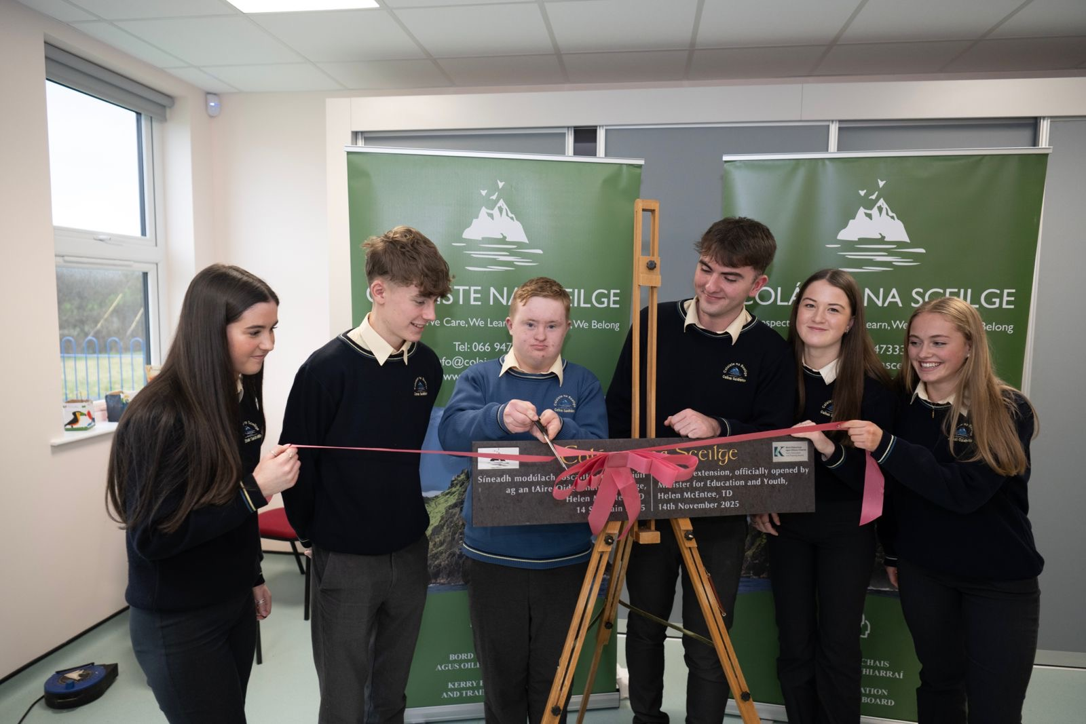
Minister for Education and Youth Helen McEntee officially opens new modular building at Coláiste na Sceilge

Goal 5: Communications, Brand Awareness and Shared Understanding of Kerry ETB
We aim to develop Kerry ETB into a widely recognised brand underpinned by high-quality communications with internal and external stakeholders.
Priority | Action | Target
5 (a) Promote Kerry ETB as the first-choice education and training provider in Kerry. | Promote Further Education and Training as the "first choice" through effective branding and  communications. | The Admissions Office will further expand engagement with Schools, parents, guidance counsellors and external agencies and enhance marketing and promotion strategies to strengthen Kerry College of Further Education and Training as a first-choice option.
5 (a) Promote Kerry ETB  as the first-choice education and training provider in Kerry. | Prioritise informal and formal events to celebrate learner achievements across the organisation. | Continue the annual graduation ceremonies, recognising and celebrating learner and apprenticeship success.  Strengthen marketing and promotional activity to increase positioning of Further Education and Training as the first choice, including enhanced digital campaigns, increased visibility across community and School engagement and with external stakeholders.  Kerry ETB schools will be represented at the BT Young Scientist Competition Q1 2027.  Annual Students Awards ceremony to be held in Q 1, 2026.  Awards ceremonies and graduation events held annually across 4 Youthreach Centre to recognise learner achievements.  Graduation Ceremonies to be scheduled in recognition of learner and apprentice success.
5 (a) Promote Kerry ETB  as the first-choice education and training provider in Kerry. | Commence development of Strategy Statement 2028-2032. | See Communications Plan 2025 – 2027.  Please refer to Appendix 3 for details on this plan.
5 (b) Transition from a  fragmented communications model  to a fully resourced, dedicated Kerry ETB communications function. | Implementation of the  Communications Plan. | See Communications Plan 2025 – 2027  Please refer to Appendix 3 for details on this plan.
5 (c) Adopt and launch a new Kerry ETB brand to enhance awareness and highlight the range of education and training services available to all  learner cohorts. | Build on the launch of the new Kerry ETB brand by increasing its visibility and ensuring consistent use. | See Communications Plan 2025 – 2027  Please refer to Appendix 3 for details on this plan.
5 (d) Enhance communications with internal stakeholders in a structured manner. | Rollout Kollab platform for the organisation. | See ICT Strategy 2023 – 2027  Please refer to Appendix 7 for details on this strategy.
5 (d) Enhance communications with internal stakeholders in a structured manner. | Continue with publication of the  organisation's annual newsletter | See Communications Plan 2025 – 2027  Please refer to Appendix 3 for details on this plan.
5 (e) Enhance communications with external stakeholders in a structured manner. | Ensure effective implementation of the Official Languages (Amendment) Act 2021. | Irish Language Plan developed by Q4
5 (e) Enhance communications with external stakeholders in a structured manner. | Implement a plan aimed at communicating the ETBI Patron's Framework on Ethos to the wider public. | Educational Policy and Development Officer with ETBI will attend a Principal Meeting in Q1 2026 to promote Ethos and the IMBVE patron’s framework.  Social Media campaigns in all Schools to reference our Ethos and Core Values.  Ethos and Core Values to be highlighted during Schools 'events, such as open days and awards.
5 (e) Enhance communications with external stakeholders in a structured manner. | Promote Further Education and Training as the "first choice" through effective branding and communications. | Strengthen marketing and promotional activity to increase positioning of Further Education and Training as the first choice, including enhanced digital campaigns.  Increased visibility across community and School engagement and with external stakeholders.
5 (e) Enhance communications with external stakeholders in a structured manner. | Review and update Kerry ETB Corporate Website. | See Communications Plan 2025 – 2027  Please refer to Appendix 3 for details on this plan.
5 (f) Ensure all Kerry ETB materials publications are widely available,  accessible and understood. | Deliver training in the use of plain language and enhance accessibility of  Kerry ETB website. | See Communications Plan 2025 – 2027  Please refer to Appendix 3 for details on this plan.
5 (f) Ensure all Kerry ETB materials publications are widely available,  accessible and understood. | Implement revised Customer Charter and Action Plan setting out shared commitments to providing accessible services (Disability Act 2005). | See Communications Plan 2025 – 2027  Please refer to Appendix 3 for details on this plan.
5 (g) Maximise opportunities to  communicate our culture and core values across internal and external audiences. | Implementation of the Communications Plan. | See Communications Plan 2025 – 2027  Please refer to Appendix 3 for details on this plan.

Appendix I: Projected Receipts and Expenditure

Projected Receipts and Expenditure
 | Year Ended | Year Ended
 | 31/12/2026 | 31/12/2025
 | (Estimate) | (Pre Audit)
 | Total | Total
RECEIPTS | € | €
Schools & Head Office Grants | €39,773,568 | €38,000,325
Primary School Grants | €59,931 | €113,690
Further Education and Training Grants | €54,794,721 | €51,974,991
Youth Services Grants | €1,807,649 | €1,699,592
Agencies & Self-Financing Projects | €2,641,934 | €3,141,241
Capital | €21,798,973 | €7,476,463
 | €120,876,777 | €102,406,302
PAYMENTS
Schools & Head Office | €40,119,775 | €37,767,403
Primary School | €59,931 | €70,735
Further Education and Training | €55,254,721 | €50,445,878
Youth Services | €1,807,649 | €1,932,899
Agencies & Self-Financing Projects | €3,011,934 | €2,631,453
Capital | €16,218,151 | €13,784,301
 | €116,472,161 | €106,632,669
Cash Surplus / (Deficit) For Period * | €4,404,615 | -€4,226,367
* Note that this figure does not include the opening cash balance of €11,087,636 as of 1st January 2026.

School and Head Office Payments
 | Year Ended 31/12/2026 | Year Ended 31/12/2025
 | (Estimate) | (Pre Audit)
 | Total | Total
 | € | €
PAY
Instruction | €32,367,661 | €29,958,558
Administration | €3,862,305 | €3,411,086
Maintenance | €770,209 | €691,234
 | €37,000,175 | €34,060,878
NON PAY
Non-Pay Expenditure | €2,015,440 | €2,079,227
ASSOCIATED PROGRAMMES
School Services Support Fund | €315,414 | €314,458
DEIS Grant & Home School Liaison (incl. Summer Programme) | €190,000 | €189,492
Book Grant |  | €12,084
Junior Cycle Schoolbooks Grant Incl Admin | €120,000 | €491,943
Senior Cycle Post Primary Schoolbooks Scheme | €50,000 | €236,096
Transition Year Post Primary Schoolbooks Scheme |  | €20,337
Junior Certificate School Programme | €18,648 | €6,267
Transition Year | €32,600 | €35,486
Leaving Cert Applied | €12,720 | €13,623
Traveller Capitation | €7,648 | €13,569
School Attendance Campaign |  | €5,826
Senior Cycle Science (Form. Physics, Chemistry, and Science) | €26,175 | €4,946
ICT Grant | €128,959 | €120,935
DEY approved special needs equipment grant |  | €26,969
Bus Escort Grant |  | €27,982
Mobile Phone Storage Fund | €30,000 | €9,480
Foreign Language Assistant |  | €2,140
Science Implementation Support Grant | €60,000 | €20,512
Gaeltacht Education Funding - Grant for Irish Medium Resources | €25,564
IPB Red Fund | €86,207 | €62,178
Others | €225 | €12,975
 | €1,104,161 | €1,627,298
Primary School
Capitation/Ancillary/ICT/Book Scheme/Standardised Testing | €59,931 | €70,735

Further Education and Training Payments
 | Year Ended 31/12/2026 | Year Ended 31/12/2025
 | (Estimate) | (Pre Audit)
 | Total | Total
Further Education | € | €
Core | €13,610,954 | €12,473,264
Workforce Skills Development/Transformation | €13,805,795 | €13,429,502
FET Pathways | €11,030,944 | €11,295,204
Apprenticeship Funding | €16,785,291 | €13,203,659
Discretionary Funding | €21,737 | €44,249
 | €55,254,721 | €50,445,878
Youth Services Payments
 | Year Ended 31/12/2026 | Year Ended 31/12/2025
 | (Estimate) | (Pre Audit)
 | Total | Total
 | € | €
UBU - Your Place Your Space | €996,822 | €1,062,382
UBU - Resilience and Effectiveness Initiative + Summer Meals | €8,000 | €33,333
Youth Work Services | €175,000 | €148,929
Youth Information | €132,091 | €112,045
Integration Fund (Discontinued) |  | €130,645
Youth Club Grant Scheme | €77,736 | €78,210
Youth Employability Initiative | €60,000 | €65,751
Youth Night | €22,000 | €21,751
Gaeltacht Action Research | €126,000 | €50,000
Creative Youth Programme | €210,000 | €229,853
 | €1,807,649 | €1,932,899

Appendix 2 – Public Sector Duty Action Plan 2026
Public Sector Duty Action Plan 2026
Strategy Statement Reference | Strategy Statement Objective | Action | Target
2b | Promote a culture that is inclusive, non-discriminatory and respectful of human and civic rights. | Continue to raise awareness of the PSD amongst staff | Equity, Diversity and Inclusion working group was established in 2025.  Prepare and publish newsletter for distribution to staff, learners and stakeholders in 2026.
2b | Promote a culture that is inclusive, non-discriminatory and respectful of human and civic rights. | Consult on and prioritise human rights and equality issues through Kerry ETB employment processes. | Roll out organisation‑wide training on the newly developed Dignity at Work Policy, Diversity and Inclusion Policy and Reasonable Accommodation Policy, supported by a 2026 internal poster campaign to raise awareness of staff responsibilities and available supports.
2h | Create opportunities for learners and staff to access equality, diversity and inclusion education and training opportunities. | Rollout targeted training for staff  Including Diversity Awareness, PSD Familiarisation etc. | Provide targeted training informed by the 2026 Diversity & Inclusion Staff Survey and aligned with EDI, PSD and Human Rights objectives.  Deliver an annualised EDI and PSD training schedule from 2026 onwards, informed by survey‑identified training needs, including Diversity Awareness, PSD familiarisation, Reasonable Accommodation guidance and Dignity at Work training.
2b | Promote a culture that is inclusive, non-discriminatory and respectful of human and civic rights. | Rollout Dignity in the Workplace training for staff. | Deliver Dignity in the Workplace training to all staff as part of the 2026–2027 Training and Development Plan, aligned with PSD obligations and supported by survey findings that validate priority training areas.
2h | Create opportunities for learners and staff to access equality, diversity and inclusion education and training opportunities. | Release all admin staff to complete the 3 modules (3 hours total) Public Sector Duty online eLearning course. | Ensure 100% completion of the PSD eLearning modules by administrative staff, monitored quarterly and supported by follow‑up sessions to reinforce PSD understanding and application in work practices.
2h | Create opportunities for learners and staff to access equality, diversity and inclusion education and training opportunities. | Develop a PSD training module for staff | Design and pilot a PSD training module by Q4 2026, informed by PSD responsibilities, EDI survey findings, relevant HR policy updates and training needs identified through organisational feedback channels.
2e | Ensure our structures actively promote inclusion and provide accessible and appropriate support for people with disabilities. | Develop methods/systems to ensure our workforce reflects appropriate disability targets. | Collaborate with the Department of Social Protection and aligned public sector bodies to monitor disability representation, identify recruitment barriers and strengthen inclusive employment pathways.
2d and 2e | Support our learners and staff by strengthening access to and raising awareness of support services  Ensure our structures actively promote inclusion and provide accessible and appropriate support for people with disabilities. | Ensure staff are fully aware of the process for making reasonable accommodation requests, including assistive technologies | Implementation of the finalised Kerry ETB Reasonable Accommodation Policy and Procedure  Strengthen and promote the role of Kerry ETB’s Access Officers as the primary contact points for disability‑related supports. This includes ensuring that staff are aware of the Access Officers’ responsibilities under the Disability Act; that the Reasonable Accommodation Policy is consistently applied; and that queries relating to disability accommodations, assistive technologies and support needs are effectively identified and supported. This will ensure timely responses, clear communication channels and consistent application of disability‑related procedures across the organisation
2d | Support our learners and staff by strengthening access to and raising awareness of support services. | Provide information to staff about support services | Equity, Diversity and Inclusion working group was established in 2025. Build on Equity, Diversity and Inclusion project commenced in 2025.
2c and 2h | Ensure our core values guide the organisation’s behaviours and are the lived experience for all our stakeholders.  Create opportunities for learners and staff to access equality, diversity and inclusion education and training opportunities. | Include PSD as part of all inductions and training programmes | Integrate PSD awareness with all staff, informed by outcomes of the 2026 Diversity & Inclusion Staff Survey, and incorporate identified PSD and equality‑training needs into the 2026–2027 Training and Development Plan.  Strengthen and promote the role of Kerry ETB’s Access Officers as the primary contact points for disability‑related supports. This includes ensuring that staff are aware of the Access Officers’ responsibilities under the Disability Act; that the Reasonable Accommodation Policy is consistently applied; and that queries relating to disability accommodations, assistive technologies and support needs are effectively identified and supported. This will ensure timely responses, clear communication channels and consistent application of disability‑related procedures across the organisation
3b | Create opportunities for closer cross-pillar collaboration to strengthen synergies and promote shared objectives. | Reconstitute the new cross-pillar and cross-grade PSD Steering Group | PSD Steering Group replaced with Equity, Diversity and Inclusion working group established in 2025. Build on Equity, Diversity and Inclusion project commenced in 2025.
2b | Promote a culture that is inclusive, non-discriminatory and respectful of human and civic rights. | Continue to engage with and raise awareness of the Public Sector Equality and Human Rights Duty amongst learners and external stakeholders | Equity, Diversity and Inclusion working group established in 2025 prepare and publish newsletter for distribution to staff, learners and stakeholders.
2e | Ensure our structures actively promote inclusion and provide accessible and appropriate support for people with disabilities. | Continue to raise awareness of disability issues amongst learners and external stakeholders | Build on Equity, Diversity and Inclusion project commenced in 2025.
2d | Support our learners and staff by strengthening access to and raising awareness of support services | Raise awareness of the role of the Kerry ETB Access Officers amongst internal and external stakeholders | Equity, Diversity and Inclusion working group established in 2025 and includes Kerry ETB Access Officers will publish information on the role of the Access Officers.
3d | Achieve excellence in the delivery of support services fully aligned to legislation | Publish publicly core policies and procedures that relate to equality and human rights | Public Sector Duty Assessment and Plan published in accessible format on Kerry ETB website.
3d | Achieve excellence in the delivery of support services fully aligned to legislation | Design and implement a strategic software module dedicated to monitoring PSD implementation. | Ensure that Governance, Compliance and Risk Management Software System is utilised to record progress on implementation of plan.
3d | Achieve excellence in the delivery of support services fully aligned to legislation | Establish a systematic approach for the planned review of organisational policies, procedures, and internal systems | Utilise the Board approved Policy development framework commenced in 2025 to review existing and develop new policies ensuring they are equality proofed and training is provided on each revised/new policy.
2b | Promote a culture that is inclusive, non-discriminatory and respectful of human and civic rights. | Publish Gender Pay Gap 2023 report | Ensure publication of the Gender Pay Gap 2023 Report on the Kerry ETB Website, accompanied by internal communications that promote awareness of findings.
2e | Ensure our structures actively promote inclusion and provide accessible and appropriate support for people with disabilities. | Implement revised Customer Charter and Action Plan setting out shared commitments to providing accessible services  (Disability Act 2005) | Revised and updated Customer Charter 2026 – 2027 to include commitment.
1h | Ensure that the capital and buildings programme is delivered and that all new projects are designed to comply with Departmental guidelines and the highest standards for energy efficiency | Ensure 100% of new builds or upgrades are fully accessible | Continue to implement a structured capital delivery programme that ensures all new building projects progress through design, procurement and construction stages in full alignment with Department of Education and Youth/ DFHERIS guidelines, including Technical Guidance Documents (TGDs) on energy efficiency, sustainability, and nearly‑zero energy building (NZEB) standards (where relevant).
2c | Ensure our core values guide the organisation’s behaviours and are the lived experience for all our stakeholders. | Incorporate discussion about human rights and equality issues at the Board and management meetings. | Quarterly reports by OSD Director to the Board on the progress of the EDI working Group
5a and 5b | Promote Kerry ETB as the first-choice education and training provider in Kerry.  Transition from a fragmented communications model to a fully resourced, dedicated Kerry ETB communications function. | Include the PSD as part of our communications plans | Build on the implementation of the Communications Plan 2026 - 2027
3d | Achieve excellence in the delivery of support services fully aligned to legislation | Include human rights and equality requirements in procurement processes, grants and service level agreements and capital projects | Kerry ETB’s revised Procurement policy will reflect Kerry ETB’s legal requirement to eliminate discrimination and will endeavor to eliminate unintentional disadvantage to any protected group.
2b | Promote a culture that is inclusive, non-discriminatory and respectful of human and civic rights. | Carry out a human rights and equality assessment when drafting or reviewing strategies or plans | Utilise the Board approved Policy development framework commenced in 2025 to review existing and develop new policies ensuring they are equality proofed and training is provided on each revised/new policy.
3e | Establish a dedicated evidence-based research and development function to support decision-making. | Compile a draft Assessment Report with the most up-to-date data and information and publish a new Action Plan (2026-2027) | Diversity and Inclusion staff survey to be undertaken in 2026. Results from survey will inform the basis of the new action plan.
1a | Create high-quality, holistic educations and training environment informed by learners’ voice and actively addressing access for all. | Develop/review of services and programmes to ensure learners' needs and expectations are being met | Continue to address and support equality of outcomes for our students, particularly those from marginalised groups.
5a | Promote Kerry ETB as the first-choice education and training provider in Kerry. | Include across all open days and promotional events/initiatives a focus on Duty and its relevance for prospective and current learners | Continue the annual graduation ceremonies, recognising and celebrating learner and apprenticeship success.
2b | Promote a culture that is inclusive, non-discriminatory and respectful of human and civic rights. | Organise events that celebrate diversity and human rights | All Kerry ETB Schools to achieve yellow flag for inclusion and Belong to Q Mark.
2g | Work to meet the needs arising from the Irish Refugee Protection Programme and provision for international protection applicants | Continue to meet the needs arising from the Irish Refugee Protection Programme* | Proritise REALT support as and when required
1a | Create a high-quality, holistic education and training environment informed by learners' voice and actively addressing access for all. | Continue to roll out the Child Protection Monitoring Plan | Training and Child Protection for BOM in all Schools Q1 2026.
2b | Promote a culture that is inclusive, non-discriminatory and respectful of human and civic rights | Develop a Traveller and Roma Education and Training Policy across Further Education and Training and SYM | The Kerry ETB Traveller education support worker will link with the Traveller peer mentors to improve educational outcomes for Travellers. In addition, Kerry ETB will work closely with the community link workers who have been employed as part of the Travellers and Roma Education Strategy 2024-2030.
1e | Adapt and develop our education and training as new learning approaches and technologies emerge. | Continue to roll out Schools’ and Further Education and Training Universal Design for Learning Plan* | As part of Kerry ETB’s MOU with Mary Immaculate College Limerick Kerry ETB students will be engaging in a Universal Design for Learning research initiative with the working title of Universal Design for Learning and the continuum of support - examining Schools’ practices
1e | Adapt and develop our education and training as new learning approaches and technologies emerge. | Continue to explore how technology can be used to improve the service provided to our learners | Establish a Further Education and Training AI Working Group to develop policy and guidelines for Further Education and Training for use of AI in teaching, learning and assessment for both learners and staff.
2f | Build stronger relationships with other regional agencies to proactively address barriers to inclusion for marginalised individuals or groups. | Develop methods to better evaluate outcomes of learners from identified groups | Continued engagement in the RISE programme (Realising Inclusive Special Education) which has incorporated Provision Mapping.
2e | Ensure our structures actively promote inclusion and provide accessible and appropriate support for people with disabilities. | Establish an access and disability support function. | Continue the work of the Equity, Diversity and Inclusion Working Group established in 2025. This will include defining clear roles for Access Officers in line with statutory obligations, coordinating disability‑related supports across HR and centres, and progressing the EDI project initiated in 2025 to embed consistent, accessible processes for staff and learners with disabilities.
2e | Ensure our structures actively promote inclusion and provide accessible and appropriate support for people with disabilities. | Ensure the www.kerryetb.ie website is accessible to all users | Maintain and build on high accessibility scoring achieved in 2025 (90.27% as per Ireland's Monitoring Report for the EU Web Accessibility Directive 2025)
2b | Promote a culture that is inclusive, non-discriminatory and respectful of human and civic rights. | Achieve yellow flags for inclusion and Belong to Q Mark across all Kerry ETB Schools. | All Kerry ETB Schools to achieve yellow flag for inclusion and Belong to Q Mark
2f | Build stronger relationships with other regional agencies to proactively address barriers to inclusion for marginalised individuals or groups. | Continue the delivery of the ‘Traveller Education Support’ programme/role across Kerry Schools* | The Kerry ETB Traveller education support worker will link with the Traveller peer mentors to improve educational outcomes for Travellers. In addition, Kerry ETB will work closely with the community link workers who have been employed as part of the Travellers and Roma Education Strategy 2024-2030.
2e | Ensure our structures actively promote inclusion and provide accessible and appropriate support for people with disabilities. | Continue to conduct special education needs mapping across all Kerry ETB Schools. | Continued engagement in the RISE programme (Realising Inclusive Special Education) which has incorporated Provision Mapping.
2c | Ensure our core values guide the organisation’s behaviours and are the lived experience for all our stakeholders. d) Support our learners and staff by | Continue to roll out the ETBI Patrons' Framework on Ethos across all Kerry ETB Schools, including the patron’s curriculum* | Two of the three remaining Post Primary Schools have committed to implementing the IMBV in September 2026.
3f | Establish more linkages for the integration of youth services with Schools and Further Education and Training. | Research a model of best practice between Schools and Youthwork | Collaboration between Further Education and Training Managers and School Principals to build on solid practice currently in place.  Work with UCC under MOU to research best practice in Schools/Youth work practice.
3f | Build stronger relationships with other regional agencies to proactively address barriers to inclusion for marginalised individuals or groups. | Culturally appropriate youthwork | Successful development and implementation of the Youth Work Development Plan 2023-2027.
1c and 1d | Provide widely accessible education and training opportunities in a range of areas, including creativity and music.  Provide excellent responsive delivery to support the local and national economy, taking account of local and national labour shortages and delivering programmes to best meet this skills gap. | Continue to roll out targeted Further Education and Training programmes, including Youthreach, Adult Literacy and Basic Education, ESOL/EAL, etc. | Maintain consistent assessment and QA practice through shared templates and a fully digital assessment workflow (submission, marking, IV and EA), and contribute learning from the new Youth Work provision at Kerry College, Killorglin Town Campus into wider programme development discussions.

Appendix 3 – Communications Plan
Communications Plan 2026
Priority | Action | Performance Indicator | Target
(a) Promote Kerry ETB as the first-choice education and training provider in Kerry | Kerry ETB consistently promoted as a first-choice provider in all press releases, social media posts, and sharing of student, learner, and alumni stories. | Establish a structured system within Further Education and Training to collate, filter and queue learner and success stories for use across Kerry ETB communications. | System agreed and operational across Further Education and Training by Q3 2026
 | Promote Further Education and Training as the "first choice" through effective branding and communications. | Identify practical supports (including equipment where appropriate) to enable easier capture of learner stories, subject to SEM approval. | Supports identified and SEM decision recorded by Q4 2026
 |  | Provide training to support the development of a learner-story culture, including clear editorial parameters and submission processes. | At least one training session delivered and guidance issued by Q4 2026
 | Increase applications and engagement through targeted branding and communications strategies. | Plan and deliver a targeted Community National School (CNS) awareness campaign per year, aligned with School open days/enrolment periods, and provide each CNS with a support pack (social media assets, key messages, and guidance) to strengthen local promotion and increase applications. | One CNS campaign delivered annually; support packs issued to 100% of CNSs
 |  | Use learner stories strategically across digital, social and promotional communications to support engagement and encourage applications from priority learner groups. | Learner stories used across channels with activity reviewed annually
 | Prioritise informal and formal events to celebrate learner achievements across the organisation. | Maintain and coordinate existing formal and informal events, including graduations, student awards, Ethos and Culture Days, and organisation-wide events such as ETB Day, to celebrate learner achievement and reinforce Kerry ETB’s role as a first-choice provider. | Existing events delivered annually with communications support
(b) Transition from a fragmented communications model to a fully resourced, dedicated Kerry ETB communications function | Establish an annual communications plan outlining priorities, key messages, target audiences, and timelines. | Draft and publish the 2026 Annual Communications Plan by February 2026, setting out priorities, key messages, target audiences, timelines, and cross-pillar responsibilities, and circulate it across all pillars for implementation. | Communications Plan published and circulated by February 2026
 | Allocate resources to strengthen communications capacity, | Seek SEM agreement that SYM and Further Education and Training each nominate a responsible person to maintain accurate staff directory information for their areas that can be shared and kept up to date as an online document. | SEM agreement recorded and nominees identified by Q2 2026
 | Allocate resources to strengthen communications capacity, | A Kerry ETB-wide calendar was developed and issued to Senior Management and Heads of Department in January 2024 but was not used. Undertake a short review to identify barriers to use and gather feedback on how the calendar would need to function to meet user needs before considering any further development. | Review completed and findings reported to SEM by Q3 2026
 | Implement and monitor the Communications Plan. | Implement and monitor the Communications Plan through the Communications Cross-Departmental Implementation Group, using structured updates from each pillar to coordinate activity, track progress and identify issues requiring escalation. | Structured updates provided at all quarterly meetings.
(c) Adopt and launch a new Kerry ETB brand to enhance awareness and highlight the range of education and training services available to all learner cohorts | Build on the launch of the new Kerry ETB brand by increasing its visibility and ensuring consistent use. | Develop a set of easy-to-use branded templates (posters, letters, certificates, PowerPoint, and social media graphics) by Q4 2025, along with short “how to use” training videos to help staff apply them correctly. | Templates and videos available by Q4 2025
 | Simplify the consistent use of the Kerry ETB logo by providing pre-approved templates for commonly used materials, ensuring compliance with branding guidelines without requiring extensive training or monitoring. | Support consistent use of the Kerry ETB brand by providing pre-approved Canva templates for commonly used materials and delivering targeted training to help staff apply branding guidelines confidently and correctly. | Canva templates in use and training delivered by Q2 2026
 | Implement an annual sampling review process to assess the integration and compliance of the Kerry ETB logo and branding guidelines across all digital platforms, printed materials, branded items, and the website. This will ensure consistent application, reinforce brand identity, and enhance professionalism in all Kerry ETB communications. | Carry out one annual “brand sampling review” across a pillar (covering a small sample of signage, social media posts, printed materials and templates) | One sampling review completed annually
(d) Enhance communications with internal stakeholders in a structured manner | Publication of the organisation's annual newsletter to provide key updates and promote transparency. | Publish the 2025 internal newsletter in Q2, and issue clear guidelines for the development and content of the 2026 newsletter by Q4 to support regular and consistent internal communication across Kerry ETB. | 2025 internal newsletter published by end Q2 2026; written guidelines for 2026 newsletter issued, approved and shared with all pillars by end Q4 2026.
 | Implementation of the Communications Plan. | At each meeting, the Cross-Pillar Group highlights: Examples of what’s working well across pillars and any shared challenges emerging for internal communications. | Item included as a standing agenda item at 100% of Communications Cross-Departmental Implementation Group meetings, with examples recorded in meeting notes.
 | Implementation of Policy Priority Register. | Build on the framework commenced in 2025 to review existing and develop new policies ensuring they are prioritised in terms of importance (high, medium or low), equality proofed, circulated for feedback as appropriate and training is provided on each revised/new policy. | Policy Priority Register reviewed annually, with priorities agreed and updates reported to SEM at least once per year.
 | Scheduled sharing of communications policies, procedures, and branding guidelines to ensure clarity, consistency, and compliance across the organisation. | Create a simple annual schedule for sharing communications policies, procedures, and branding guidelines | Annual schedule agreed and published, with scheduled items issued in line with the timetable and tracked annually.
 | Creation and implementation of a Writing in Plain English Policy to enhance clarity, accessibility, and consistency in all communications across Kerry ETB. | Progress the development and phased implementation of a Writing in Plain English Policy, supported by an in-house staff member trained in Plain English through SOLAS funding, to enable the structured roll-out of training and the use of high-visibility examples to embed good practice across Kerry ETB. | Policy approved by SEM and phased rollout of training commenced by end Q4 2026.
 | Update the Areas of Responsibility – Official Names Register to ensure accuracy, consistency, and alignment with current organisational structures, roles, and responsibilities across Kerry ETB. This will involve a comprehensive review, verification of official titles, and communication of updates to all relevant stakeholders. | The Official Names Register is a register of the correct names of all Kerry ETB Schools, Campuses and Centres. Continued monitoring will continue through 2026 to ensure that it remains up to date. | Register reviewed and confirmed as accurate at least once annually in 2026.
 | Maintain the Head Office Directory as an up-to-date and accurate resource throughout the year by implementing a structured review and update process. This will involve regular verification of staff details, Departmental allocations, and contact information to ensure all internal stakeholders have access to the most current information. | Undertake a full review of the Head Office Directory, including verification of staff details and updated staff photographs by Department, and maintain the directory on a dedicated tile on the Kollab OSD page. As part of induction, IT will notify the nominated staff member responsible so photographs can be taken as part of the staff member’s induction. | Full directory review completed by end Q3 2026, with ongoing updates embedded through induction and staff change processes.
 | Update the Email Policy to reflect current best practices, organisational needs, and compliance requirements. The revised policy will ensure clarity on appropriate email usage, etiquette, security, and data protection, aligning with Kerry ETB’s communication standards. | Update the Email Policy in collaboration with relevant stakeholders to ensure it reflects current best practice, organisational requirements and ISMS controls, and provides clear guidance on email usage, etiquette, security and data protection. | Revised Email Policy approved by SEM and communicated to all staff by end Q4 2026.
 | Establish cross-departmental implementation groups to support the roll-out and integration of key organisational plans including the Public Sector Duty plan, Communications plan, etc. | The established cross-departmental implementation groups must provide regular structured presentation updates to Senior Executive Management as the formal route for progressing actions and seeking approval. | Structured updates provided to SEM from each group in line with agreed reporting cycles.
 | Two senior leadership in-service events, based on the adaptive leadership approach. | Hold two senior leadership in-service events, in March and August 2026, using the adaptive leadership approach to support shared understanding, consistent leadership behaviours and effective organisational communication. | Both in-service events delivered as scheduled in March and August 2026.
 | Promote inclusive communication practices across all staff grades. | Use Kollab as the central platform for internal communications, and ensure all Departments, Schools and Centres are informed and supported to submit news items by emailing news@kerryETB.ie with “Kollab news” in the subject line. | All Departments, Schools and Centres informed of Kollab submission process by end Q2 2026.
 |  | Conduct a short survey of staff and students who have access to Kollab to assess levels of use, ease of access, information needs and whether the platform supports them to feel informed and use the findings to inform improvements to internal communications via Kollab. | Survey completed, analysed and key findings reported to the Communications Cross-Departmental Implementation Group by end Q2 2026.
 |  | Use findings from EDI staff surveys and engagement activities to inform improvements to internal communications practices and ensure they support inclusion across all staff grades. | EDI staff survey findings reviewed following publication, with agreed communications-related improvements identified and progressed as appropriate
 | Develop a structure to facilitate shared understanding across the organisation’s three pillar | The Communications Cross-Departmental Implementation Group, to meet Quarterly, as the structured forum to support shared understanding and coordination across the organisation’s three pillars. | Quarterly meetings held, with agreed actions and updates from each pillar recorded and fed back into ViClarity following each meeting
(e) Enhance communications with external stakeholders in a structured manner | Implement a plan aimed at communicating the ETBI Patron's Framework on Ethos to the wider public. | Develop our School communities understanding of our Ethos and make it more visual in our Schools. | Visual Ethos developed and made available for use in Schools.
 | Ensure effective implementation of the Official Languages (Amendment) Act 2021. | Support the effective implementation of the Official Languages (Amendment) Act 2021 by ensuring that advertising activity, including recruitment and admissions-related advertising, is planned and delivered in line with statutory Irish language requirements, in collaboration with Admissions and HR. | Irish Language advertising activity continues to be planned and delivered in line with statutory Irish language requirements, with budgets allocated and advertisements placed by the Admissions Office and HR, in coordination with Communications.
 | Complete the annual reporting process to ensure Kerry ETB's compliance with the Official Languages (Amendment) Act 2021, in relation to advertising requirements. This will involve compiling data on all advertising activities and submitting a compliance report to The Office of An Coimisinéir Teanga through their portal. | Support the completion of the annual advertising compliance reporting process required under the Official Languages (Amendment) Act 2021, based on Head Office data submitted through the Office of An Coimisinéir Teanga portal. | Annual advertising compliance report supported and submitted within statutory timelines.
 | Ensure all communications activities are planned and delivered in line with the principles of the Public Sector Duty, promoting equality, preventing discrimination, and protecting human rights in all interactions. | Use the Kerry PPN Community Newsletter as a structured channel to share inclusive, accessible Kerry ETB information with community and equality-focused groups, and ensure all Centres, Departments and Schools are aware of this channel and supported through clear guidance or training on how to submit content that reflects Public Sector Duty principles. | PPN Community Newsletter used as an established channel for inclusive communications, with guidance issued to Centres, Departments and Schools on how to submit appropriate content.
 |  | Support the delivery of Public Sector Duty commitments through the ongoing work of the Equality, Diversity and Inclusion (EDI) Action Group, including Quarterly meetings, staff surveys and engagement activities, and progression from Bronze to Silver accreditation. | EDI Action Group activities continue as planned, with progress on Public Sector Duty commitments supported and monitored through agreed EDI processes.
(f) Ensure all Kerry ETB materials publications are widely available, accessible and understood | Deliver training in the use of plain language, accessible format and enhance the accessibility of all Kerry ETB content. | Provide an annual short, practical training sessions each year (online or in-person) on using plain language and creating accessible documents. | At least one short, practical training session delivered in 2026, with attendance recorded.
 | Engage with relevant stakeholders and learners to ensure the ETB's services are accessible. | Include signage considerations within future communications accessibility reviews. | Signage considerations included as a standard element in all future communications accessibility reviews.
 |  | Ensure accessibility requirements are reflected in communications policies and future reviews. | Accessibility requirements referenced in all new or revised communications policies and considered during scheduled policy reviews.
 | Develop and implement an Inclusive Communication Policy that aligns with Universal Design for Learning Principles to ensure that all Kerry ETB materials, including digital content, printed resources, and multimedia materials, are fully accessible to everyone including individuals with disabilities, people with diverse literacy levels and anyone who may benefit from alternative formats or supports. | Develop and implement an Inclusive Communication Policy grounded in Universal Design for Learning principles, ensuring a shared organisational understanding of inclusive communication through AHEAD training (Universal Design for Learning Badge and “Beyond the Classroom” modules) for policy makers, senior and middle management, and embedding clear, actionable guidelines on language, formatting, accessibility, and alternative formats across all Kerry ETB communications. | Inclusive Communication Policy approved and implementation commenced, with AHEAD training offered to relevant staff groups.
 |  | Recognising that different stakeholders within Kerry ETB (may interpret inclusive communication differently) it is essential to ensure a shared understanding across all levels of the organisation. All staff, particularly policy makers, senior and middle management, should participate in AHEAD training, including the Universal Design for Learning Badge and "Beyond the Classroom" modules, to build capacity and embed Universal Design for Learning principles into practice.  An Inclusive Communication Policy should be developed and implemented, grounded in Universal Design for Learning’s core principles of multiple means of representation, engagement, and expression. This policy must include clear, actionable guidelines on language use, formatting, accessibility standards, plain English, and the provision of alternative formats. All elements should align with the ETBI Universal Design for Learning Guidance for Further Education and Training. | AHEAD training promoted and made available to policy makers, senior and middle management, with participation tracked.
 | Conduct an annual accessibility Audit of Kerry ETB communication materials, ensuring compliance with best practices and legal requirements such as WCAG 2.1 guidelines. | Sustain 90%+ WCAG Accessibility Through Ongoing Periodic Review | Regular accessibility Audit completed, with WCAG compliance maintained at 90% or above.
 | Provide training for staff on creating accessible and inclusive communication materials, equipping them with the necessary knowledge and tools to make materials more user-friendly and universally understood. | Provide practical training to staff on creating accessible and inclusive communication materials. The Technology Enhanced Learning Officer and Communications Officer will deliver training across all Departments and organisational pillars to support the use of plain English, inclusive design, and accessibility standards in all communications. | At least one cycle of practical accessibility training delivered in 2026 across Departments and organisational pillars.
(g) Maximise opportunities to communicate our culture and core values across internal and external audiences | Implementation of the Communications Plan. | At each meeting, the Cross-Pillar Group that highlights: Examples of what’s working well across pillars with the communication of our culture and core values across internal and external audiences | Examples of effective communication of culture and core values shared and recorded at each Cross-Pillar Group meeting.
 | Develop a new Customer Charter for 2026–2029 to reflect updated organisational priorities, stakeholder needs, and service commitments. | Finalise the draft Customer Charter and bring it forward for approval in Q1 2026, ensuring it reflects updated organisational priorities, stakeholder needs, and service commitments. | Draft Customer Charter finalised and submitted for approval by end Q1 2026.
 |  | Create clear, accessible visual communications to support the internal and external rollout of the Customer Charter, ensuring it is easily understood and consistently communicated across all channels. | Visual and accessible communications materials developed and made available to support internal and external rollout following approval of the Customer Charter.
(h) Support management and staff to become key communicators | Continue the rollout of Email Etiquette Policy training across all Kerry ETB Schools and Centres to ensure consistent, professional, and effective email communication aligned with organisational standards. | Continue the rollout of Email Etiquette Policy training across all Kerry ETB Schools and Centres, with regular progress and completion updates provided to Senior Executive Management. | Email Etiquette Policy training continued rollout, with progress and completion updates provided to Senior Executive Management at agreed intervals.
(h) Support management and staff to become key communicators | Roll out required communications training across all pillars of the organisation to enhance staff capability, consistency, and effectiveness in internal and external communications. | Support staff across when required through appropriate communications training and guidance, including social media, design tools and PR, to enhance the effectiveness of communications activity. | Communications training and guidance provided as required across all pillars, with delivery aligned to identified needs and available capacity.

Appendix 4 – Corporate Procurement Plan 2025 - 2027
Corporate Procurement Plan 2025 - 2027
Key Performance Indicator | Action required | Key Performance Indicator Measurement
Review of 2023 Procurement Policy and Procedure | Review and Draft Procurement Policy and procedures | New Procurement Policy approved and implemented by December 2026
Review of 2023 Procurement Policy and Procedure | On Approval role out training and awareness of policy and changes | All relevant staff have attended a briefing on the new Procurement Policy
The continued development and implementation of the centralised procurement and purchasing model | Prepare a Standard Operating Procedure for CPPU Staff | SOP are formalised and available to relevant staff
 | Review of staffing requirements to ensure priorities will be achieved | Review of the Centralised Function completed every 12 months to include staffing
 | Continue training and awareness of Central procurement and Purchasing function to Kerry ETB Staff | A process or active recording of training and awareness communication issued by Procurement Officer is implemented to monitor receipt of Training/ briefings
 | Awareness campaign for existing and new suppliers on function of CPPU | Increased communication with suppliers and creation of a data base of goods/ service provided by suppliers
Increase utilisation of OGP frameworks/contracts and continue reduction in the purchase of goods/services outside of identified framework/ contracts to those approved in exceptional circumstances | Monitor OGP, Review and recommend to Kerry ETB management suitable Frameworks/ Arrangements as they arise. | All Relevant Frameworks are bought to the attention of Kerry ETB Management.
 | Utilise all relevant frameworks | Where identified as suitable Frameworks are formally entered in to.
 | Informing the Budget Holders of the goods and services provided in the frameworks | All relevant information is available on Kollab.
 | Provide the centralised procurement and purchasing staff with clear guidelines on the use of the frameworks | Briefing notes are developed when Frameworks are entered into.
 | Frameworks for commonly purchased goods/services to be activated | Where identified as suitable Frameworks are formally entered in to.
 | Implement Continue Improvement tool to highlight all purchases outside activated frameworks/contracts to Budget Holders/Relevant Directors | SOP developed on identifying and recording instances of purchases outside of framework and implementation in to Continuous Improvement tool.
 | Implement a process to record approval to purchase outside of frameworks in exceptional circumstances | SOP developed to record approval to purchase outside of frameworks in exceptional circumstances
Learning and Development Plan implemented | A Learning and Development Plan to be drafted to include
Learning and Development Plan implemented | Development of procurement staff | A process or active recording of training and awareness communication issued by Procurement Officer is implemented to monitor receipt of Training/ briefings
Learning and Development Plan implemented | Raising awareness of Budget Holders and Requestors
Learning and Development Plan implemented | Informal learning and standardisation of good practice will continue to be supported by regular, scheduled joint meetings of procurement and accounts payable staff.
Training/ Awareness for non-procurement Staff | Roll out revision training to existing Budget Holders, Budget Administrators, P2P administrators on P2P
Training/ Awareness for non-procurement Staff | Centralised Procurement and Purchasing Function | A process or active recording of training and awareness communication issued by Procurement Officer is implemented to monitor receipt of Training/ briefings
Training/ Awareness for non-procurement Staff | Completing a Request to Purchase
Training/ Awareness for non-procurement Staff | Specification of Goods/ Service required
Training/ Awareness for non-procurement Staff | Process on P2P
Training/ Awareness for non-procurement Staff | Post Procurement Contract management
Training/ Awareness for non-procurement Staff | Delivers
Training/ Awareness for non-procurement Staff | Resolving issues
Training/ Awareness for non-procurement Staff | Record keeping and feedback
Reduction in low value/ high volume as required purchases | Continue to determine the scope of low value/high volume procurement and purchasing competitions and analysis suitable for single procurement competition such as DPS, Single Supplier Framework or Multi Supplier Framework | Quarterly Expenditure Analysis is carried out by the Procurement Officer
Reduction in low value/ high volume as required purchases | Continue to engage with relevant budget holders on planning procurement to avoid high volume of individual procurement and purchasing competitions. | SOP development on process to engage with Budget holders
Reduction in low value/ high volume as required purchases | Continue to develop a planned approach to purchasing, to allow for single procurement competition with bulk purchases | Corporate procurement Plan reviewed and amended
Continue to improve communication and information available to staff involved in procurement | Continue to leverage the benefits of the centralised procurement and purchasing model to ensure all staff engaged in procurement have full and relevant information | Increase in compliance and reduction of non-compliant procurement.
 | Produce regular updates for Budget Holders to promote compliance and address issues
Prioritise Completion of the following Procurement Competitions | Kerry ETB will undertake a number of procurement competitions during the period of this plan to ensure continued compliance with public procurement regulations and national guidelines. These competitions will be carried out in a structured and transparent manner, aligned with approved frameworks and internal procurement policies. This approach supports good governance, value for money, and consistent compliance across all procurement activity.
Implementation of an online based Contract Management System | Research and compile a comprehensive list of all contracts in place (including SLAs)
Implementation of an online based Contract Management System | Set up templates based on contract requirements and diarise review of existing contracts as required

Appendix 5 – Training and Development Plan 2026 -2027

Training and Development Plan 2026 -2027
Strategy Statement Goal | Strategy Statement Objective | Objective (Priority SS) | Action/Service Plan 2026 | Target
Goal 1- Excellence in Education and Training Services | 1(a)(iii) | Create a high-quality, holistic education and training environment informed by learners' voice and actively addressing access for all. | We will strengthen organisational capability by formalising and expanding our management and staff mentoring supports and establishing a structured, organisation wide- mentoring framework. | Consistent mentoring framework in place across the organisation, leading to strengthened leadership capability and improved staff development support.
Goal 1- Excellence in Education and Training Services | 1(f) | Design and deliver a career development programme for staff | Draft Training and Development Plan to be reviewed by Senior Executive Management and Board in Quarter 1 2026. | Training and Development Plan formally reviewed and endorsed, ensuring clear organisational priorities for staff development.
Goal 1- Excellence in Education and Training Services | 1(f) | Design and deliver a career development programme for staff | Kerry ETB will continue to implement the Continuous Professional Development Policy and Procedure – NFQ Levels 6-9. | Staff supported to undertake accredited CPD programmes, resulting in enhanced qualifications and professional capability across the organisation.
Goal 1- Excellence in Education and Training Services | 1(f)(iii) | Design and deliver a career development programme for staff | We will continue to position adaptive leadership principles as the foundation of our biannual leadership events with an emphasis on People Leadership. | Leadership events delivered with a strong adaptive leadership focus, increasing leadership confidence and capability across all teams.
Goal 2 - Strong, Inclusive and Respectful Organisational Culture | 2(c)(iii) | Ensure our core values guide the organisation’s behaviours and are the lived experience for all our stakeholders | We will review and enhance the current induction process to expand the use of mentors and ensure stronger support for staff transitioning into new roles, not just new appointees. This will include incorporating the Learning Platform to deliver training on high priority policies, ensuring consistent, accessible, and role relevant onboarding experiences across the organisation. --relevant onboarding experiences across the organisation. | Improved onboarding process in operation, providing consistent, accessible and role relevant onboarding for all new and transitioning staff. -relevant onboarding for all new and transitioning staff.
Goal 2 - Strong, Inclusive and Respectful Organisational Culture | 2(f)(i) | Build stronger relationships with other regional agencies to proactively address barriers to inclusion for marginalised individuals or groups | We will embed the Dignity and Respect at Work Policy by delivering a comprehensive training programme for all managers. | Managers trained in policy requirements, resulting in consistent practice and strengthened organisational culture and climate.
Goal 2 - Strong, Inclusive and Respectful Organisational Culture | 2(h) | Build stronger relationships with other regional agencies to proactively address barriers to inclusion for marginalised individuals or groups | With the support of the Irish Centre for Diversity we will develop and implement an Action Plan in response to the Silver Assessment accreditation survey, incorporating required PSD actions and the delivery of the necessary training to support implementation. | Action Plan implemented with required PSD actions embedded, strengthening organisational culture and inclusive practice.
Goal 3 - Opportunities for Greater Organisational Synergies | 3(c)(i) | Ensure greater integration of management and staff teams across the organisation | We will continue to embed adaptive leadership principles in our Spring and late Summer leadership events, with a particular focus on People Leadership, supported by additional targeted sessions to strengthen leadership capability across all teams. | Leadership events delivered with increased focus on People Leadership, reinforcing adaptive leadership practice across all teams.
Goal 3 - Opportunities for Greater Organisational Synergies | 3(c)(ii) | Ensure greater integration of management and staff teams across the organisation | Schools, Youth & Music and Further Education & Training Pillar event to be held in 2026? | Pillar event successfully delivered, supporting collaboration, information sharing and organisational cohesion. -
Goal 4 - A Leader in Education and Training Services | 4(e)(iii) | Establish a dedicated evidence based research and development function  to support decision making | In 2026, Climate Action Training will be delivered through a range of channels: - E-Learning (i) Energy in Education courses for Schools and FET, (ii) Training opportunities from the Irish Sustainable Schools Network, (iii) Online learning through the SEAI Energy Academy/ Energy Link, (iv) Green Public Procurement. In-Person Kerry College programmes such as the QQI Level 4 Environmental Sustainability Awareness and QQI Level 5 Environmental Sustainability in the Workplace. | Staff and learners engaged in climate action focused training, contributing to increased environmental awareness and sustainable practice. --focused training, contributing to increased environmental awareness and sustainable practice.
Goal 5 - Communications, Brand Awareness and Shared Understanding of Kerry ETB | 5(h)(i) | Support management and staff to become key communicators | Communications Officer will continue to provide training to Leadership and Management Post holders, with responsibility for Public Relations in their respective Schools. | Improved PR capability in schools, resulting in more consistent, effective communication.
Goal 5 - Communications, Brand Awareness and Shared Understanding of Kerry ETB | 5(g)(ii) | Maximise opportunities to communicate our culture and core values across internal and external audiences. | With guidance from the Irish Centre for Diversity, we will use the findings of the Silver Assessment accreditation survey to drive organisation wide cultural development, creating a focused Action Plan and delivering training that strengthens shared values, behaviours, and commitment to an inclusive culture.-wide cultural development, creating a focused Action Plan and delivering training that strengthens shared values, behaviours, and commitment to an inclusive culture. | Cultural development initiatives implemented, strengthening shared values and inclusive behaviours.
Goal 1- Excellence in Education and Training Services | 1(f) | Design and deliver a career development programme for staff | Provide online AI awareness and literacy training to all ETB staff and Board members. | AI literacy improved across the organisation, supporting compliance with the EU AI Act and safe, responsible AI use.
Goal 1- Excellence in Education and Training Services | 1(f) | Design and deliver a career development programme for staff | Promote and support organisation wide uptake of Microsoft Copilot recorded training. | Increased staff confidence and competence in using approved AI tools, enhancing productivity and responsible practice.
Goal 3 - Opportunities for Greater Organisational Synergies;  Goal 5 - Communications, Brand Awareness and Shared Understanding of Kerry ETB | 3(d)  5(h) | Achieve excellence in the Delivery of Support Services fully aligned to the legislation.  Support management and staff to become key communicators; | Deliver Evidential Based Writing Skills Training. | Improved quality, clarity and consistency in organisational reporting and written outputs.
Goal 3 - Opportunities for Greater Organisational Synergies | 3(d) | Achieve excellence in the Delivery of Support Services fully aligned to the legislation. | Fixed Asset Management Training. | Staff equipped to manage asset processes correctly, ensuring compliance with policy and accurate asset control.
Goal 1- Excellence in Education and Training Services | 1(f) | Design and deliver a career development programme for staff | Deliver ICDL Computer Essentials programme. | Staff digital literacy strengthened, supporting effective and confident use of core IT tools.
Goal 1- Excellence in Education and Training Services | 1(f) | Design and deliver a career development programme for staff | Excel Training - delivered by the Business Support Unit. This training will support staff in developing practical spreadsheet skills, improving data handling, reporting, and efficiency in day-to-day work. --day work. | Staff demonstrate improved spreadsheet skills, supporting accurate data handling and reporting.
Goal 1- Excellence in Education and Training Services | 1(f) | Design and deliver a career development programme for staff | Data Protection training for the data protection team. | Enhanced oversight, compliance and risk management within data protection functions.
Goal 1- Excellence in Education and Training Services | 1(f) | Design and deliver a career development programme for staff | Data Security and Cybersecurity training for the DPO. | Strengthened awareness of cyber risks and data security responsibilities, improving organisational security posture.
Goal 1- Excellence in Education and Training Services | 1(f) | Design and deliver a career development programme for staff | IPM Level 8 Project Management training for Erasmus Officer. | Improved project management capability supporting effective delivery and governance of EU projects.
Goal 1- Excellence in Education and Training Services | 1(f) | Design and deliver a career development programme for staff | Train the Trainer - this training for the Procurement Officer | Inhouse training capability enhanced, enabling effective internal knowledge sharing. -house training capability enhanced, enabling effective internal knowledge sharing.
Goal 1- Excellence in Education and Training Services | 1(f) | Design and deliver a career development programme for staff | Procurement Refresher Training. | Improved compliance with procurement policy and legislation, reducing organisational risk.
Goal 1- Excellence in Education and Training Services | 1(f) | Design and deliver a career development programme for staff | Additional procurement training facilitated by ETBI. | Staff supported to meet emerging procurement needs with up to date knowledge and skills. --date knowledge and skills.
Goal 3 - Opportunities for Greater Organisational Synergies | 3(d) | Achieve excellence in the Delivery of Support Services fully aligned to the legislation. | Protected Disclosure training for Senior Managers. | Strengthened governance and statutory compliance in handling protected disclosures.
Goal 3 - Opportunities for Greater Organisational Synergies | 3(d) | Achieve excellence in the Delivery of Support Services fully aligned to the legislation. | Risk Management Training for Board Members and S45 Committees. | Greater understanding of risk oversight responsibilities, supporting robust governance and informed decision making. -
Goal 3 - Opportunities for Greater Organisational Synergies | 3(d) | Achieve excellence in the Delivery of Support Services fully aligned to the legislation. | Refresher training for Kerry ETB Board. | Board governance capability reinforced, supporting effective oversight aligned with best practice.
Goal 3 - Opportunities for Greater Organisational Synergies | 3(d) | Achieve excellence in the Delivery of Support Services fully aligned to the legislation. | Ongoing communications training provided to post holders to enable them to consistently and effectively communication Kerry ETB's values and key messages supporting clear internal and external engagement. | Consistent and effective communication of Kerry ETB values and messages.
Goal 3 - Opportunities for Greater Organisational Synergies | 3(d) | Achieve excellence in the Delivery of Support Services fully aligned to the legislation. | Pensions Training. | Improved accuracy and continuity in delivery of pension services.
Goal 3 - Opportunities for Greater Organisational Synergies | 3(d) | Achieve excellence in the Delivery of Support Services fully aligned to the legislation. | Fixed Asset System Training for Finance staff. | Finance staff proficient in system use, supporting accurate financial and asset management.
Goal 2 - Strong, Inclusive and Respectful Organisational Culture | 2(e) | Ensure our structures actively promote inclusion and provide accessible and appropriate support for people with disabilities. | Website accessibility training. | Kerry ETB website maintained in line with accessibility standards, promoting inclusive access.
Goal 2 - Strong, Inclusive and Respectful Organisational Culture | 2(e) | Ensure our structures actively promote inclusion and provide accessible and appropriate support for people with disabilities. | Roll out training for Dignity & Respect and Reasonable Accommodation Policies (Phase 1). | Managers equipped to manage conflict, promote respectful workplaces and fulfil reasonable accommodation obligations.
Goal 3 - Opportunities for Greater Organisational Synergies | 3(d) | Achieve excellence in the Delivery of Support Services fully aligned to the legislation. | Cyber Security Training - Continue mandatory, role appropriate cyber security awareness training. | Staff cyber awareness strengthened, reducing organisational risk and supporting compliance with security standards.
Goal 4 - A Leader in Education and Training Provision | 4(b) | Promote Kerry ETB as key regional employer to prospective job applicants, positioning us as an organisation of choice. | Recruitment Training: If approval is granted to procure a recruitment package, we will proceed with delivering the required training. | Staff competent in the use of the new recruitment package, supporting efficient and compliant processes.
Goal 1- Excellence in Education and Training Services | 1(f)(ix) | Design and deliver a career development programme for staff | Encourage attendance at professional training including education conferences. | Management and teachers equipped with current professional knowledge and best practice insights.
Goal 2 - Strong, Inclusive and Respectful Organisational Culture | 2(c)(iii) | Ensure our core values guide the organisation’s behaviours and are the lived experience for all our stakeholders | Induction for new teaching staff and SNAs in August | New staff supported to integrate successfully into their roles and school environments.
Goal 1- Excellence in Education and Training Services | 1(f)(ix) | Design and deliver a career development programme for staff | New managers receive additional training with the Heads of Departments | New managers equipped with essential leadership and management skills.
Goal 1- Excellence in Education and Training Services | 1(f)(ix) | Design and deliver a career development programme for staff | Principals and Deputy Principals meet three times a year with additional monthly meetings for Principals | School leaders supported through structured engagement, enhancing collaboration and leadership consistency.
Goal 1- Excellence in Education and Training Services | 1(f)(ix) | Design and deliver a career development programme for staff | Middle management training offered to future leaders. | Pipeline of future leaders strengthened through structured development opportunities.
Goal 1- Excellence in Education and Training Services | 1(f)(ix) | Design and deliver a career development programme for staff | Teachers are encouraged to attend middle leadership training with ETBI each July. Progression to professional graduate courses to education development at Mary I this is encouraged and financially supported (MOU with Mary Immaculate supports post graduate courses) | Teacher leadership capacity and professional qualifications enhanced.
Goal 1- Excellence in Education and Training Services | 1(f)(ix) | Design and deliver a career development programme for staff | Communities of Practice (COPs) for subjects and strategies such as UDL and RISE. | Improved collaboration, shared practice and curriculum alignment across teaching teams.
Goal 2 - Strong, Inclusive and Respectful Organisational Culture | 2(e) | Ensure our structures actively promote inclusion and provide accessible and appropriate support for people with disabilities. | To embed the newly revised, nationally agreed Policy for the Prevention and Resolution of Sexual Harassment and Harassment at Work, Training will be provided by ETBI in person to CEO, Directorate, HR and Deputy HR Manager, Contact Persons in early 2026. Training will then be rolled out to Line Managers online in Q1 2026. Communication to be issued to Line Managers prior to the Training from Directorate highlighting the importance of this training. HR Department to roll out training to all staff by end of 2026. | Managers and Staff will be provided with the knowledge, confidence, and skills to recognise inappropriate behaviour, respond appropriately, and promote a safe, inclusive, and respectful workplace, with strengthened staff awareness of their rights, responsibilities, and available supports under the National Policy.

Appendix 6 – Customer Charter Action Plan 2026 - 2027

Customer Charter Action Plan
Kerry ETB is committed to the 12 Guiding Principles of Quality Customer Service.
Our Commitments to the Guiding Principles
Principle | Our Commitment
1. Quality Service Standards | We publish clear information on the nature and quality of our customer service. The Kerry ETB Customer Charter and Action Plan, and the Kerry ETB Complaints Procedure are available on our website (www.kerryetb.ie) and are updated as needed.
2. Equality and Diversity | We strive to ensure equal treatment for everyone and value diversity. We will remove barriers that prevent people from accessing our services. We will:  - Make an effort to build a workforce that reflects the communities we serve.  - Maintain a strong focus on equality, diversity and inclusion (ED&I).  - Treat all customers fairly and respectfully, in line with equality legislation (gender, civil or family status, sexual orientation, religion, age, disability, race, and membership of the Traveller community).
3. Physical Access | Kerry ETB has 3 access officers across the organisation to assist anyone who may have access difficulties. Individual details are available on the Kerry ETB website or alternatively you can email accessofficer@kerryetb.ie  We commit to providing clean, safe and accessible offices that ensure privacy and meet health and safety standards. We will:  - Maintain accessibility for people with disabilities and others with specific needs.  - Direct access queries to our Access Officer (see contact details on www.kerryetb.ie).  - Comply fully with Health and Safety legislation.
4. Information | We make sure information is clear, accurate, timely and accessible. We will:  - Publish information on our website in accessible formats.  - Ensure our website meets WCAG 2.1 AA.  - Use technology to make information easy to find and understand.  - Simplify forms, leaflets and procedures where possible.
5. Timeliness and Courtesy | We deliver services with courtesy, sensitivity and efficiency. We will:  - Treat everyone with respect and deal with enquiries promptly.  - Ensure staff identify by name when answering calls.  - Keep voicemail messages up to date and return messages in line with our Customer Charter. Staff voicemails must be in both Irish and English in line with the Irish Language Act.  - Include contact details on all correspondence.
6. Complaints | We operate a clear, accessible and fair complaints system.  We will:  - Acknowledge complaints within 5 working days.  - Investigate and reply within 20 working days.  - Handle all complaints promptly, fairly, impartially and in confidence.  - Keep complaint records separate from other records.  - Ensure that complaints made in good faith will not affect your future dealings with Kerry ETB.  - Use complaints and feedback to identify trends and improve our services.  - Publish and promote our Complaints Procedure on the Kerry ETB website.
7. Appeals | We provide a simple and transparent appeals process for customers who are dissatisfied with decisions. We will:  - Explain how to appeal in our Complaints Procedure.
8. Consultation and Evaluation | We consult customers and partners to improve our services. We will:  - Encourage feedback via customerservice@kerryetb.ie.
9. Choice | We provide choice in how you access our services. We will:  - Offer flexible options for payment, contact points and service delivery.  - Use modern technologies to increase access, convenience and quality.
10. Official Languages Equality | We respect the public’s right to use either of Ireland’s official languages. We will:  - Publish and follow our Irish Language Scheme (see Section 7).  - Encourage staff to take part in Irish language training.  - Provide selected publications in both Irish and English.  - Comply with the Irish Sign Language Act 2017 to support Deaf and hard‑of‑hearing customers.
11. Better Coordination | We will strengthen cooperation within Kerry ETB and with other organisations to deliver integrated public services.
12. Internal Customers | We recognise staff as internal customers. We will:  - Provide the same high level of service internally as externally.  - Support and consult with staff to improve service delivery.

Appendix 7 – ICT Strategy 2023 - 2027
ICT Strategy 2023 - 2027
Strategy Statement 2023 - 2027 | ICT Strategy Priority | Action for 2026 | Target
Excellence in Education and Training Service | Goal 1: ICT Infrastructure: Objective: Fit for purpose networks, devices, peripherals, cloud solutions and software tools to support Teaching and Learning, administration and Management Information Systems
Excellence in Education and Training Service | C. Ensure appropriate high-speed broadband to support teachers, instructors and tutors to leverage the internet and accessing the Kerry ETB cloud, in all Kerry ETB locations. | Kerry ETB, in conjunction with school/centres management will continue to develop and improve broadband connectivity across schools and centres to support staff access to online services and learning resources. | Deliver network infrastructure upgrades and new/improved high-speed connectivity across five Kerry ETB sites in 2026.
Excellence in Education and Training Service | D. Develop and document a common Local Area Network (LAN) architecture in all sites. | LAN documentation will be updated for four new installs due to happen in 2026, these sites will have their LAN setup in line with Kerry ETB LAN architecture. | Complete LAN architecture-aligned installs at four sites in 2026 and update the LAN documentation set for each site in Q3 2026 to confirm compliance with the Kerry ETB LAN architecture
Excellence in Education and Training Service | E. Continue to develop and deploy hardware replacement templates for all locations across the scheme (On-going upgrade of PCs and related equipment (projectors, white boards etc.) and ensure all hardware (infrastructural, devices, peripherals) conform to industry standard to support the teaching and learning requirements of each program and to support evolving business needs and emerging technologies. | Kerry ETB will continue to centrally procure all ICT equipment for all sites to ensure hardware and software is appropriate for the teaching and learning requirements of each program and to support the evolving business needs and emerging technologies. | Kerry ETB in the completion of the Start of Year Estimates for 2026 plan to spend approximately €454,000 on hardware replacement during 2026.
Excellence in Education and Training Service | I. Minimize the use of paper but where its required develop and enhance a fit-for-purpose, cost effective printing solution. | Kerry ETB will continue to review in place printing solutions in place and identify where a site can be added to the print management solution.  Kerry ETB will continue to monitor and record paper usage utilising the SEAI M&R System. | Reduce reliance on paper-based processes and strengthen cost-effective printing controls by  (i) onboarding two additional Kerry ETB sites (schools/centres) to the existing Managed Print solution during 2026;  (ii) implementing targeted “reduce your use” / paper-reduction awareness campaigns in collaboration with the Sustainability Officer; and  (iii) completing an annual review of paper consumption/printing activity and reflecting progress within the annual monitoring and reporting cycle led by the Sustainability Officer
Excellence in Education and Training Service | J. Ensure appropriate back-up and recovery systems are in place and utilized for all sites. | Kerry ETB utilises a mixture of cloud and traditional backup and recovery systems to ensure the best outcome in the case of an outage. In 2026 Kerry ETB will continue to utilise their cloud backup of O365, Network backup, including air gapped tapes, WAN Backup, and disaster recovery site. | Enhance and implement Kerry ETB's backup and recovery capability by Q3 2026, and completion of documented recovery validation to confirm Kerry ETB’s ability to recover critical services during an outage.  Expand Commvault Microsoft 365 backup coverage across Kerry ETB schools and centres in 2026 by onboarding additional sites and data sets into the Commvault backup platform.
Excellence in Education and Training Service | L. Building upon existing practice, develop and maintain fit-for-purpose management information and payment systems for Kerry ETB e.g. Payroll, Accounts Payable, HR, Pensions, Fixed Asset Management, Student Attendance, Digital Filing etc, allowing for the commencement of and Financial Shared Services. | Kerry ETB will continue to source fit-for-purpose management information systems. In 2026 Kerry ETB will seek to implement a HR Recruitment Package and a revised specification SMIS system for schools. | In Q3 2026 Kerry ETB will have appointed a supplier for a Management Information System for all post-primary schools and by Q4 have implemented an HR Recruitment Package.
Excellence in Education and Training Service | M. To provide fit for purpose Wi-Fi access in all centres to enable the effective embedding of digital technology in teaching, learning and assessment as well as promoting the use of flexible learning hubs and cloud computing and to support school administration | Kerry ETB will continue to provide fit for purpose Wi-Fi across all schools and centres in 2026 | Continue to provide fit-for-purpose Wi-Fi across Kerry ETB schools and centres, prioritising planned infrastructure upgrades and standardised configuration to improve reliability and coverage  Complete a minimum of two Wi-Fi infrastructure upgrades in 2026 across Kerry ETB Head Office and Killarney Community College.  Undertake site specific reviews and surveys to identify gaps and plan future upgrades.
Excellence in Education and Training Service | N. Centralised purchasing of IT equipment to ensure compatibility, value for money and future proofing of the organisation’s infrastructure. | Kerry ETB will continue to centrally procure all ICT equipment for all sites to ensure value for money and future proofing the organisations infrastructure. | Kerry ETB in the completion of the Start of Year Estimates for 2026 plan to spend approximately €454,000 on hardware replacement during 2026.
Excellence in Education and Training Service | O. Continually review the latest technology in, cloud computing, Wi-Fi, security, accessibility, AI, etc., to ensure Kerry ETB provides the best experience to its staff students and learners. | Kerry ETB will continually review technology enhancements to ensure the organisation can provide the best experience to its staff, students and learners. | Deliver a coordinated training and development programme across Kerry ETB in 2026 by:  1. Rolling out AI awareness/literacy training scheme-wide via the ETBI led sectoral e-learning approach for staff and Board members.  2. to expand cybersecurity awareness and phishing/cyber training, building on the existing e-learning delivery model used for Kerry ETB staff.  Progressing AI governance by: -  1. Finalising and publishing the proposed Kerry ETB AI Policy and maintaining the outputs of the AI Working Group and alignment with sectoral guidance and an AI adoption framework.  2. Further expanding Microsoft Copilot adoption across Kerry ETB through structured staff training and practical use-case development, building on the existing raining sessions delivered by Ergo in 2025.
Excellence in Education and Training Service | Goal 5: Governance, Systems, Security and Safety. Objective: A robust governance and security framework to safeguard Kerry ETB’s systems and information in order to meet Kerry ETB’s requirements for the National Cyber Security Baseline Standards
Excellence in Education and Training Service | A. Foster a culture of data protection and security across Kerry ETB to ensure the integrity of Kerry ETB data is maintained and is compliant with our data protection obligations. | Kerry ETB will continue its programme of Phishing training and testing for all staff, including working with repeat offenders to ensure the best results in phishing testing for Kerry ETB staff. Kerry ETB will also undertake Penetration Testing to ensure the safety and integrity of Kerry ETB data. We will also introduce DMARC for all domains in Kerry ETB in 2026; DMARC (Domain-based Message Authentication, Reporting & Conformance) is an email authentication protocol that protects our organisation’s domain from being impersonated. | Progress will be evidenced through scheduled phishing cycles, documented completion of follow-up training for repeat offenders, and delivery of the pen test report and DMARC implementation milestones.
Excellence in Education and Training Service | C. Centrally develop appropriate policies to ensure the security controls necessary to safeguard Kerry ETB information systems and ensure the security, confidentiality, availability and integrity of Kerry ETB data and information is maintained. | Kerry ETB will continue to develop, review and revise existing ICT Security policies and implement new policies in response to a changing environment. | Revised Computer Usage Policy Q2 2026  Revised Physical and Environmental Security Access control Policy Q2 2026.  Revised ICT Change Management Policy Q3 2026.  Revised Password Standards Policy Q3 2026.  Revised Backup Policy Q3 2026.  Revised ICT Access Control Policy Q4 2026.  New AI Policy Q2 2026.  New AI Guidance Document Q2 2026.  New AI Adoption Register Q2 2026.
Excellence in Education and Training Service | F. Continuously improve the organisation’s cybersecurity measures to protect against evolving threats and ensure data and systems remain secure. Provide Phishing Awareness Training and testing to all staff. | Kerry ETB will continually improve the organisation's cybersecurity measures by implementing the ISMS roadmap for ETBs based on the Baseline standards. | Strengthen Kerry ETB’s cyber resilience and email security by continuing organisation-wide phishing training/testing (with targeted follow-up for repeat offenders), completing penetration testing across HQ/School/FET environments, activating the HEAnet Incident Response service to support the SOC/SIEM capability, progressing cyber insurance arrangements with IPB, and implementing DMARC across all Kerry ETB domains
Excellence in Education and Training Service | G. Develop security system as AI develops including the development and implementation of AI policies. | Kerry ETB will follow the Government Guidelines for the Responsible Use of AI in the Public Service. | In 2026 Kerry ETB will focus on finalising and publishing the proposed Kerry ETB AI Policy and maintaining the outputs of the AI Working Group and alignment with sectoral guidance and an AI adoption frameworks.  Further expanding Microsoft Copilot adoption across Kerry ETB through structured staff training and practical use-case development, building on the existing raining sessions delivered by Ergo in 2025.
Excellence in Education and Training Service | Goal 2: Teaching and Learning. Objective: The integration of digital tools to support excellence in Teaching and Learning activities. To  develop students/learners’ digital skills, support creativity and collaboration and maximise teaching and learning opportunities
Excellence in Education and Training Service | F. Continue to support the use of student / learner and teacher/instructor/tutor devices in schools/centres. | Kerry ETB will continue to support the use of devices throughout our schools and centres. Frameworks will be utilised to ensure the best specification and value for money. ICT equipment will be centrally purchased to ensure compatibility with existing systems. New frameworks will be utilised or developed where the need arises. | Kerry ETB will develop a new Framework for the supply of Student Devices by Q2 2026.
Excellence in Education and Training Service | V. Investigate the potential for AI and generated AI technologies. | Kerry ETB will follow the Government Guidelines for the Responsible Use of AI in the Public Service and follow the guidelines of the Kerry ETB AI Working Group to ensure the potential of AI can be harnessed while maintaining data security. | In 2026 Kerry ETB will focus on finalising and publishing the proposed Kerry ETB AI Policy and maintaining the outputs of the AI Working Group and alignment with sectoral guidance and an AI adoption framework.  Further expanding Microsoft Copilot adoption across Kerry ETB through staff training and the potential deployment of Internal AI Agents across Kerry ETB's Office 365 Environment.
Excellence in Education and Training Service | Goal 3: Continuous Professional Development (CPD) for Staff. Objective: Continue to invest in excellence and creativity of staff by integrating digital tools within all  service delivery, continue to develop embedded digital leadership within programmes and provide opportunities to harness the potential of new and emerging digital technologies
Excellence in Education and Training Service | J. Ensure appropriate data protection and cyber security training for all Kerry ETB staff, students and learners. | Kerry ETB will continue its Data Protection and Phishing Awareness Testing and Training programme for 2026. | Kerry ETB will continue its Data Protection and Phishing Awareness testing and training programme throughout 2026, including a repeat-offenders review and targeted follow-up training/re-testing to be completed by end of Q1 2026, and ongoing year-round phishing campaigns in line with the Kerry ETB Phishing Awareness & Training Policy & Procedure.  Deliver a coordinated training and development programme across Kerry ETB in 2026 by:  1. Rolling out AI awareness/literacy training scheme-wide via the ETBI led sectoral e-learning approach for staff and Board members.  2. to expand cybersecurity awareness and phishing/cyber training, building on the existing e-learning delivery model used for Kerry ETB staff.
Goal 3: Opportunities for Greater Organisational Synergies | Goal 4: Organisational Communications: Objective: Establish a comprehensive and inclusive communication framework across the organization, leveraging ICT tools to foster collaboration, knowledge sharing, problem-solving, and goal attainment among staff members
Goal 3: Opportunities for Greater Organisational Synergies | B. Develop and implement a structured communication portal for the efficient dissemination of organisational information to staff, students and learners. | Kerry ETB will continue to develop its structured communications portal - Kollab - to disseminate organisational information to staff, students and learners. | In 2026, Kerry ETB will deploy a Policy Agent within Kollab/Policies & Procedures to help staff search, navigate and cross-reference policies  Kerry ETB will continue to develop Kollab as Kerry ETB’s structured communications portal/intranet.
Goal 3: Opportunities for Greater Organisational Synergies | A. Establish a single unique identifier, e.g. a single email address, for all users within the Kerry ETB WAN to maximise effective communication and enable efficient log-on and consistent access to ICT services. | Kerry ETB has established the Kollab Tenancy and put in place an MTO (Multi Tenant Organisation) with Kerry College Tenant, allowing schools and FET to retain their own domains. | Kerry ETB in 2026 will enhance the Multi-Tenant Organisation (MTO) between the Kollab tenant and the Kerry College tenant to improve cross-tenant collaboration and communications in line with the stated MTO objectives.
Goal 5: Communications, Brand Awareness and Shared Understanding of Kerr ETB | Strategic Goal 4: Organisational Communications. Objective: Establish a comprehensive and inclusive communication framework across the organization, leveraging ICT tools to foster collaboration, knowledge sharing, problem-solving, and goal attainment among staff members.
 | E. Encourage staff to access Kerry ETB Cloud Services and continue to develop and enhance this resource. | Promote Kerry ETB’s Cloud Services (Microsoft 365 including Kollab/SharePoint/OneDrive/Teams) through regular staff communications and leadership channels, and maintain a central training hub containing user guides, tutorial videos and recorded training sessions for ongoing self-directed learning and future inductions. | Deliver and facilitate structured ICT training and provide access to recordings where uptake is limited, ensuring materials remain accessible to schools and departments across the year.
 | G. Continue to review emerging technologies to enhance communication for the entire organisation. | Continue strengthening the organisation-wide “digital workspace” approach by improving how information is centralised, structured and communicated through SharePoint/Teams/Kollab so that any new tools integrate cleanly into the existing systems. | In 2026, Kerry ETB will deploy a Policy Agent within Kollab/Policies & Procedures to help staff search, navigate and cross-reference policies  Kerry ETB will continue to update and develop training materials based on new and emerging technologies once they are deployed.
 | C. Connect all staff and student learners to the Kerry ETB WAN. Create effective communications structures such as groups, classes and teams to facilitate organization wide communication and synergy. | Kerry ETB has connected all schools to the WAN and many of the FET sites. This work will continue as we develop the WAN in a controlled and secure manner in 2026. | Add the following new sites to the Kerry ETB WAN in 2026;  An Tóchar,  Killarney Pathways  Kerry College Denny Street Campus  Kerry College Clash Road Campus.
 | J. Replace manual paper-based systems with digital systems where possible to increase speed, cut down duplication and improve speed of communications whilst being mindful of our digital footprint. | Kerry ETB will continue to develop it's structured communications portal - Kollab - to disseminate organisational information to staff, students and learners. As this is a cloud based solution available from anywhere, 24/7, it gives staff the security of being able to access their data without resorting to printing. | Continue to develop and promote the use of Office 365 as Kerry ETB's default cloud work space for education, training and administration.  The roll-out of a new Joiners, Movers, Leavers process by Q4 2026 will reduce the need for the paper based processes following staff appointments.  The implementation of a cloud based HR Recruitment Package in Q4 2026 will reduce the need for the paper based processes surrounding recruitment and selection.
 | K. Develop automated systems where possible to increase efficiency and to improve decision-making and to enhance stakeholder experience | Kerry ETB will use it's structured communications portal - Kollab - to automate manual, time-consuming tasks where relevant. | In 2026, Kerry ETB will promote the use of Office 265 (Kollab) to automate manual, time-consuming tasks through the use of Microsoft tools such as (Co-Pilot, Power Automate and AI Agents).  In Q2 2026 Kerry ETB will deploy the new Policy Agent to help staff self-serve policy queries.  Kerry ETB in 2026 will provide further training on Office 365 building on the existing training sessions delivered by Ergo in 2025.

Appendix 8 – Sustainability Strategy 2024 - 2026
Sustainability Strategy 2024 - 2026
Strategy Statement 2023 - 2027 | Priority | Action for 2026 | Target
Goal 1 - Excellence in Education and Training Services | Sustainable Goal: Estates Management
Goal 1 - Excellence in Education and Training Services | Ensure that our Schools, Campuses, Centres and Administration Offices are safe, comfortable, and sustainable environments for all staff, students and learners. | Continue to engage with DFHERIS, SOLAS and the DEY to identify, progress and secure funding opportunities for buildings requiring retrofit and climate action interventions. | Secure funding and complete installation and commissioning of the Monavalley Campus biomass boiler project; deliver four Climate Action Summer Works projects; and maximise utilisation of the SOLAS Green Devolved Capital Grant to support energy efficiency and sustainability improvements across the FET estate.
Goal 1 - Excellence in Education and Training Services | Sustainable Goal: Estates Management
Goal 1 - Excellence in Education and Training Services | Promote and use the natural environment in our estates in teaching and learning. | Explore, with the Department of Agriculture, Fishery and the Marine, the possibility of establishing native Irish woodlands on our estates. | The establishment of a native Irish Woodland on at least one Kerry ETB in 2026.
Goal 1 - Excellence in Education and Training Services | Sustainable Goal: Energy Sustainability
Goal 1 - Excellence in Education and Training Services | Continue to explore opportunities to install Solar PV and battery storage in our owned buildings. This will reduce overheads in these buildings thereby increasing operational budgets available. | Continue to use Green Devolved Capital Grant to install Solar PV/Batteries in FET buildings. Engage with the DEY around additional Solar PV in schools. | Installation of Solar PV/batteries in at least three further Kerry ETB premises in 2026, in support of the objectives outlined in the Kerry ETB Climate Action Plan
Goal 2 - Strong, Inclusive and Respectful Organisational Culture | Sustainable Goal: Staff Engagement
 | Continue to engage with staff in our Schools, Centres and Campuses to ensure that their ideas and feedback inform Kerry ETB's strategy around sustainability and climate action. | Establish an online community of practice for staff, Green Teams, etc. to share knowledge and successes. | TES Department to establish the online Community of Practice for Kerry ETB in Q1 2026.
 | Sustainable Goal: Student, Learner and Apprentice Engagement
 | Conduct awareness campaigns around sustainability throughout the year across the organisation to promote awareness and behaviour change. | Continue to implement SEAI energy awareness and behavioural change initiatives, including Reduce Your Use, Summer Closure, and mid-term shutdown campaigns, to support energy efficiency and sustainability objectives across Kerry ETB | Deliver energy awareness campaigns during 2026 and monitor, evaluate and document outcomes, including energy usage impacts and staff engagement levels.
 | Sustainable Goal: Student, Learner and Apprentice Engagement
 | Engage students, learners and apprentices to assist in monitoring biodiversity in Schools, Campuses and Centres. | Identify and implement sustainability and environmental monitoring initiatives across schools, campuses and centres (e.g. traffic and mobility surveys, and other climate action or environmental assessments). | Deliver and complete identified activities during 2026, with documented outcomes and findings. Achieve implementation of at least one activity within a post-primary school, primary school, FET centre and Kerry College campus.
 | Sustainable Goal: External Stakeholder Engagements
 | Continue to identify and engage with potential stakeholders. | Identify and engage with relevant Government Departments (e.g. Department of Agriculture, Food and the Marine) and external organisations (e.g. Tree Council of Ireland) to develop collaborative climate action and sustainability initiatives | Establish collaboration with at least one Government Department and one external organisation and progress at least one joint climate action or sustainability project during 2026.
Goal 3 - Opportunities for greater Organisaional synergies | Sustainable Goal: Staff Engagement
Goal 3 - Opportunities for greater Organisaional synergies | Liaise with staff in the Corporate and Procurement Department to ensure Climate and Sustainability considerations and Green Public Procurement are incorporated into procurement activities. | Support collaboration between the Sustainability Officer and Procurement Officer/ Centralised Procurement Function to identify opportunities to integrate sustainability principles and Green Public Procurement (GPP) practices into procurement activities. | Identify and catalogue key spend categories where sustainability considerations and/or Green Public Procurement criteria can be incorporated, with documented outcomes completed during 2026.
Goal 3 - Opportunities for greater Organisaional synergies | Sustainable Goal: Staff Engagement
Goal 3 - Opportunities for greater Organisaional synergies | Sustainability and Climate Action training offered in Kerry College (QQI Level 4 course “Environmental Sustainability Awareness” and QQI Level 5 course “Environmental Sustainability in the Workplace”) to be offered to all Kerry ETB staff. | Promote environmental and sustainability-related training opportunities to staff and raise awareness of the benefits of participation. | Increase staff awareness of available environmental training programmes and achieve increased enrolment levels in sustainability-related courses during 2026.
Goal 4 - A Leader in Education and Training provision | Sustainable Goal: Staff Engagement
Goal 4 - A Leader in Education and Training provision | To ensure our Students/Learners/Apprentices are effectively contributing to Kerry ETB’s sustainability aspirations and objectives. | Provide training to our staff around Climate Action and Sustainability via: Energy in Education, Kerry College QQI Level 4 and Level 5 awards and SEAI Energy Academy. | Achieve completion of Energy in Education training by all caretaking staff by end of 2026, while promoting participation in QQI sustainability programmes and SEAI Energy Academy courses by other ETB staff.
Goal 4 - A Leader in Education and Training provision | Sustainable Goal: Student, Learner and Apprentice Engagements
Goal 4 - A Leader in Education and Training provision | Incorporate Sustainability and Climate Action into our education and training provision. | Continue to engage with bodies such as SEAI, Irish Sustainable School Networks, Green Flags etc. to incorporate Climate Action and Sustainability into the Curriculum. | Progress integration of climate action and sustainability content, including behavioural and technical elements, into relevant curriculum areas during 2026
Goal 4 - A Leader in Education and Training provision | Sustainable Goal: Energy Sustainability
Goal 4 - A Leader in Education and Training provision | Reduce the environmental impact of Kerry ETB's provision. | Assess Kerry ETB locations to identify suitable opportunities for electric vehicle (EV) charge point installation and procure a third-party provider to install, operate and maintain EV charging infrastructure. | Procure and appoint a third-party supplier under a concessionary arrangement to deliver EV charge point infrastructure across suitable Kerry ETB locations during 2026.
Goal 5 - Communications, Brand awareness and shared understanding of Kerry ETB | Sustainable Goal: Staff Engagement
 | Clear communication around Climate Action and Sustainability targets and progress | Report on Kerry ETB greenhouse gas emissions and energy efficiency performance within the Annual Report 2025. | Publish data in the Annual Report 2025.
 |  | Report on progress in implementing the Government’s Climate Action Mandate within the Annual Report 2025. | Publish data in the Annual Report 2025.
 | Sustainable Goal: Staff Engagement
 | Celebrate Milestones achieved by Kerry ETB Schools/Campuses/Centres | Promote and communicate climate action and sustainability achievements through internal and external channels, including Kerry ETB Kollab, the Annual Report and the Kerry ETB Newsletter. | Recognise and highlight to internal and external stakeholder in 2026, the key milestones and achievements in climate action and sustainability initiatives..
 | Sustainable Goal: External Stakeholder Engagement
 | Foster and develop partnerships with External stakeholders | Continue to engage with the SOLAS E-16 Sustainability Group. | Attendance at all E-16 Meeting and Decarbonisation workshops.
 | Foster and develop partnerships with External stakeholders | Continue to engage with Kerry County Council around potential collaboration in projects such as Bio-diversity. | Complete at least one significant biodiversity project in conjunction with Kerry County Council in 2026.
 | Foster and develop partnerships with External stakeholders | Continue to engage the services of external companies to bring unique perspectives, expertise, resources and experience. | Engage the appointed third party to undertake four Statutory Instrument 426 Audits in 2026
 | Sustainable Goal: Student, Learner, Apprentice and Staff Engagement
 | Clear communication around Climate Action and Sustainability targets and progress | Review and update the Kerry ETB Climate Action Roadmap in line with revisions to the Government’s Climate Action Mandate (due April 2026) and communicate the updated plan to staff via CEO Memo and publication on the Kerry ETB website. | Publication of the Kerry ETB Climate Action Plan by October 2026.

QQI Level 5 Professional Cookery and Hospitality Operations of Kerry College, Clash Road Campus meal showcase March 2025.


