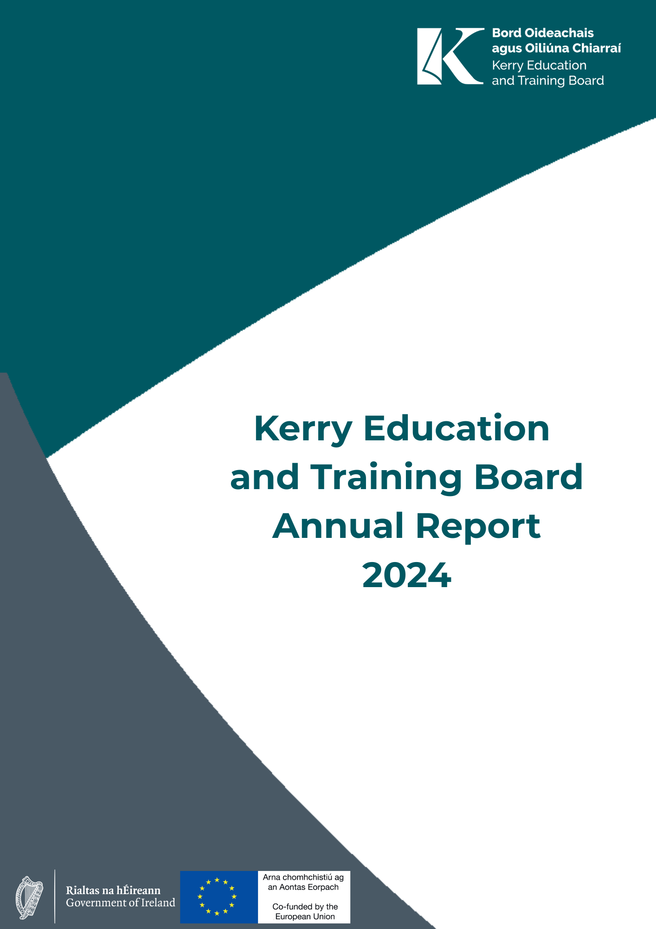


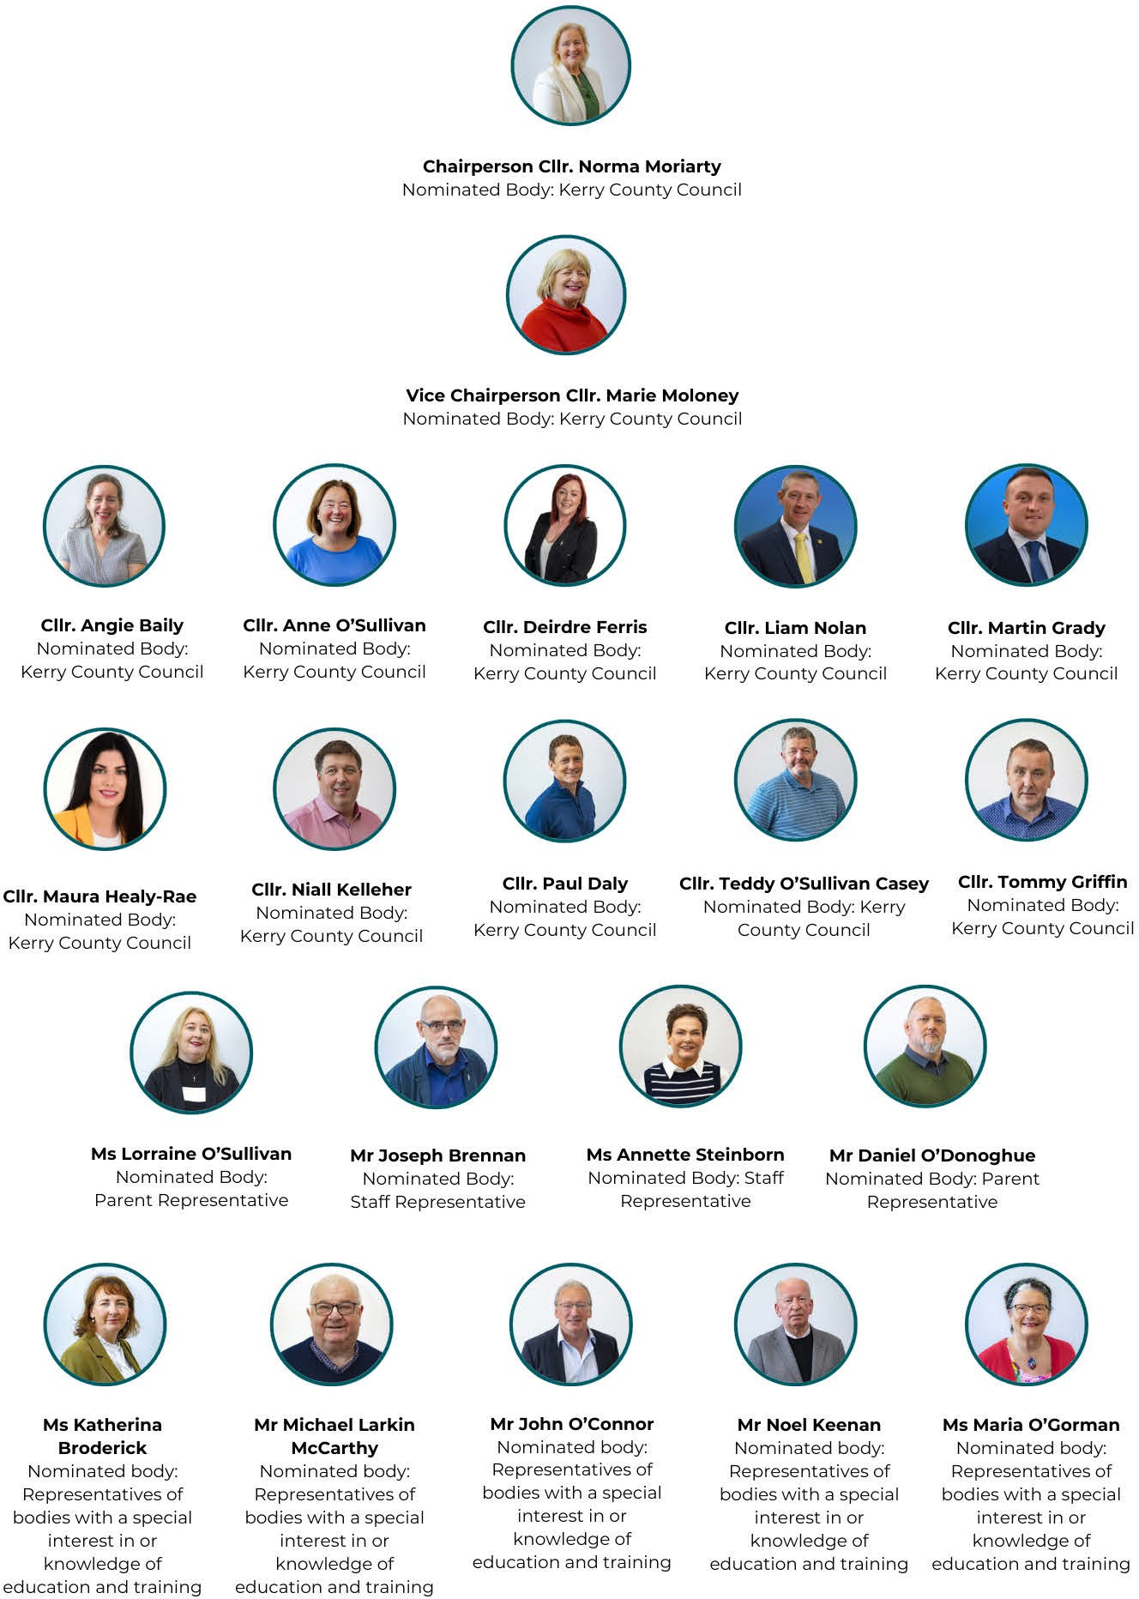

Kerry ETB Board 2024

Kerry ETB Executive 2023

Ms. Ann O’Dwyer Chief Executive Officer
Mr. Con Moynihan Director of Schools, Youth and Music
Ms Maria Brennan Director of Organisation Support and Development
Mr Owen O'Donnell Director of Further Education and Training
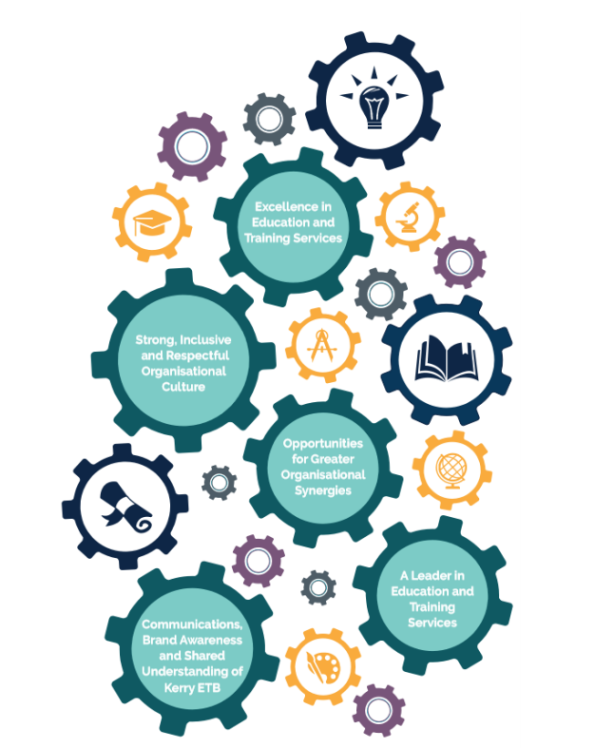
Contents
Joint Foreword from
Joint Foreword from Our Chairperson and Chief Executive Officer 5
Kerry Education and Training Board Statement 7
Kerry ETB: Organisation Profile 15
Statement of Services 2024 23
Kerry ETB Strategic Reports 51
Communications Plan 2025-2027 52
Corporate Procurement Plan 2023-2024 53
Customer Charter and Action Plan 2023-2025 54
Further Education and Training Buildings Estate Strategy 54
ICT Strategy 2023-2027 55
Irish Language Plan 2020-2023 56
Local Creative Youth Partnership Strategy 2023-2027 57
Public Sector Equality and Human Rights Duty Action Plan 2024-2026 58
Quality Assurance Action Plan 2022 - 2027 59
Strategic Performance Agreement 2022-2024 62
Sustainability Strategy 2024-2026 63
Universal Design for Learning Plan 2023-2025 65
Youth Work Development Plan 2023-2027 67

Joint Foreword from

Our Chairperson and Chief Executive Officer

We are pleased to present the Kerry Education and Training Board (Kerry ETB) Annual Report for 2024, prepared in accordance with Section 28 of the Education and Training Boards Act, 2013.

As we reflect on the past year, we do so with a deep sense of pride in the collective achievements across our organisation, and with renewed commitment to the strategic direction outlined in our Strategy Statement 2023–2027, Building Your Future.

Throughout 2024, Kerry ETB continued to build momentum in implementing our five strategic goals, grounded in the core values that guide everything we do: Inclusion, Respect, Equality, Quality, and Excellence in Learning. These values are not only our foundation, they are our daily practice, shaping our services, culture, and relationships with the communities we serve.

This year, we focused on embedding the strategy across our three pillars, Schools, Youth and Music; Further Education and Training; and Organisation Support and Development, ensuring that each area is working cohesively to advance our shared mission:

To promote the development of a lifelong and life-wide learning society in Kerry, where all individuals have equal access to high-quality, inclusive education and training opportunities.
Key developments in 2024 included:

- The strategic positioning of Kerry ETB as the first-choice provider of education and training in Kerry, supported by targeted communications, stakeholder engagement.
- The strengthening of our internal communications and governance structures, fostering greater alignment, transparency, and collaboration.
- Enhanced focus on staff development and learner voice, empowering our people and shaping services that are responsive, accessible, and learner-centred.
- A continued commitment to sustainable practice, ensuring that our work contributes positively to the social, economic, and environmental status of Kerry.

As we mark the first full year of our new strategy in action, the milestones and progress captured in this report reflect the dedication, adaptability, and professionalism of our staff and stakeholders.

We wish to thank all those who contribute to the success of Kerry ETB, our students/learners, staff, board and committee members, partners, and community. Your continued trust, support, and belief in the value of lifelong learning are what enable us to deliver on our mission.

Norma Moriarty Ann O’Dwyer
Chairperson Chief Executive Officer
Kerry Education and Training Board Kerry Education and Training Board

Kerry Education and Training Board Statement

Kerry Education and Training Board was established under the Education and Training Boards Act 2013 and is responsible and accountable for the proper direction and control of its functions in the Kerry local authority area.

Kerry Education and Training Board complies with the Code of Practice for Governance of Education and Training Boards, Department of Education Circular 0083/2024. The purpose of the code is to ensure that the principles of good governance and management are applied by Kerry Education and Training Board.

Functions of the ETB Board:

Decisions taken by the Board are reserved functions and are set out in Section 12 (2) of the Education and Training Board Act 2013 and in Circular 0083/2024 Code of Practice for the Governance of Education and Training Boards, with a full schedule set out in Appendix A of the Code. Decisions not specified in the Code are deemed to be Executive Functions for the Chief Executive Officer. The Board is satisfied that the Chief Executive Officer delegates functions where appropriate and in accordance with the Education and Training Board Act 2013.

Responsibilities of the Board:

The Board is responsible for keeping proper books of account which disclose with reasonable accuracy at any time the financial position of the Board and which enable it to ensure that the Financial Statements comply with Section 51 of the Education and Training Boards Act 2013. The Board is also responsible for safeguarding its assets and for taking reasonable steps for the prevention and detection of fraud and other irregularities. The Board considers that the Annual Financial Statements properly present the income and expenditure of the Board and the state of affairs of the Board.

In preparing those accounts, the Board is required to:

(a) apply the standard accounting policies for the preparation of ETB financial statements
(b) make judgements and estimates that are reasonable and prudent
(c) disclose and explain any material departures from the standard accounting policies

During 2024 the Board approved the following documentation:

- Adoption of the 2023 Annual Report
- Financial Statements 2023
- Adoption of the Service Plan 2024
- Authorised attendance of members at conferences
- Approved the acquisition, holding and disposal of land or interest in accordance with Department of Education and Youth (DEY) regulations
- Ensured accurate records were kept of meetings and decisions
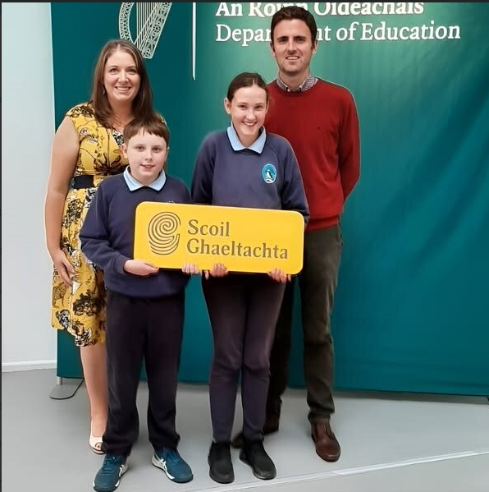

Board Meetings - The Board met on 12 occasions during 2024, with details of attendance outlined in the table below.
Name | Nominating Body | 30th Jan | 27th Feb | 26th Mar | 28th May | 27th Aug | 3rd Sept | 10th Sept | 15th Oct | 29th Oct | 19th Nov | 10th Dec | 23rd Dec | Total
Cllr. Cathal Foley | Kerry County Council | x |  |  | x |  |  |  |  |  |  |  |  | 2/4
Cllr. Fionnán Fitzgerald | Kerry County Council | x |  | x | x |  |  |  |  |  |  |  |  | 3/4
Cllr. Jim Finucane | Kerry County Council | x | x | x | x |  |  |  |  |  |  |  |  | 4/4
Cllr. Johnnie Wall | Kerry County Council | x | x | x | x |  |  |  |  |  |  |  |  | 4/4
Cllr. Michael Cahill | Kerry County Council | x |  | x | x |  |  |  |  |  |  |  |  | 3/4
Cllr. Niall O’Callaghan | Kerry County Council | x |  | x | x |  |  |  |  |  |  |  |  | 3/4
Cllr. Terry O’Brien | Kerry County Council | x |  | x | x |  |  |  |  |  |  |  |  | 3/4
Cllr. Aoife Thornton | Kerry County Council |  | x | x | x |  |  |  |  |  |  |  |  | 3/4
Ms Celia O’Shea | Staff | x | x |  | x |  |  |  |  |  |  |  |  | 3/4
Mr John O’Roarke | Special Interest |  | x |  |  |  |  |  |  |  |  |  |  | 1/4
Ms Joan McCrohan | Special Interest | x | x |  | x |  |  |  |  |  |  |  |  | 3/4
Mr Tim Daly | Special Interest | x | x | x |  |  |  |  |  |  |  |  |  | 3/4
Mr Zaid Kassoob | Special Interest | x |  |  | x |  |  |  |  |  |  |  |  | 2/4
Mr Niall Lucey | Parent |  | x | x |  |  |  |  |  |  |  |  |  | 2/4
Ms Tara Donoghue | Parent |  | x |  |  |  |  |  |  |  |  |  |  | 1/4
Cllr. Angie Baily | Kerry County Council |  |  |  |  | x | x | x | x | x |  |  | x | 6/8
Cllr. Anne O’Sullivan | Kerry County Council |  |  |  |  | x | x | x | x | x | x | x |  | 7/8
Cllr. Deirdre Ferris | Kerry County Council | x | x | x | x |  |  |  | x | x | x | x | x | 9/12
Cllr. Liam Nolan | Kerry County Council |  |  |  |  | x |  | x |  |  |  | x | x | 4/8
Cllr. Marie Moloney | Kerry County Council | x | x | x |  | x | x |  |  |  |  |  |  | 5/12
Cllr. Martin Grady | Kerry County Council |  |  |  |  | x |  | x | x | x |  |  | x | 5/8
Cllr. Maura Healy Rae | Kerry County Council | x |  |  |  |  |  |  |  |  | x |  |  | 2/12
Cllr. Niall Kelleher | Kerry County Council |  |  |  |  | x | x | x |  | x |  |  | x | 5/8
Cllr. Norma Moriarty | Kerry County Council | x | x | x | x | x | x | x | x | x | x | x | x | 12/12
Cllr. Paul Daly | Kerry County Council |  |  |  |  | x | x | x | x | x | x | x | x | 8/8
Cllr. Teddy O’Sullivan Casey | Kerry County Council |  |  |  |  | x | x | x | x | x | x | x |  | 7/8
Cllr. Tommy Griffin | Kerry County Council |  |  |  |  | x | x | x | x | x | x | x | x | 8/8
Ms. Annette Steinborn | Staff |  |  |  |  | x | x | x | x |  | x | x |  | 6/8
Mr. Joseph Brennan | Staff | x | x |  | x | x | x | x | x | x |  |  | x | 9/12
Ms. Lorraine O’Sullivan | Parent |  |  |  |  | x | x | x | x | x |  | x | x | 7/8
Mr. Daniel O’Donoghue | Parent |  |  |  |  |  | x | x | x | x | x |  | x | 6/7
Mr. John O Connor | Special Interest |  |  |  |  |  | x | x | x |  | x | x | x | 6/7
Ms. Katherina Broderick | Special Interest |  |  |  |  |  | x | x | x | x | x | x |  | 6/7
Mr. Noel Keenan | Special Interest |  |  |  |  |  | x | x | x | x | x | x | x | 7/7
Ms. Maria O’Gorman | Special Interest | x | x | x | x |  | x | x | x | x | x | x | x | 11/11
Mr. Michael Larkin McCarthy | Special Interest |  |  |  |  |  | x | x | x | x | x | x | x | 7/7
Note:
The 2019 – 2024 Board of Kerry ETB held their last board meeting on 28th May 2024.

The newly formed board held their first meeting on 27th August 2024 and the first meeting with complete membership was held on 15th October 2024.

Gender Balance in the Board membership
As at 31 December, the Board had 10 (48%) female and 11 (52%) male members, with 0 positions vacant. The Board therefore meets the Government target of a minimum of 40% representation of each gender in the membership of State Boards. The following measures are planned to maintain and support gender balance on this Board:
- Ensure senior leaders actively champion gender balance
- Monitor gender diversity targets at board level

Audit and Risk Committee
The Audit and Risk Committee met on 5 occasions in 2024, and the details of attendance are outlined in the table below.
Register of Attendance and Frequency of Meetings of the Audit and Risk Committee
Name | Nominee | 19.03 | 08.05 | 22.05 | 20.11 | 05/12* | Total  No. of  Meetings
Mr. John C. O’Connor | External | X | X | X | X | X | 5/5
Cllr. Jim Finucane | Kerry ETB |  |  |  | X |  | 1/5
Cllr. Norma Moriarty | Kerry ETB | X |  |  | X | X | 3/5
Ms. Maria O’Gorman | Kerry ETB |  | X |  |  |  | 1/5
Mr. Pádraig Ó Donnabháin | External | X | X | X | X | X | 5/5
Mr. John M. Naughton | External |  |  |  |  |  | 0/5
Mr. Gerard O’Donoghue | External | X |  | X | X |  | 3/5
* the purpose of meeting of 05/12 was to agree the minutes of meeting of 20/11/24.
Finance Committee
The Finance Committee met on 5 occasions in 2024, and the details of attendance are outlined in the table below.
Register of Attendance and Frequency of Meetings of the Finance Committee
Name | Nominee | 20.02 | 25.03 | 28.03 | 01.05 | 28.11 | No. of Meetings
Mr. Brendan Tuohy | External | X |  | X | X | X | 4/5
Cllr. Deirdre Ferris | Kerry ETB |  |  |  | X |  | 1/5
Mr. Brendan Daly | External | X | X | X | X | X | 5/5
Mr. Karol Kissane | External |  | X |  |  | X | 2/5
Cllr. Terry O’Brien | Kerry ETB |  |  |  | X |  | 1/5
Mr. Noel Keenan | External | X | X | X |  | X | 4/5

Note:
The duration of appointment of the Section 45 Committees was for the term of the ETB Board, each Board had its final meeting in May 2024.

On 11th September 2024 the Department of Education wrote to the Chair of ETB Boards, directing that the term of office of members of the Finance and Audit and Risk Committees ‘may be extended to 30th November 2024 in order to facilitate transition and to ensure continuity of governance and oversight during this period of changeover from the current Committee and Board to the new Committees and Board of ETBs’.

Following notification of this, both the Audit and Risk and Finance Committees held meetings in November 2024.

Risk Management:
The Board maintains active oversight of risk management and confirms that it has carried out an assessment of the principle risks, associated mitigation measures and reviewed the effectiveness of these measures in 2024.

The Board manages risk for the organisation through a structured risk management programme. The Board is assisted in its risk management function by the Audit and Risk Committee. The Board also relies on the Internal Audit Unit (IAU) and its reports including sectoral reports, on the C&AG annual audit and any external Audit such as an ESF audit and or Revenue Audit. In addition, there is a review of Internal Controls performed on an annual basis.

Risk Management is a standing item at all Board meetings and consideration includes:
• Risk reports from senior management including the Chief Risk Officer (CRO)
• Reports of the Audit and Risk Committee
• Changes in risk ratings
• Audit Register

Details of the principle risks and associated mitigation measures or strategies have been included in the Statement of Internal Controls (SIC) as part of the audited financial statements which will be published within one month of receipt from the Office of the Comptroller and Auditor General (C&AG) and as an appendix to the Chairpersons Comprehensive Report

System of internal controls:
At the Board meeting of 26th March 2024 the Board confirms that there has been a review of the effectiveness of the system of internal control and that the SIC, which is subject to change until the external audit is completed, has been included in the Annual Financial Statements (AFS) for the year ended the 31st of December 2024 which will be published within one month of receipt from the Office of the C&AG and as an appendix to the Chairpersons Comprehensive Report that has been submitted to the Minister.

Procurement Policy and Procedures:
The Board confirms that the organisation is adhering to the relevant aspects of the Public Spending Code and affirms adherence to the relevant procurement policy and procedures and the development and implementation of the Corporate Procurement Plan.

Non-compliance with Procurement Guidelines has been included in the Annual Financial Statements (pages 6 and 7).

Taxation:
The Board confirms that the ETB has complied with its obligations under tax law.

Financial Statements 2024:
Financial Statements 2024 – Kerry ETB’s Annual Financial Statement for the year ended the 31st of December 2024 is subject to audit by the Office of the C&AG at the time of publication of Kerry ETB’s Annual Report for 2024. Kerry ETB’s Financial Statements 2024 will be available on the website, www.kerryetb.ie once they have been audited.

Financial data in relation to the following are included in the Annual Financial Statement:

- Details of non-salary related fees paid in respect of Board Members analysed by category of fees
- Aggregate details of compensation of key management analysed by the following categories including management compensation in total;
  - Salaries and short term employee benefits
  - Post-employment benefits
  - Termination benefits
- Key management compensation if any;
- Details of the number of employees whose total employee benefits (excluding employer pension cost) for the reporting period fell between €0 and €59,999 and within each pay band of €10,000 above €60,000 and upwards and an overall figure for total employer pension contributions.

Gifts
Kerry ETB received no gifts in 2024.

Protected Disclosures
The Protected Disclosures Act 2014, as amended by the Protected Disclosures (Amendment) Act 2022, provides a framework within which staff can raise concerns regarding potential wrongdoing that has come to their attention in the workplace, knowing that they can avail of protections if they are penalised by their employer or suffer any detriment for doing so.

The Kerry ETB Protected Disclosure Policy works within national legislation to encourage and support staff in reporting potential wrongdoings, knowing their concerns will be taken seriously and their confidentiality respected.

As required under Section 22 of the Protected Disclosures Act, 2014, Kerry ETB confirms that no protected disclosures were received to the end of 2024.

Freedom of Information Act 2014
Kerry ETB continues to meet its obligations in relation to responding to Freedom of Information requests. Kerry ETB received 3 requests in 2024.

Corporate Social Responsibility
Under Statutory Instrument 426 of 2014, European Union (Energy Efficiency) Regulations 2014, all public sector bodies are required to report annually on their energy usage and any actions taken to reduce consumption.

Table 1 Kerry ETB Energy Usage 2024
Energy Source | Consumption kWh | Emissions kgCO2
Electricity | 2,218,567 | 625,077
Thermal | 2,090,352 | 500,690
Transport | 57,355 | 13,882
Totals | 4,366,274 | 1,139,649

Please refer to “Our Strategic Reports” later in the document for further details on how we have implemented our sustainability strategies and efforts to reduce energy usage.

Official Languages Act 2024
Section 10A of the Official Languages Act introduced a new obligation for public bodies in relation to advertising. This provision requires that at least 20% of advertising placed by the body shall be in the Irish language, and at least 5% of any monies spent on advertising by the body shall be through Irish language media. Based on an internal assessment, Kerry ETB achieved the 20% requirement but fell short of achieving the 5% requirement in 2024. Kerry ETB are working on ways to achieve this going forward.

Kerry ETB: Organisation Profile
Kerry ETB was established on July 1st, 2013, in accordance with the ETB Act 2013.

Our mission at Kerry ETB is to promote the development of a lifelong and life-wide society in Kerry so that all who live here have access to education and training.

Kerry ETB delivers the full range of education and training services to learners of all ages. Our wide-ranging services are delivered throughout the county and extend to include:
- Primary (community national school) education
- Post-primary (second-level) education
- Youthreach
- Further education and training
- Outdoor recreation and education
- Learner supports
- Regional Education and Language Team (REALT)
- Youth Work
- Music Education
- Irish language
- Corporate supports.
Kerry ETB adopts a multifaceted approach and works with the Department of Education and Youth, Department of Further and Higher Education, Research, Innovation and Science, Department of Children, Equality, Disability, Inclusion and Youth, and SOLAS (The State Agency for Further Education and Training). In addition, we also work with other local stakeholders across the community, voluntary, business, industry, education and commercial sectors. Kerry ETB provides services to the community, providing all services at the local level to meet local demands.

As a large education and training provider, we currently have approximately 3,242 primary and post-primary students and 14,000 further education and training beneficiaries enrolled annually, with circa 670 part-time and 590 full-time staff working across the breadth of the county.
Kerry ETB also has designated charitable status (registered charity number: 20083243)
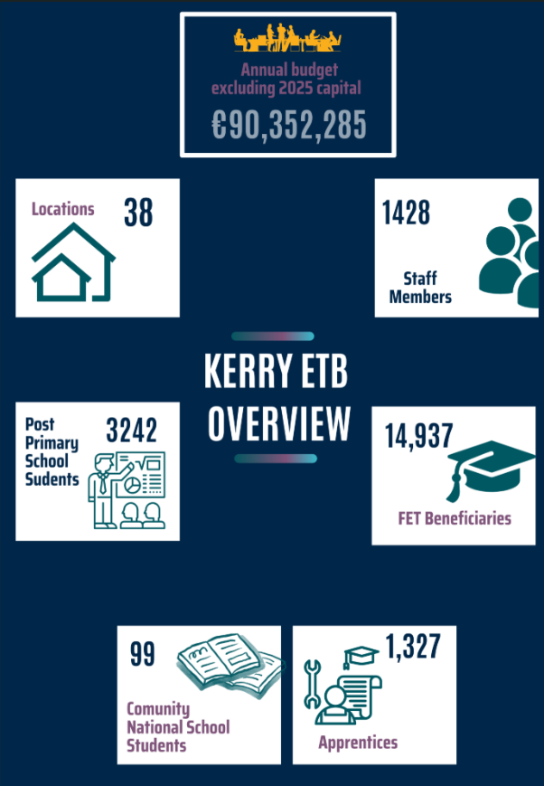

Locations
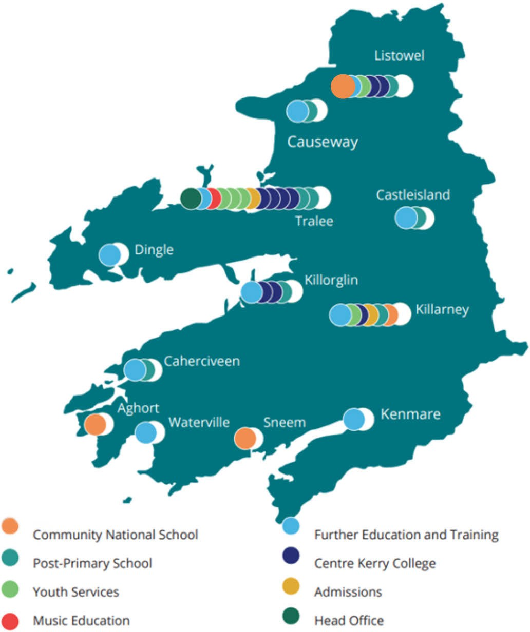

Figure 1 Kerry ETB Locations and Programmes

Our Vision, Mission and Core Values
Vision
Our shared vision is that Kerry ETB will be an innovative leader in the design and delivery of quality-assured and sustainably delivered education and training opportunities in Kerry.

Mission
We will continue to promote the development of a lifelong and life-wide learning society in Kerry so that all persons have equal access to education and training opportunities.

To achieve our vision, we put a strong emphasis on working closely with our internal and external stakeholders, particularly marginalised groups.

Core Values
Our core values, Inclusion, Respect, Equality, Quality, and Excellence in Learning, underpin our actions and behaviours. These values are centred on the belief that every person should have the right to access education and training opportunities to help them realise their potential and meet their personal, social, civic, cultural and economic needs.
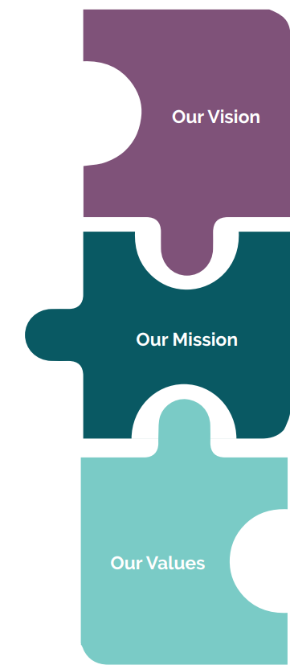

Strategic Goals

Goal 1: Excellence in Education and Training Services
We aim to ensure the continued review, design, delivery and support of quality-assured education and training opportunities to meet all learners’ evolving lifelong and life-wide learning needs.
Goal 2: Strong, Inclusive and Respectful Organisational Culture
We aim to ensure our structures, processes, and behaviours underpin an environment that is safe, supportive and inclusive of all people, regardless of identity, background or circumstance.
Goal 3: Opportunities for Greater Organisational Synergies
We aim to strengthen integration across our three pillars in a planned and strategic manner, adopting more cohesive and unified approaches.
Goal 4: A Leader in Education and Training Provision
We aim to establish ourselves as a leader in the development of education and training at both regional and national levels.
Goal 5: Communications, Brand Awareness and Shared Understanding of Kerry ETB
We aim to develop Kerry ETB into widely recognised brand underpinned by high-quality communications with internal and external stakeholders.
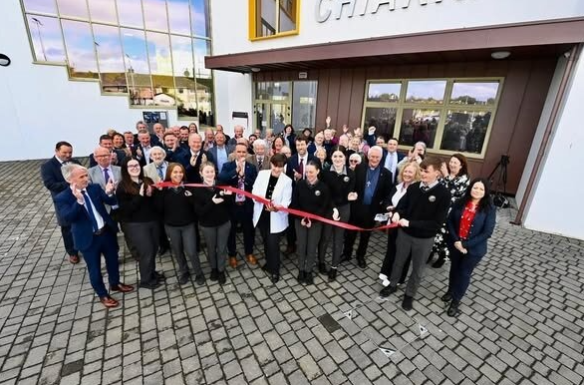

Organisational Structure
The Chief Executive Officer is responsible for the executive management of the organisation and is supported in this role by three directors, namely:
- Director of Schools, Youth and Music
- Director of Further Education and Training
- Director of Organisation Support and Development

The three director roles reflect the three pillars of service delivery, with each director formally delegated authority in their role as per Section 16 of the ETB Act 2013.

The following chart depicts the high-level organisation structure of Kerry ETB in 2023:

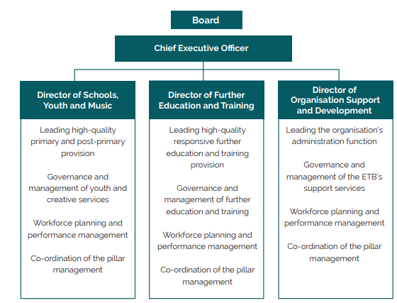

Statement of Services 2024

Performance Delivery Agreement
Optimise Student/Learner Experience
Priority | Action | Performance Milestones
Provide a positive learning experience for all learners, including those from marginalised groups | Continue to address and support equality of outcomes for our learners, particularly those from marginalised groups | The Traveller Education Support Teacher for Kerry ETB and non-ETB schools has continued to support Traveller families during 2024 and has worked closely with the Traveller Peer Educators and the Kerry Interagency Traveller Education Group and School Completion and Education Welfare Service and HSCL (TESS) to bring about better educational outcomes for Traveller students.  Universal Design for Learning (UDL) training events for teachers took place throughout 2024 to support equality of outcomes for learners.
 | Continue Traveller education support programme/role for schools, increasing leaving certificate completion rates. | The introduction of a transition programme designed specifically for incoming first-year Traveller students in 2023/2024 was continued into 2024/2025.  A referral programme, initiated in 2023/2024, to encourage Traveller parents/guardians of post-primary students to participate in our Adult Literacy and Basic Education (ABE) programme continued.
Support learners at risk of educational disadvantage in line with current national policy | Leverage Delivering Equality of Opportunity in Schools (DEIS) grants to prevent marginalisation and reduce the risk of educational disadvantage | Our schools have continued to implement DEY guidance regarding DEIS funding and School Self-Evaluation. Twice annually, principals and key staff completed a review of their respective plans, assessing the achievement of targets identified. Throughout the year, Boards of Management and the school community were kept consistently updated on progress.

Optimise Student/Learner Experience (continued)
Priority | Action | Performance Milestones
Support learners at risk of educational disadvantage in line with current national policy (continued) | Continue to support the School Completion Programme in line with Department of Education/TUSLA Assurance Document | Discussions have taken place around the governance structure of SCP throughout 2024. It is envisaged that a governance structure taking much of the responsibilities off the Local Management Committee will be agreed nationally.  New to DEIS schools were incorporated into the South Kerry SCP.
Ensure all necessary child safeguarding measures are in place in accordance with the Child Procedures for Primary and Post-Primary Schools 2017 | Ensure that all schools and Youthreach centres are informed and adhere to the revised 2023 Child Protection Procedures issued by the Department of Education and Youth. | An online training event for Board members of Schools and Youthreach centres took place in Q4 2024.  Two in person training sessions were delivered to all Youth centre staff during 2024.  The Child Protection Oversight Committee (CPOC) met twice in 2024 and provided a comprehensive report on Kerry ETB Child Protection and Compliance at the 29th October 2024 Board meeting.
Ensure full compliance with the Child Protection Procedures for Primary and Post-Primary Schools 2017

Protection Programmes
Priority | Action | Performance Milestones
Assist the Department of Education, as needed, to meet the needs arising from the Irish Refugee Protection Programme and provision for International Protection applicants | Continue to meet the needs arising from our International Protection programme | The REALT Programme supported the placement of  In excess of 450 students in primary and post-primary schools and sourced school transport where necessary.  The Kerry ETB International Protection and Ukrainian Response Team consisting of Schools, FET and OSD pillar, has continued to meet and co-ordinate the diverse learning and youthwork needs of Ukrainian and International Protection applicants throughout 2024.

Governance
Priority | Action | Performance Milestones
Attendance rates at board meetings | Individual boards should re-emphasise the requirement for attendance at all board meetings as per the Code of Practice for Governance of ETBs (Circular Letter 0002/2019 subsequently Circular Letter 83/2024) | The Board Chairperson regularly reinforced good attendance at Board meetings, and a mid-year and end-of-year report on attendance was provided to the Chairperson.  Board attendance rate for 2024 – 76%  A quorum was achieved for all meetings.
Board self-assessments | All boards should carry out self-assessments using the questionnaire included in Circular Letter 0002/2019 to identify areas where improvements are required | As a result of the formation of a new Board in 2024 comprehensive programme of training sessions took place from Quarter 3 2024 to Quarter 2 2025.  Due to the formation of the new Board and the comprehensive programme of training sessions Board self-assessment has been deferred to Q 4 2025.
Financial expertise on audit and finance committees | Appointments to audit and finance committees should be made by the Board in consultation with committee chairs. External members of committees should bring the required audit and financial skills and experience to the role | A structured process is in place for the appointment of new Section 45 Committee members, as per Circular Letter 0002/2019 and subsequently Circular Letter 83/2024.  This process was adhered to in the appointment to new Section 45 Committees in Q4 2024 to ensure audit and financial expertise on audit and finance committees
Board appraisal of work carried out by audit and finance committees | The chair of each Board to ensure that board members are provided with written reports on the work carried out by audit and finance committees | Written reports detailing the proceedings of each Section 45 Committee meeting were formally presented at a subsequent Board meeting, ensuring transparency and dissemination of relevant information between these committees and the Board.  The Annual Report from the Chair of the Audit and Risk Committee was tabled at the March 2024 Board meeting and the Annual Report from the Chair of the Finance Committee was tabled at the May 2024 Board meeting.
Self-assessment by audit and finance committees | The chairs of the audit and finance committees to ensure that a self-assessment exercise is completed annually as required under the Code of Practice. | As a result of the formation of a new Board in 2024 the first meeting of the newly formed Section 45 committees did not take place until Q 1 2025.  Self-assessment by the new committees will take place in Q 4 2025.

Governance (continued)
Priority | Action | Performance Milestones
Staff development | The Chief Executive  Officer should ensure that  - a member of staff is appointed as the training manager  - training needs analysis in financial management is carried out on an annual basis  - a training programme on financial management is developed and implemented | Under the Department of Education workplan in relation to strengthening ETB's Head Office Administration staffing Kerry ETB was sanctioned a Grade VI permanent post. This post was assigned to HR and filled in Q4 2024. The job description encompasses oversight of training provision.  In 2024, we began using an online learning platform to deliver training, marking a significant step forward in our training methods. Our goal is to expand the use of this platform and integrate it more comprehensively. Concurrently, we are developing a Training and Development Plan to enhance the delivery, tracking, and management of all training activities. This ongoing development aims to provide an efficient learning experience for all staff.  Kerry ETB CPD Policy and Procedure continues to be implemented.  Two staff commenced apprenticeship training on sales and marketing.  One staff member completed a one year programme of study in Adaptive Leadership Challenge Programme, and three staff members—one from each pillar—continuing their studies with support on a Master of Business Administration (MBA) programme.
Departmental reporting deadlines | Returns to the Department must be accurate, and reporting deadline adhered to | Accurate reports submitted to the relevant Department and reporting deadlines were successfully met during the reporting period in so far as possible.
Risk Management Policy | The Board should ensure an ongoing process designed to identify and address significant risks involved in achieving an entity’s outcomes. The audit and risk committee should support the Board in this role | Kerry ETB has Corporate Risk Management in place across the organisation. The Corporate Risk Register was reviewed at each meeting of the Audit and Risk Committee in 2024, and the Committee continues to  monitor the development of the Kerry ETB Strategic Risk Management plan.
Internal controls | The Board of each ETB should ensure that it receives adequate assurance that specified controls are operating as intended | In 2024, Kerry ETB continued to develop and implement the Governance, Compliance and Risk  Software for conducting the annual evaluation of the system of internal controls. Maintaining the  system of internal controls is a continuous process and the system, and its effectiveness are kept  under ongoing review.  At the March 2025 meeting, the Board received assurance that specified controls were operating as intended. The overall results of the assessment showed a compliance rate of 98% and non-compliance of 2% for the relevant measures.  No incidents were reported under the Kerry ETB Anti-Fraud and Corruption Policy in 2024.


Annual Report 2024
The following actions were either commenced or delivered during 2024 in line with Kerry ETB’s Strategy Statement
Goal 1: Excellence in Education and Training Services
We aim to ensure the continued review, design, delivery and support of quality-assured education and training opportunities to meet all learners’ evolving lifelong and life-wide learning needs.

Ref. | Objective | Performance Milestones 2024
1A | Create a high-quality, holistic education and training environment informed by learners' voice and actively addressing access for all | Kerry ETB schools (community national schools and post-primary schools) continued to have dedicated Teaching and Learning Teams to ensure a strong focus on innovative pedagogical approaches.  All of our post-primary schools continued to actively implement the Relationship and Sexuality Education programme, as well as the Friends for Life initiative, promoting holistic well-being.  All of our Student Councils, the Student Forum, and the Parents’ Forum continued to provide a platform for student and parent/guardian voices to be heard, addressing key matters including ethos, access and the development of our new strategy.  A Student Experience survey was carried out across all Kerry ETB post primary schools which highlighted high levels of satisfaction and recommendations on areas such as teaching and learning assessment and homework policies and participation of girls in sports.  Across FET provision, learner involvement included active participation in various forums, such as FET Quality Council, Kerry College Governance Board, FET Centres Governance Board, and the Kerry ETB Commis Chef National Apprenticeship Programme meetings. This participation allowed these fora to gather valuable feedback and perspectives directly from learners.  We maintained a responsive work culture to address the needs of front-line education and training delivery across a range of corporate services, including human resources, procurement, capital, ICT technological support, and accounts payable.
1B | Provide comprehensive guidance to all learners, offering academic, employment and personal support | The Kerry College Admissions Office continued to play a pivotal and growing role in providing information to the public. Operating from two locations in Tralee and Killarney, the admissions team also hosted dedicated information clinics in identified hubs throughout the county, offering the public a centralised resource for inquiries and information.

Goal 1: Excellence in Education and Training Services (continued)
Ref. | Objective | Performance Milestones 2024
1C | Provide widely accessible education and training opportunities in a range of areas, including creativity and music | Kerry Local Creative Youth Partnership (LCYP) marked a successful year with an increase to 36 programmes (up from 31 in 2023). The project worked with 24 community-based organisations as participating partners in the programme and across ten locations in the county. There was a total of 21 creative practitioners engaged by the project and three county-side showcases of creative work. Eleven different targeted child and youth cohorts were worked with using 14 different creative disciplines. Disciplines included the performing arts, visual art, film, music and rap, graffiti, fashion, construction, drumming, science, dance, garden design, special effects, make-up for film, sound for film. The LCYP continues to deliver successfully on its five-year strategy. Enhanced spending allowed for an additional 12 projects and enhanced funding up to 2027 has been indicated.  Music Generation Kerry continued to deliver inclusive and high-quality music education opportunities to children and young people across the county, supported by Kerry ETB, Kerry County Council, MTU and the Music Generation National Development Office. In 2024, the programme reached approximately 4,451 individual participants (a 13% increase on 2023) through school-based, after-school and community-led provision.  Building a sustainable ecosystem of music education and performance, the Music Generation Kerry increasingly focused on addressing gaps in access and participation. After-school provision expanded via the newly launched Castleisland Hub with in-demand tuition in piano, brass, ukulele/guitar and singing.  Music Generation Kerry’s Band Projects and String and Wind Ensembles played a central role in the county’s cultural calendar, performing at key community events such as the Tralee Food Festival, K-Fest, Féile Thrá Lí and the Chamber Music on Valentia Festival. These experiences support musical progression and nurture a sense of pride, belonging and achievement among young performers. Music Generation Kerry also delivered workshops for Cruinniú na nÓg and Culture Night 2024. The newly launched Oidhreacht Traditional Music Ensemble represented the programme on a national stage with a televised TG4 performance during Galway's TradFest in November 2024 in collaboration with other Music Generation areas.  Music Generation Kerry engaged on a national level as lead partner on Corda Connections, a string ensemble residential held annually at Dundalk Grammar School, in collaboration with Music Generation Louth and the Irish Chamber Orchestra Youth Orchestra.  Planning advanced on a long-term vision for a Kerry ETB School of Performance Music; a strategically aligned initiative aimed at integrating and expanding music education pathways across the county.

Goal 1: Excellence in Education and Training Services (continued)
Ref. | Objective | Performance Milestones 2024
1D | Provide excellent responsive delivery to support the local and national economy taking account of local and national labour shortages and delivering programmes to best meet this skills gap | Responsive delivery was demonstrated through the introduction of targeted new programmes across FET, part-time, full-time, and tertiary levels, including Digital Media Production, Care Skills, Intellectual Disability Studies, and Adapted Physical Activity. These programmes, alongside new tertiary Nursing degrees and practical TY modules in engineering, media, coding, and construction, respond directly to workforce demands, regional skills gaps, and support smoother transitions into employment and further education.  New Part-time and Full-time Courses  In 2024, Kerry ETB introduced several new part-time and full-time courses across campuses to meet local demand in areas such as health, care, physical activity, and digital media. These programmes were developed in consultation with industry needs and community interests, helping learners upskill and transition into employment or further study.  Part-time Courses  Killorglin Campus  - Adapted Physical Activity  - White Water Surf Skills  Listowel Campus  - Intellectual Disability Studies  - Person Centred focus on Disability  - Care Skills  Full-time courses  Clash Campus  - Digital Media Production (L6)  The QA Unit’s collaboration with centres on curriculum review ensured relevance to labour market trends.  Integration of practical, life-based learning such as financial literacy during Maths Week in schools highlighted real-world application and economic alignment.  The Digital Marketing Pathway, co-developed with Discover Kerry, exemplifies a strong linkage between Kerry ETB’s Business Support Unit and the regional business community.  FET and Transition Year  Killorglin Campus  - Orienteering Ability Awards  Monavalley Campus  - Explore a Career in Engineering  - Explore a Career in Media Production  - Explore a Career in Networks, Coding and Game Design  - Explore a Career in Construction  - Explore a Career in Commis Chef  - Introduction to the world of Apprenticeship  Clash Campus  - Health Related Fitness  - Career Planning  Apprenticeship  There was a major expansion in Craft Apprenticeship with 661 Phase 2 Apprenticeship beneficiaries in 2024.  - Electrician  - Plumbing  - Carpentry and Joinery  - Mechanical Automation and Maintenance Fitting (MAMF)  - Metal Fabrication  - Motor Mechanics  - Stone Cutting and Masonry  Kerry ETB are the lead provider of 2016+ Apprenticeship in  - Wind Turbine Maintenance Technician  - Commis Chef  Kerry ETB hosted the inaugural National Commis Chef Apprenticeship Competition, which brought together apprentices from across the country for a dynamic event featuring live competitions and expert-led panel discussions. The event showcased the exceptional skills of emerging culinary talent and highlighted the strength of Ireland’s apprenticeship model in addressing skills needs within the hospitality sector.  Kerry ETB also runs as a second provider  - Cyber Security  - Software Developer  - National Sales  Tertiary Degree Programmes  A major milestone in 2024 was the launch of new tertiary degree pathways in partnership with MTU and other Higher Education Institutions. These nursing programmes represent a significant advancement in regional access to higher education, enabling learners to progress from Further to Higher Education without leaving the county.  Denny Street Campus:  - BSc (Hons) in Mental Health Nursing  - BSc (Hons) in General Nursing  Listowel Campus:  - BSc (Hons) in General Nursing  These innovative offerings not only respond to the national skills shortage in healthcare but also promote equity of access to degree-level education in rural Kerry.  The expansion of the O’Connell FET Centre aligns with Kerry ETB’s strategic aim to anticipate and respond to evolving labour market demands. With the introduction of a practical hairdressing traineeship, the first of its kind in the region. Kerry ETB demonstrates proactive leadership in skills planning. The centre now provides industry-relevant, hands-on training in a modernised, learner-focused setting.
1E | Adapt and develop our education and training as new learning approaches and technologies emerge | The Kerry ETB ICT Strategy 2023-2027 was approved at the ETB Board meeting on November 7th, 2023. Further details on this strategy are available on page 56 of this report.  UDL CPD for educators focused on digital literacy and inclusive learning design, ensuring staff and students could harness new technologies confidently and equitably.  Recognition at the Tech Industry Alliance Awards spotlighted Coláiste Gleann Lí’s integration of technology and UDL into daily teaching. Robotics, coding, and the use of assistive technologies showcased our embrace of emerging methods.  Coláiste na Sceilge students participated in the Space Messengers programme with Dr. Steve Goldfarb.
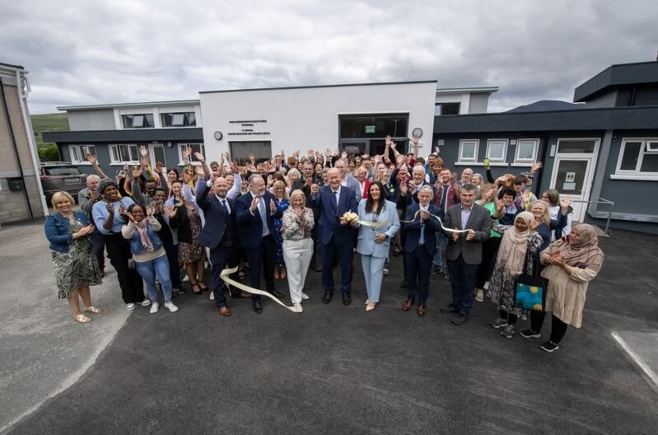
Goal 1: Excellence in Education and Training Services (continued)
Ref. | Objective | Performance Milestones 2024
1F | Design and deliver a career development programme for staff | Under the Department of Education workplan in relation to strengthening ETB's Head Office Administration staffing Kerry ETB was sanctioned a Grade VI permanent post. This post was assigned to HR and filled in Q4 2024. The job description encompasses oversight of training provision.  In 2024, we began using an online learning platform to deliver training, marking a significant step forward in our training methods. Our goal is to expand the use of this platform and integrate it more comprehensively. Concurrently, we are developing a Training and Development Plan to enhance the delivery, tracking, and management of all training activities. This ongoing development aims to provide an efficient learning experience for all staff.  Kerry ETB CPD Policy and Procedure continues to be implemented.  Staff professional development was prioritised through structured CPD in ICT integration, Universal Design for Learning (UDL), and curriculum design. Success at national award platforms reflected the outcomes of this investment.  Line Management Day held in June, focusing on communications strategy, email etiquette, and values-aligned leadership.  Two staff commenced apprenticeship training on sales and marketing.  One staff member completed a one-year programme of study in Adaptive Leadership Challenge Programme, and three staff members—one from each pillar—continuing their studies with support on a Master of Business Administration (MBA) programme.
1G | Research and implement future educational reforms in line with government policy and international best practices | The QA and Curriculum Development Unit led structured research, data analysis, and implementation of reforms aligned with national standards and international trends. Reports, including the Quality Council Annual Report, were published transparently on the Kerry ETB website. Ongoing governance, programme reviews, and integration of learner feedback positioned Kerry ETB as a leader in forward-looking, policy-aligned education delivery.  The Quality Council Annual Report was published and made publicly available through the Kerry ETB website. This comprehensive report provides detailed insights into quality assurance activities across all education and training services, including curriculum reviews, programme validations, learner feedback integration, and continuous improvement initiatives. It highlights how Kerry ETB remains aligned with national and international quality standards, supports evidence-based decision-making, and ensures the delivery of high-quality, relevant, and responsive education and training programmes.  Kerry ETB proudly welcomed Lyreacrompane Community National School under its patronage, supporting the Government’s policy to community, increase diversity and parental choice in education. This move aligns with the Action Plan for Education and the Schools Reconfiguration for Diversity Process, promoting inclusive, multidenominational learning environments that reflect the values of equality, respect, excellence and community.
1H | Ensure that the capital and buildings programme is delivered and that all new projects are designed to comply with Department guidelines and the highest standards for energy efficiency | Kerry ETB, in 2024, undertook a significant number of Capital Projects across Department of Education (DoE) and SOLAS, FET Funded projects in 2024.  In 2024 the total capital expenditure for Kerry ETB was c.€17.99 Million and this represented one of the biggest investments in Kerry ETB's Estate to date.  A number of notable projects completed in 2024 include: -  - New Apprenticeship Facility for Kerry College Monavalley Campus  - The refurbishment of O'Connell Adult Education Centre  - An ASD Unit Extension to Killarney Community College  - A deep-retrofit to Castleisland Community College under the Department of Education (DoE) Pathfinder Programme.  - In 2024, Kerry ETB undertook construction of several modular accommodation projects across the Kerry ETB estate, providing c.1,170 m2 of additional accommodation in total across:-  - Coláiste na Sceilge.  - Castleisland Community College.  - Killorglin Community College.  - Causeway Comprehensive School.

Goal 2: Strong, Inclusive and Respectful Organisational Culture
We aim to ensure our structures, processes, and behaviours underpin an environment that is safe, supportive and inclusive of all people, regardless of identity, background or circumstance.

Ref. | Objective | Performance Milestones 2024
2A | Complete an organisation-wide culture audit and address recommendations | A project plan has been developed including the establishment of an Equality Diversity and Inclusion Action Group, the Culture Audit will be a key deliverable for this group. This audit will offer valuable insights into the organisation's strengths and highlight areas for improvement, ensuring an inclusive, effective, and engaged workplace.
2B | Promote a culture that is inclusive, non-discriminatory and respectful of human and civic rights | The Assessment of Equality and Human Rights Issues and the Public Sector Equality and Human Rights Duty Action Plan 2024 -2025 were approved by the Board of Kerry ETB on 10th December 2024.  Administration staff were released to complete the Irish Human Rights and Equality Commission eLearning Module.  Killorglin Community College and Coláiste Gleann Lí were awarded the LGBTQ+ Quality Mark in recognition of their strong commitment to creating safe, inclusive environments. Both schools implemented support groups, staff training, and celebrated Pride events, embedding inclusion across school life. Two additional schools were awarded the Yellow Flag for Inclusion.  Kerry ETB staff member awarded the John Kelly for Universal Design for Learning for Further and Higher Education.  Diversity Days and inclusion events across campuses celebrated cultural awareness, promoted equality, and encouraged open conversations on identity and belonging, helping to foster inclusive learning environments  The Kerry ETB Gender Pay Gap Report 2023 is published on the Kerry ETB website.  Six Kerry ETB post primary schools commenced engagement with the ETBI Provision Mapping Programme. The needs of individual students are assessed and provision designed and delivered to meet their needs.
2C | Ensure our core values guide the organisation’s behaviours and are the lived experience for all our stakeholders. | Significant progress has been made on the development of the Kerry ETB Communications Plan, which is on track for completion in 2025. Further details are available on page 52 of this report.  Kerry ETB's commitment to embedding its core values across all levels of the organisation was evident in several initiatives that turned values into visible practice. In Coláiste na Ríochta, the House System fostered belonging, leadership, and healthy competition through inclusive, student-led activities that celebrated participation and achievement. The Kindness Project, led by students, promoted empathy, respect, and active community engagement, demonstrating how values such as compassion and responsibility can become part of the daily school culture.  Two major recognitions further showcased this values-driven approach:  The Pieta House Amber Flag was awarded to Coláiste na Ríochta and Killarney Youthreach in recognition of their outstanding commitment to promoting positive mental health. These centres created Amber Flag Committees, ran well-being campaigns, hosted fundraisers (including bake sales and ‘Walk & Talk’ events), and embedded mental health awareness into the curriculum and wider school activities.  The AIB Future Sparks School Impact Award was presented to Coláiste na Ríochta for its socially impactful student-led initiative promoting inclusion and mental health awareness. This national recognition highlighted how schools within Kerry ETB empower students to be agents of positive change, linking community involvement with personal development.  Kerry ETB schools continued to implement the ETBI Patrons' Framework on Ethos.
2D | Support our learners and staff by strengthening access to and raising awareness of support services | New structural progress was made through the planning of a biennial staff day, designed to foster cross-departmental collaboration and shared learning. A dedicated working group was established, with topics and speakers already selected. Final planning stages include confirming the budget and securing a date. This event will serve as a valuable platform for professional development and strengthening organisational cohesion.  Mental health workshops, wellbeing campaigns, free hygiene products, and learner forums, such as those held at Kerry College Listowel ensured that supports were visible and accessible. Killarney Youthreach exemplified a holistic approach through its Amber Flag initiative, daily affirmations, and resilience training delivered in partnership with Jigsaw. CPD and staff training through NYCI further strengthened inclusive practices across the county.  Kerry College continued to develop its Learning Support Unit across all campuses.  A comprehensive Special Education Needs (SEN) programme continued to be implemented across our schools.  Commitment to supporting staff is evident in the provision of accessible resources for their well-being, including the Employee Assistance programme and a Financial Well-Being programme.
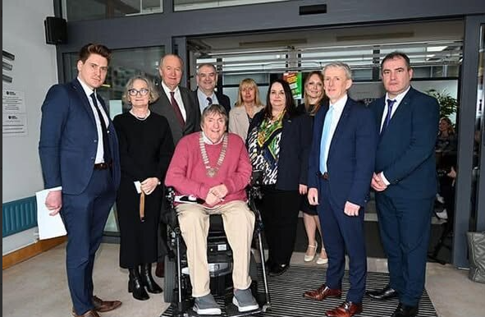
Goal 2: Strong, Inclusive and Respectful Organisational Culture (continued)
Ref. | Objective | Performance Milestones 2024
2E | Ensure our structures actively promote inclusion and provide accessible and appropriate support for people with disabilities | Three access officers in place - one per pillar. Contact details available on Kerry ETB website  Unconscious Bias Workshop on 8th February 2024 at Senior Management conference.  Universal Design for Learning (UDL) was a cornerstone of provision in centres like Tech Amergin, where assistive technologies and QR-based learning tools supported neurodivergent learners and non-native English speakers. Partnerships with Down Syndrome Kerry and tailored Life Skills courses demonstrated a commitment to enabling access for all. UDL training and implementation continue to expand across Kerry ETB.  Annual Disability Survey of all staff was carried out. All reasonable accommodation requests advised across the scheme were met.  Kerry College has a cross-campus focus on UDL. Each campus has established a UDL/Teaching and Learning Committee. Additionally, an online library of resources has been developed, and designated Teaching and Learning boxes have been introduced. Furthermore, additional staff members are completing the UDL Badge programme.  Kerry ETB provided training and education places through its specialist training provision to 187 learners which included centre based, employer based and blended learning.  Kerry ETB also provided interventions through the SOLAS fund for disabilities across a range of interventions for learners with additional needs.
2F | Build stronger relationships with other regional agencies to proactively address barriers to inclusion for marginalised individuals or groups | Tertiary Degree Programmes – see Goal 1D.  The Youth Work Plan was launched strengthening Kerry ETB’s commitment to wellbeing, inclusion, and learner voice. It demonstrates a strategic, cross-sectoral approach to youth engagement, aligns services with young people's needs, and ensures youth development is integrated, not siloed. It promotes equity and access, while reinforcing organisational values in practice.  Kerry ETB led the first full year of the Kerry Regional Adult Literacy Coalition, coordinating Plain English training, digital inclusion efforts, and outreach in rural communities. A new mobile literacy hub and awareness campaigns strengthened access to supports.  LCYP led a powerful inclusion project bringing together young people of mixed abilities and diverse backgrounds to create four short films across Kerry. In partnership with local agencies, the initiative promoted creativity, cross-cultural connection, and youth voice.  Music Generation Kerry’s Summer Band Camp exemplified Kerry ETB’s commitment to learner inclusion. Open to young musicians of all levels, the camp provided a supportive and engaging space where participants could develop technical skills, explore new musical genres, and collaborate with their peers in a dynamic learning environment.  In December the Adult Literacy for Life programme marked a powerful moment of inclusion, achievement, and community engagement with a graduation event at the Butler Centre, Listowel. This was the first time the participating learners members of Kerry Parents and Friends achieved a QQI award in Writing.  Lyreacrompane Community National School welcomed students under the new patronage of Kerry ETB, following a successful transition from a Catholic ethos to a multidenominational framework. The school for the first time has a school transportation service. This transition reflects Kerry ETB’s deep commitment to address barriers and promote inclusion.
2G | Work to meet the needs arising from the Irish Refugee Protection Programme and provision for international protection applicants | Kerry ETB’s Ukrainian and International Protection Response Team coordinated education and integration supports for over 2,000 learners in 18 locations. English tuition totalled over 11,000 hours. Events like the Derrynane Intercultural Day and stories of successful integration of students in to our schools how education fosters dignity, connection, and belonging. Kerry ETB REALT continued to assist families and integrate learners including International Protection Programme.  Kerry ETB provided English for Speakers of Other Languages (ESOL) to 3,544 beneficiaries from the International Protection Programme.
2H | Create opportunities for learners and staff to access equality, diversity and inclusion education and training opportunities | Across Kerry ETB, learners and staff engaged in targeted Equality, Diversity and Inclusion initiatives, including Active Consent training for schools, Inclusion CPD for Youth Workers, and Equality workshops. BelongTo-led programmes, Stand Up Week, Yellow Flag for Inclusion, student forums, and open celebrations (like International Day at Clash Campus) fostered a shared understanding of inclusion as a lived, learned, and evolving experience.  Kerry College provides a comprehensive and inclusive system of learner supports across all campuses to ensure learners are fully supported throughout their educational journey. Each campus is equipped with an open learning support centre offering academic assistance such as assignment support, learning accommodations and individualised interventions for learners with additional educational needs. It is anticipated that approximately one third of all learners will avail of these supports in 2025.  Further targeted supports include Personal Assistant (PA) provision, with an estimated 60 to 70 learners set to benefit from this service under the SOLAS Fund for Learners with Disabilities. In addition, 250 learners will have access to laptops on loan helping to reduce barriers to digital access. Learners can also avail of scheduled guidance services and external counselling supports, where needed, to assist with academic, personal and career related matters.  To further enhance the learner experience, Kerry ETB will introduce a series of learner focused initiatives in 2025. A dedicated Learner Support Unit will be established to provide standardised and targeted assistance, particularly for those returning to education, requiring academic writing support or presenting with additional educational needs. Celebrating learner achievement is also a priority and a graduation event is hosted annually to celebrate learner achievements.  Learner voice will continue to be a core principle within programme development and quality assurance. Learners will actively contribute to QA policy and assessment procedure reviews through mechanisms such as structured surveys and focus groups. Staff training will support the facilitation of meaningful learner engagement and learner involvement will be built into programme development processes.  To support continuous improvement, tracking systems will monitor learner supports and reasonable accommodations with reports guiding future planning and resource allocation. Certification targets for 2025 include 1,100 major awards, 1,700 minor awards and 120 special purpose awards, with pilot grade benchmarks expected to be introduced based on trends from previous years.
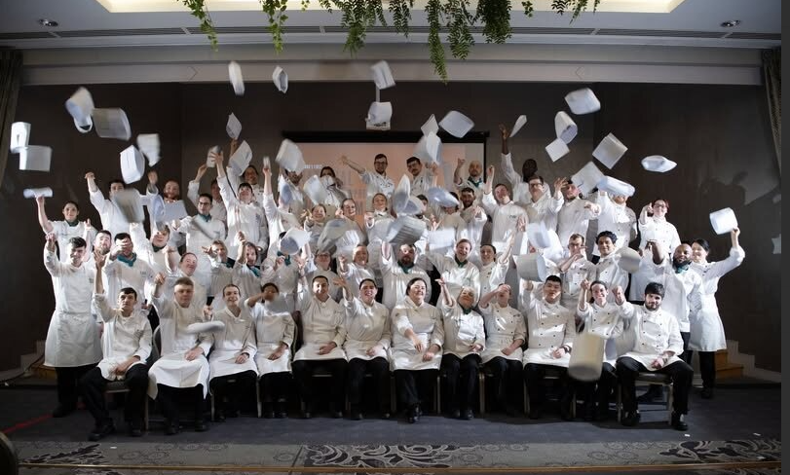
Goal 3: Opportunities for Greater Organisational Synergies
We aim to strengthen integration across our three pillars in a planned and strategic manner, adopting more cohesive and unified approaches.

Ref. | Objective | Performance Milestones 2024
3A | Develop a structure to facilitate shared understanding across the organisation's three pillars | The Cross-Pillar Forum, held in June 2024, brought together staff representatives from all three pillars to inform organisational direction, policy, and priorities. The forum fostered rich dialogue, focusing on Goals 4 and 5, and produced actionable insights to strengthen interdepartmental cooperation.  The co-location of the Quality Assurance and Curriculum Development Team with the Training Standards Office has created a streamlined, centralised structure that supports cross-pillar alignment. By consolidating QA functions in the Head Office, this move promotes consistency, collaboration, and a shared understanding of quality standards across all education and training delivery arms. The introduction of the Quality News E-Zine and QA Briefings has enhanced communication, ensuring that standardised, evidence-based practices are understood and applied across schools, FET, and Youth Services reinforcing organisational cohesion.  The formation of the Corporate and Procurement Department in 2024 created a unified structure that connects governance, communications, and compliance across the Schools, FET, and Youth pillars—providing the organisation with a common operational language and shared service mode.
3B | Create opportunities for closer cross-pillar collaboration to strengthen synergies and promote shared objectives | In 2024, Kerry College’s Clash Campus offered Transition Year students accredited QQI and ITEC modules in areas such as health and beauty, fitness, and career planning. These structured, hands-on learning opportunities provided students with early exposure to FET and supported smoother transitions from second-level education. By building learner confidence and showcasing alternative pathways, this initiative actively contributes to long-term progression planning and career decision-making.  The Kollab Project, an organisation-wide Microsoft Office 365 SharePoint, established a single digital tenancy, enhancing communication, data sharing, and collaboration across schools, FET, and Youthreach. In 2024 the rollout supported 693 staff and 5,826 students, with final FET migration set for completion in 2025.
3C | Ensure greater integration of management and staff teams across the organisation | In line with Kerry ETB’s aim to build a cohesive culture, planning commenced for biennial staff days designed to promote cross-pillar thinking and strategic planning. A working group was established, topics and speakers were selected, and procurement completed. Once the 2025 date and budget are confirmed, the staff day will serve as a key milestone in reinforcing whole-organisation integration.  The FET Staff Day held in March 2024 drew 267 educators together for CPD workshops and strategic dialogue 91% found the event valuable, with 96% reporting improved work practices as a result.
3D | Achieve excellence in the delivery of support services fully aligned to legislation | The final year implementation of the current Corporate Procurement Plan 2022-2024 (please refer to “Our Strategic Reports” for further information on implementation).  Continued efforts were dedicated to ensuring that health and safety practices align with regulatory standards. This involved ongoing maintenance of Kerry ETB’s comprehensive Health and Safety Management System, accompanied by the provision of staff training and upskilling opportunities.  In September 2024, following an engagement process, the Corporate Safety Statement was revised and effectively communicated to all staff members, reinforcing Kerry ETB’s commitment to a culture of safety.
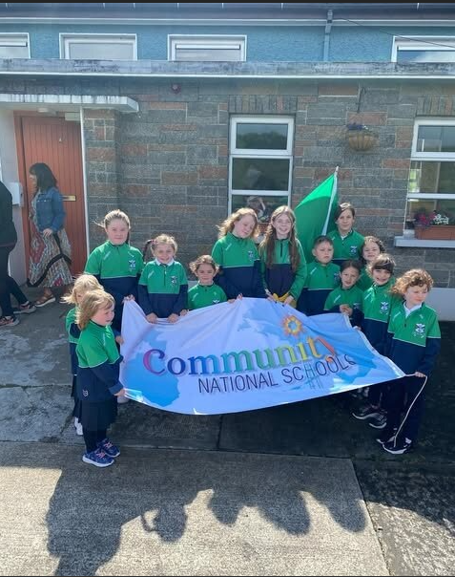

Goal 3: Opportunities for Greater Organisational Synergies (continued)
Ref. | Objective | Performance Milestones 2024
3E | Establish a dedicated evidence-based research and development function to support decision-making | On review of objective 3E Kerry ETB decided to engage with 3rd level institutions instead of developing its own research function to leverage on existing research and expertise. An MOU with Mary Immaculate College has facilitated the publication of research in the implementation of UDL in primary, post primary and FET within Kerry ETB.  Kerry ETB Quality Assurance systems have continued to develop with constant review and evaluation. Kerry ETB has fostered a closer alignment in research, policy implementation, curriculum development and QA communications. Initiatives such as the Quality News E-Zine and QA briefings have standardised information sharing, ensuring all FET educators have access to up-to-date, evidence-informed practice. This integrated model supports smarter, data-driven decision-making.
3F | Establish more linkages for the integration of youth services with schools and FET | In 2024, Kerry ETB launched its first-ever Youth Work Plan, marking a significant milestone in delivering coordinated, values-led youth services across the county. The plan was shaped by meaningful engagement with young people, youth workers, education staff, and community partners, ensuring it reflects the real needs and aspirations of young people in Kerry. The plan outlines strategic priorities around participation, inclusion, mental health, digital safety, and transition supports, reinforcing Kerry ETB’s commitment to youth voice and wellbeing. Its cross-pillar relevance spanning schools, FET, and youth work underscores a whole-organisation approach to inclusion and creates a strong foundation for responsive, joined-up youth supports.  The Youth Work Development Plan 2023-2027 was launched in February 2024. A key objective of the plan is to establish more linkages for the integration of youth services with Schools and FET provision.  Transition Year to FET Progression Pathways - see Goal 1D
3G | Create more opportunities to engage with all our stakeholders to better understand their needs and address specific requirements and expectations | Through a wide array of engagements from the Sustainability Strategy consultation to the Kerry LCYP Film Project and the 50-year celebration of the SHEP partnership Kerry ETB continued to embed stakeholder collaboration at every level. These events gathered voices from learners, educators, partners, and community groups, shaping policy through lived experience. Strategic engagements, such as the Climate Action Plan and FET/Schools collaborations, ensured Kerry ETB remains responsive to evolving societal and learner needs.  Board subcommittees, including Boards of Management and Governance Boards, continued to play a key oversight role throughout 2024, informing delivery.  Stakeholders, including young people, learners, and parents/guardians, were consulted across a range of forums, including student forums, parent councils, Kerry ETB Parent Forum, and learner surveys.  We maintained continuous engagement and constructive consultations with our staff and relevant unions. These interactions played a crucial role in fostering collaboration, addressing concerns, and ensuring inclusive decision-making processes within our organisation.  In 2024, Kerry College’s Business Support Unit engaged with employers across the region through a variety of activities, including business and Chamber meetings, as well as briefing employers at a regional level.  Kerry College successfully hosted its annual recruitment fair and Open Week, providing an interactive platform for prospective learners and the community to explore the diverse academic offerings and opportunities available.

Goal 4: A Leader in Education and Training Services
We aim to establish ourselves as a leader in the development of education and training at both regional and national levels.

Ref. | Objective | Performance Milestones 2023
4A | Proactively expand the accessibility of the ETB’s support services to non-Kerry ETB schools and centres | The REALT team supported over 450 Ukrainian students across non-Kerry ETB schools, while the Regional Adult Literacy Coalition (RALC) made significant inroads with non-affiliated centres.
4B | Promote Kerry ETB as a key regional employer to prospective job applicants | In 2024, Kerry ETB made visible strides in strengthening its reputation as a key regional employer. A blended working pilot was successfully rolled out at Head Office, reflecting Kerry ETB’s commitment to modern, flexible work practices and staff wellbeing. This initiative supports work-life balance while maintaining productivity and collaboration.  To attract high-quality candidates aligned with organisational culture, recruitment campaigns were shared widely on social media, with videos that include Kerry ETB’s core values: Inclusion, Respect, Equality, Quality, and Excellence in Learning.
4C | Demonstrate innovative leadership in identifying and delivering future local and national development skills in response to local and national labour trends. | By launching degree-level nursing programmes in partnership with MTU, Kerry ETB demonstrated leadership in addressing Ireland’s nursing shortage while removing geographical barriers to third-level study.  The ICDL Digital Marketing Pathway with Discover Kerry. These responses to emerging industry needs align with national strategy and illustrate proactive labour market alignment.  The Digital Media Production (Level 6) course at Kerry College’s Clash Campus is another key example of Kerry ETB’s responsiveness to future labour market needs. Designed to prepare learners for careers in the fast-growing digital economy, the course equips students with advanced technical and creative skills relevant to media, marketing, and content creation sectors. With hands-on learning from day one, it supports learners in building strong portfolios and accessing employment or further study in areas aligned with Ireland’s digital transformation priorities. This programme exemplifies Kerry ETB’s commitment to delivering future-ready education that matches industry demand with learner potential.  Kerry ETB’s TY-to-FET Career Exploration Modules, delivered at Monavalley Campus, exemplify a forward-thinking approach to building early awareness of future skills pathways. These practical, hands-on modules ranging from engineering and construction to media production, game design, and culinary arts introduce Transition Year students to in-demand industries aligned with Ireland’s National Skills Strategy. By engaging students at a pivotal stage in their education, these tasters support informed decision-making, promote FET as a viable first choice, and ensure that learners are exposed to high-quality skills training from an earlier age. This proactive model strengthens progression routes and helps build a pipeline of talent for priority sectors in the regional and national economy.  In 2024, Kerry ETB continued to demonstrate its commitment to delivering responsive, industry-aligned training through the Animal Grooming course at An Tóchar, Causeway. This QQI Level 5 programme is run in a fully equipped grooming salon and attracts a diverse learner base.  The expansion of the O’Connell FET Centre aligns with Kerry ETB’s strategic aim to anticipate and respond to evolving labour market demands. With the introduction of a practical hairdressing traineeship, the first of its kind in the region. Kerry ETB demonstrates proactive leadership in skills planning. The centre now provides industry-relevant, hands-on training in a modernised, learner-focused setting.
4D | Build stronger relationships with employers in the region through the establishment of a Kerry ETB Employers Forum | The ICDL Digital Marketing programme, launched in collaboration with Discover Kerry, is a model of employer-driven education that strengthens Kerry ETB’s ties with regional industry. This innovative initiative was developed in direct response to identified skills gaps and employer needs. Its flexible four-step pathway, hands-on mentoring, and progression opportunities (including an advanced ICDL and a new apprenticeship programme) position Kerry ETB as a responsive and proactive partner for business.  Kerry ETB has sought the sanctioning of a dedicated post for an enterprise engagement officer to work exclusively in the co-ordination and promotion of employer engagement and skills to advance.  By engaging employers early and often from programme development to learner mentorship Kerry ETB is building trust, strengthening relationships, and proving the value of education in driving regional economic growth and embedding employer engagement in the DNA of our programme design and delivery.

Goal 4: A Leader in Education and Training Services (continued)
Ref. | Objective |  | Performance Milestones 2023
4E | Publish the second Kerry ETB Sustainability Strategy 2023-2025 and establish a sustainability support function to address sustainability matters |  | In 2024, the Kerry ETB Sustainability Strategy 2024 – 2026 was finalised. The Sustainability Strategy 2024 – 2026, adopted by the Kerry ETB Board on 28th May 2024, builds on the progress of the Sustainability Strategy 2020 – 2022.  Some key milestones achieved in 2024 include:  - Appointment of a permanent Sustainability Officer  - Under the Solar for Schools Programme all Primary and Post Primary Schools that did not have solar panels received a 6kw Solar PV Panels array.  - Kerry ETB, similar to other ETBs, were granted “Green Devolved Capital” in November 2024 by SOLAS. For 2024 Kerry ETB has been sanctioned €507,500. This funding was used in 2024 to undertake  - A deep retrofit was being undertaken in Castleisland Community College as part of the Schools Pathfinder Program. The school has been retrofitted and upgraded to a Building Energy Rating (BER) of B and provided with renewable heating to reduce CO2 emissions. The school is one of fourteen Schools nationally that had been selected for the Pathfinder Program in 2024.  - Kerry ETB distributed the first traunch of devolved green capital across FET including the purchase of the first electric bus and the installation of solar panels across multiple sites.
4F | Build on existing relationships with the local Gaeltacht and non-Gaeltacht communities to support the use of Irish as a living language |  | Strong ties with the Gaeltacht community were reinforced through Gaelbhratach activities and Irish-language collaboration between schools, e.g., the 'Tóg Amach Mé', TY collaboration.  Scoil an Ghleanna’s designation as a Gaeltacht Community National School marked a national first, showcasing Kerry ETB’s leadership in Irish-language education.  Commenced TEG course for Kerry ETB Head Office staff.  Delivered training provision through the Irish language to 177 beneficiaries,  Supported the appointment of the Tralee Language Planning Officer.
4G | Foster and develop mainstream European and international opportunities for learners and staff |  | Erasmus+ expanded across schools and FET, with multiple successful mobility projects -  - Killorglin Community College: Student mobilities to the Netherlands, Spain, Italy & Belgium  - Coláiste na Ríochta, Listowel: Student mobilities to Spain  - Causeway Comprehensive: Student mobilities to France  - Gaelcholáiste Chiarraí, Trá Lí: Student mobilities to Germany  Accredited Erasmus status was awarded to the FET sector, securing future funding and ensuring learner and staff access to international learning.  Staff exchanges, including Normandy and Western Norway visits, enriched collaboration.  We made significant progress in establishing an organisational staff and learner mobility programme with the appointment of a European Union Projects Development Officer.
4H | Strengthen existing and build new relationships with government departments, funders, ETBs, universities, community organisations and other education and training providers |  | Multi-stakeholder collaborations developed in 2024, exemplified by events like the SHEP 50th Anniversary and joint initiatives with MTU and tertiary providers. These partnerships supported transitions, curriculum development, and community engagement aligned to national education strategies.  Worked in collaboration with Department of Youth and Údarás na Gaeltachta to secure funding for Irish Language Youth Workers in the two Kerry Gaeltacht areas.  Continued to engage with UCC under the 2023 MOU.
Goal 5: Communications, Brand Awareness and Shared Understanding of Kerry ETB
We aim to develop Kerry ETB into a widely recognised brand underpinned by high-quality communications with internal and external stakeholders.

Ref. | Objective | Performance Milestones 202
5A | Promote Kerry ETB as the first-choice education and training provider in Kerry | Throughout 2024, Kerry ETB continued to strengthen its position as the first-choice education and training provider in Kerry by delivering high-quality programmes, celebrating learner success, and hosting standout events that showcased our commitment to excellence, inclusion, and innovation. Our learners and staff achieved national recognition across multiple platforms, reflecting the strength and impact of our education and training service.  Awards and Achievements:  - Maths Eyes National Award – Caoimhe O’Gorman (presented by Minister Norma Foley).  - LGBTQ+ Quality Mark – Awarded to Killorglin Community College and Coláiste Gleann Lí.  - Intellectual Property Award – Castleisland Community College students.  - Platinum Science Award – Two Mile Community National School, recognised by Science Foundation Ireland.  - Rotary Youth Leadership Development Competition Winner – Mischa McCarthy, Killarney Community College.  - RDS Craft Award – Killian O’Flaherty, former Kerry College apprentice.  - Animation Competition Winner – Oran Hamilton at the Dingle Animation Festival 2024.  - Headline Mental Health Media Awards – Siobhan Brosnan shortlisted for her journalism project.  - Young Social Innovators of the Year Finalists – Castleisland Community College and Killorglin Community College.  - LCYP Project – RTÉ Factual Award for 'Home from Home' documentary created by Ukrainian youth.  - Former Killarney Community College student Colin O’Sullivan’s novel ‘The Dark Manual’ adapted by Apple TV+.  - Darragh Scanlon (Gaelcholáiste Chiarraí graduate) featured in the Irish Independent’s 30 Under 30.  Key Events in 2024:  - Kerry College Graduation Ceremonies.  - Kerry ETB Student Awards celebrating Youthreach and 8 Post-Primary Schools.  - Official Opening of Gaelcholáiste Chiarraí by Minister for Education, Norma Foley, T.D.  - Kerry ETB’s Annual Christmas Card Competition promoting inclusion.  - International Students Day at Kerry College Clash Campus.  - Kerry College hosted the first National Commis Chef Apprenticeship Competition.  - Kerry College Content Development for Film & TV Course praised at national level.  - Launch of the Kerry ETB Youth Work Plan 2023–2027  - Kerry ETB’s Adult Literacy for Life Graduation – Butler Centre, Listowel.  - O’Connell FET Centre Official Opening following major refurbishment.  - Transition-Year Students across Kerry completed industry-recognised Level 4 certifications.  - Music Generation Kerry Summer Band Camp with final performances at Siamsa Tíre and Féile Thrá Lí.  - LCYP Youth Film Day and Diversity & Inclusion Film Lab showcases.  - Empowering Inclusion Event at Ballygarry Estate Hotel, supporting inclusive employment.  - Official First Day of Lyreacrompane Community National School under Kerry ETB patronage.  A dedicated social media campaign showcased alumni success stories, featuring graduates from Art, Animal Grooming, Yoga Instruction, Applied Science, and Office Administration.  Kerry ETB’s values were embedded in all messaging, strengthening brand identity and community trust.

Goal 5: Communications, Brand Awareness and Shared Understanding of Kerry ETB (continued)
Ref. | Objective | Performance Milestones 2023
5B | Transition from a fragmented communications model to a fully resourced, dedicated Kerry ETB communications function | A permanent Communications Officer was appointed in Q4 2024.  A new Scheme-Wide Communications Plan was initiated to establish a more cohesive and strategic approach to internal and external communications across all Kerry ETB departments. This plan outlines clear roles and responsibilities, promotes consistent messaging aligned with organisational values, and supports proactive engagement with stakeholders. The plan also includes the development of content guidelines, enhanced use of digital platforms, and improved coordination of media relations to strengthen Kerry ETB’s brand visibility and public profile.
5C | Adopt and launch a new Kerry ETB brand to enhance awareness and highlight the range of education and training services available to all learner cohorts | In 2024, Kerry ETB maintained strong momentum in brand integration following the 2023 launch.  Newly developed digital and print materials complied with branding guidelines were regularly reviewed to ensure consistency.  Monitoring showed sustained growth, with website traffic and engagement remaining significantly higher than pre-launch levels.  Staff continued to receive guidance and support on brand application to reinforce Kerry ETB’s unified visual identity across all communications.
5D | Enhance communications with internal stakeholders in a structured manner | In 2024, Kerry ETB initiated the development of the 2023 newsletter by issuing clear content guidelines and submission deadlines to all departments.  Planning commenced for the 2025 staff engagement event, with themes and speakers identified early to facilitate timely preparation and maximise impact.  Line Managers’ Communications Day was held in June 2024. This dedicated event supported the development of the Communications Plan and provided targeted training on communications policies, reinforcing internal consistency and strengthening communication practices across the organisation.

Goal 5: Communications, Brand Awareness and Shared Understanding of Kerry ETB (continued)
Ref. | Objective | Performance Milestones 2023
5E | Enhance communications with external stakeholders in a structured manner | In 2024, Further Education and Training (FET) was consistently positioned as the “first choice” for learners in all external communications, including press releases, social media, and public relations activities. This messaging was applied across platforms to ensure a unified, strategic voice that aligned with national FET priorities.  Kerry ETB also contributed four compelling learner success stories to the SOLAS national school leaver campaign, showcasing the transformative impact of FET. These stories highlighted real-world outcomes and diverse learner journeys, resonating with prospective students, parents, and education stakeholders nationwide.  Significant progress was also made on the accessibility and user experience of the Kerry ETB website. Following a review and the procurement of a new website provider, the accessibility score of the site increased from 40% to 50.36%. This improvement reflects a focused effort to ensure all users regardless of ability can easily access essential information. Work continues to ensure all departments review and update their content in line with accessibility standards.
5F | Ensure all Kerry ETB materials publications are widely available, accessible and understood | In 2024, Kerry ETB initiated a Plain Language training programme, beginning with the Communications Officer, who completed the certified training in November 2024.  This foundational step supports the organisation’s wider goal of making all communications clearer, more inclusive, and easier to understand for all audiences.
5G | Maximise opportunities to communicate our culture and core values across internal and external audiences | Throughout 2024, Kerry ETB strengthened its commitment to communicating its core values Inclusion, Respect, Equality, Quality, and Excellence in Learning, across all internal and external platforms. A key milestone in this effort was the systematic inclusion of the organisation’s core values in all job advertisements on social media Reinforcing the brand identity and demonstrating Kerry ETB’s values to prospective applicants and the wider public.  The Youth Work Plan is a values-led initiative. It reflects Inclusion, Respect, Equality, Quality, and Excellence in Learning and promotes these through both its content and collaborative development process. That makes it a strong tool for reinforcing and communicating the organisational culture outwardly.  The 2024 edition of the Kerry ETB newsletter featured a dedicated section on organisational culture, highlighting real examples of inclusion, teamwork, and respect in practice across the organisation. This initiative not only celebrated staff achievements but also served as a platform to deepen internal understanding and commitment to the values that define the Kerry ETB culture.
5H | Support management and staff to become key communicators | In June 2024, Kerry ETB’s Line Management Day placed a strategic spotlight on communications. The day included a dedicated Email Etiquette training session, supporting line managers in upholding Kerry ETB’s core values Inclusion, Respect, Equality, Excellence, and Learning through clear, professional, and value-driven written communication. The session explored practical dos and don’ts, tone of voice, and strategies for maintaining professionalism in internal and external emails.  Alongside the training, managers were invited to identify and share the communications training needs of both themselves and their teams. This feedback is now informing the development of the 2025 communications training programme, which aims to expand communication capacity at all levels of the organisation.  Training sessions were held throughout 2024 to support staff on the OSD pillar and the SYM pillar on the shared platform KOLLAB.

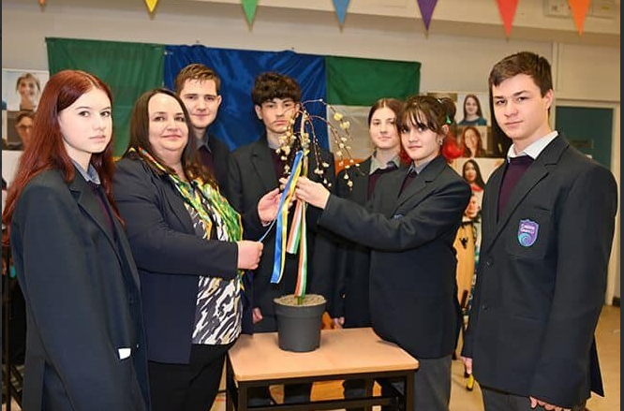

Kerry ETB Strategic Reports

Communications Plan 2025 - 2027

Corporate Procurement Plan 2023-2024

Customer Charter and Action Plan 2023-2025

Further Education and Training Buildings Estate Strategy

ICT Strategy 2023-2027

Irish Language Plan 2020-2023

Local Creative Youth Partnership Strategy 2023-2027

Public Sector Equality and Human Rights Duty Action Plan 2024-2026

Quality Assurance Action Plan 2022-2027

Strategic Performance Agreement 2022-2024

Sustainability Strategy 2024-2026

Universal Design for Learning Plan 2023-2025
Youth Work Development Plan 2023-2027

Communications Plan 2025 - 2027
Significant progress has been made on the development of the Kerry ETB Communications Plan, which is on track for completion in 2025.

The draft communications plan was presented at senior leadership team communications event in June 2024. Senior leadership were afforded the opportunity to provide additional feedback on the draft communication plan objectives following the event.

This plan is a key strategic initiative developed to directly support and align with Kerry ETB’s broader strategic goals, ensuring that communications efforts reinforce Kerry ETB’s mission, vision, core values, and long-term objectives.

A central component of the plan is the formation of a cross-pillar working group, drawing representatives from Kerry ETB’s three pillars (Organisational Support and Development, Schools Youth and Music, Further Education and Training). This group will ensure consistency in messaging, foster alignment across pillars and help translate strategic objectives into clear, cohesive communications.

The group, known as the Communications Cross-Departmental Implementation Group, will meet quarterly and use the Governance Compliance and Risk management software system to track progress, assign actions, and support transparent follow-up. Updates from each meeting will feed into the development of the Annual Communications Report, which forms part of the Kerry ETB Annual Report, ensuring our work is measurable and strategically aligned.

Membership includes a manager, a communications-focused staff member, and a union representative from each pillar, reflecting a balanced and inclusive structure.
The collaborative nature of this work underscores Kerry ETB’s commitment to inclusive planning and continuous improvement. To ensure relevance and impact, the group’s effectiveness and Terms of Reference will be reviewed annually, with adjustments made as needed based on feedback and organisational priorities.

Corporate Procurement Plan 2023-2024
Performance milestones achieved in 2024 are as follows:
- The continued implementation of the 2023 Procurement Policy and Procedure (Revision).
- The implementation of Centralised Procurement and Purchasing function was completed.
- Increased utilisation of the Office of Government Procurement Schedule of Frameworks and Contracts.
- Completion of identified procurement competitions, including competitions for Agency Staff, Alarms Maintenance and Repair (Security & Fire) Monitoring and Key Holding, Engineering Consumables FET, Welding Tools & Equipment, Phone Systems

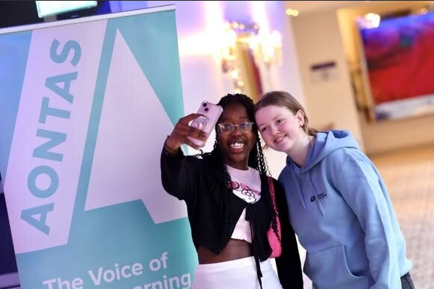

Customer Charter and Action Plan 2023-2025
The Customer Charter serves as a foundational document outlining Kerry ETB service standards, customer commitments, and the mechanisms for feedback and accountability. The implementation phase has focused on embedding the Charter into our operational culture, enhancing service delivery, and improving customer satisfaction.

The Charter has been made available on Kerry ETB’s website and is displayed in customer-facing areas.

A formal review of the Charter is scheduled for the end of the next quarter to capture lessons learned and integrate improvements.

Further Education and Training Buildings Estate Strategy
In 2024, progress continued in the development of a Further Education and Training Buildings Estate Strategy. The strategy is anticipated to be finalised by Quarter 4, 2025.

ICT Strategy 2023-2027
The Kerry ETB ICT Strategy 2023-2027 was approved at the ETB Board meeting on November 7th, 2023. An ICT Strategy implementation group has been established to plan, monitor and review all objectives and actions identified in the 2023 – 2027 ICT Strategy.

The group plans to meet every three months and in 2024 the group met on five occasions: -
- 20th February 2024
- 16th April 2024
- 28 May 2024
- 14 Oct 2024
- 3 Dec 2024

Kerry ETB, in 2024 made notable progress under its ICT Strategy (2023-2027). Key achievements include expanding the Wide Area Network (WAN) architecture and rolling out Kollab, Kerry ETB MS 365 across Kerry ETB OSD and SYM Pillars.

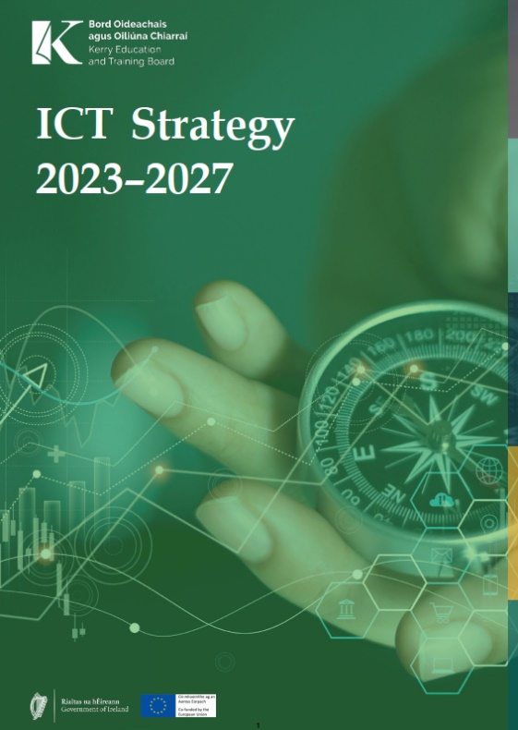
On cybersecurity, Kerry ETB is working toward compliance with Public Sector Cyber Security Baseline Standards. An Information Security Management System (ISMS) team has been appointed to oversee the implementation of the ISMS and liaise with KOSI and the IAU in relation to the frameworks implementation. Throughout 2024, Kerry ETB was engaged in the implementation of the first three ISMS Audit Areas: -

1. Corporate Governance
2. Asset Management
3. Risk Management.

The establishment of policies and procedures, initiation
of risk assessments, and alignment of ISMS objectives
with business goals. Kerry ETB were audited on the
ISMS implementation in Q4 2024 and following receipt
of the audit report Kerry ETB achieved an adequate finding.

Irish Language Plan 2020-2023
The Irish Language Plan 2020 – 2023 was extended to 2024
The following milestones were achieved in 2024.

Towards a bilingual public service:
- 20% of recruits in the public service to be competent in Irish by 2030.
- As the act gives recognition under the constitution as the first language of the state. Citizens have the right to do business through the medium of Irish.
- Kerry ETB is committed to providing services and classes in Irish in Corca Dhuibhne and Bi-lingually in Dingle.

Kerry ETB Progress to date:
- Voicemail (Glórphost) & Out of Office (As an Oifig) automatic replies. (Gaeilge ar dtús) Lámhleabhar/ Irish Language Handbook was launched.
- Irish Language courses for 13 Staff. Staff Survey (TEG A2 level)
- Advertising/signage/speeches etc with Irish content.
- Kerry ETB is the lead agency in the appointment of Language Planning Officer in Tralee. The candidate took up position on November 6th, 2024.

Local Creative Youth Partnership Strategy 2023-2027

Implementation across all Strategic Priorities of the Local Creative Youth Partnership Strategy 2023-2027 continued including:
- Engagement of children and young people in informing programme definition and delivery
- Progression towards inclusivity across all projects, using a phased basis approach
- Improved quality and visibility in the work of LCYP in the areas of social media marketing, traditional press, and radio presence.
- Introduction of new evaluation processes to enhance feedback from young participants

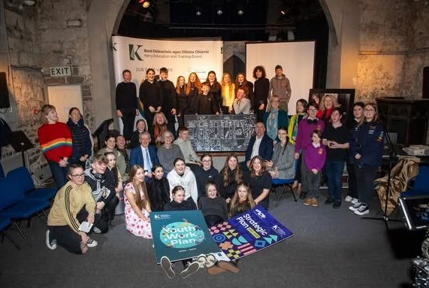

Public Sector Equality and Human Rights Duty Action Plan 2024-2026

Kerry ETB is committed to a policy of equal opportunity, adopts a positive approach to equality in the organisation and seeks to ensure fair and equitable treatment under the nine grounds set out in the Equal Status Act.

Section 42 of the Irish Human Rights and Equality Commission Act, 2014, the Public Sector Equality and Human Rights Duty, requires Public Bodies to undertake a process to Assess, Address and Report in relation to the promotion of equality and prevention of discrimination across all functional areas of Kerry ETB.

In 2024 Kerry ETB published its Equality and Human Rights Values Statement, Assessment and Implementation Plan. Work was ongoing in 2024 in the implementation of this plan and included a workshop for Senior Management to progress this area of activity.

Kerry ETB continues to give due regard to the promotion of diversity and inclusion in all aspects of its governance and operations, in line with its statutory obligations and values. The composition of the Board reflects this commitment, with 10 women and 11 men currently serving as members. Notably, the Chair of the Board is a woman, underscoring the organisation’s dedication to gender balance at the highest level of decision-making.

At the executive level, diversity is also evident, with the senior management team comprising 8 members: 5 women and 3 men. This representation supports a broad range of perspectives and inclusive leadership practices across the organisation.

During the reporting period, significant work was undertaken to initiate a comprehensive culture audit across the organisation (to be completed in 2025). This process aims to assess the current organisational climate with regard to diversity, equity, and inclusion and provide recommendations to guide future improvements in promoting an inclusive workplace culture. The findings will inform strategic planning and targeted actions to ensure continued progress in fostering an environment where all individuals feel respected, valued, and empowered to contribute.
Quality Assurance Action Plan 2022-2027
Kerry ETB’s Quality Action Plan 2022 – 2027 continued to be implemented in 2024. An Annual Quality Implementation Plan was developed by the QA Unit for the FET Quality Council. This was reported on by the QA Manager at each of the FET Quality Council meetings that took place in
- February
- March
- May
- June
- July
- October
- December
Key milestones and outcomes are reported in the 2024 FET Quality Council Annual Report which is published on Kerry ETB’s website along with meetings notes.
Some key milestones identified in this report were:
- Extensive Learner Engagement: More than 16,000 Beneficiaries participated in Kerry ETB FET courses in 2024, with courses designed to improve knowledge, abilities, and opportunities for work, further education, or voluntary/community work.

- Robust Programme Development and Approval: The Programme Governance Board considered 33 new course approval applications and approved 31 in 2024. These included applications to seek approval to write new programmes as well as approval for programmes written by Kerry ETB programme development groups or received from other ETBs. Included were programmes and courses developed to meet specific industry or community needs, covering diverse areas such as Commercial Scuba Diving, Animation and 3D Character Creation, Sustainable Supply Chain Procurement, Lean Practice for Sustainable Business, Animal Science Level 5, and Sommelier.

- Successful Implementation of Blended Learning: The FET Quality Council continued to support blended learning delivery via MS Teams and approved 19 courses to run in this format.

- High Certification Levels and Positive Outcomes:
  - A total of 5,368 results were ratified in 2024 (1,425 major awards, 3,803 minor awards, and 140 special purpose awards).
  - This represents a 55% increase in total certification levels compared to 2023, with an 84% increase in minor awards. The increase in minor awards is noted as potentially indicative of providing flexible opportunities and recognized certificates for learners who may not complete a major award, helping them build towards future learning.
  - Learners achieved high standards in graded certifications, with 1,815 Distinctions, 925 Merits, and 780 Passes awarded.
  - Certification was achieved across a range of awarding bodies beyond QQI, including City & Guilds, ICDL, METLAB, iTEC, and VTCT, with a marked increase seen in City & Guilds, ICDL, and iTEC certification.

- Positive Learner Feedback and Impact: Analysis of the learner/apprentice survey showed that the majority of participants rated their course very positively. Learners reported significant positive impacts, including gaining 'new experiences', building 'self-confidence', 'making new friends', and developing a more 'positive outlook on the future'. A majority also reported that their digital skills improved. "Getting employment" was frequently cited as a reason for taking a course.

- Enhanced Staff Professional Development: FET staff undertook significant Continuous Professional Development (CPD) in 2023, with 4,576 hours of CPD and 1,095 staff engagements across 87 distinct events. A substantial portion (38% of events, 62% of engagements) focused on "Working with and supporting learners," addressing areas like autism, challenging behaviour, trauma-informed approaches, and restorative practices. A successful FET Staff Day was held in March 2024, focusing on Equality, Diversity, and Inclusion.

- Robust Quality Assurance Processes: The FET Quality Council provided central oversight for quality assurance, supported by the diligence and contributions of its members. The Annual Quality Plan for 2024 was approved and actions tracked. The Council ratified results for certification. External Authentication processes were conducted for 116 days by 37 authenticators, with reports highlighting good practice in assessment planning, clear deadlines, feedback, and the use of technology. Three assessment procedures were reviewed and modified, and a consultation process commenced on another.

- Active Learner Voice Engagement: Learners were given the opportunity to attend FET Quality Council meetings and share feedback. The annual learner/apprentice survey was conducted, and its key findings were considered. Kerry ETB also partnered with Aontas to facilitate a Regional FET Learner Forum, providing learners with an additional platform to share their experiences and ideas. Learners were also involved in the review of the Learner Engagement Handbook.

- Engagement with Employers: Kerry ETB actively engaged with employers through various activities, including business and chamber meetings and briefings, which is critical for determining and delivering courses that meet specific skills and societal needs.

- Role in Apprenticeships: Kerry ETB served as the co-ordinating provider for two post-2016 apprenticeships: Commis Chef and Wind Turbine Maintenance Technician. The FET Quality Council provided oversight to ensure programme development and delivery aligned with employer needs and labour market trends. Results for both Year 1 completion and full award completion were ratified for the Commis Chef apprenticeship. Modifications to apprenticeship programmes were considered and approved, and the revalidation process for the Wind Turbine Maintenance Technician programme commenced. External authentication processes were conducted for both apprenticeships.

Strategic Performance Agreement 2022-2024
The following table provides a comprehensive overview of our 2024 target performance as per the Strategic Performance Agreement (SPA) 2022-2024 with SOLAS.

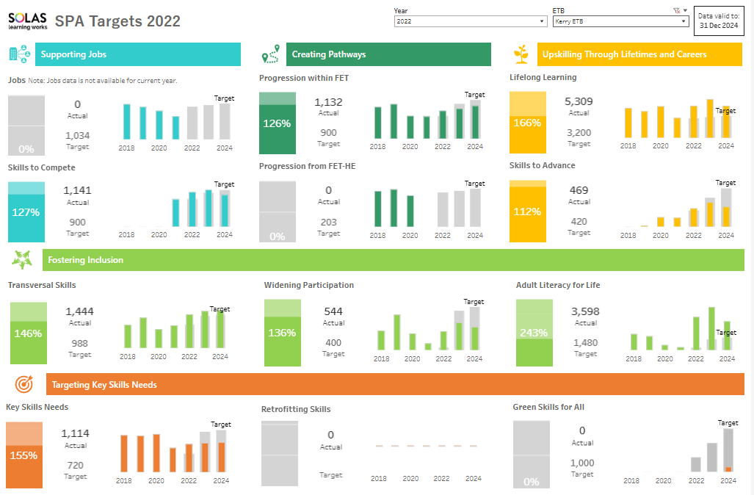

Information Source SOLAS

Sustainability Strategy 2024-2026
In 2024, the Kerry ETB Sustainability Strategy 2024 – 2026 was finalised. The Sustainability Strategy 2024 – 2026, adopted by the Kerry ETB Board on 28th May 2024, builds on the progress of the Sustainability Strategy 2020 – 2022.
The Sustainability Strategy 2024 – 2026 sets out Kerry ETB’ commitment to enhancing existing, and adopting new, sustainable practices which are aligned with Kerry ETB’s overall vision.
The Sustainability Strategy 2024-2026 focuses on five key areas:
1. Staff Engagement
2. Student, Learner & Apprentice Engagement
3. External Stakeholder Engagement
4. Energy Sustainability
5. Estates Management
Underpinning these five key goals are nine strategic objectives that address Climate Action and Sustainability across a broad range of areas including: estates management, energy management, sustainable transport and green spaces.
The Kerry ETB Climate Action Plan 2025-2026 was adopted by the Kerry ETB Board on 25th February 2025. The Climate Action Plan sets out how Kerry ETB will achieve the five goals and nine objectives of this Sustainability Strategy.
Some key milestones achieved in 2024 include:
- Under the Solar for Schools Programme all Primary and Post Primary Schools that did not have solar panels received a 6kw Solar PV Panels array. These panels will help schools reduce electricity costs and assist in Kerry ETBs overall carbon reduction goals.
- In October 2024 Kerry Education and Training Board transitioned from a paper-based Travel and Subsistence Claims system to an online system. This means that all travel claims will now be processed on a paperless basis.
- Kerry ETB, similar to other ETBs, were granted “Green Devolved Capital” in November 2024 by SOLAS, funded by the Department of Further and Higher Education, Research, Innovation and Science (DFHERIS). The funding is provided to improve sustainability and Energy Efficiency in FET properties, in the ownership of Kerry ETB. For 2024 Kerry ETB has been sanctioned €507,500. It has been confirmed that the same level of funding will be made available to ETBs for a further two years. Therefore, in the next three years €1,522,500 in funding will be made available to Kerry ETB. Kerry ETB plan on using the initial tranche of “Green Devolved Capital” to address some of the recommendations of the Energy Audits previously undertaken.
- A deep retrofit was being undertaken in Castleisland Community College as part of the Schools Pathfinder Program. The school has been retrofitted and upgraded to a Building Energy Rating (BER) of B and provided with renewable heating to reduce CO2 emissions. The school is one of fourteen Schools nationally that have been selected for the Pathfinder Program in 2024.
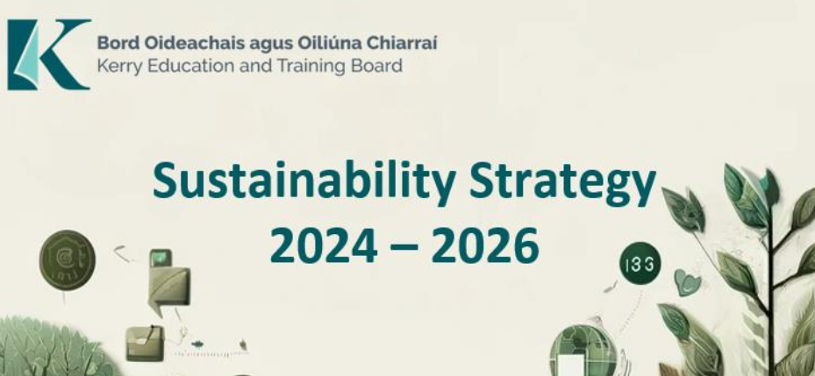

Universal Design for Learning Plan 2023-2025
Implementation of the 3-year Universal Design for Learning Plan continued in 2024. Performance milestones highlighted as follows:

18 Kerry ETB FET staff received UDL Digital badges from AHEAD this year. 5 of these staff undertook a new digital badge UD Beyond the Classroom. For the first time Kerry ETB also had 2 facilitators from Kerry college. Dr Jean Reale, Assistant Professor of Academic Practice at Mary Immaculate College (MIC) supported Kerry College staff in Listowel and Tralee with UDL sessions on assessment. One of the Kerry College Clash staff was nominated for the John Kelly award for UDL in 2024.

Discussions began with Mary Immaculate College on a Memorandum of Understanding. This will allow Kerry ETB to benefit from the pedagogical expertise of Mary Immaculate College staff and also create synergies between Kerry College ETB’s leadership programme and MIC’s masters in education leadership.

A survey of Kerry ETB post primary students took place in March 2024. Participants were surveyed anonymously. The results were analysed and shared with Principals. The session took place in June 2024 to discuss the results of the survey and actions that would be needed across schools.

AI guidance for teachers and a draft AI policy for schools were developed.

The new teacher Induction for post primary teachers featured a 1 hour UDL session introducing all the teachers to UDL concepts.

The UDL Community of Practice whose membership consists of teachers from primary, post-primary, and FET met in January to share good practice. A meeting was scheduled for September 2024 this did not take place until January 2025.

Teachers Across The 8 post-primary schools received support around migration to the new Kerry ETB cloud from September to December. All-staff, subject department and individual sessions took place to ensure that the technology was set up to support teachers classroom practice.

One further school commenced a UDL class for first year students, five schools who now offer a UDL class for first year students.
Peer observation took place across schools for teachers to share their individual practice.

UDL priorities are built into all school SIP/ SSE/ DEIS plans.

Youth Work Development Plan 2023-2027
2024 saw the launch of Kerry ETBs inaugural Youth Work Plan which outlines the strategic objectives that guide the day-to-day operations of the Youth Development Office.
Kerry ETB Youth Development Office delivered actions in 2024 under the following headings:
Goal 1: Quality Youth Work Provision and Practice in Kerry
The primary focus of this goal is to enhance both universal preventative and targeted youth work across Kerry. Key actions included:
- Universal Youth Work: Supporting volunteer-led youth clubs through the promotion and administration of the Local Youth Club Grant Scheme, advocating for increased funding for club development officers, promoting youth volunteering, and providing integration training to clubs.
- Targeted Youth Work: Numerous engagements with Department officials regarding the under-resourcing of underserved areas (e.g., Mid Kerry, West Kerry) particularly focusing on marginalised communities and young people with additional needs.
- Integrated Model: Piloting integrated models of universal and targeted youth services, such as through minor grant schemes in Killarney and Killorglin.
- Quality Standards: Embedding quality standards into all youth service reviews and meetings, ensuring best practices are maintained.
- Inclusive Practices: Promoting culturally inclusive youth work responses, including support for migrant integration and Gaeltacht Irish language initiatives.
Significant progress has been made in mapping youth provision, securing additional funding for migrant integration and Gaeltacht youth work, supporting creative hubs, and coordinating interagency efforts to support vulnerable youth.
Goal 2: Governance and Sustainability
This goal emphasises strengthening governance structures within the Youth Development Office and funded organisations to ensure transparency, accountability, and sustainability. Key actions included:
- Internal Governance: Continued implementation of robust administrative systems and internal controls. This included the induction of new staff to the Youth Development office and review of existing systems.
- Monitoring and Compliance: Ongoing review and site visits to ensure compliance with Service Level Agreements, child protection protocols, health and safety standards, and financial accountability.
- Child Protection: Active participation in the Kerry ETB Child Protection Oversight Committee, ensuring that all youth services meet safeguarding requirements.
- Sustainability Advocacy: Representing youth work in pre-budget submissions and advocating for sustainable resourcing to maintain high-quality youth services.
Governance mechanisms have been strengthened through regular monitoring, unannounced visits, and structured reporting, while ongoing engagement with stakeholders ensures continuous improvement in governance standards.
Goal 3: Research, Promotion & Advocacy
This goal aims to elevate the visibility and impact of youth work through research, advocacy, and youth participation. Key actions included:
- Youth Voice: Strengthening youth participation via Kerry ETB Youth Work Committee, Comhairle na nÓg, youth advisory panels, and involvement in policy-making and planning processes. This also included the development of a comprehensive youth voice initiative in collaboration with Radio Kerry.
- Best Practice Sharing: Capturing and promoting examples of impactful youth work, attending national conferences, and organising networking events.
- Research & Evidence Base: Initial scoping of a research partnership with UCC to better understand youth needs and develop a best practice model.
- Advocacy: Coordinating stakeholder forums and promotion of Youth Work in Kerry through the launch of Youth Work Plan and ongoing participation on stakeholder forums.
Notable outcomes include the increased youth involvement in strategic planning, and the initiation of research partnerships to inform future service development.
Goal 4: Networking, Connecting & Collaborating
This goal focuses on building strong inter-agency networks and collaborative frameworks to enhance youth service delivery. Key actions included:
- Education Linkages: Developing a structured model connecting youth work with schools and FET, including referral pathways and integration days involving educators and youth workers.
- Multi-Agency Collaboration: Strengthening ties with family support services, social care, and statutory bodies to create cohesive support systems for all young people.
- Network Development: Engaging with ETBI Youth Work Network, participating in regional and national collaborations, and supporting the organisation of the ETBI Youth Work Matters conference.
- Language and Cultural Integration: Liaising with Irish language planners to support youth work in Gaeltacht areas and integrating cultural identity into service delivery.
- Supporting NEETs: Continuing collaboration on the TYESI initiative to provide tailored interventions for young people not in education, employment, or training.
Collaborative efforts have led to the successful implementation of the TYESI programme, stronger cross-sectoral partnerships, and the establishment of formalised linkages between youth work and further education systems.

Summary
The four goals collectively aim to strengthen youth work in Kerry through quality service delivery, robust governance, youth empowerment, and strategic collaboration. Significant progress has been made across multiple domains, including securing additional funding, improving governance compliance, enhancing youth voice, initiating research partnerships, and building inter-agency networks. Continued focus will be placed on sustaining these gains and addressing emerging needs through innovation and inclusivity.





Kerry Education and Training Board

Centrepoint
John Joe Sheehy Road
Tralee
Co Kerry
V92 P2FE

Tel: 066 7121488
Email: info@kerryetb.ie www.kerryetb.ie

