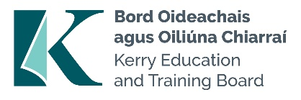

Kerry Education and Training Board Annual Report 2023

Kerry ETB Board 2023

Councillor Aoife Thornton Councillor Cathal Foley Councillor Deirdre Ferris Councillor Fionnán Fitzgerald
Councillor Jim Finucane (Chairperson) Councillor Johnnie Wall
Councillor Marie Moloney Councillor Maura Healy-Rae Councillor Michael Cahill Councillor Niall O'Callaghan Councillor Norma Moriarty
Councillor Terry O'Brien (Deputy Chairperson) Ms Tara Donoghue
Mr Niall Lucey Ms Celia O'Shea
Mr Joseph Brennan Ms Joan McCrohan Mr John O'Roarke Ms Maria O'Gorman Mr Tim Daly
Mr Zaid Kassoob

Kerry ETB Executive 2023
Mr Colm McEvoy Chief Executive
Ms Ann O'Dwyer Director of Schools, Youth and Music
Ms Maria Brennan Director of Organisation Support and Development
Mr Owen O'Donnell Director of Further Education and Training

Contents

Joint Foreword from our Chairperson and Chief Executive 4
Kerry ETB Board Statement 8
Kerry ETB: Our Community 17
Our Vision, Mission and Core Values 22
Organisational Structure 24
Strategic Performance Framework 25
Statement of Services 2023 27
Performance Delivery Agreement: Optimise Student/Learner Experience 27
Future Back Report Performance 33
Our Strategic Reports 59
Annual Communications Plan 59
Corporate Procurement Plan 2023–2024 59
Customer Charter and Action Plan 2023–2025 60
Further Education and Training Buildings Estate Strategy 60
ICT Strategy 2023–2027 61
Irish Language Plan 2020–2023 (Official Languages (Amendment) Act, 2021) 61
Local Creative Youth Partnership Strategy 2023–2027 62
Public Sector Equality and Human Rights Duty Action Plan 2024–2026 62
Quality Assurance Action Plan 2022–2027 63
Strategic Performance Agreement 2022–2024 63
Sustainability Strategy 2024–2026 65
Universal Design for Learning Plan 2023–2025 66
Appendix I: Glossary of Terms 67

Joint Foreword from our Chairperson and Chief Executive

As we reflect on the accomplishments and challenges of the past year, it is with great anticipation that we welcome you to the Kerry ETB Annual Report 2023. This report has been compiled in accordance with Section 28 of the Education and Training Boards Act, 2013.
In 2023, Kerry ETB embarked on a transformative journey guided by our strategic themes of “Adaptive Leadership,
Creativity, Economic Efficiency, Proactiveness, Strong Governance, and Sustainable Practices” and core values of “Inclusion, Respect, Equality, Quality and Excellence in Learning.” These themes and values have served as a compass to guide our actions and decisions throughout the year as we navigated the process of finalising the vision, mission and goals identified in our new Strategy Statement 2023-2027, "Building Your Future.”

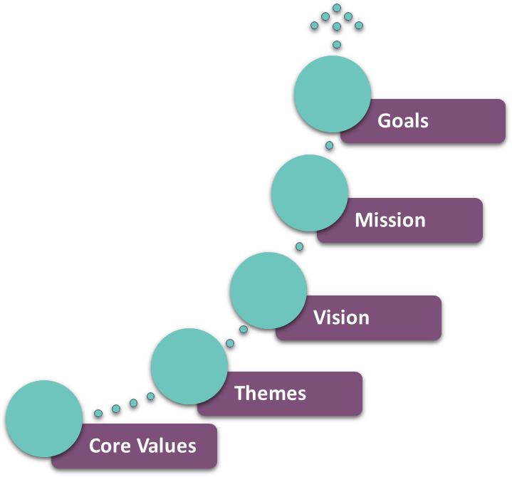

Our shared mission throughout Kerry ETB is to foster the development of a lifelong and life-wide learning society by ensuring equal and equitable access to education for every learner. In achieving this mission, our overarching vision for our organisation, as outlined in this latest strategy, is to lead with innovation in the design and delivery of education and training opportunities. It is important for us that these education and training opportunities adhere to the highest standards of quality and sustainability while also being inclusive of all individuals, especially those from identified groups under equality legislation.

As 2023 began, we initiated strategic dialogues with management and relevant staff teams. These in-depth discussions aimed to inform a Future Back Implementation Report under the new strategy, setting a clear trajectory towards the achievement of our long-term goals by 2027. Launched in our Tech Amergin Further Education and Training Centre in Waterville in June 2024, Strategy

Statement 2023-2027 is built around five key goals:
- Excellence in Education and Training Services
- Strong, Inclusive, and Respectful Organisational Culture
- Opportunities for Greater Organisational Synergies
- Leadership in Education and Training Services
- Communications, Brand Awareness, and Shared Understanding of Kerry ETB

Throughout the Statement of Services contained in this report, you will find the first overview of our progress in executing the strategy across our three core pillars: Schools, Youth, and Music; Further Education and Training; and Organisation Support and Development. These early implementation milestones stand as a testament to our team's dedication and hard work, strengthened, as always, by the unwavering support of our internal and external stakeholders.

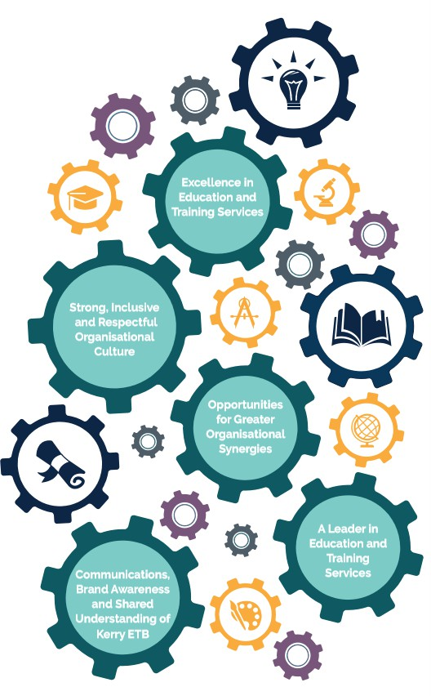
Figure 2 Strategy Goals

As we begin 2024, it offers us an opportunity to reflect on the past decade of our journey as an Education and Training Board. The growth experienced over these years is evidently marked by significant organisational changes, including the appointment of the three Directors, the transferring of patronage to Kerry ETB of three new Community National Schools, the establishment of Kerry College of Further Education and Training, and the construction of multiple devolved capital projects for non-ETB schools etc.

As the education and training landscape continues to evolve, Kerry ETB remains committed to embracing change with an innovative, inclusive and challenging mindset. We understand the importance of adapting to new challenges while remaining steadfast in our commitment to our core values and the fulfilment of our commitments under the Public Sector Equality and Human Rights Duty. With this approach, we are confident that we will continue serving our community effectively, meeting the evolving needs of our learners and stakeholders.

We want to take this opportunity to extend our sincere gratitude to all those past and present who have contributed to our journey not only in 2023 but over the past 10 years. As Chairperson and Chief Executive, together, we look forward to continued collaborations and partnerships with all our stakeholders into 2024 and beyond.

Throughout 2023, the work of the Executive was supported by the members of the Board and subcommittees. The Executive is very appreciative of your support over your respective terms, and we wish to thank all of you for your continued commitment.

We wish to thank the Directors, Senior Leadership Team, staff, learners, parents/guardians, and other invaluable stakeholders for their continued support of Kerry ETB, our shared community.
Best wishes to all our staff, learners, and stakeholders and continued success in 2024 as we continue to work together in

‘Building Your Future’ in line with Strategy Statement 2023-2027.

Councillor Jim Finucane Mr Colm McEvoy
Chairperson Chief Executive

Kerry ETB Board Statement

Kerry ETB was established under the Education and Training Boards Act, 2013. It is responsible and accountable for the proper direction and control of its functions in the Kerry local authority area.

Kerry ETB complies with the Code of Practice for Governance of Education and Training Boards, Department of Education Circular Letter 0002/2019. The purpose of the Code is to ensure that the principles of good governance and management are applied by Kerry ETB.

Functions of the Board
Decisions taken by the Board are reserved functions. Reserved functions are set out in Section 12 (2) of the Education and Training Boards Act, 2013, with a full schedule in Appendix A of the Code. Decisions not specified in the Code are deemed executive functions of the Chief Executive.

The Board is satisfied that the Chief Executive delegates functions where appropriate and in accordance with the Education and Training Boards Act, 2013.

Responsibilities of the Board
The Board is responsible for keeping proper books of account which disclose with reasonable accuracy at any time the financial position of the Board and which enable it to ensure that the Annual Financial Statements comply with Section 51 of the Education and Training Boards Act, 2013. The Board is also responsible for safeguarding its assets and for taking reasonable steps for the prevention and detection of fraud and other irregularities.

The Board considers that the Annual Financial Statements properly present the income and expenditure of the Board and the state of affairs of the Board. In preparing those accounts, the Board is required to:

  - Apply the standard accounting policies for the preparation of Kerry ETB’s financial
statements
  - Make judgements and estimates that are reasonable and prudent
  - Disclose and explain any material departures from the standard accounting policies

In 2023, the Board adopted/approved the following:
- Annual Report
- Financial Statements
- Service Plan
- Attendance of members at conferences
- Acquisition, holding and disposal of land or interest in accordance with Department regulations

In addition, the Board ensured accurate records were kept of meetings and decisions.

The Board ensures that the governance structure allows it to effectively fulfil its duties. Board members lead by example, setting a good governance tone and culture for the entire organisation. Collectively, the Board is responsible for the strategic direction and management of the organisation and overseeing the work of the Executive.

The Board always brings an informed, independent judgement on both performance and conformance.

Annual Report 2023

Board Meetings
The Board met on 10 occasions during 2023, with details of attendance outlined in the table below.

Table 1 Board Member Attendance | Nominating Body | 31.01.23 | 28.02.23 | 29.03.23 | 25.04.23 | 06.06.23 | 26.06.23 | 25.07.23 | 26.09.23 | 07.11.23 | 05.12.23 | Total
Councillor Aoife Thornton | Kerry County Council | X | X | X |  | X | X | X | X | X | X | 09/10
Councillor Cathal Foley | Kerry County Council |  |  | X |  | X |  | X |  |  |  | 03/10
Ms Celia O'Shea | Staff | X | X | X | X | X | X | X | X | X | X | 10/10
Councillor Deirdre Ferris | Kerry County Council | X | X | X | X | X |  | X | X | X | X | 09/10
Councillor Fionnán Fitzgerald | Kerry County Council | X | X | X |  | X | X |  | X | X | X | 08/10
Councillor Jim Finucane (C) | Kerry County Council | X | X | X | X | X | X | X | X | X | X | 10/10
Ms Joan McCrohan | Special Interest | X |  | X |  | X | X | X |  |  |  | 05/10
Mr John O'Roarke | Special Interest |  |  |  | X |  |  |  |  |  | X | 02/10
Councillor Johnnie Wall | Kerry County Council | X | X | X | X | X |  | X | X |  | X | 08/10
Mr Joseph Brennan | Staff | X | X | X | X | X | X |  | X | X | X | 09/10
Ms Maria O'Gorman | Special Interest |  |  | X | X | X | X | X |  | X | X | 07/10
Councillor Marie Moloney | Kerry County Council | X |  | X | X | X | X |  | X | X | X | 08/10
Councillor Maura Healy-Rae | Kerry County Council |  |  |  |  |  | X | X | X |  |  | 03/10
Councillor Michael Cahill | Kerry County Council |  | X |  |  |  |  |  | X | X |  | 03/10
Councillor Niall O'Callaghan | Kerry County Council | X | X | X | X | X | X | X | X | X | X | 10/10
Mr Niall Lucey | Parent | X | X |  | X | X |  | X | X | X |  | 07/10
Councillor Norma Moriarty | Kerry County Council | X | X | X | X | X | X | X | X | X | X | 10/10
Ms Tara Donoghue | Parent |  | X | X |  | X | X |  | X |  | X | 06/10
Councillor Terry O'Brien | Kerry County Council | X | X | X | X | X |  | X | X | X |  | 08/10
Mr Tim Daly | Special Interest | X | X |  | X |  |  | X |  | X | X | 06/10
Mr Zaid Kassoob | Special Interest | X | X | X |  | X |  |  | X |  |  | 05/10

Subcommittees
The Audit and Risk Committee met on four occasions in 2023, and the details of attendance are outlined in the table below.

Table 2 Register of Attendance and Frequency of Meetings of the Audit and Risk Committee
Name | Nominee | 16.03 | 24.05 | 11.10 | 29.11 | Total No. of  Meetings
Mr John C. O’Connor (C) | External | X | X | X | X | 4/4
Councillor Jim Finucane | Kerry ETB | X |  | X |  | 2/4
Councillor Norma Moriarty | Kerry ETB | X | X | X | X | 4/4
Ms Maria O’Gorman | Kerry ETB | X | X |  |  | 2/4
Mr Pádraig Ó Donnabháin | External | X | X | X | X | 4/4
Mr John M. Naughton | External | X | X |  |  | 2/4
Mr Gerard O’Donoghue | External |  | X | X | X | 3/4

The Finance Committee met on four occasions during the year, and the details of attendance are outlined in the table below.

Table 3 Register of Attendance and Frequency of Meetings of the Finance Committee
Name | Nominee | 24.02 | 27.03 | 27.10 | 08.12 | No. of Meetings
Mr Brendan Tuohy (C) | External | X | X | X | X | 4/4
Councillor Deirdre Ferris | Kerry ETB | X |  |  |  | 1/4
Mr Brendan Daly | External |  | X | X | X | 3/4
Mr Karol Kissane | External | X |  | X |  | 2/4
Councillor Terry O’Brien | Kerry ETB | X |  |  |  | 1/4
Mr Noel Keenan | Kerry ETB | X | X | X | X | 4/4

Risk Management
The Board maintains active oversight of risk management. It confirms that it has carried out an assessment of the principal risks and associated mitigation measures and reviewed the effectiveness of these measures in 2023. The Board manages risk for the organisation through a structured risk management programme. The Board is assisted in its risk management function by the Audit and Risk Committee. The Board also relies on the Internal Audit Unit and its reports, the Comptroller and Auditor General annual audit and any external audit such as a European Social Fund audit and/or Revenue audit. In addition, there is a review of internal controls performed yearly. Risk management is a standing item at all Board meetings, and consideration includes:
- Risk reports from senior management, including the Chief Risk Officer
- Reports of the Audit and Risk Committee
- Changes in risk ratings
- Audit register

Details of the principal risks and associated mitigation measures or strategies have been included in the Statement of Internal Control as part of the Annual Financial Statements, which will be published within one month of receipt from the Office of the Comptroller and Auditor General and as an appendix to the Chairperson's Comprehensive Report.

System of Internal Control
The Board confirms that there has been a review of the effectiveness of the system of internal control and that the Statement of Internal Control, which is subject to change until the external audit is completed, has been included in the Annual Financial Statements for the year ended December 31st, 2023, which will be published within one month of receipt from the Office of the Comptroller and Auditor General and as an appendix to the
Chairperson’s Comprehensive Report that has been submitted to the Minister.

Procurement Policy and Procedures
The Board confirms that the organisation is adhering to the relevant aspects of the Public Spending Code and affirms adherence to the relevant procurement policy and procedures and the development and implementation of the Corporate Procurement Plan.
Non-compliance with Procurement Guidelines has been included in the Annual Financial Statements (pages 7 and 8).
Taxation
The Board confirms that Kerry ETB has complied with its obligations under tax law.

Financial Statements 2023
The Annual Financial Statements for the year ended December 31st, 2023, are subject to audit by the Office of the Comptroller and Auditor General at the time of publication of the Annual Report 2023. Kerry ETB will publish the audited financial statements as soon as practicable after they have been signed off by the Comptroller and Auditor General.
Financial data concerning the following is included in the Annual Financial Statements:
- Details of non-salary related fees paid in respect of Board members analysed by category of fees
- Aggregate details of compensation of key management analysed by the following categories, including management compensation in total:
  - Salaries and short-term employee benefits
  - Post-employment benefits
  - Termination benefits
- Key management compensation, if any
- Details of the number of staff whose total staff benefits (excluding employer pension cost) for the reporting period fell between €0 and €59,999 and within each pay band of €10,000 and €60,000 upwards and an overall figure for total employer pension contributions.

Gifts
Kerry ETB received no gifts in 2023.
Ethics in Public Office Act 1995 and Standards in Public Office Act 2001

Board members and designated staff are required to provide annual disclosures of interest regarding issues that could materially influence the performance of functions. Disclosures and non-disclosures for 2023 were completed and forwarded to the Standards in Public Office Commission.

Protected Disclosures
The Protected Disclosures Act 2014, as amended by the Protected Disclosures (Amendment)
Act 2022, provides a framework within which staff can raise concerns regarding potential wrongdoing that has come to their attention in the workplace, knowing that they can avail of protections if they are penalised by their employer or suffer any detriment for doing so.

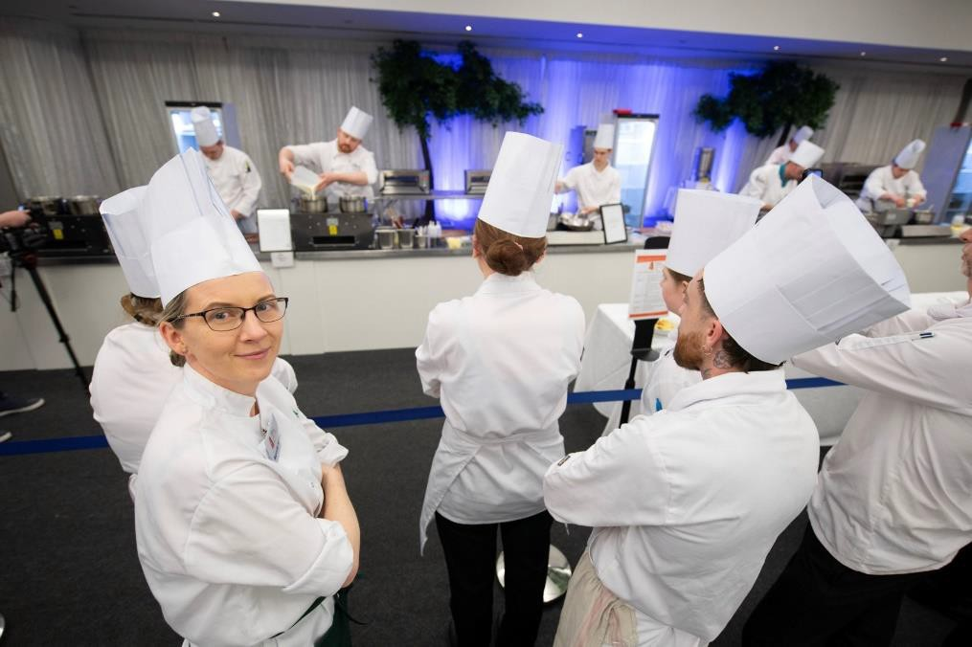
The Kerry ETB Protected Disclosure Policy works with national legislation to encourage and support staff in reporting potential wrongdoings, knowing their concerns will be taken seriously and their confidentiality respected. As required under Section 22 of the Protected Disclosures Act, 2014, Kerry ETB confirms that no protected disclosures were received to the end of 2023.

Policy documents developed by the executive and approved by the Board (2023)

- Authorised Signatories Policy and Authority Matrix
- CEO’s Memo: Protocol for Executive
Orders
- Child Safeguarding Policy and Procedure (Revision)²
- Conflict of Interest Policy (Revision)
- Continuous Professional Development Policy and Procedure (Revision)
- Contractor Management and Construction Compliance Procedure for Building Works (Non-Capital)
- Corporate Procurement Plan 2022- 2024
- Customer Charter and Action Plan 2023-2025
- Garda Vetting Employee/Volunteer Policy and Procedure (Revision)
- Health and Safety Procedure for Events Management
- Health and Safety Training Register Procedure
- ICT Strategy 2023-2027
- Kerry College Admissions Policy
- Outreach Inspection Policy (Revision)
- Parent's Leave Policy and Procedure (Revision)
- Procedure for Monitoring and Compliance with Section 10A of the Irish Language Act
- Process for Internal Audit Unit Audits
- Procurement (Purchases) of up to
€50k using Public Funds Received Under Grant from Kerry ETB (Revision)
- Procurement Policy (Revision)
- Strategy Statement 2023-2027
- Third-Party Governance Policy and Procedure (Revision)
- Videoconferencing Policy
- Written Charter and Terms of Reference for Section 44 Committees (Revision)

Freedom of Information Act 2014
Kerry ETB continues to meet its obligations in relation to responding to Freedom of Information requests. During the reporting period, Kerry ETB received 12 requests in 2023. One of these requests did not meet the Freedom of Information criteria and was responded to outside of the Freedom of Information process.

Corporate Social Responsibility
Under Statutory Instrument 426 of 2014, European Union (Energy Efficiency) Regulations 2014, all public sector bodies are required to report annually on their energy usage and any actions taken to reduce consumption.

Table 4 Kerry ETB Energy Usage 2023
Energy Source | Consumption kWh | Emissions kgCO2
Electricity | 2,189,289 | 688,249
Thermal | 2,402,821 | 590,429
Transport | 62,124 | 16,339
Totals | 4,654,234 | 1,295,017

Please refer to “Our Strategic Reports” later in the document for further details on how we have implemented our sustainability strategies and efforts to reduce energy usage.

Third-Party Arrangements
In recent years, third-party arrangements have played an increasingly crucial role in Kerry ETB's strategic development. These arrangements can support the delivery of services, provide access to knowledge, and add overall value to the business of Kerry ETB.
In particular, regarding grants, several grant agreements exist between Kerry ETB and non- commercial bodies, primarily in the community and voluntary sector, to provide services on behalf of the state.

The scale at which Kerry ETB engages with third parties is much larger now than in the past. The executive maintains a register of third-party arrangements to support its oversight role.

Councillor Jim Finucane Chairperson

Kerry ETB: Our Community


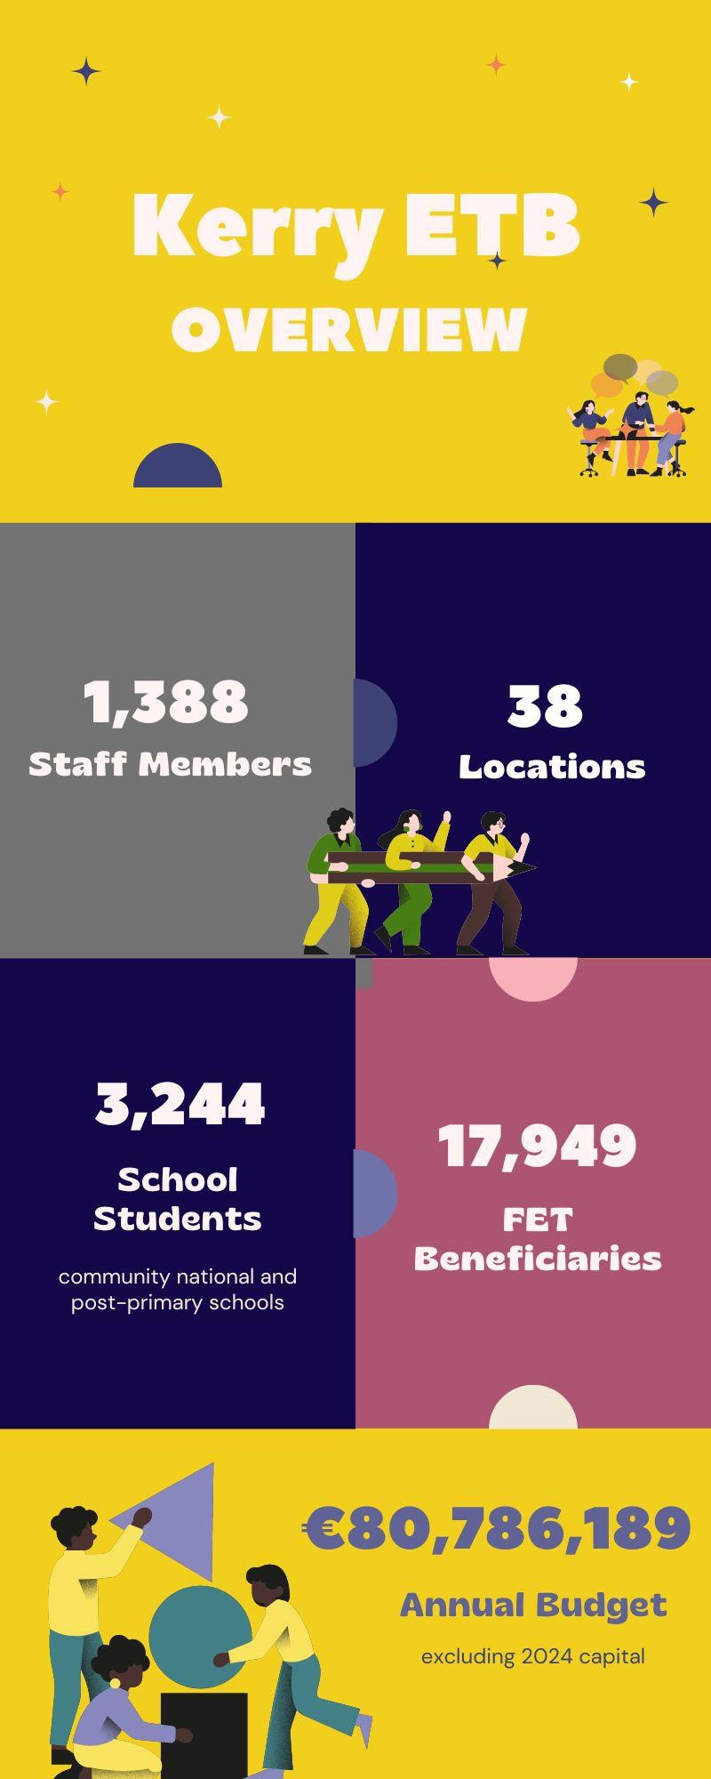

Community National Schools
- Scoil an Ghleanna, Scoil Náisiúnta Phobail
- Tahilla Community National School
- Two Mile Community National School

Post-Primary Schools
- Castleisland Community College
- Causeway Comprehensive School
- Coláiste Gleann Lí
- Coláiste na Ríochta
- Coláiste na Sceilge
- Gaelcholáiste Chiarraí
- Killarney Community College
- Killorglin Community College

Kerry College of Further Education and Training
- Kerry College, Tralee Admissions Office
- Kerry College, Killarney Admissions Office
- Kerry College, Clash Road Campus
- Kerry College, Denny Street Campus
- Kerry College, Listowel Campus
- Kerry College, Monavalley Campus
- Kerry College, Killorglin Campus (OETC)
- Pathway Programmes: Killarney, Killorglin, Listowel, Tralee
- Units: Business Support Unit and Learner Support Unit

Head Office Departments
- Corporate, Capital and Technology
- Human Resources
- Finance
- Units: Audit and Compliance, Centralised Procurement and Purchasing, Executive Support, Irish Language and European Union Projects

Further Education and Training Centres
- An Tóchar Further Education and Training Centre
- Ionad Breisoideachais agus Oiliúna an Daingin
- Kenmare Further Education and Training Centre
- O’Connell Further Education and Training Centre
- Tech Amergin Further Education and Training Centre

Adult Literacy and Basic Education Centres
- Castleisland Adult Literacy and Basic Education Centre
- Caherciveen Adult Literacy and Basic Education Centre
- Dingle Adult Literacy and Basic Education Centre
- Kenmare Adult Literacy and Basic Education Centre
- Killarney Adult Literacy and Basic Education Centre
- Killorglin Adult Literacy and Basic Education Centre
- Listowel Adult Literacy and Basic Education Centre
- Tralee Adult Literacy and Basic Education Centre
Youthreach
- Killarney Youthreach
- Listowel Youthreach
- Tralee Leaving Certificate Applied Youthreach
- Tralee Youthreach

Youth Development Office
- Local Creative Youth Partnership
- Music Generation Kerry
Community Education
Kerry Regional English and Language Team
Quality Assurance
Sports Centre
Tralee Regional Sports and Leisure Company Limited by Guarantee

Kerry ETB is a leading provider of education and training in County Kerry, offering a comprehensive range of services to meet the diverse needs of our growing local community. As one of the largest statutory providers in the region, we provide access to high-quality education and training to individuals of all ages, regardless of their background or circumstances.

Kerry ETB was established in 2013 in line with the Education and Training Boards Act, 2013. This legislation led to the dissolution of Vocational Education Committees nationwide and the consolidation of service delivery into 16 Education and Training Boards.
Concurrently, FÁS, the national agency responsible for apprenticeships and training programmes, was disbanded, with its functions integrated into these Education and Training Boards.

For over a decade, Kerry ETB has diligently served the Kerry community. What sets us apart from other education and training providers is our wide-ranging delivery of services to learners of all ages. Our diverse offerings span the entire county, encompassing primary and post-primary
education and further education and training (FET) programmes, i.e. National Framework Qualifications 1 to 6 and apprenticeships. Additionally, we deliver outdoor education, creative, music, youth and community initiatives, fostering a holistic approach to learning. We proudly incorporate the Irish language across all our services. Specialising in adult literacy and numeracy programmes, we continuously expand our portfolio.
Complementing our front-line delivery, we provide crucial learner support services.
All our delivery is underpinned by our corporate support services, which serve as the cornerstone of our operational framework.

Kerry ETB adopts a multifaceted approach and works with our government partner departments, including the Department of Education, Department of Further and Higher Education, Research, Innovation and Science, Department of Children, Equality, Disability, Inclusion and Youth, and SOLAS. Additionally, we actively engage with local stakeholders across the skills and labour market and the community and voluntary sectors to ensure our services meet the unique needs of people in Kerry.

At the local level, we are one of the largest education and training providers, amassing over 3,244 primary and post-primary students and 17,949 FET beneficiaries annually. It is because of these learners that Kerry ETB is also one of Kerry’s leading employers, with circa 1,388 staff (804 part-time and 584 full-time staff) working across the full breadth of the county.

Kerry ETB also has designated charitable status (Registered Charity Number: 20083243).


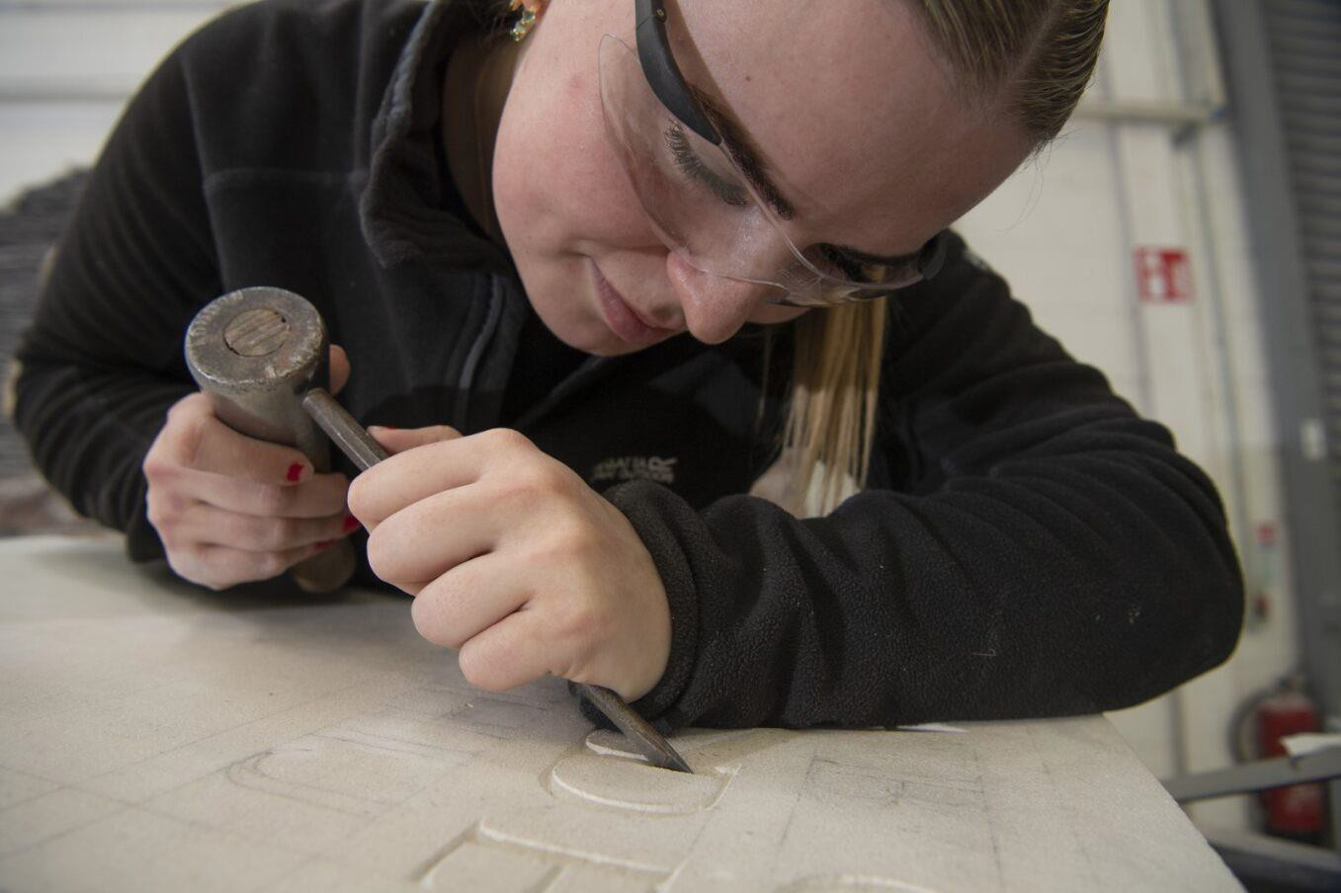

Our Vision, Mission and Core Values

Vision
Our shared vision is that Kerry ETB will be an innovative leader in the design and delivery of quality-assured and sustainably delivered education and training opportunities in Kerry.

Mission
We will continue to promote the development of a lifelong and life-wide learning society in Kerry so that all persons have equal access to education and training opportunities.

To achieve our vision, we put a strong emphasis on working closely with our internal and external stakeholders, particularly marginalised groups.

Core Values
Our core values, Inclusion, Respect, Equality, Quality, and Excellence in Learning, underpin our actions and behaviours. These values are centred on the belief that
every person should have the right to access education and training opportunities to help them realise their potential and meet their personal, social, civic, cultural and economic needs.
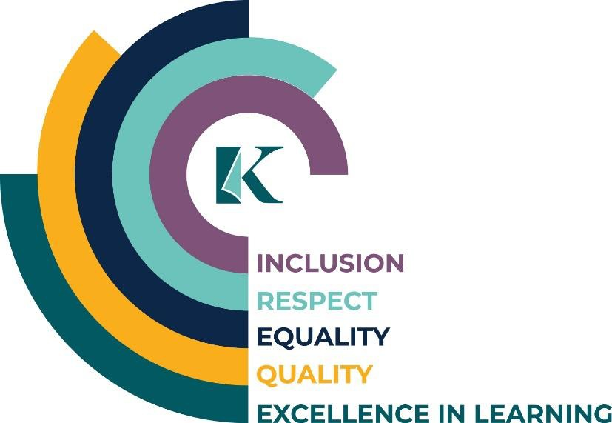

Strategic Goals

Goal 1: Excellence in Education and Training Services
We aim to ensure the continued review, design, delivery and support of quality-assured education and training opportunities to meet all learners’ evolving lifelong and life-wide learning needs.

Goal 2: Strong, Inclusive and Respectful Organisational Culture
We aim to ensure our structures, processes, and behaviours underpin an environment that is safe, supportive and inclusive of all people, regardless of identity, background or
circumstance.

Goal 3: Opportunities for Greater Organisational Synergies
We aim to strengthen integration across our three pillars in a planned and strategic manner, adopting more cohesive and unified approaches.

Goal 4: A Leader in Education and Training Provision
We aim to establish ourselves as a leader in the development of education and training at both regional and national levels.

Goal 5: Communications, Brand Awareness and Shared Understanding of Kerry ETB
We aim to develop Kerry ETB into a widely recognised brand underpinned by high-quality communications with internal and external stakeholders.

Organisational Structure
The Chief Executive is responsible for the executive management of the organisation and is supported in this role by three Directors, namely:

- Director of Schools, Youth and Music
- Director of Further Education and Training
- Director of Organisation Support and Development

The three Director roles reflect the three pillars of service delivery, with each Director
formally delegated authority in their role as per Section 16 of the Education and Training Boards Act, 2013.

The following table depicts the high-level structure of our organisation:

Role/Position | Key Responsibilities
Board | Overall governance and oversight
Chief Executive | Executive management of the organisation
Director of Schools, Youth and Music | Leading high-quality primary and post-primary provision- Governance and management of youth and creative services- Workforce planning and performance management- Co-ordination of pillar management
Director of Further Education and Training | Leading high-quality and responsive further education and training provision- Governance and management of further education and training- Workforce planning and performance management- Co-ordination of pillar management
Director of Organisation Support and Development | Leading the organisation’s administration function- Governance and management of ETB support services- Workforce planning and performance management- Co-ordination of pillar management

Strategic Performance Framework

Kerry ETB acknowledges the pivotal role of continuous performance monitoring in the successful execution of not only our Strategy Statement but also the sub-strategy documents comprising our Strategic Performance Framework (please refer to “Our Strategic Reports” later in this document for further information). To facilitate effective monitoring, we have invested in strategic implementation software tailored to our specific needs, equipped with features such as real-time progress tracking.

This software empowers us to monitor the progress of each strategic document in real-time, providing detailed insights into performance trends. Thus, we can identify areas for improvement. By adopting this holistic approach to performance monitoring, our decision- makers are empowered with timely insights, enabling them to refine strategies for optimal outcomes.
Performance
Review/ Reports
Strategic
Planning
Performance
Monitoring and Reporting
To facilitate this reporting process, project leads, along with their team members and stakeholders, align activities on a biannual basis. Furthermore, our reporting structures are designed to be flexible, accommodating ad hoc reporting throughout the year to enable proactive responses to evolving
circumstances and emerging priorities.

Sharing performance reviews and reports with stakeholders is integral to our approach, contributing to improved planning throughout the year. This transparent communication also serves to highlight the valuable contributions of education and training in Kerry, fostering a deeper understanding of our impact and reinforcing a top-down and bottom-up commitment to excellence.
At the core of our reporting framework lies a steadfast commitment to our overarching vision and mission. Guided by our Board and Senior Leadership Team, we ensure that all implementation is intricately aligned with this vision and mission. Our objectives, alongside all actions and behaviours, remain firmly grounded in our core values, driving us towards our organisational goals with clarity and purpose.

Annual Report 2023
The ensuing “Statement of Services” in this annual report provides a detailed examination of Kerry ETB's activities and milestones throughout 2023, aligning closely with the overarching goals and objectives outlined in our Strategy Statement 2023-2027 and Service Plan 2023. Each milestone outlined in this report reflects our commitment to delivering high-quality education and training opportunities that address the evolving needs of our community and contribute to the realisation of our vision and mission.

Furthermore, the Statement of Services integrates the key performance indicators identified in the Performance Delivery Agreement between Kerry ETB and the Department of Education. This agreement serves as the foundation of our collaboration with the Department, outlining a management and accountability framework aimed at delivering high-quality education services to the public.

Strategy Statement
Service Plan and Performance Delivery Agreement

Annual Report

Statement of Services 2023

Performance Delivery Agreement: Optimise Student/Learner Experience

Priority | Action | Performance Milestones
Provide a positive learning experience for all learners, including those from marginalised groups | Expand the range of supports offered under our Traveller Education Support Programme | The Traveller Education Support Programme continued across schools in 2022/2023. It expanded to include a transition programme for incoming first-year Traveller students. A referral programme was initiated to encourage Traveller parents/guardians of post-primary students to participate in Adult Literacy and Basic Education (ABE). A new Traveller Education Support Teacher was appointed in November 2023.
Continue to address and support equality of outcomes for learners, particularly those from marginalised groups | Implement the Public Sector Equality and Human Rights Duty through training | Training delivered included Familiarisation for the Senior Leadership team and Diversity training for the FET management team and one post-primary school. A key success factor was developing staff awareness of diversity and inclusion issues, reducing prejudiced attitudes and behaviours, and building a more inclusive and respectful organisational culture.
Support learners at risk of educational disadvantage in line with current national policy | Embed the Public Sector Equality and Human Rights Duty into systems, processes and behaviours | The Duty Assessment and Action Plan were drafted, with a full roll-out set for 2024. Actions already achieved include: The Duty shaped the Strategy Statement and Service Plans (2023 and 2024), giving a more purpose-driven direction.  The assessment was incorporated into policy development and revisions, ensuring the framework addresses equality and human rights issues.
Support learners at risk of educational disadvantage in line with current national policy (continued) | Leverage Delivering Equality of Opportunity in Schools (DEIS) grants to prevent marginalisation and reduce disadvantage | Schools implemented DEIS funding and School Self-Evaluations. Each school created DEIS Action Plans aligned with national themes. Principals and staff reviewed targets twice annually, with updates provided to boards of management and school communities. In 2023, Kerry ETB organised DEIS Action Plan training through PDST, strengthening school leaders’ knowledge and capacity.
Ensure all necessary child safeguarding measures are in place in accordance with the Child Protection Procedures for Primary and Post-Primary Schools (2017, revised 2023) | Update the internal Child Protection Monitoring Plan | The 2022/2023 Child Protection Annual Report, submitted to the Board in October 2023, highlighted several milestones demonstrating commitment to safeguarding. One milestone was achieving “full compliance” across Kerry ETB schools, Kerry College, Youthreach, Local Creative Youth Partnership, Music Generation Kerry, partnership schools, and third-party providers.
Ensure full compliance with the Child Protection Procedures for Primary and Post-Primary Schools (2017, revised 2023) |  | Covered in the compliance reporting and annual monitoring outlined above.

Protection Programmes

Priority | Action | Performance Milestones
Assist the Department of Education, as needed, to meet the needs arising from the Irish Refugee Protection Programme and provision for International Protection applicants | Continue to meet the needs arising from our International Protection Programme and support the Department of Education in responding to the Irish Refugee Protection Programme | The International Protection and Ukrainian Response Team continued to meet the diverse learning needs of Ukrainian and International Protection applicants. In 2023, enrolments included approximately 1,500 learners across Kerry schools (around 297 in Kerry ETB schools) and 6,300 learners in FET programmes.

Governance

Priority | Action | Performance Milestones
Attendance rates at Board meetings | Individual Boards should re-emphasise the requirement for attendance at all meetings as per the Code of Practice for Governance of ETBs (Circular Letter 0002/2019) | The Board chairperson regularly reinforced the importance of attendance. Mid-year and end-of-year reports on attendance were produced. In 2023, the performance rate was 80%, showing a positive trend in commitment and participation. The reports also showed a preference for on-site meetings over virtual, at a 2:1 ratio.
Board self-assessments | All Boards should carry out self-assessments using the questionnaire in Circular Letter 0002/2019 to identify areas for improvement | The 2023 Self-Assessment Evaluation of the Board was conducted between September and December. Findings indicated overall satisfaction, with strengths in risk management, internal controls, and strategic planning. The Board Chairperson will lead a discussion on the findings in the new year to ensure continuous improvement.
Self-assessment by Audit and Finance Committees | Committee chairs to ensure an annual self-assessment is completed under Circular Letter 0002/2019 | The Chairs of the Audit and Finance Committees ensured completion of the 2023 self-assessment exercise. Findings indicated an overall positive evaluation.
Board appraisal of Audit and Finance Committees’ work | The Board chair to ensure members are provided with written reports on Audit and Finance Committees’ work | Written reports of Section 45 Committee meetings were presented at subsequent Board meetings, ensuring transparency and information sharing.
Financial expertise on Audit and Finance Committees | Appointments to committees should be made by the Board in consultation with committee chairs. External members should bring audit and financial skills and experience | A structured appointment process is in place in line with Circular Letter 0002/2019. No new appointments were made in 2023.
Staff development | The Chief Executive ensures a staff member is appointed as Training Manager | This is being addressed as part of the national Organisational Design II process, led by ETBI. In the interim, HR coordinates Continuous Professional Development (CPD) applications.
Staff development (continued) | The Chief Executive ensures annual training needs analysis in financial management and delivery of a training programme | In November 2023, the Finance Department surveyed staff to assess skills, CPD needs, and experience. This identified specific professional development requirements.
Departmental reporting deadlines | Reporting deadlines set by the Department should be adhered to | Reporting deadlines were met during the period wherever possible.
Risk Management Policy | The Board should ensure ongoing processes to identify and address significant risks, with Audit and Risk Committee support | In line with Circular Letter 0002/2019, we continued to roll out and develop the Risk Management Policy and Framework, reporting regularly to the Audit and Risk Committee and the Board. Key activities included: The Corporate Risk Register was revised three times.The Board approved the revised Risk Management Policy and Appetite Statement in January 2024.
Internal controls | Each ETB Board should ensure it receives adequate assurance that specified controls are operating as intended | At the March 2024 meeting, the Board received assurance that specified controls were operating as intended. Results showed 97% compliance and 3% non-compliance. Significant progress was also made in deploying governance, compliance, and risk software, strengthening the control framework. No incidents were reported under the Anti-Fraud and Corruption Policy in 2023.

The 2023 Board Self-Assessment Evaluation yielded an average score of 1.17 out of 5, with 1 indicating consistent good performance and 5 suggesting areas for improvement.


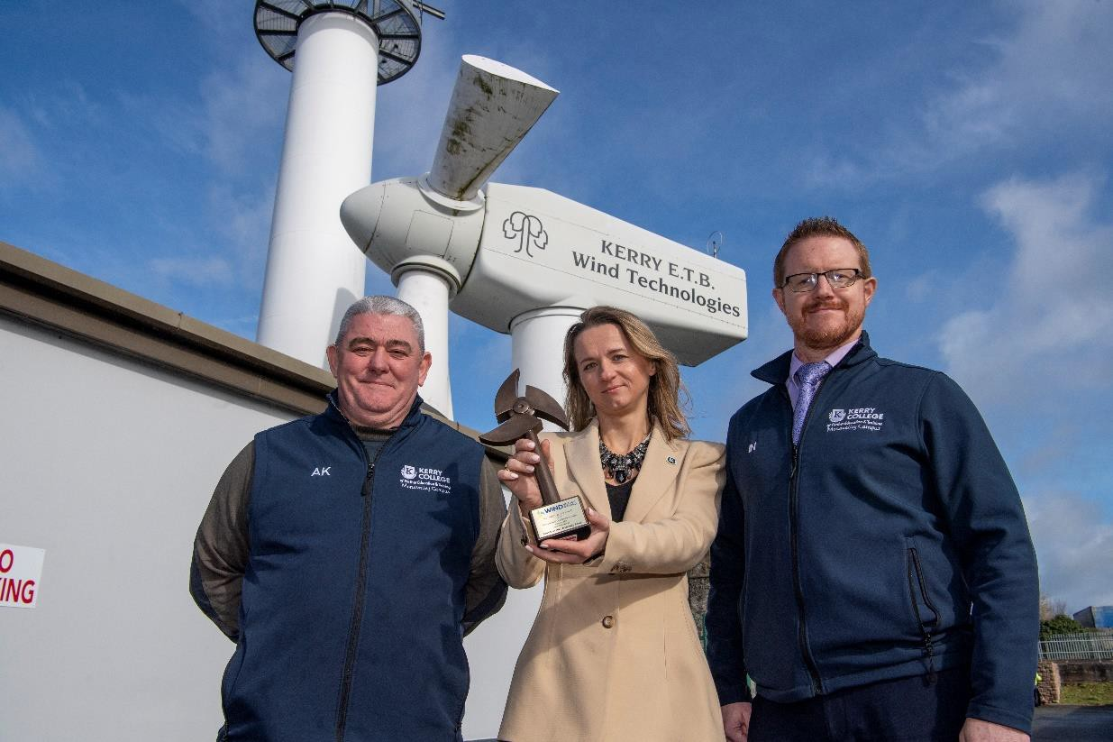

Future Back Report Performance

Goal 1: Excellence in Education and Training Services
We aim to ensure the continued review, design, delivery and support of quality-assured education and training opportunities to meet all learners’ evolving lifelong and life-wide learning needs.

Ref. | Objective | Performance Milestones 2023
1A | Create a high-quality, holistic education and training environment informed by learners’ voice and actively addressing access for all | Dedicated Teaching and Learning teams in community national and post-primary schools focused on innovative pedagogy.  Post-primary schools implemented the Relationship and Sexuality Education programme and Friends for Life initiative.  Student councils, Student Forum, and Parents’ Forum provided platforms for learner/parent voices on ethos, access, and strategy.  FET learners participated in governance bodies including the Youthreach Board of Management, FET Quality Council, Kerry College Governance Board, FET Centres Governance Board, and the Commis Chef National Apprenticeship meetings.  FET Learner Survey (c. 549 responses) showed 93% rated programmes “Very Good” or “Good”.  Corporate services (HR, procurement, capital, ICT, accounts payable) supported responsive front-line delivery.
1B | Provide comprehensive guidance to all learners, offering academic, employment, and personal support | Kerry College Admissions Office operated in Tralee and Killarney and hosted clinics countywide.  In October 2023, QQI Chief Executive and senior staff met Kerry ETB; discussions covered quality enhancement, programme development, monitoring, and the upcoming review of Common Awards System.  A business case was submitted for extending FET Access and Pathways Information Officer posts.
1C | Provide widely accessible education and training opportunities in creativity and music | Local Creative Youth Partnership expanded to 31 programmes (from 23 in 2022) and continued the Creative Youth Grant Scheme; classes included drumming, game design, and podcasting.  Music Generation Kerry attracted c. 3,935 participants in 2023 (101% increase vs. 2022) through expanded offerings including online lessons, ensembles, and youth programmes.  Work advanced on plans for a Kerry ETB School of Performance Music, including accommodation reviews.
1D | Provide excellent responsive delivery to support local and national economy, addressing labour shortages and skills gaps | Programme Governance Board approved “Programme Approval Operating Guidelines” to support staff in programme modification and development.  37 new programmes approved in 2023.  Two new apprenticeships launched: Wind Turbine Maintenance Technician and National Sales, aligned with market demand.
1E | Adapt and develop education and training as new learning approaches and technologies emerge | All post-primary schools updated Digital Plans in line with the Department’s Digital Strategy for Schools.  FET Quality Council reviewed pilots of Turn-It-In and Microsoft Teams for blended learning.  FET Learner Survey: c. 80% reported improved digital skills.  FET provision advanced use of the national Programme Learner Support System (PLSS).  Board approved ICT Strategy 2023-2027 (technology integration across education, training, and corporate services).  October 2023: c. 400 staff took part in a Day of Learning on Universal Design for Learning (UDL), with ~20 workshops showcasing best practice in technology for UDL.

New Programmes Proposed
- Advanced Digital Design 6M20496
- Digital Business Skills 5S21869
- Youthwork 5M4732
- Music and Sound Productions 6M20602
- Nature Based Early Learning and Care (ELC) Levels 5 & 6
- Enhanced Eye Treatments Level 5
- Content Development for Film and TV Level 6
- Cartoon Animation 6M5545
Addition of New Modules to Kerry ETB Programmes and Course Name/Title Change
- Outdoor Sport and Recreation 5M5146 (Mind, Body and Nature: Yoga Teaching and Outdoor Wellness)
- Security Studies 5M2110 (Garda and Security Studies)
- Sports and Recreation 5M5146
47 Course Approval Application to date in 2023 and 37 courses were approved.
Addition of New Module to a Kerry ETB Programme – QQI
- Software Development 5M0529
- Legal Studies 5M3789
- Construction Groundwork and General Construction 4S2854
- Outdoor Sport and Recreation 5M5148
Other Awarding Body
- IT Support Technician (CompTIA)
- IT Support Fundamentals (CompTIA)
- Welding ISO 9606 (Metlab)
Course Duration Extensions
- Coded Pipe Welding EN 9606 SS04 (H-L045)

Delivery Mode from In-Class to Blended Extended
- Payroll Manual and Computerised 5N1546
- Supervisory Management Bookkeeping and Computerised 5N1354
- Train the Trainer 6N3326
- Challenging Behaviour 5N1706
- Medical Terminology 5N2428
- Children with Additional Needs 5N2396
- Digital Marketing 5N1364
- Computer and Online Essentials ICDL-C&OE
- Spreadsheet Methods ICDL-SpSheets
- Word Processing ICDL-DOC5
- Special Needs Assisting 5N1957
- Irish Natural Heritage and Culture 6N20231
Courses Approved Through Differential Validation
- Level 6 Circular Economy in the Workplace
- Level 5 Lean Practices for a Sustainable Business
- Level 4 Sustainable Procurement and Supply Chain
- Level 3 Special Purpose Award in Learning to Support Children in Primary School
- Level 5 Specific Purpose Certificate in Sustainable Supply Chain Procurement
- Level 5 Specific Purpose Certificate in Lean Practice for Sustainable Business
Programme Development Groups Established
- Kerry College Monavalley Campus Special Purpose Award in Micro Solar Photovoltaic Systems: Solar PV Panel Installation 6S0324
- Kerry College Monavalley Campus QQI Level 6 Minor Award in Domestic Heat Pump Installation 6N5646
- Level 6 NEW Professional Award Surface Supplied Offshore Diving
- Welding Apprenticeship
- Junior Sales and Marketing Executive Apprenticeship (Irish Hotel Federation)

Goal 1: Excellence in Education and Training Services (continued)

Ref. | Objective | Performance Milestones 2023
1F | Design and deliver a career development programme for staff | Development of a three-year Adaptive Leadership programme for Kerry ETB Senior Management is ongoing.  Kerry ETB FET facilitated comprehensive CPD interventions for administrators and practitioners, spanning QQI Levels 6–9 and a wide range of short upskilling courses.  42 Assistant Principals from across eight post-primary schools completed the Middle Management Leadership Training Programme, receiving a Kerry ETB certificate endorsed by the Centre for School Leadership.  Three staff (one from each pillar) supported to enrol on an MBA programme. Additional programmes undertaken included:  Certificate in Strategic ETB Communication and Practice  Bachelor of Arts Applied Early Childhood Education and Care  Professional Certificate/Diploma in Creativity and Innovation for Education  Master of Arts in Guidance Counselling  Master in Special Education Needs  Master in Choral Studies
1G | Research and implement future educational reforms in line with government policy and international best practices | In September 2023, official confirmation was received from SOLAS regarding the mainstreaming of the Kerry College Pilot. SOLAS Chief Executive Andrew Brown Lee commended Kerry ETB’s pioneering role, stating it was “already helping to grow the contribution and impact of further education and training across Ireland.”  Benefitted from the Central Applications Office (CAO) opening access for FET and apprenticeships, which led to increased application numbers. Advanced the collaborative tertiary initiative with MTU, Cork ETB, and UCC. In September, Kerry College introduced two new degree programmes with MTU:  Honours Degree in Animation, Visual Effects, and Motion Design  Honours Degree in Business  Kerry ETB played a leading role in the national re-categorisation of FET programmes, reducing the categories from 26 to 8.

1H Ensure that the capital and buildings programme is delivered and that all new projects are designed to comply with Department guidelines and the highest standards for energy efficiency

Performance Milestones 2023:

Table 5 – Major Devolved Projects
Project | Description | Current Phase/Status
Gaelcholáiste Chiarraí Campas Nua | Construction of a new post-primary school | Stage 5 – Defect Period
Listellick National School | Construction of a new primary school | Stage 5 – Defect Period
Knocknagoshel National School | Construction of a new primary school | Stage 1 – Preliminary Design
Coláiste na Ríochta and Gaelscoil Lios Tuathail | Development of a shared education campus, including a new primary school for Gaelscoil Lios Tuathail and an extension to Coláiste na Ríochta | Stage 1 – Preliminary Design
Tralee Educate Together National School | Construction of a new primary school | Stage 1 – Preliminary Design

Table 6 – Additional School Accommodation Project Summary
Project | Description | Current Phase/Status
Causeway Comprehensive School | Construction of an extension to the school | Stage 2B – Preparation of Tender Documentation
Castleisland Community College | Construction of an extension to the school | Stage 1 – Report Submitted to the Department for Approval
Killorglin Community College | Construction of an extension to the school | Stage 1 – Preliminary Design
Killarney Community College | Construction of an extension to the school | Stage 4 – Construction
St. Oliver’s National School | Construction of an extension to the school | Stage 2B – Preparation of Tender Documentation
Moyderwell Primary School | Construction of an extension to the school | Stage 1 – Preliminary Design

Table 7 – Schools Projects Summary
Project | Description | Current Phase/Status
Castleisland Community College | Home Economics classroom (Emergency Works Scheme) | Stage 4 – Construction
Causeway Comprehensive School | Window replacement (Summer Works Scheme) | Stage 4 – Construction
Causeway Comprehensive School | Universal Access Works | Stage 4 – Construction
Coláiste Gleann Lí | Upgrade of fire doors | Stage 4 – Construction
Coláiste na Sceilge | Upgrade life safety system (Emergency Works Scheme) | Stage 4 – Construction
Coláiste na Sceilge | Replacement of boilers (Emergency Works Scheme) | Stage 1 – Design
Coláiste na Sceilge | Upgrade of gas proving system (Emergency Works Scheme) | Stage 1 – Design
Coláiste na Sceilge | Upgrade of fume extraction (Emergency Works Scheme) | Stage 1 – Design
Coláiste na Sceilge | Roof works (Summer Works Scheme) | Stage 3 – Tender
Killorglin Community College | Mechanical Upgrade | Stage 4 – Construction
Castleisland Community College (Modular) | 2 mainstream classrooms | Stage 1 – Design
Castleisland Community College (Modular) | 2 mainstream classrooms | Stage 4 – Construction
Causeway Comprehensive School (Modular) | Two mainstream classrooms and one Special Education Needs classroom | Stage 1 – Design
Coláiste na Sceilge (Modular) | Four mainstream classrooms and two Special Education Needs classrooms | Stage 1 – Design

Table 8 – FET Project Summary
Project | Description | Current Phase/Status
Kerry College Listowel Campus | Construction of an extension to the college campus | Stage 1 – Preliminary Design
Kerry College Monavalley Campus | Construction of a college apprenticeship facility | Stage 1 – Preliminary Design
Kerry College Monavalley Campus | Installation of 3 new apprenticeship workshops and refurbishment of accommodation | Stage 4 – Construction
Kerry College Monavalley Campus | Replacement of welding fume extraction | Stage 4 – Construction
O’Connell Further Education and Training Centre | Refurbishment of the centre | Stage 4 – Construction
An Tóchar Further Education and Training Centre | Replacement of boilers and installation of energy-efficient heat pump | Stage 4 – Construction

Goal 2: Strong, Inclusive and Respectful Organisational Culture

We aim to ensure our structures, processes, and behaviours underpin an environment that is safe, supportive and inclusive of all people, regardless of identity, background or circumstance.

Ref. | Objective | Performance Milestones 2023
2A | Complete an organisation-wide culture audit and address recommendations | Preparation of a tender for a culture audit is scheduled to commence in 2025. This audit will conduct a thorough examination of organisational culture, identifying both strengths and areas for improvement.
2B | Promote a culture that is inclusive, non-discriminatory, and respectful of human and civic rights | In line with statutory obligations under Section 42 of the Irish Human Rights and Equality Commission Act, 2014 (Public Sector Equality and Human Rights Duty), we conducted an assessment of equality and human rights issues faced by groups relevant to our core functions.  In 2023, some of our female apprentices were featured nationally on the RTÉ Today Show.  We published our Gender Pay Gap Report 2022.
2C | Ensure our core values guide the organisation’s behaviours and are the lived experience for all stakeholders | In 2023, we redeveloped our core values through a consultative process, resulting in a new visual representation and statement.  Kerry ETB schools continued implementation of the ETBI Patrons’ Framework. Milestones included providing Ethos training for staff, boards of management, students, and parents/guardians.  All Social, Personal and Health Education teachers in post-primary schools completed Anti-Bullying training in 2023.
2D | Support our learners and staff by strengthening access to and raising awareness of support services | Kerry College continued to develop its Learning Support Unit across campuses.  A comprehensive Special Education Needs (SEN) programme continued across schools. Two post-primary schools completed SEN Provision Mapping.  Kerry ETB schools integrated Universal Design for Learning (UDL) goals into DEIS and School Improvement Plans.  Staff were supported through accessible well-being resources, including the Employee Assistance Programme and a Financial Well-Being programme.
2E | Ensure our structures actively promote inclusion and provide accessible and appropriate support for people with disabilities | Conducted annual Disability Survey of all staff in line with legislative requirements. All reasonable accommodation requests were met.  Completed the second year of our Universal Design for Learning (UDL) Plan 2023–2025 (see “Our Strategic Reports” for details).  Kerry College implemented a cross-campus UDL focus, with each campus establishing a UDL/Teaching and Learning Committee. An online library of resources was created, Teaching and Learning boxes introduced, and additional staff enrolled in the UDL Badge programme.
2F | Build stronger relationships with other regional agencies to proactively address barriers to inclusion for marginalised individuals or groups | Established our Regional Adult Literacy Coalition and began developing the Regional Adult Literacy Action Plan with local partners.  Continued collaboration with local agencies to support groups under the Duty through initiatives such as the Youth Work Development Programme, Community Education, ABE, Creative Youth Grant Scheme, Adult Literacy for Life Strategy Collaboration and Innovation Fund, and the Reach Fund.  In June, the Kerry Regional English and Language Team (REALT) hosted an inter-agency “Reflection on Integration Day” with 16 stakeholder organisations to share learning and plan for continuous improvement.
2G | Work to meet the needs arising from the Irish Refugee Protection Programme and provision for international protection applicants | Kerry REALT continued assisting families and integrating learners from Ukraine.  The International Protection and Ukrainian Response Team worked with stakeholders to support International and Temporary Protection applicants. Approximately 1,500 learners were enrolled across Kerry schools (c. 297 in Kerry ETB schools), and around 6,300 learners in FET programmes in 2023.  Expanded ESOL/IELTS provision with technical-related courses in key skills areas.
2H | Create opportunities for learners and staff to access equality, diversity, and inclusion education and training | Expanded the Adult Basic Education (ABE) programme, increasing certifications at Levels 1 and 2 and adding tailored offerings for employed learners.  Delivered a suite of training as part of ongoing work to implement the Public Sector Equality and Human Rights Duty.

Goal 3: Opportunities for Greater Organisational Synergies

We aim to strengthen integration across our three pillars in a planned and strategic manner, adopting more cohesive and unified approaches.

Ref. | Objective | Performance Milestones 2023
3A | Develop a structure to facilitate shared understanding across the organisation's three pillars | The preparation of terms of reference for a Cross-Pillar Forum to inform organisation direction, policy and priorities was commenced and will be finalised in 2024.
3B | Create opportunities for closer cross-pillar collaboration to strengthen synergies and promote shared objectives | The new Schools-FET Pathways programme has quickly become a key factor in the development of strategic synergies between our post-primary schools and FET.  Aligned with the SOLAS National Strategy Future FET: Transforming Learning, in 2023 it achieved significant milestones, including c. 270 post-primary students being awarded FET certification across a range of courses, including Health-Related Fitness, Career Planning, Sports Coaching, and Beauty Therapy.  These courses seek to increase awareness regarding FET progression and career opportunities among our post-primary stakeholders.
3C | Ensure greater integration of management and staff teams across the organisation | We hosted the Schools Youth and Music Pillar Day in October. This event was dedicated to addressing key “Schools” priorities aligned with the new Strategy Statement. The FET and Organisation Support and Development Pillar Days are set to take place in early 2024.  2023 marked the second year of our Leadership programme, which includes two annual events, including the Leadership Seminar in February, based on the Adaptive Leadership approach.
3D | Achieve excellence in the delivery of support services fully aligned to legislation | We completed the second-year implementation of our Corporate Procurement Plan 2022–2024 (please refer to “Our Strategic Reports” for further information on implementation).  Continued efforts were dedicated to ensuring that our health and safety practices align with regulatory standards. This involved ongoing maintenance of our comprehensive Health and Safety Management System, accompanied by the provision of staff training and upskilling opportunities.  In September 2023, following an engagement process, the Corporate Safety Statement was revised and effectively communicated to all staff members, reinforcing our commitment to a culture of safety.
3E | Establish a dedicated evidence-based research and development function to support decision-making | Engagements throughout 2023 were ongoing with a third-party higher education institution to establish a shared evidence-based research and development initiative. Further actions identified for 2024.
3F | Establish more linkages for the integration of youth services with schools and FET | The Youth Work Development Plan 2023–2027 has been finalised and will be officially launched in early 2024. A key objective of the plan is to establish more linkages for the integration of youth services with schools and FET provision.
3G | Create more opportunities to engage with all our stakeholders to better understand their needs and address specific requirements and expectations | Board subcommittees, including Boards of Management and Governance Boards, continued to play a key oversight role throughout 2023, informing delivery.  Stakeholders, including youths, learners, and parents/guardians, were consulted across a range of forums, including student forums, parent councils, and learner surveys.  We maintained continuous engagement and constructive consultations with our staff and relevant unions. These interactions played a crucial role in fostering collaboration, addressing concerns, and ensuring inclusive decision-making processes within our organisation.  In 2023, Kerry College’s Business Support Unit engaged with employers across the region through a variety of activities, including business and Chamber meetings, as well as briefing employers at a regional level. Engagement was most evident through the increased participation in the Skills to Advance programme, rising to c. 608 learners in 2023 from c. 471 learners in 2022 — an increase of c. 29%.  Kerry College successfully hosted its annual recruitment fair and Open Week, providing an interactive platform for prospective learners and the community to explore the diverse academic offerings and opportunities available.  In September, the Board approved the Customer Charter (2023–2025) and Action Plan after extensive engagement with our stakeholders (please refer to “Our Strategic Reports” for further information on implementation).

Goal 4: A Leader in Education and Training Services

We aim to establish ourselves as a leader in the development of education and training at both regional and national levels.

Ref. | Objective | Performance Milestones 2023
4A | Proactively expand the accessibility of the ETB’s support services to non-Kerry ETB schools and centres | The preparation of terms of reference for a Cross-Pillar Forum to inform strategy implementation, policy and priorities was commenced and will be finalised in early 2024.  Our Community National School programme has shown steady growth throughout 2023, with one additional school identified to transfer its patronage to Kerry ETB for the 2024/2025 academic year.  The handover of Listellick National School, our first devolved capital project, was completed in Quarter 1, 2023. Other ongoing capital projects for non-ETB schools that progressed in 2023 include Tralee Education Together, Knocknagoshel National School, Gaelscoil Lios Tuathail, St Oliver’s National School and Mercy Moyderwell Primary School.
4B | Promote Kerry ETB as a key regional employer to prospective job applicants | In July 2024, a business case was developed and submitted for the refurbishment of Kerry ETB-owned premises at Moyderwell, Tralee, marking a significant step toward achieving a permanent Kerry ETB head office for our organisation.  We commenced a six-month pilot for blended working arrangements for head office functions. The pilot's outcomes will help inform a broader roll-out in 2024.  Progress has been made with the development of a teacher substitution app.
4C | Demonstrate innovative leadership in identifying and delivering future local and national development skills in response to local and national labour trends | We continued to develop our Blended Applied Maths programme.  Successful implementation of the second year of the Kerry ETB Quality Assurance Action Plan 2022–2027. Our FET centres responded to a remarkable increase of approximately 70% in full-time provision as demand for EAL/ESOL provision grew. Particularly noteworthy was the O'Connell Centre in Caherciveen, which saw a significant enrolment surge of approximately 126% compared to planned enrolments.  Successfully began the delivery of new outdoor education upskilling programmes, targeting teachers, scout leaders and youth leaders.
4D | Build stronger relationships with employers in the region through the establishment of a Kerry ETB Employers Forum | Plans for a Kerry ETB Employers’ Forum are set to be progressed in 2024.
4E | Publish the second Kerry ETB Sustainability Strategy 2023–2025 and establish a sustainability support function to address sustainability matters | In line with Statutory Instrument 426 of 2014, European Union (Energy Efficiency) Regulations 2014, we have reported on our energy usage and actions taken to reduce consumption in our Annual Report 2022 to the Department. (Please refer to “Our Strategic Reports” for further information on 2023 implementation).
4F | Build on existing relationships with the local Gaeltacht and non-Gaeltacht communities to support the use of Irish as a living language | We expanded our FET programmes delivered through the Irish language, widening access by offering additional online provision. Provision increased by 48% up to 256.  In 2023, we established a dedicated working group to oversee the alignment of advertising expenditure with amendments to the Official Languages Act (2021). Subsequently, a procedure was developed to support management in monitoring compliance (please refer to “Our Strategic Reports” for further information on implementation).
4G | Foster and develop mainstream European and international opportunities for learners and staff | We made significant progress in establishing an organisational staff and learner mobility programme with the appointment of a European Union Projects Development Officer.  A second school was successful in securing Erasmus’ accreditation status.
4H | Strengthen existing and build new relationships with government departments, funders, ETBs, universities, community organisations and other education and training providers | Signed our 2023 to 2025 Oversight Agreement with the Department of Education. Our relationships with key stakeholders, including the new National Apprenticeship Office (NAO) and National Tertiary Office, continue to thrive. In addition, our participation in emergency measures has contributed to additional provision by the NAO.  We completed the second year of implementing the Performance Agreement with SOLAS (please refer to “Our Strategic Reports” for further information on implementation).  The Third-Party Governance Policy was updated and approved by the Board in October.  We continue to engage with the Local Development Committee, Local Action Group, and Social Inclusion Community Action Programme.

Goal 5: Communications, Brand Awareness and Shared Understanding of Kerry ETB

We aim to develop Kerry ETB into a widely recognised brand underpinned by high-quality communications with internal and external stakeholders.

Ref. | Objective | Performance Milestones 2023
Goal 5 | Communications, Brand Awareness and Shared Understanding of Kerry ETB | We aim to develop Kerry ETB into a widely recognised brand underpinned by high-quality communications with internal and external stakeholders.
5A | Promote Kerry ETB as the first-choice education and training provider in Kerry | Throughout 2023, we continued to actively engage in initiatives to showcase the diverse education and training opportunities we have to offer as an Education and Training Board. Promotional campaigns and events such as in-person information sessions and hubs, virtual open evenings, and Pathway Open Days facilitated direct engagement with prospective learners and their families.  Our annual Schools Week and Kerry College Open Week were well-attended, as was our webinar on Community National School provision. As an Education and Training Board, we value and actively seek community engagement to promote our diverse range of programmes, particularly our ABE and Community Education programmes.  Word-of-mouth recommendations remained the cornerstone of our outreach efforts, reflecting the satisfaction of our learners. Our presence in local area advertisements and newspapers continued to attract new learners. We are also proud of our collaborations with key local stakeholders to enhance the accessibility and impact of our initiatives in the community. We celebrated the achievements of our learners at events, including the Kerry ETB Student Awards and Kerry ETB/Kerry College graduation ceremonies. Our learners have been recognised across a wide range of national and international competitions, including the following: Age Friendly Ireland Awards; All Ireland Linguistic Olympiad Awards; Curious Minds Awards; Connect Kerry Hospitality Awards; Generation Apprentice Apprentice of the Year Awards; Green Schools Ireland; IMRO Radio Awards; Irish Culinary Championships; John Kelly Awards; Kerry Student Enterprise Awards; SciFest Awards; Special Olympics World Games; Talent and Skills Development Awards; Think Languages Social Media Competition; Tech Industry Alliance Leaders Awards; World Skills Ireland; Young Social Innovators of the Year Awards; Youth Start Entrepreneurship Network.
5B | Transition from a fragmented communications model to a fully resourced, dedicated Kerry ETB communications function | To support the transition to a fully resourced, dedicated communications function, we have appointed an Events and Public Relations Officer (communications@kerryetb.ie) who collaborates across our three organisational pillars. In 2023, we published our cross-pillar newsletter, which continues to serve as a useful tool for disseminating updates, achievements, and important information across all facets of our organisation. We made significant strides in bolstering our communications infrastructure with the introduction of a cross-pillar Public Relations Plan. This initiative aimed to streamline our communication efforts, ensuring consistency, clarity, and effectiveness in our messaging across the three pillars.
5C | Adopt and launch a new Kerry ETB brand to enhance awareness and highlight the range of education and training services available to all learner cohorts | The adoption and introduction of the new Kerry ETB brand represented a significant achievement in enhancing awareness and understanding of Kerry ETB. Unveiled in June 2023 as part of the launch of our new Strategy Statement, the new logo featuring the letter "K" alongside a book symbolising the Book of Knowledge was revealed.
5D | Enhance communications with internal stakeholders in a structured manner | Work on our Communication Plan commenced in 2023 with plans to have it finalised by June 2024. The official transition to a single scheme-wide Microsoft platform, Kollab, was progressed with revised timelines implemented. The initiative to redevelop our policy library commenced with the design of a new, user-friendly "Policies and Procedures" site on the Kollab platform. The new internal platform is set to go live in Quarter 2, 2024, and will provide staff with efficient access to updated policies, procedures, reports, and so forth. Simultaneously, we have conducted a comprehensive review of our policy development framework. The outcome of this has been the implementation of a new Microsoft application aimed at fostering a more streamlined and effective process for managing new and revised policies.
5E | Enhance communications with external stakeholders in a structured manner | In our ongoing efforts to enhance communications with external stakeholders, we have implemented Branding Guidelines to ensure the uniform application of our new brand. Our contracted vendors actively employ these guidelines with the goal of enhancing recognition and comprehension of Kerry ETB. We initiated the production of the Kerry ETB Podcast, which is scheduled for launch late next year. This podcast will feature exciting input from learners and experts on matters pertaining to Kerry ETB. In 2023, we also completed a comprehensive search engine optimisation audit of the www.kerryetb.ie website. This audit was designed to enhance the website's visibility and effectiveness, as well as its accessibility, aid search engines in understanding our content, and restructure the architecture to improve functionality for all users.
5F | Ensure all Kerry ETB materials publications are widely available, accessible and understood | In ensuring that all Kerry ETB materials and publications are widely available, accessible, and understood, initiatives such as the UDL Plan have continued to be implemented. Our new Strategy Statement was made available in an accessible format.
5G | Maximise opportunities to communicate our culture and core values across internal and external audiences | The redevelopment of our Values Statement in May 2023 and its inclusion in our Strategy Statement played a key role in promoting our culture and core values to internal and external stakeholders. Staff and learners celebrated #ETBDay2022 with a range of events taking place across the scheme.
5H | Support management and staff to become key communicators | All staff responsible for communications underwent targeted training sessions throughout the year. These sessions were designed to equip them with the necessary skills to convey Kerry ETB's messages effectively, covering key topics such as: Facebook Marketing Tactics; Twitter for Corporate Communications; LinkedIn for Stakeholder Engagement; Instagram Marketing for Public Engagement; Public Relations Crisis Management.

Performance Measures

School | 2022/2023 | 2023/2024 | Variance
Scoil an Ghleanna Scoil Náisiúnta Phobail | 24 | 24 | 0
Tahilla Community National School | 34 | 27 | -7
Two Mile Community National School | 57 | 50 | -7
Castleisland Community College | 338 | 381 | 43
Causeway Comprehensive School | 598 | 617 | 19
Coláiste Gleann Lí | 270 | 308 | 38
Coláiste na Ríochta | 163 | 188 | 25
Coláiste na Sceilge | 594 | 586 | -8
Gaelcholáiste Chiarraí | 323 | 312 | -11
Killarney Community College | 446 | 464 | 18
Killorglin Community College | 292 | 287 | -5
TOTAL | 3,139 | 3,244 | 105

Youth Participants per Funding Scheme

Categorisation / Funding Scheme | Year | Awarded Organisation | Participants
UBU Project Castleisland | 2022 | Kerry Diocesan Youth Service | 114
UBU Project Castleisland | 2023 | Kerry Diocesan Youth Service | 310
UBU Project Listowel | 2022 | Kerry Diocesan Youth Service | 285
UBU Project Listowel | 2023 | Kerry Diocesan Youth Service | 240
UBU Project Tralee | 2022 | Kerry Diocesan Youth Service | 241
UBU Project Tralee | 2023 | Kerry Diocesan Youth Service | 434
UBU Project Killarney | 2022 | Kerry Diocesan Youth Service | 109
UBU Project Killarney | 2023 | Kerry Diocesan Youth Service | 181
UBU Project Rural Inclusion North Kerry | 2022 | Kerry Diocesan Youth Service | 1,416
UBU Project Rural Inclusion North Kerry | 2023 | Kerry Diocesan Youth Service | 223
UBU Project West Iveragh | 2022 | Foróige | 151
UBU Project West Iveragh | 2023 | Foróige | 285
Youth Information Centres | 2022 | Kerry Diocesan Youth Service | 2,844
Youth Information Centres | 2023 | Kerry Diocesan Youth Service | 2,873
Local Youth Club Grant Scheme (incorporating the National Quality Standards for Volunteer-led Youth Groups) | 2022 | 31 affiliated and 1 non-affiliated youth clubs/groups | 1,387
Local Youth Club Grant Scheme (incorporating the National Quality Standards for Volunteer-led Youth Groups) | 2023 | 37 affiliated and 1 non-affiliated youth clubs/groups | 1,617
Integration Fund | 2023 | Kerry Diocesan Youth Service | 157
Integration Fund | 2023 | Foróige | 101

Beneficiaries 2023 (Per Programme Category)

Programme Category | Planned | Actual | Variance
Employment Progression | 1,797 | 1,684 | -113
Higher Education Progression | 842 | 845 | 3
Pathways | 238 | 368 | 130
Part-time | 2,074 | 2,612 | 538
Youth Provision | 228 | 292 | 64
Community Education | 2,050 | 3,271 | 1,221
Adult Literacy for Life | 3,574 | 7,102 | 3,528
Learning in Employment | 453 | 566 | 113
Apprenticeship | 1,084 | 1,209 | 125
TOTAL | 12,340 | 17,949 | 5,609

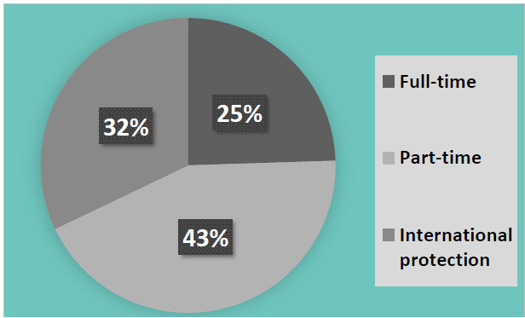

Our Strategic Reports

- Kerry ETB Strategy Statement (including Service Plan and Annual Report)
- Annual Communications Plan
- Corporate Procurement Plan 2023–2024
- Customer Charter and Action Plan 2023–2025
- Further Education and Training Buildings Estate Strategy
- ICT Strategy 2023–2027
- Irish Language Plan 2020–2023
- Local Creative Youth Partnership Strategy 2023–2027
- Public Sector Equality and Human Rights Duty Action Plan 2024–2026
- Quality Assurance Action Plan 2022–2027
- Strategic Performance Agreement 2022–2024
- Sustainability Strategy 2024–2026
- Universal Design for Learning Plan 2023–2025

Annual Communications Plan
In 2024, we are eagerly anticipating the publication of our inaugural Communication Plan, which is currently in the final stages of drafting and scheduled for publication in June 2024.
This comprehensive plan signifies a significant milestone in our continuous efforts to elevate communication practices and develop “Kerry ETB into a widely recognised brand underpinned by high-quality communications with internal and external stakeholders” as set out in the Strategy Statement 2023–2027.

Corporate Procurement Plan 2023–2024
The Board approved the Corporate Procurement Plan 2023–2024 in March 2023. Four performance milestones achieved in 2023 are:
- Successful publication of the Procurement Policy and Procedure (Revision). This updated document provides staff with comprehensive guidelines and directives for all aspects of procurement.
- Full implementation of the Centralised Procurement and Purchasing Model, including migration of historical purchasing data from SAP to the P2P system and the co-location of procurement and purchasing staff in a single team.
- Increased utilisation of the Office of Government Procurement Schedule of Frameworks and Contracts.
- Completion of identified procurement competitions, including competitions for legal services/employment law, automated external defibrillator supply and maintenance, and print management services.

Customer Charter and Action Plan 2023–2025
The Board approved the Customer Charter and Action Plan 2023–2025 in September 2023.
Four performance milestones achieved in 2023 are:
- Throughout 2022 and 2023, we conducted extensive consultations involving representatives from the Board, staff, learners, and external stakeholders. This fostered a collaborative approach and ensured that diverse perspectives were taken into account.
- We began the graphic design of the new Charter documentation, laying the foundation for a visually engaging and informative resource to support delivery of our customer service commitments.
- Our new Strategy Statement was made available in an accessible format, ensuring that individuals of all abilities can engage with and contribute to our strategic vision for the future.
- A Customer Charter training video was published to provide staff with insights and practical guidance on how to implement and uphold the principles outlined in the Charter effectively.

Further Education and Training Buildings Estate Strategy
In 2023, significant progress was achieved in the development of a Further Education and Training Buildings Estate Strategy. The strategy is anticipated to be finalised by Quarter 4, 2024.

ICT Strategy 2023–2027
The Board approved the ICT Strategy 2023–2027 in November 2023.
Four performance milestones achieved in 2023 are:
- Significant progress was made in the development of the Wide Area Network.
- Comprehensive and recurring testing of networks and systems was conducted.
- New Voice Over Internet Protocol (VOIP) technology was implemented across Head Office to enhance communications capacity and improve flexibility for blended working.
- Recognising the importance of protecting our systems against cyber attacks, scheme-wide phishing training and ICT security measures were implemented on an ongoing basis.

Irish Language Plan 2020–2023 (Official Languages (Amendment) Act, 2021)
In 2023, implementation of the Irish Language Plan 2020–2023 entered its final year. Concurrently, additional reporting obligations were introduced under the Official Languages (Amendment) Act, 2021.
These obligations require a summary of any reported matters to be included in the annual report of the respective body. The Irish Language Commission shared a checklist to support compliance with the provisions of the Act.
Key implementation step:
- Ms Ann O’Dwyer, Director of Schools, Youth and Music (SY&M), was appointed as the point of contact for the purposes of the Act (oifigeachgaeilge@kerryetb.ie).
We made significant progress in fulfilling our commitments outlined in the Irish Language Plan 2020–2023.
This included:
- Ensuring that all written communication is responded to in the official language in which it was received.
- Enhancing the provision of courses delivered in Irish.
- Maintaining a bilingual corporate website at www.kerryetb.ie.
- Considering full compliance with Irish Language provisions when erecting new external signage.
- Publishing corporate documents, including the Strategy Statement 2023–2027, Service Plan 2023, and Annual Report 2022, in both Irish and English.
- Providing Head Office oral announcements to the public in both Irish and English.
- Establishing a dedicated working group to oversee the alignment of advertising expenditure with the provisions of the Act.

Local Creative Youth Partnership Strategy 2023–2027
In 2023, significant progress was achieved in the development of the Local Creative Youth Partnership Strategy 2023–2027, in collaboration with children, young people, and partner organisations.
The strategy is anticipated to be launched in March 2024.
Four performance milestones achieved in 2023 are:
- Delivery of a diverse range of 31 initiatives, including a Visual Art Programme in two direct provision settings and the establishment of a Creativity Hub in South Kerry.
- Participation of approximately 611 learners in 2023, generating more employment opportunities for local creatives.
- Strong collaboration, with 14 partner organisations coming together to support and enhance programme delivery.
The grant scheme continued to serve as a crucial aspect of the programme’s operations in 2023, with a total of five grants allocated during the reporting period.

Public Sector Equality and Human Rights Duty Action Plan 2024–2026
In 2023, significant progress was made in the development of the Public Sector Equality and Human Rights Duty Action Plan 2024–2026. The strategy is anticipated to be finalised by May 2024.
Four performance milestones achieved in 2023 are:
- Delivery of a Duty familiarisation session to the Senior Leadership Team, providing comprehensive insights into the Duty and outlining responsibilities.
- Commencement of the rollout of “Dignity at Work” training with staff.
- Publication of the Gender Pay Gap 2022 report.
- Ongoing implementation of measures to ensure equitable gender representation across all interview panels.

Quality Assurance Action Plan 2022–2027
The Kerry ETB Quality Assurance Action Plan 2022–2027 was approved in December 2022, alongside the Kerry ETB Annual Quality Plan 2023, which was reviewed throughout the year.
Four key actions implemented in 2023 are:
- Publication of the Kerry ETB Quality Assurance Manual.
- Completion of the Learner Survey Analysis Report 2023.
- Publication of the English Language Proficiency Policy.
- Publication of the Academic Integrity Policy.

Strategic Performance Agreement 2022–2024
The following page provides a comprehensive overview of Kerry ETB’s 2023 target performance, as set out in the Strategic Performance Agreement (SPA) 2022–2024 with SOLAS.

Sustainability Strategy 2024–2026
In 2023, significant progress was achieved in the development of our second Sustainability Strategy 2024–2026. The strategy is anticipated to be finalised by Quarter 2, 2024.
Four performance milestones achieved in 2023 are:
- Kerry ETB enrolled in the Sustainable Energy Authority of Ireland (SEAI) Engaging People Accelerator Programme. This provides support through workshops, mentoring, expert assistance, and communications materials, and will help deliver an integrated and innovative energy awareness campaign using SEAI resources.
- Implementation of recommendations from the 2022/2023 energy audits began, marking a proactive step towards improving energy efficiency across all facilities.
- A delegation from Kerry College visited the Green Campus at University College Cork, recognised for best practices in sustainability. This visit supports Kerry College’s efforts to pursue a Green Campus Award.
- A contractor was procured to install solar photovoltaic (PV) panels across three FET sites, supported by SEAI grants. In addition, applications were submitted for seven post-primary schools and three community national schools under the Department’s Schools PV Programme, all of which were approved to proceed to tendering.

Universal Design for Learning Plan 2023–2025
Kerry ETB remained steadfast in the implementation of the three-year Universal Design for Learning (UDL) Plan throughout 2023. Significant progress was made, with four key performance milestones highlighted below:
- From January to May, primary, post-primary, and FET teachers met weekly as part of a Community of Practice focusing on UDL.
- In May 2023, Minister Norma Foley launched the UDL Champions Teaching and Learning Project in Tralee. Each UDL Champion completed a research project and academic poster to present their findings at the event.
- A full-day event for school leaders was held in Tralee in September 2023. Champions, principals, and deputy principals exchanged best practices and collaborated on developing UDL implementation plans for the year ahead.
- Across FET provision, UDL commitments were evident in multiple ways. One staff member commenced a Master’s programme in a UDL-related field; another began a PhD with funding support from the Irish Research Council; and a third staff member received the John Kelly Award for UDL in 2023. Kerry College also actively participated in the Programme for Access to Higher Education (PATH) 4 Leadership project.

Appendix I: Glossary of Terms
- ABE – Adult Literacy and Basic Education
- CAO – Central Applications Office
- CPD – Continuous Professional Development
- DEIS – Delivering Equality of Opportunity in Schools
- ETB – Education and Training Board
- FET – Further Education and Training
- ICT – Information and Communications Technology
- NAO – National Apprenticeship Office
- OETC – Outdoor Education and Training Centre
- PATH – Programme for Access to Higher Education
- PDST – Professional Development Service for Teachers
- PLSS – Programme Learner Support System
- PV – Photovoltaic
- QQI – Quality and Qualifications Ireland
- REALT – Regional English and Language Team
- SEAI – Sustainable Energy Authority of Ireland
- SEN – Special Education Needs
- SPA – Strategic Performance Agreement
- UDL – Universal Design for Learning
- VOIP – Voice Over Internet Protocol




Kerry Education and Training Board

Centrepoint
John Joe Sheehy Road Tralee
Co Kerry V92 P2FE
Tel: 066 7121488
Email: info@kerryetb.ie Website www.Kerryetb.ie

