

Kerry Education & Training Board (ETB)

Sustainability Strategy

2024 – 2026


Foreword by Chief Executive Officer and An Cathaoirleach

As An Cathaoirleach and Chief Executive Officer (CEO) of Kerry Education and Training Board (Kerry ETB), we are proud to introduce our second Sustainability Strategy for the period of 2024-2026. Building upon the solid foundations of our inaugural strategy (2020-2022), we remain committed to sustainable development, guided by the principle of meeting the needs of the present without compromising the ability of future generations to meet their needs.

Our first strategy successfully advanced five goals: staff engagement, student/learner/apprentice engagement, external stakeholders, energy sustainability and estates management. Over two years, along with the scheme-wide support of our learners, staff, green teams, sustainability representatives, Sustainability Strategy Implementation Group and Board/Subcommittees, we have achieved significant milestones, including the completion of energy audits, reduction in transport emissions, increased organisation awareness and the implementation of more sustainable practices across our organisation.

As we embark on this next chapter, we will continue to address the evolving challenges we face by ensuring the structure of our systems, processes, and behaviours are such that they are systemically addressing the targets identified throughout our strategy. In particular, the Kerry ETB Sustainability Strategy 2024-2026 will focus on the following key areas:
- Staff Engagement
- Student, Learner & Apprentice Engagement
- External Stakeholder Engagement
- Energy Sustainability
- Estates Management
In addition, sustainable practices are a core theme in the Kerry ETB Strategy Statement 2023-2027 (all activities conducted in a more sustainable and responsible manner).

As we work towards achieving these ambitious objectives, we recognise the invaluable contributions of our students, learners, staff, and the Kerry ETB Board and subcommittees. Your dedication and expertise are critical to our ongoing success.

Together, we can create a more sustainable and resilient future for the next generation. We are excited to embark on this journey with all of you and are confident that our collective efforts will have a lasting positive impact.
Ní neart go cur le chéile.

Cllr. Jim Finucane Colm Mc Evoy
AN Cathaoirleach Chief Executive Officer

Overview of Kerry ETB

Organisation Support and Development

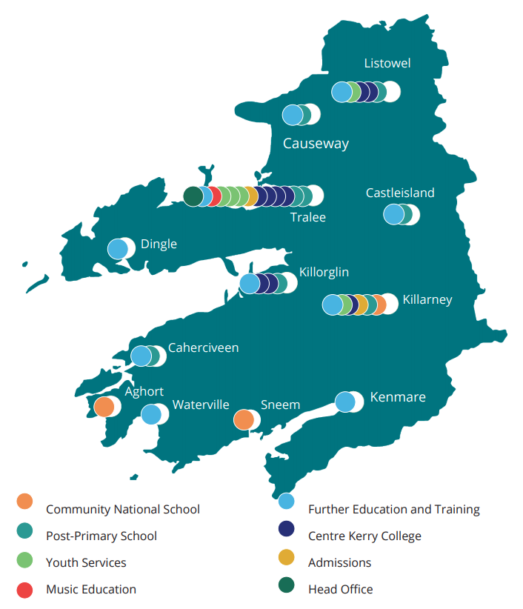

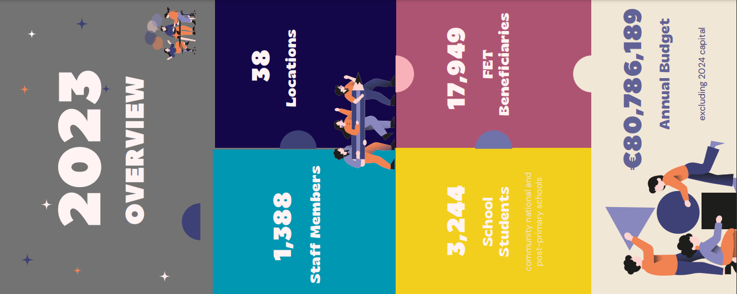

Sustainability in Kerry ETB:

Kerry ETB’s Strategy Statement 2023-2027 outlines ambitious strategic objectives to establish Kerry ETB as a leader in Education and Training provision. The theme of sustainable practices underpins every goal and objective within the Strategy Statement.

With this theme in mind, this Kerry ETB Sustainability Strategy 2024-2026 has been developed with five sustainable goals identified.

The Kerry ETB Climate Action Plan has also been developed which identifies nine objectives to help achieve the sustainable goals.

The Kerry ETB Climate Action Roadmap is a technical document with clear targets and actions which will enable Kerry ETB report on their achievements to date.

Our Journey to date:
Kerry ETB’s inaugural Sustainability Strategy (2020-2022) was launched in February 2021 and was developed to ensure Kerry ETB’s commitment to conducting activities in a more sustainable and responsible manner. It included a range of actions with associated responsibilities and timelines (please see appendix 1). A review of progress to date and an indication on how to progress further into 2024-2026 is included in this appendix.
It set out an integrated framework for the management of sustainability for the entire organisation. This integrated framework was shaped by:
- Clear roles and responsibilities
- Sustainable strategic goals
- Overarching objectives and actions, all of which supported Kerry ETBs contribution to greater sustainability whilst also maintaining the promotion of a life-long, life-wide learning society in the county.

Much was learned during the implementation of this initial strategy which will influence our Climate Action work into the future. Strategy Implementation Meetings took place on a quarterly basis during the two years to track progress and identify any issues.

All of the Schools, Primary and Post-Primary, are engaged with the An Taisce Green Flag program. Many have been working on Sustainability for years and have achieved a number of Green Flags. The FET Centres, VTOS, ABE and Youthreach are addressing Sustainability in a manner specific to their centres and are sharing ideas and resources via the Sustainability Representative meetings.

A number of Electric Vehicle Charging Points have been installed at Kerry College and FET Centre locations with plans to develop further charging points in line with the national EV charging infrastructure strategy.

Kerry ETB identified the requirement to appoint a Sustainability Officer (initially on a part-time basis) to ensure the actions as set out in the Kerry ETB Sustainability Strategy 2020-2022 were carried out as required and communication and reporting requirements were provided. Each facility nominated a Sustainability Representative to organise climate action at a local level and to report on progress made.

A Green Team was built around each Sustainability Representative to work locally on sustainability. Sustainability Representative meetings were held throughout the year to enable Sustainability Representatives to share ideas and best practice and to raise any issues they experienced. The Sustainability Officer engaged and coordinated with the Green Teams through Teams’ meetings and site visits.

Kerry ETB procured a Sustainability Consultancy company to carry out Energy Audits across fourteen schools and Centres. The recommendations from these audits will assist Kerry ETB in reaching our 2030 Climate Action targets and assist in the formation and implementation of this Sustainability Strategy 2024-2026.

Context and our Climate Action Mandate

The Kerry ETB Sustainability Strategy 2024-2026 continues from our initial Sustainability Strategy. In line with the Strategy, Kerry ETB have also developed a Climate Action Plan and Climate Action Roadmap which will be updated annually. Public sector bodies must develop and implement Climate Action Plans in their organisations as mandated by government in line with the governments Climate Action Plan (CAP). This mandate is designed to ensure that public sector bodies are acting to reduce carbon emissions and are contributing to the government’s overall goal of achieving carbon neutrality by 2050.

The mandate requires public sector bodies to implement a Climate Action Plan, including measures to reduce our carbon emissions, increase our energy efficiency and promote the use of renewable energy. The plan must also include measures to reduce the environmental impact of our operations, such as reducing waste, reducing water consumption and promoting sustainable transport.

The mandate requires public sector bodies to report on progress in meeting their climate action goals and to set targets for further reductions in carbon emissions. Finally, the mandate requires public sector bodies to engage with their stakeholders to ensure that the climate action plan is effective and that meaningful action is being taken to reduce carbon emissions.

The National Climate Action Plan 2023 has established clear targets on emission reduction and energy efficiency for the Public Sector. These targets are a 51% reduction in overall greenhouse gas emissions by 2030 and a 50% improvement in public sector energy efficiency, setting us on a path to reach net-zero emissions by 2050. The goal is to ensure Ireland becomes a sustainable economy and society and to avert the devastating consequences of Climate Change.

Mitigation and Adaptation
In the Government’s Climate Action Plans Climate Action is seen as two integrated responses that society has to take to meet the challenges of Climate Change: Mitigation and/or Adaptation.
Mitigation: mitigation actions seek to prevent Climate Change.
Adaptation: adaptation actions seek to respond to the impacts of Climate Change.
When setting out the Climate Action Roadmap we have endeavoured to classify the actions within it as (i) Mitigation (ii) Adaptation or (iii) a combination of both.

The Public Sector Climate Action Mandate is set out below:

The following targets to be achieved by 2030:
- Reduce GHG emissions by 51% in 2030
- Increase the improvement in energy efficiency in the public sector from the 33% target in 2020 to 50% by 2030
- Put in place a Climate Action Plan
- Establish and resource Green Teams, reporting to senior management, to become integrated drivers of sustainability in every public sector body
- Nominate a member of the Board of Management as the Climate and Sustainability Champion with responsibility for implementing and reporting on the Mandate
- Incorporate appropriate climate action and sustainability training (technical and behavioral) into learning and development strategies for staff
- Organise staff workshops (at least annually) to engage on climate issues, including a focus on decreasing the organisation’s carbon footprint
- Report GHG emissions and sustainability activities in the annual report
- Review any paper-based processes, and evaluate the possibilities for digitisation so it becomes the default approach
- Achieve formal environmental accreditation for large public sector bodies, such as ISO 50001 (Energy Management Standard) or ISO 14001 (Environmental Management System)

Monitoring and Reporting

The Sustainable Energy Authority Ireland’s (SEAI) Gap-To-Target model (GTT model) is a spreadsheet model used to evaluate energy efficiency (EE) performance and energy-related greenhouse gas (GHG) emissions over time.
The model tracks Kerry ETB’s progress from the 2016-2018 baseline towards the 2030 targets. The Gap to Target model is our primary tool in selecting the projects that will achieve our 2030 targets. It identifies the impact of each project on our overall organizational targets.
Additionally, Kerry ETB similar to other public bodies is obliged to report to SEAI annually on its energy usage. This is done via the SEAI Monitoring and Reporting (M&R) system.
The M&R system is an online system which reports an organization’s energy usage and the emissions relating to this usage. The system tracks an organization’s progress towards energy and climate targets as set out under the Government’s climate action plan.

The Kerry ETB Climate Action Roadmap sets out how Kerry ETB will achieve the goals and nine objectives of this Sustainability Strategy.
The Climate Action Roadmap is a technical document with clear actions, key performance indicators (KPIs) and timeframes. The Climate Action Roadmap will enable Kerry ETB to report on the progress made under each of the nine objectives, all of which contribute to the five goals, and Kerry ETBs overall progress towards becoming a more sustainable organization.

International Context

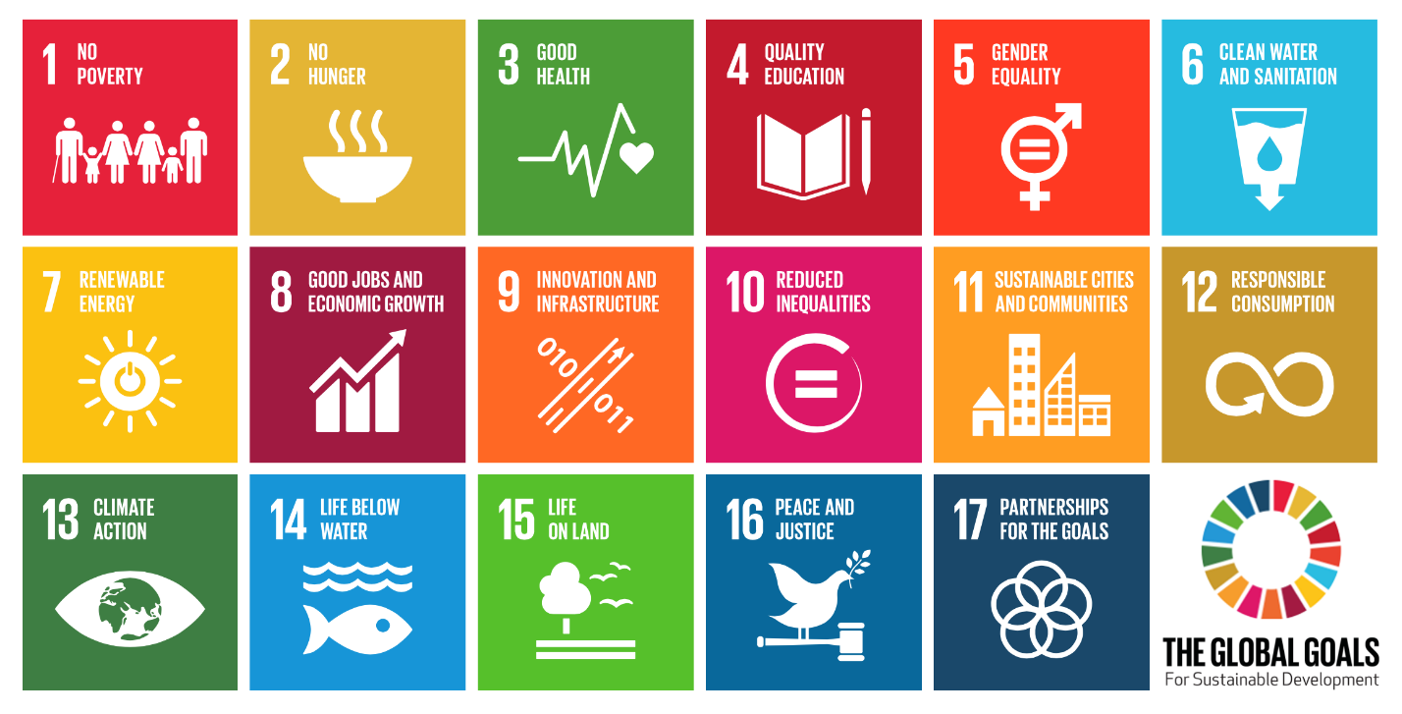
Figure 1 Sustainable Development Goals (SGDs)

In 2015, the world leaders adopted the Sustainable Development Goals (SDGs) figure 1 to provide a roadmap for nations and businesses alike to solve the world’s greatest challenges by 2030. The SDG’s are a comprehensive set of global objectives adopted by all United Nations Member States as a universal call to action to end poverty, protect the planet, and ensure prosperity for all by 2030. They consist of seventeen interconnected goals aimed at addressing various social, economic, and environmental challenges facing the world today.

The SDGs call for action from all countries, irrespective of their wealth or development status. They recognize that global challenges like poverty, inequality, climate change, and environmental degradation require collective efforts and collaboration among nations, stakeholders, and individuals worldwide.

Kerry ETB fully recognises the part it must play in meeting the challenge to ensure Ireland meets its commitments to the 2030 Agenda for Sustainable Development, and the contribution the organisation can make to support the realisation of these goals.

Climate Action Plan and strategy Implementation

Meeting public sector duties in line with Ireland’s Climate Action Plan and developing and implementing a strategy is a critical step for Kerry ETBs commitment to addressing climate change and reducing our carbon footprint.

The below headings identify nine strategic objectives as laid out in the Kerry ETB Climate Action Plan in order to achieve the five key goals as outlined in the Kerry ETB Sustainability Strategy 2024-2026:

Upgrade Building Stock:
Energy efficiency measures will be chosen to reduce carbon emissions from heating, cooling, lighting, and operating public buildings. This could be achieved through deeply retrofitting the existing building stock, improving insulation, installing energy-efficient lighting and HVAC systems, and transitioning to low or zero carbon heating systems.

Sustainable Construction:
Any new buildings will be constructed to nearly zero-energy buildings (nZEBs) standards or above. These standards align with the CAP's commitments and minimize the buildings' energy use and carbon emissions.

Energy Management:
Kerry ETB will Implement an energy management system to monitor and control energy use. This could be part of a wider environmental management system.

Sustainable Transport:
Initiatives to minimize carbon emissions from public sector transport are paramount. This will involve improving Kerry ETB’s fleet's fuel efficiency, transitioning towards electric or hybrid vehicles, supporting active transport (like cycling and walking), and encouraging carpooling and the use of public transport.

Waste Management:
Efficient waste management strategies will be incorporated, consisting of robust recycling programs, composting of organic waste, and initiatives to reduce waste creation in the first place.

Green Procurement:
We will review procurement practises to prioritise products and services with lower environmental impacts. This should cover everything from office supplies to catering and building materials.

Remote Work and Digitization:
Kerry ETB will reduce, where possible, the need for physical commuting, such as flexible working policies and Teams meeting solutions that support remote working and minimize our paper use.

Green Spaces:
Maintain and expand green spaces for both biodiversity and recreational purposes. This would promote carbon sequestration as well as community health and wellness.

Public Sector Engagement:
We will engage staff in Kerry ETB to foster a culture of environmental responsibility. Provide them with information and training about climate change and ways they can help reduce emissions in their roles

Sustainable Goals and Actions to meet Kerry ETB’s Vision for Future

Clear strategic goals and actions have been identified and agreed during the development of Kerry ETB’s Sustainability strategy. Here are the five key strategic goals of this strategy:

- Staff Engagement

- Student, Learner & Apprentice Engagement

- External Stakeholder Engagement

- Energy Sustainability

- Estates Management

Sustainable Goal 1: Staff Engagement

Focus: To ensure our Students/Learners/Apprentices are effectively contributing to Kerry ETB’s sustainability aspirations and objectives.

Clear Communication: Maintain clear communications throughout Kerry ETB on people’s roles and responsibilities. Keep staff informed about organisational goals, decisions, and changes. Allow for clear and concise messaging of Kerry ETB Sustainability Strategy 2024-2026. Include Climate Action and Sustainability governance meeting agendas.

Staff Training: Offer training in sustainability to staff on Climate Action (technical and behavioural) e.g.
QQI Level 4 course “Environmental Sustainability Awareness”. The aim of this course is to equip learners with an awareness of the impacts of human activities on the environment and with the knowledge, skills and competence to identify the key sustainable practices that they can take in their personal life and in their community.
QQI Level 5 course “Environmental Sustainability in the Workplace”. The aim of this course is to develop the learner’s awareness of the impacts of environmental change and the key sustainable practices that can be implemented.

Staff awareness: Provide continuous learning sessions for staff involved in sustainability on each of our campuses e.g. through involvement in working groups, workshops, consultation days, seminars and networking events. Run Climate Action week during the year. Use Kollab to promote sustainability to staff.

A greener culture: Integrate a sustainability culture within the organization. Allow for training courses being offered to staff e.g. Level 4 & Level 5 Modules above. Offer SEAI Energy in Education Training.

Suitable technology platforms: Kerry ETB will use reliable and user-friendly video conferencing platforms such as Zoom, Microsoft Teams, Google Meet, across the organisation's for meetings.

Celebrate milestones: Acknowledge and celebrate achievements or milestones by using graphical images showing continuous progress displayed throughout Kerry ETB to boost team morale. Report on sustainability improvement in our annual report.

Sustainable Goal 2: Student, Learner and Apprentice Engagement

Focus: To ensure our Students/Learners/Apprentices are effectively contributing to Kerry ETB’s sustainability aspirations and objectives.

Include Sustainability Education: Integrate sustainability principles, concepts, and practices into the curriculum across various disciplines and training programs. This includes modules or courses focused on environmental conservation, social responsibility, and economic sustainability.

Hands-On Projects and Practical Learning: Engage students in practical projects or real- experiences related to sustainability. Encourage them to work on initiatives that tackle environmental issues, promote social equity, or address economic challenges within the community.

Student Involvement in Decision-Making: Foster a culture of participation by involving students in discussions, planning, and decision-making processes related to sustainability initiatives within the organisation. Invite students to present their initiatives at a Kerry ETB Board meeting.

Promote Awareness and Behaviour Change: Conduct awareness campaigns, workshops, and seminars to educate students about sustainability issues and inspire behavioural changes. Encourage responsible consumption, waste reduction, energy conservation, and ethical practices among students and learners.

Green Flag Program: Identify and progress the opportunity to develop green flag programmes in FET. Identify potential ‘Green Awards’ Kerry ETB could achieve through sustainable practices.

Recognition and Incentives: Recognise and reward students and groups who demonstrate exceptional commitment in contributing to sustainability goals. This could include awards, certificates, or opportunities for further development.

Continuous Improvement and Feedback: Seek feedback from students regularly on sustainability initiatives. Use their input to refine and improve programmes.

No to plastics: Ban specific single-use plastic items including plastic food containers, cups and drinks containers in line with the Single Use Plastic Directive.

Sustainable Goal 3: External Stakeholder Engagement

Focus: To foster and develop productive partnerships with external stakeholders, ensure our external stakeholders are effectively contributing to Kerry ETB’s sustainability aspirations and objectives.

Diverse Perspectives and Expertise: External stakeholders encompass a wide range of entities, including communities, Local Governments, businesses, academia, and more. Each brings unique perspectives, expertise, resources, and experiences to the table, enabling comprehensive problem-solving and innovative solutions. For example, collaboration between Kerry ETB and Kerry County Council and Local Link to progress Smarter Travel initiatives throughout Co. Kerry.

Partnerships and Collaboration: Collaborating with external stakeholders fosters partnerships that can amplify the impact of sustainable initiatives. Partnerships encourage resource-sharing, joint planning, and coordinated action, leveraging the strengths of each stakeholder for greater effectiveness. Kerry ETB will carry out Green Procurement strategies to encourage suppliers to implement more sustainable practices.

Local Context and Participation: Engaging local communities and stakeholders ensures that sustainable initiatives are contextually relevant and responsive to the needs of the people they aim to benefit. Involving these stakeholders in decision-making processes promotes ownership and increases the chances of successful implementation.

Long-Term Sustainability: Liaise with SEAI on sustainable initiatives across Kerry ETB that engage external stakeholders to be more sustainable in the long run. Engage with Private Sector, and local Sustainability organisations to jointly develop Sustainability initiatives in urban and rural areas across County Kerry.

Education and Capacity Building: Provide education and capacity-building opportunities for external stakeholders to enhance their understanding of sustainability issues. Support initiatives that promote skill development and empowerment within communities.

Sustainable Goal 4: Energy Sustainability

Focus: To reduce our environmental impact across all our operations.

Transition to renewable Energy: Transitioning from fossil fuels to renewable energy sources like solar, geothermal, air to water heat pumps and biomass is vital. Investing in these sources reduces greenhouse gas emissions and promotes cleaner energy production at Kerry ETB sites.

Electrification of Transportation: Encourage the adoption of electric vehicles and invest in EV charging infrastructure, where possible, to reduce reliance on fossil fuels in the transportation sector.

Policy and Regulatory Frameworks: Implementing supportive policies, incentives, and regulatory frameworks is crucial for advancing energy sustainability. This includes grants from SEAI for renewable energy, carbon pricing mechanisms, energy efficiency standards, and supportive legislation.

Green Building Practices: Design and construct energy-efficient and environmentally sustainable buildings in line with DoE and DFHERIS guidance. Retrofit existing buildings with energy-saving technologies.

Energy Efficiency Measures: Install energy efficient lighting, appliances and equipment across all Kerry ETB Schools, Centres and Campuses.

Monitoring and Reporting: Establish an EMS (Energy Management System) to monitor energy consumption on the sites. We can track progress and report on the implementation of energy sustainability initiatives. This ensures accountability and facilitates evidence-based decision-making

Sustainable Goal 5: Estates Management

Focus: To ensure Kerry ETB implements effective Sustainability procedures across all Schools and Centres.

Capital Preservation: Safeguard the value of the estate by keeping up with regular planned and preventive maintenance and investing in enhancements that will add to the property's overall value.

Climate Action for the buildings: Implementing measures to reduce carbon emissions, such as using renewable energy sources, energy-efficient building designs, and sustainable transportation options.

Cost Efficiency: Aim for the most efficient use of resources. This involves managing and reducing operating and maintenance expenses without compromising the quality of the property. Avoid costly emergency repairs through proactive maintenance.

Green Infrastructure: Incorporating green spaces, biodiversity preservation, and sustainable landscaping practices into estate planning contributes to creating sustainable and resilient communities.

Water Conservation: Install water-saving technologies, such as low-flow taps and water-efficient landscaping practices. Investigate and implement opportunities for rainwater harvesting/water conservations across all Kerry ETB locations.

Waste Reduction and Recycling: Establish a comprehensive waste management system that includes recycling, composting, and waste reduction strategies.

Estate Biodiversity Conservation: Reduce frequency of grass cutting of estates property by 50%. Establish “set-aside” areas on grounds of Kerry ETB properties, where possible, to support nature, using pollinator - friendly plants. Irish rewilding initiative to help Ireland’s bee and pollinator population. Avoid using harmful pesticides and herbicides that can negatively impact the ecosystem.

Green Estate Building Practices: Identify and develop a new green facility in Kerry ETB to become a Centre in sustainability and new green technology for apprentices, students and staff throughout the country.

Teaching and learning - Promote and use the natural environment of our estates in training and education. Establish a monitoring system to track the growth and health of planted trees over time.

Appendix1: Review of Kerry ETB Sustainability Strategy 2020-2022

GOAL 1 - STAFF ENGAGEMENT

ACTIONS | TIMELINE | RESPONSIBILITY | PROGRESS | 2023-2025
Formally appoint an ETB Energy/Sustainability Officer. | Short | CEO & Directorate | Completed | Continue
Include and Promote Sustainability as a Kerry ETB Core Value through clear communications. | Long | Implementation Group | Progress Made | Develop further
Develop and articulate clear messaging of Kerry ETB Sustainability Strategy 2020-2022 | Medium | Implementation Group | Work in Progress | Action
Elect /appoint a “Sustainability Representative” for each centre/school/office with ownership for all liaison and recording work on initiatives | Short | Line Managers | Completed | Continue
Establish “Green Team” in each school/centre/ campus to support sustainability initiatives | Short | Line Managers | Progress Made | Develop further
Encourage the incorporation of sustainability culture into training courses delivered, where practical. | Long | Implementation Group | Progress Made | Develop further
Sustainability to be a standing item on Board, Committee and management/staff meetings agendas | Short | Senior Executive | Progress Made | Develop further
Access SEAI Sustainability training. | Short | Implementation Group | Progress Made | Develop further
50% of all offsite meetings to be held using technology platforms | Short | Line Managers | Progress Made | Develop further
Sustainability to be addressed as part of all strategies, plans and policies new or revised. | Medium | Line Managers | Progress Made | Develop further
Publish Remote-Working Policy | Short | HR Department | Work in Progress | Action
Set up a Sustainability Forum, an annual meeting of all the Sustainability Representatives to share ideas and good practice etc. | Long | Implementation Group | Work in Progress | Action
Agree Terms of Reference for Kerry ETB Sustainability Reps | Short | CEO & Directorate | Completed | Continue
Clear graphical representation of goals, objectives and progress (displayed in reception areas, canteens, classrooms, online etc.) | Short | Green Team | Work in Progress | Action
Report on sustainability progress in the Annual Report | Medium | Implementation Group | Progress Made | Develop further

GOAL2 - STUDENT, LEARNER & APPRENTICE ENGAGEMENT
ACTIONS | TIMELINE | RESPONSIBILITY | PROGRESS | 2023-2025
Include and Promote the Kerry ETB Core Values – notably sustainability value | Long | CEO & Directorate | Completed | Continue
Green Flags Program in Schools extended and enhanced. | Short | Principals | Progress Made | Develop further
Green Flag Program or equivalent to be identified and progressed in FET. Identify potential “Green Awards” Kerry ETB could achieve through sustainable practices. | Medium | Centre Managers | Progress Made | Develop further
Establish awareness campaigns as appropriate (e.g. Bright Eyes) | Medium | Green Team | Work in Progress | Action
Communicate the successes and results of any initiatives undertaken | Long | Implementation Group | Work in Progress | Action
Enhance and support gardening & horticulture activities in Schools and Further Education Centres | Medium | Green Team | Progress Made | Develop further
Encourage the incorporation of Sustainability culture into training courses delivered. | Long | Implementation Group | Progress Made | Develop further
Identify and support engagement by Students/Learners in relevant Student/Learner Councils | Medium | Green Team | Progress Made | Develop further
Support Schools to participate in ETBI Take 1 program in embedding sustainable goals | Medium | Green Team | Progress Made | Develop further
Engage students, learners and apprentices to assist in monitoring the biodiversity in the schools/centres | Medium | Green Team | Work in Progress | Action
Knockreer House to run workshops in all schools & centres highlighting the need for increased awareness and action on Sustainability | Medium | Director NCOET / KNPEC | Progress Made | Develop further
Introduce GLOBE (Global Learnings and Observations to Benefit the Environment) initiative in Kerry ETB schools (https://www.globe.gov/) | Long | Director NCOET / KNPEC | Progress Made | Develop further
Progress towards ensuring suppliers source Fair Trade and local supplier options for all vended products in Kerry ETB Schools and Centres | Long | Principals & Centre Managers | Work in Progress | Action
Communicate the goals and objectives of Sustainability Strategy | Short | Implementation Group | Work in Progress | Action

GOAL 3 - EXTERNAL STAKEHOLDER ENGAGEMENT
ACTIONS | TIMELINE | RESPONSIBILITY | PROGRESS | 2023-2025
Include and Promote the Kerry ETB Core Value – notably sustainability value | Long | CEO & Directorate | Progress Made | Develop further
Encourage external suppliers to source “fair-trade” products, local sustainable suppliers, and certified sustainable suppliers where possible | Medium | Principals & Centre Managers | Work in Progress | Action
Proactively engage with Private Sector, and local Sustainability organisations to jointly develop Sustainability initiatives in urban and rural areas across Co.Kerry | Medium  / Long | Implementation Group | Work in Progress | Action
Liaise with SEAI to develop Sustainability Initiatives across Kerry ETB | Medium | Implementation Group | Progress Made | Develop further
Identify and engage with all potential stakeholders | Medium  / Long | Implementation Group | Progress Made | Develop further
Leverage current stakeholder relationships to support funding applications on Sustainability related projects | Medium  / Long | Implementation Group | Work in Progress | Action

GOAL 4 - ENERGY SUSTAINABILITY
ACTIONS | TIMELINE | RESPONSIBILITY | PROGRESS | 2023-2025
Identify where electric vehicle charging points are practical and appropriate to needs, at Kerry ETB Schools and FET Centres. | Medium | Implementation Group | Completed | Continue
Develop Electricity Generation Policy | Short | Implementation Group | Completed | Continue
Install bicycle racks, appropriate to needs, at Kerry ETB Schools and FET Centres | Medium | Principals/Centre Managers | Work in Progress | Action
No single use plastic material to be used by Schools and Centres | Medium | Green Team | Work in Progress | Action
Establish baseline data for each Centre/School on resource use / recycling and re-using | Medium | Implementation Group | Progress Made | Develop further
Aim to Achieve use of 100% recycled paper across Kerry ETB operations. | Long | Implementation Group | Work in Progress | Action
Establish baseline target for print reduction across Kerry ETB | Long | Implementation Group | Work in Progress | Action
Undertake refurbishment to identified buildings to optimise insulation levels and set target BER level to achieve | Long | CCT Department | Work in Progress | Action
Monitor & Record energy performance returns (M&R returns) to Sustainable Energy Authority of Ireland (SEAI) submitted consistently | Short | Implementation Group | Completed | Continue
Ensure Kerry ETB meets Energy Efficiency targets. | Medium | Implementation Group | Progress Made | Develop further
Develop Plan to meet long-term Carbon Neutral requirements | Long | Implementation Group | Progress Made | Develop further
Assess opportunity to install intelligent and energy efficient lighting as standard across Kerry ETB | Long | Implementation Group | Work in Progress | Action
Investigate and implement site-specific options on energy generation (Wind Turbines /Biomass/ Photovoltaic Cells) | Long | Implementation Group | Work in Progress | Action
Procurement of electrical appliances will incorporate adherence to optimum Energy Efficiency rating | Medium | CEO & Directorate | Work in Progress | Action
Undertake assessment of Kerry ETB Buildings to identify suitability for implementation of automated entry/exit doors, to minimise energy consumption | Medium | Implementation Group | Work in Progress | Action
Investigate solar and wind energy project opportunities | Medium | Implementation Group | Progress Made | Develop further
Actively promote proper environmental management of WEEE and waste batteries = | Long | Implementation Group | Progress Made | Develop further
Make the sustainability strategy, and other relevant information, initiatives etc. available to the public | Short | Communications Officer | Completed | Continue

GOAL 5 - ESTATES MANAGEMENT
ACTIONS | TIMELINE | RESPONSIBILITY | PROGRESS | 2023-2025
Kerry ETB is a Sustainability leader in Estates Management | Long | Implementation Group | Work in Progress | Action
Kerry ETB Procurement policies and practices to incorporate sustainability as standard | Medium | CEO & Directorate | Progress Made | Develop further
Energy in Education Training from SEAI to be provided to all caretakers and relevant staff | Medium | Implementation Group | Work in Progress | Action
Establish “set-aside” areas on grounds of all Kerry ETB properties to support nature, using pollinator – friendly plants | Medium | Green Team | Work in Progress | Action
Reduce frequency of grass cutting of estates property by 50% | Short | Green Team | Progress Made | Develop further
Kerry ETB estates portfolio will meet National Energy Sustainability and carbon neutral targets | Long | Implementation Group | Progress Made | Develop further
Identify and develop a facility in Kerry ETB to become a self-sufficient Centre in Sustainability | Long | Implementation Group | Work in Progress | Action
Promote and use the natural environment of our estates in teaching and learning | Medium | Green Team | Progress Made | Develop further
Promote carbon sequestration through planting of native trees | Medium | Director of NCOET | Progress Made | Develop further
Implement All-Ireland Pollinator plan for Schools:  https://pollinators.ie/schools/ | Medium | Principals | Progress Made | Develop further
Develop Habitat Map for each individual School/Centre grounds | Medium | Green Team | Work in Progress | Action
Implement BioBlitz Program across Kerry ETB, provided by KNPEC Staff | Long | Director of NCOET | Work in Progress | Action
Phase out the use of herbicides by Kerry ETB staff in the maintenance of Kerry ETBs estates portfolio | Medium | Green Team | Work in Progress | Action
Incorporate swift boxes into new builds/redevelopment plans | Long | Implementation Group | Work in Progress | Action
Investigate and implement opportunities for rainwater harvesting / water conservations across all Kerry ETB locations | Long | Implementation Group | Work in Progress | Action

Appendix 2: Listing of Kerry ETB’s Estate

OWNED
Category | Location
Colaiste Gleann Li | Clash West, Tralee
Causeway Comprehensive School | Dromkeen West, Causeway
Colaiste na Riochta | Upper Church Street, Listowel
Colaiste na Sceilge | Garranebane, Cahersiveen
Gaelcholaiste Charrai | Moyderwell, Tralee
Gaelcholaiste Charrai Campas-Nua | Cloonmore, Tralee
Killarney Community College | New Road, Killarney
Killorglin Community College | Langford Street, Killorglin
Castleisland Community College | Tonbwee, Castleisland
Two Mile Community National School | Fossa, Killarney
Pobhail Scoil an Ghleanna | Ballinskelligs
Tahilla Community National School | Tahilla, Sneem

OWNED
Category | Location
Kerry College Monavalley Campus | Monavalley, Tralee
Kerry College Clash Campus | Clash West, Tralee
Kerry College Killorglin Campus | Oolagh West, Caragh Lake
Unit 1 Listowel Business Development Centre | Cliveragh Industrial Estate
An Tochar Further Education and Training Centre | Dromkeen West, Causeway
Kenmare Further Education and Training Centre | Bell Height, Kenmare
O'Connell Further Education and Training Centre | Carhan Road, Caherciveen
Tech Amergin Further Education and Training Centre | Spunkane, Waterville
Tralee VTOS (Teach Eolas) | Clash West, Tralee
Property not Owned - Leased
Category | Location
Primary level, Post Primary Level and Centres
Kerry College Monavalley Campus - Unit 5 | Monavalley Industrial Estate, Tralee
Kerry College Monavalley Campus- Unit 7 & 8 | Monavalley Industrial Estate, Tralee
Kerry College Monavalley Campus Unit 9 - Hall 1 & 2 | Block T, Monavalley Industrial Estate, Tralee
Kerry College Monavalley Campus Unit 9 - Hall 3 | Block T, Monavalley Industrial Estate, Tralee
Kerry College Denny Street Campus | Ground Floor of units 13/14 Denny Street, Tralee
Kerry College Denny Street Campus | 5, 6, 7 & 8 Denny Street, Tralee
Kerry College Clash Campus Block E | Clash West, Tralee
Kerry College Monavalley Campus - Units 1 & 4, Davcon House | Units 1 & 4, Davcon House - Monavalley Industrial Estate, Tralee
Kerry College Monavalley Campus- Ansaldo Building | Block F, Monavalley Industrial Estate, Tralee
Kerry College Admissions Office Tralee | 7 Denny Street, Tralee
Kerry College Admissions Office Killarney | 25 High Street, Killarney
LCA Youthreach Tralee | Áras an Phobail, Croílár na Mistéalach, Tralee
Unit 102 | Centrepoint, John Joe Sheehy Road, Tralee
Listowel Youthreach | Butler Centre, 12 The Square, Listowel
Killarney Youthreach | 50 High Street, Killarney
Liber House (Tralee ABE) | Units 3H, 3I and 5D Liber House, Monavalley, Tralee
Liber House Tralee (Tralee Youthreach) | Rooms 1 - 8 Liber House
Liber House Tralee (Tralee Youthreach) | Unit 1A Tralee Youthreach Liber House,
Liber House (Tralee ABE) | Units 2A and 5F, Liber House
Killarney ABE | 37 High Street, Killarney
Killorglin ABE | Unit 1 & 2 First Floor of Mulvihill’s Pharmacy Building, Lower Bridge Street, Killorglin
Castleisland ABE | Community Centre, Tonbwee, Castleisland
Killarney VTOS | New Street, Killarney
South Kerry VTOS (incl ABE) | The Lodge, Market Street, Killorglin
Dingle FET Training Centre | Rice House, Goat Street, Dingle
Irish FET - CFCD Dingle | Áras Bhréanainn, Gortmore, Ballyferriter Village, Co. Kerry, V92 K5WT
Unit 7 &8 Keltic Business Centre Listowel | Cliveragh Industrial Estate Tralee

