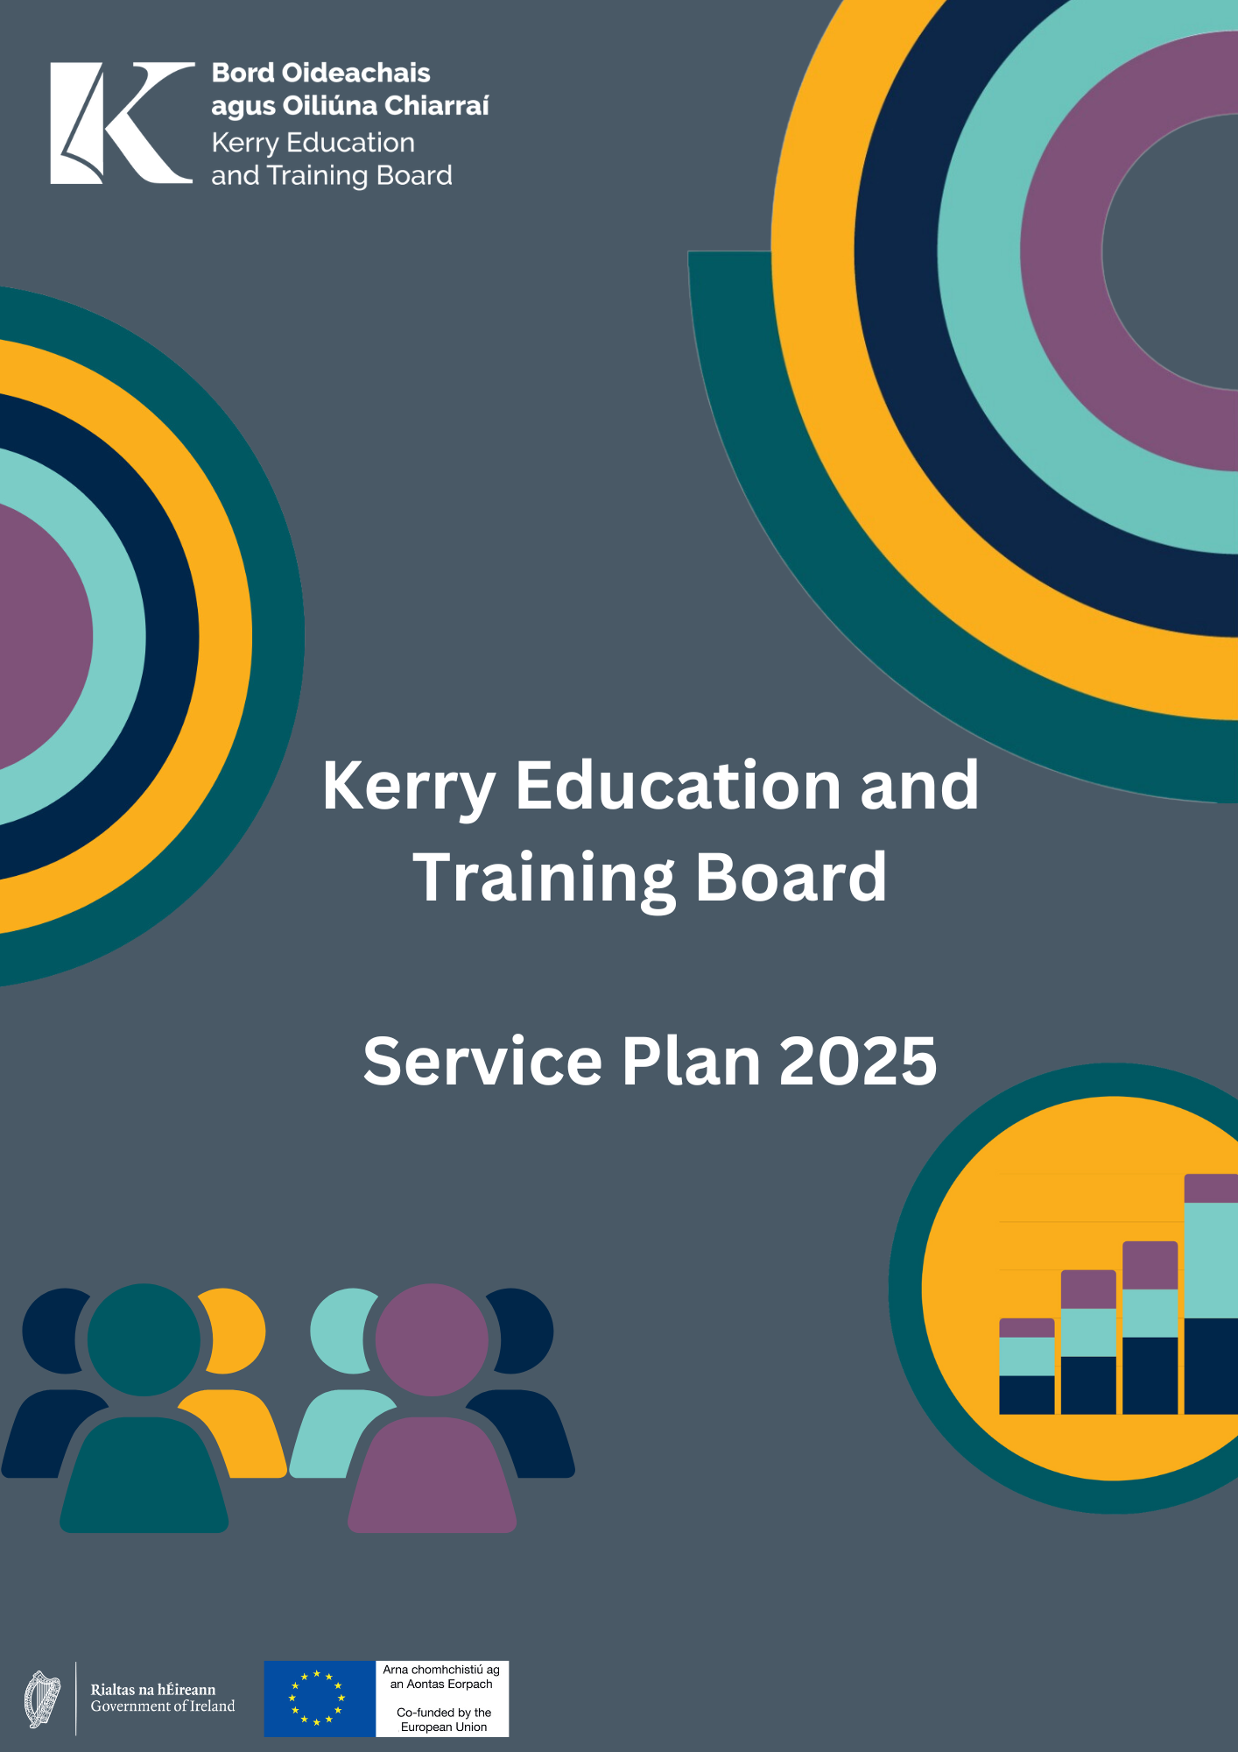
Service Plan 2025
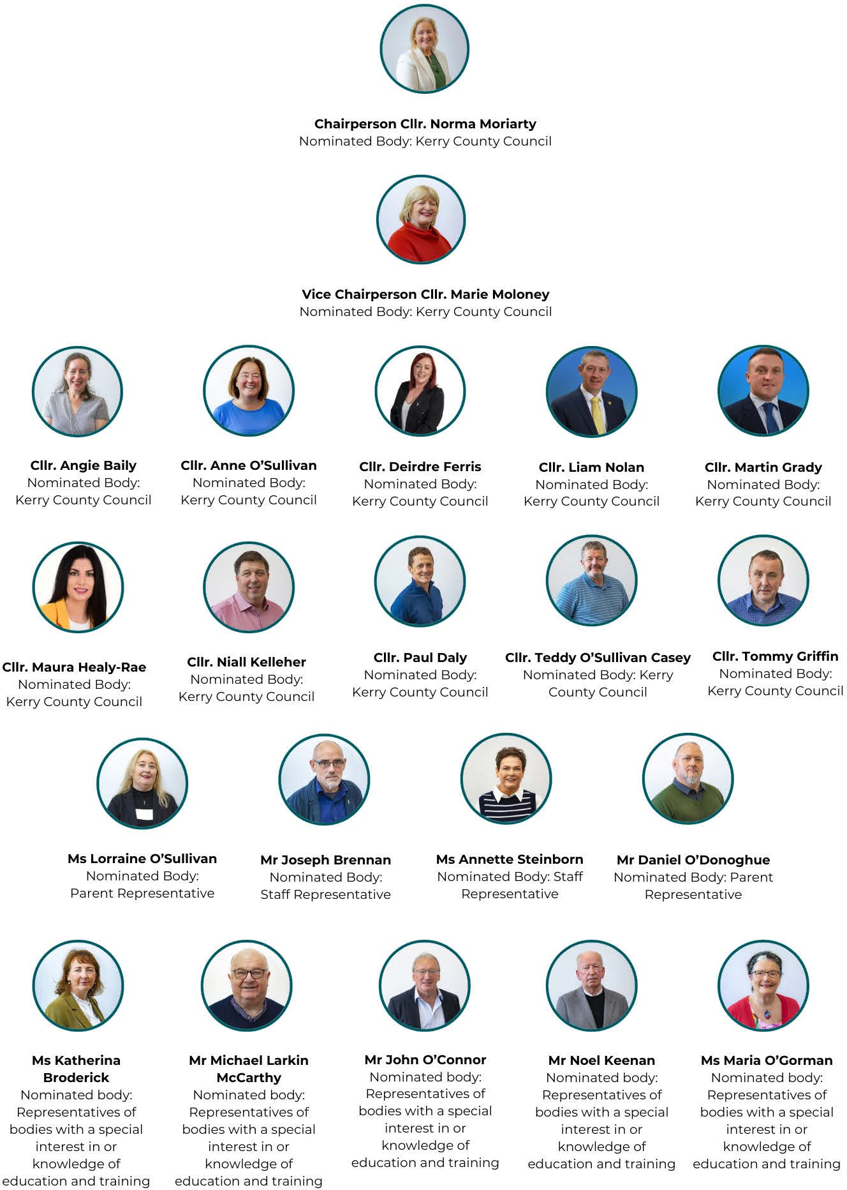
Kerry ETB Board 2025

Kerry ETB Executive 2025

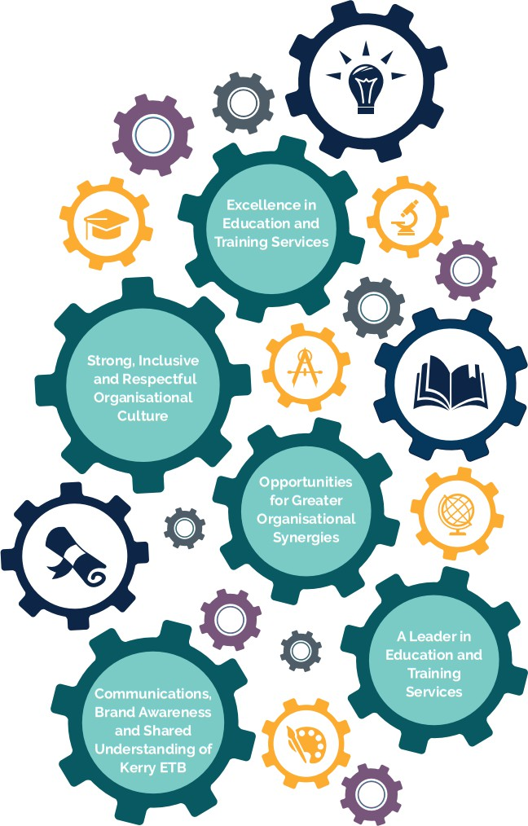
Mr. Colm Mc Evoy Ms. Ann O'Dwyer
Ms. Maria Brennan Mr. Owen O'Donnell
Chief Executive
Director of Schools, Youth and Music
Director of Organisation Support and Development Director of Further Education and Training

Contents

Joint Foreword from Our Chairperson and Chief Executive 5
Organisation Profile 6
Locations 7
Organisational Structure 8
Our Vision, Mission and Core Values 9
Strategic Goals 11
Statement of Services 12
Department of Education Performance Delivery Agreement 12
Optimise Student/Learner Experience 12
Protection Programmes 13
Governance 13
Kerry ETB Strategic Goals and Priorities 16
Goal 1: Excellence in Education and Training Services 16
Goal 2: Strong, Inclusive and Respectful Organisational Culture 23
Goal 3: Opportunities for Greater Organisational Synergies 26
Goal 4: A Leader in Education and Training Provision 28
Goal 5: Communications, Brand Awareness and Shared Understanding of Kerry ETB 33
Appendix I: Projected Receipts and Expenditure 36

Joint Foreword from
An Cathaoirleach and Chief Executive

This year marks a new chapter for Kerry ETB, being the first full year of our newly appointed Board and the introduction of the revised Code of Practice for the Governance of ETBs Circular 83/2024.
In line with the provisions of Section 47 of the Education and Training Boards Act 2013, the 2025 Service Plan outlines our key priorities and actions for the year ahead. It serves as a clear roadmap for implementing the next phase of our Strategy Statement 2023–2027, ensuring that our objectives remain aligned with national policy, stakeholder needs, and the evolving education and training landscape.
This plan identifies the specific areas of our five-year strategy that will be the focus of our efforts in 2025. We aim to build on our progress, enhance student/learner experiences, expand access to opportunities, and further embed best practices in governance and service delivery.
These priorities reflect our commitment to our values of inclusion, respect, equality, quality and excellence in learning, ensuring that our services continue to evolve to meet the needs of all our students, learners and stakeholders.
The year ahead presents both challenges and opportunities. The new Board will play a pivotal role in guiding the organisation, ensuring that we remain responsive, and forward-looking. The adoption of the new Code of Practice provides a strong foundation for ethical leadership, transparency, and robust decision-making as we work to achieve our goals.
We look forward to working with our students, parents/guardians, learners, staff, employers, and government partner departments to advance our shared mission. Together, we will continue to drive excellence in education and training, equipping individuals with the skills and knowledge needed to thrive in an ever-changing world.
We are confident that 2025 will be a year of progress, impact, and achievement, as we take the next steps in realising the vision set out in our Strategy Statement 2023–2027.

Mr. Colm Mc Evoy Councillor Norma Moriarty
Chief Executive An Cathaoirleach

Organisation Profile

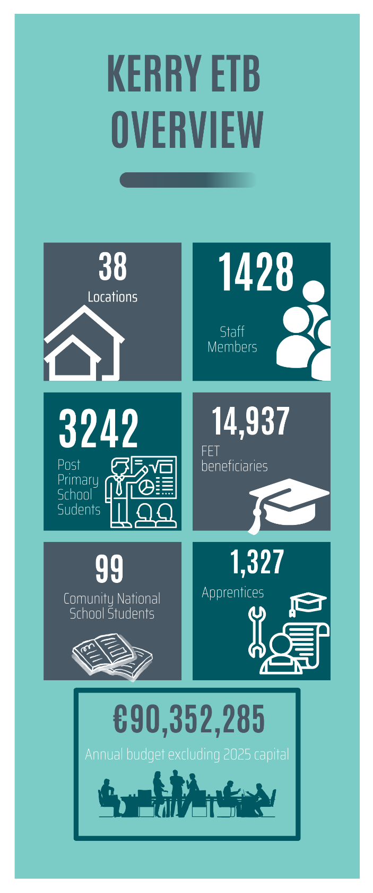
Kerry ETB is the statutory authority responsible for delivering high-quality education and training services across County Kerry.

Established in 2013 under the Education and Training Boards Act, Kerry ETB is committed to fostering lifelong learning. Each year, the organisation engages with c.3,200 students, including c.100 primary students and c.3,100 post-primary students and c. 14,937 beneficiaries and c.1,327 apprentices in Further Education and Training.

Kerry ETB operates with a workforce of c.1,428 staff members across 38 locations, with an annual budget of c.€90,300,000, excluding capital funding.

Kerry ETB is structured within a corporate governance framework comprising a democratically appointed Board and an executive management team.

The organisation delivers a diverse range of education, training, and support services, including primary, post-primary education, further education and training, and youth work support ensuring that learning opportunities are available at every stage of life.

Kerry ETB continues to expand and enhance its services to meet the evolving needs of students, parents/guardians, learners, employers, and communities.

Kerry ETB also has designated charitable status (registered charity number: 20083243).

Locations

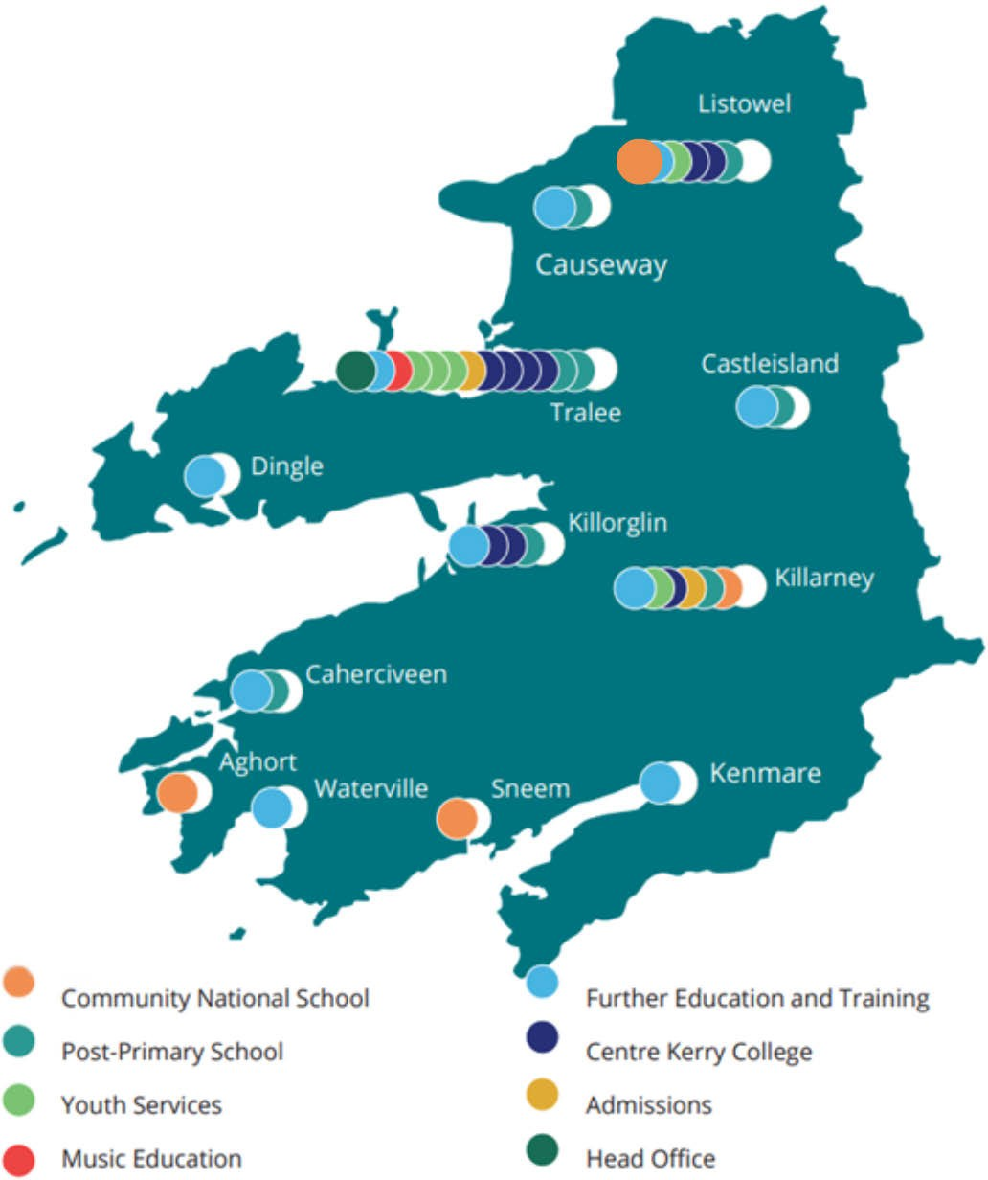

Organisational Structure

The Chief Executive is responsible for the executive management of Kerry ETB and is supported in this role by three Directors, namely:

- Director of Schools, Youth and Music
- Director of Organisation Support and Development
- Director of Further Education and Training

The three Director roles reflect the three pillars of service delivery, with each Director formally delegated authority in their role as per Section 16 of the Education and Training Boards Act, 2013.

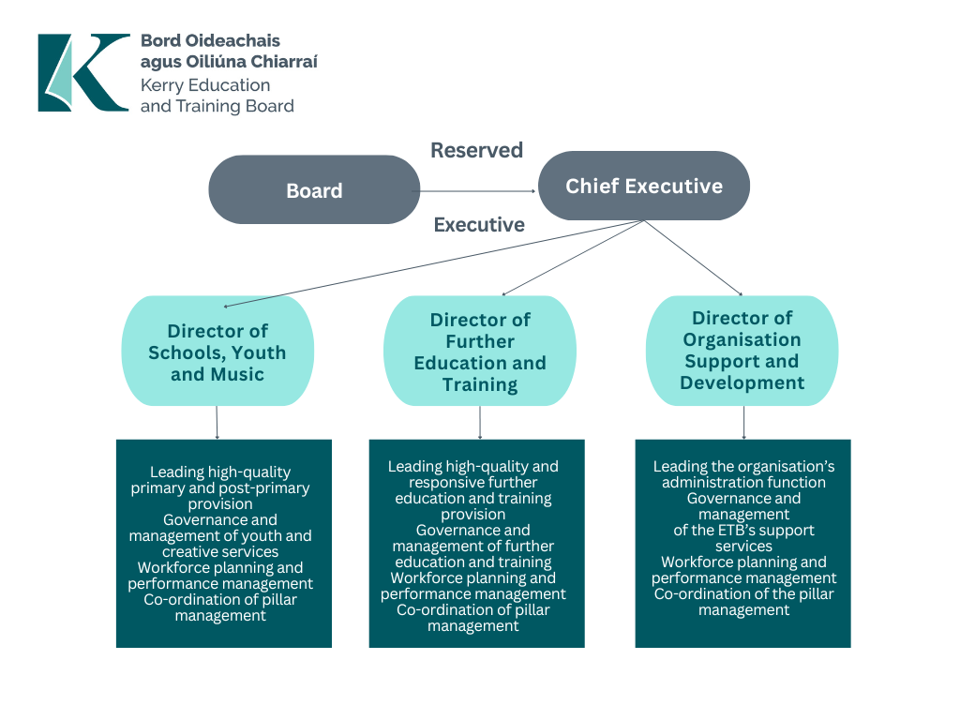

o

Our Vision, Mission and Core Values

Vision

Our shared vision is that Kerry ETB will be an
innovative leader in the design and delivery of quality- assured and sustainably delivered education and
training opportunities in Kerry.

Mission
We will continue to promote the development of a
lifelong and life-wide learning society in Kerry so that all persons have equal access to education and training opportunities.

To achieve our vision, we put a strong emphasis on working closely with our internal and external
stakeholders, particularly marginalised groups.

Core Values
Our core values, Inclusion, Respect, Equality, Quality, and Excellence in Learning, underpin our actions and behaviours. These values are centred on the belief that every person should have the right to access education and training opportunities to help them realise their
potential and meet their personal, social, civic, cultural and economic needs.

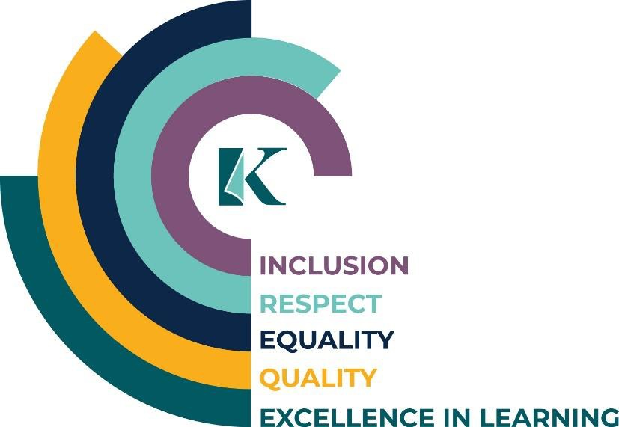

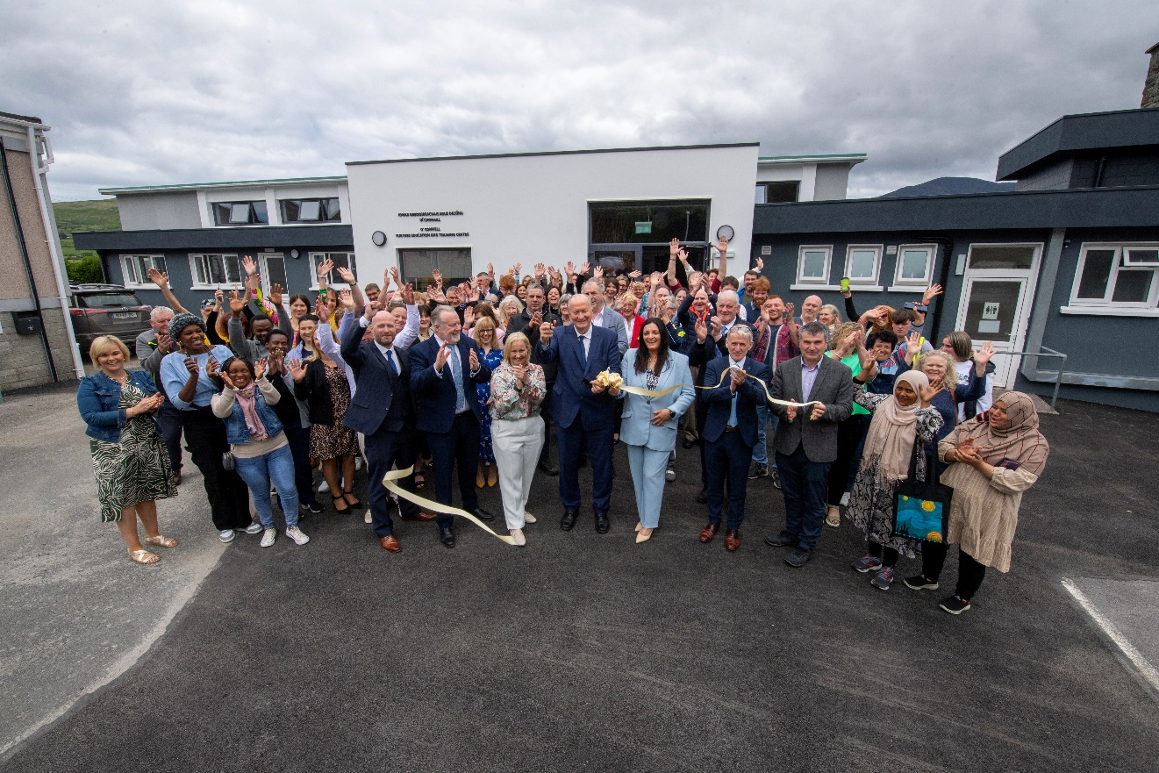

Strategic Goals

The Statement of Strategy 2023 – 2027 sets high-level objectives under five Strategic Goals.

Each goal has its own set of strategic priorities which will be achieved through actions identified in the Service Plan. These goals and priorities will assist Kerry ETB to avail of the opportunities which will arise and meet the challenges it faces over the five year term of the Strategy Statement.

Goal 1: Excellence in Education and Training Services
We aim to ensure the continued review, design, delivery and support of quality-assured education and training opportunities to meet all learners’ evolving lifelong and life-wide learning needs.

Goal 2: Strong, Inclusive and Respectful Organisational Culture
We aim to ensure our structures, processes, and behaviours underpin an environment that is safe, supportive and inclusive of all people, regardless of identity, background or circumstance.

Goal 3: Opportunities for Greater Organisational Synergies
We aim to strengthen integration across our three pillars in a planned and strategic manner, adopting more cohesive and unified approaches.

Goal 4: A Leader in Education and Training Provision
We aim to establish ourselves as a leader in the development of education and training at both regional and national levels.

Goal 5: Communications, Brand Awareness and Shared Understanding of Kerry ETB
We aim to develop Kerry ETB into a widely recognised brand underpinned by high-quality communications with internal and external stakeholders.

Statement of Services

Department of Education Performance Delivery Agreement

In accordance with Section 8.7 of the Code of Practice for the Governance of ETBs (Circular Letter 83/2024) ETBs are required to agree a Performance Delivery Agreement with the Department of Education and report to that Department on progress against targets. These agreements act as a performance contract between the Department and the ETB in which an agreed level of performance/service is formalised.
Under the terms of the Performance Delivery Agreement between the Department of Education and Kerry ETB, the following goals and priorities were identified. The specific actions, together with the performance indicators and targets to be delivered are as follows:

Optimise Student/Learner Experience

Priority | Action | Performance Indicator | Target
Provide a positive learning experience for all learners, including learners from marginalised groups | Continue to address and support equality of outcomes for our learners, particularly those from marginalised groups. | Implementation of the Public Sector Equality and Human Rights Duty Plan. | Student experience survey, of first year students, and results addressed.
 | Continue Traveller education support programme/role for schools, increasing leaving certificate completion rates. | Attendance, participation and retention of Traveller students in Post-Primary schools. | 10% improvement in attendance, participation and retention of Traveller students.
Support learners at risk of educational disadvantage in line with current national policy | Leverage DEIS grants to prevent marginalisation and reduce the risk of educational disadvantage. | Increase in retention and progression in DEIS schools. | Individual school DEIS targets achieved.
 | Continue to support the  School Completion  Programme in line with  Department of  Education/TUSLA  Assurance Document. | Ongoing communication with School Completion Programme Co-ordinator and Local Management Committee. | Department of Education School Completion Assurance document implemented.

Optimise Student/Learner Experience (continued)
Priority | Action | Performance Indicator | Target
Ensure all necessary | Ensure that all schools and Youthreach centres are informed and adhere to the revised 2023 Child Protection Procedures issued by the Department of Education. | Two Child Protection Oversight Meetings held. Training provided for all new Section 44 Committees. | Achieve full compliance in the 2024/2025 Child Protection Annual Report.
child safeguarding
measures are in place in
accordance with the
Child Protection
Procedures for Primary
and Post-Primary
Schools (revised 2023)
Ensure full compliance
with the Child
Protection Procedures
for Primary and Post-
Primary Schools
(revised 2023)

Protection Programmes

Priority | Action | Performance Indicator | Target
Assist the Department, as needed, to meet the needs arising from the Irish Refugee Protection Programme and provision for international protection applicants | Organise REALT Update and Review Meetings every 6 weeks. Organise Irish Refugee Protection Programme and International Protection Meetings (Kerry ETB Structure) every 2 months. | Students/learners enrolled in schools and FET. | Ensure timely (same week) responsive and consistent support for applicants and their families.

Governance

Priority | Action | Performance Indicator | Target
Attendance rates at board meetings | Individual boards should re-emphasise the requirement for attendance at all board meetings as per the Code of Practice for Governance of ETBs. | The importance of attendance at all board meetings will be highlighted to Board Members. | High level of Board attendance achieved.
Board self-assessments | All boards should carry out self-assessments using the questionnaire included in the Code of Practice for the Governance of ETBs to identify areas where improvements are required. | Completion of self-assessments by all board members. | Results from completed self-assessments reviewed by an Cathaoirleach of the Board.

Governance (continued)
Priority | Action | Performance Indicator | Target
Financial expertise on audit and risk, and finance committees | Appointments to audit and risk, and finance committees should be made by the board in consultation with committee chairs. External members of committees should bring the required audit and financial skills and experience to the role. | Appointments to new audit and risk, and finance committees made in consultation with committee chairs and in accordance with the new Code of Practice for the Governance of ETBs. | External members of the audit and risk, and finance committees will have significant financial expertise.
Board appraisal of work carried out by audit and risk, and finance committees | The Chair should ensure that board members are provided with written reports on the work carried out by the audit and risk, and finance committees as required under the Code of Practice. | Successful provision of written reports on the work carried out by audit and risk, and finance committees to all board members. | Achieve a 100% distribution rate of these reports to all board members following committee meetings.
Self-assessment by audit and risk, and finance committees | The chairs of both the audit and risk, and finance committees should ensure that a self- assessment exercise is completed annually as required under the Code of Practice. | Successful completion of annual self-assessment exercises by the audit and risk, and finance committees. | Utilise the self- assessment results to identify where improvements are required.
Staff development | The Chief Executive should ensure that:  - a member of staff is appointed as the training manager  - training needs analysis in financial management is carried out on an annual basis  - a training programme on financial management is developed and implemented | Newly appointed staff member (HR) will be assigned to assist with the development and implementation of a training plan and conducting training needs analysis by the HR Department. | Training Plan developed and 2025 actions implemented.

Governance (continued)

Priority | Action | Performance Indicator | Target
Departmental returns and reporting deadlines | Returns to the Department must be accurate, and reporting deadlines adhered to. | Accuracy of returns to the Department and adherence to reporting deadlines. | Returns will be completed accurately, and reporting deadlines adhered to.
Risk management policy | The board should ensure that there is an ongoing process designed to identify and address significant risks involved in achieving an entity’s outcomes. The audit and risk committee should support the board in this role. | Successful implementation of an ongoing process for identifying and addressing significant risks in achieving organisational outcomes, with support from the audit and risk committee. | Processes in place to continuously identify and mitigate significant risks that may impact the achievement of our goals.
Internal controls | The board should ensure that it receives adequate assurances that specified controls are operating as intended. | The board operates on an informed basis and, supported by the work of the audit and risk committee, receives adequate assurances that specified controls are functioning as intended. | Annual confirmation from the audit and risk committee that key controls are operating effectively.

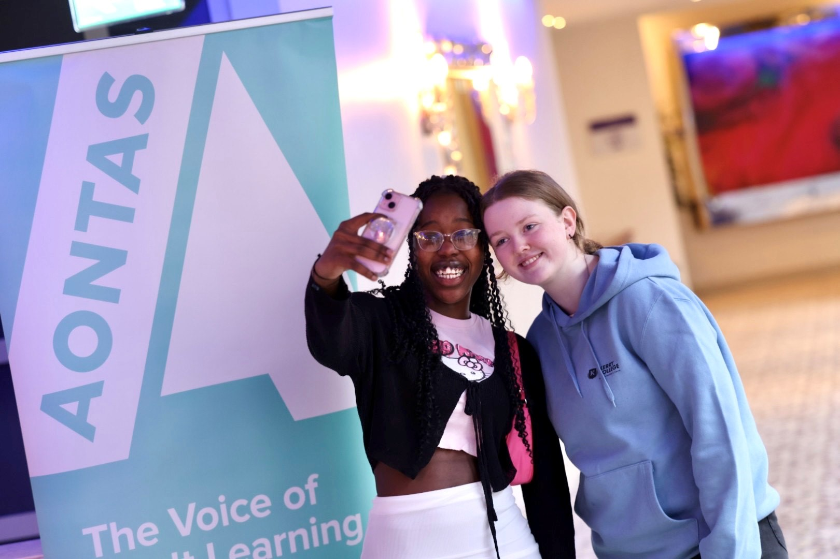

Kerry ETB Strategic Goals and Priorities

Building on the goals, priorities, and actions agreed with the Department, Kerry ETB will advance key strategic priorities from our Strategy Statement 2023–2027 throughout 2025. Guided by our core values, these initiatives are designed to promote quality, inclusivity and equity, with a particular focus on supporting those most marginalised in our community. Through the implementation of these strategic priorities, we aim to enhance access to education and create meaningful opportunities for all.

Goal 1: Excellence in Education and Training Services

Priority | Action | Performance Indicator | Target
(a) Create a high- quality, holistic education and training environment informed by learners' voice and actively addressing access for all | Continue to support and develop parent/guardian, student/learner/youth and staff voice participation to ensure provision continues to meet needs and expectations. | 5 Schools will have a timetabled Introduction to Universal Design for Learning course for 1st year students.  Teaching and Learning teams in each school will meet to plan Universal Design for Learning approach for 2025/2026.  Teaching and Learning team will provide at least one Universal Design for Learning training session to at a staff meeting. | Hold Universal Design for Learning  Champions review and planning Workshop in Quarter 1.  Cross-pillar Universal Design for Learning review event in Quarter 4.
 |  | Kerry ETB FET-Youthreach, Kerry College and FET centers Learning Support COP to continue to meet on a monthly/term basis priority action is to review and amend the Learning Support Policy to include a centre approach to UDL.  Review all current resource used across Kerry ETB FET that enhance UDL approach and develop a system to facilitate the sharing of all resources with staff across all centres.  Measuring implementation and using is our evidence base & Incorporating UDL into Course specifications | FET Staff Day Quarter 3 2025 on Universal Design for Learning bringing Teaching and Learning Teams together to share practice.

Goal 1: Excellence in Education and Training Services (Continued)

Priority | Action | Performance Indicator | Target
(a) Create a high- quality, holistic education and training environment informed by learners' voice and actively addressing access for all (Continued) | Continue to develop child protection oversight and adult safeguarding structures. | Child Protection Oversight Committee Meetings in Quarter 1 and Quarter 4.  Child protection training for school staff and for Boards of Management (BOM) members to be provided.  Online Child Protection e-modules to be completed by school staff.  Annual review and update meeting with Tusla in Quarter 4 to create closer links to support students and families.  Adopt the New Vulnerable Adults policy once received from ETBI.  Training to be procured in Quarter 3 on Vulnerable Adult policy and procedure. | Child Protection Policy to be updated Quarter 3 in line with any circulars or legislative requirements. All schools and Youthreach mandatory checklists are presented and reviewed at Quarter 1 Child Protection Oversight Committee Meeting.  Review of all Child Protection Templates across FET to ensure they are in line with Kerry ETB Child Protection and Oversight Policy.  Complete training sessions with all staff on Vulnerable Adult policy and procedure.
 | Provide opportunities for learners to engage in clubs and societies. | Promote and administer Local Youth Club Grant Scheme Quarter 1 and Quarter 2. | Youth Clubs/Groups supported to deliver services to learners through Local Youth Club Grant Scheme.
 |  | Promote club/group provision through Radio Kerry Sound and Vision Project Quarter 3.  Development of Clubs and Societies in FET Campuses to enhance the learner experience.  The establishment of sports teams in local and regional competitions. | Learners made aware of club/group provision and opportunities available to them in their local areas through Sound and Vision initiative Radio Kerry Q 2- Q4 2025.  Q3 - Clubs and Societies in Kerry College Denny Street and Listowel.  Development of Cross Campus sports teams in Kerry College

Goal 1: Excellence in Education and Training Services (continued)

Priority | Action | Performance Indicator |  | Target
(a) Create a high- quality, holistic education and training environment informed by learners' voice and actively addressing access for all (Continued) | Review practical subject facilities, sports facilities and resources and develop a plan to achieve high standards. | A review of Sports facilities will take place in each of the 8 Post Primary schools in 2025. Plan applications for upgrades with Technology, Estates and Sustainability Department in Quarter 2. |  | Home Economic Rooms and Art rooms will be reviewed in Quarter 2.  An Art teachers Community of Practice set up in Quarter 1.  Review of Art facilities in Quarter 2.
 | Continue to support and develop the Kerry ETB Student Forum. | Provide training for Post Primary Student Councils in Quarter 4. Student Councils operating to a very high standard. Kerry ETB Student Forum will meet in Quarter 1 and Quarter 4 highlighting the issues which matter most to students and develop strategies to tackle these issues locally in schools. |  | Student Councils to lead out activities during ETB Week.  Student Councils will report to Boards of Management in Quarter 2.  Student Councils will be trained to provide peer education workshops on 'Say No to Vaping' in Quarter 4.  School management will support the facilitation of peer workshops.
(b) Provide comprehensive guidance to all learners, offering academic, employment and personal support | Expand FET to HE pathways  for learner progression with  MTU and UCC – unified  tertiary education. |  | New Occupational Therapy Course 1+4 with UCC.  Renew agreements with MTU to continue the BA in Animation. Grow numbers accessing Tertiary Nursing in our Denny Street and Listowel Campuses in addition to work with the NTO and UCC to develop Dental Nursing. | New intake in September 2025.

Goal 1: Excellence in Education and Training Services (continued)

Priority | Action | Performance Indicator | Target
(b) Provide comprehensive guidance to all learners, offering academic, employment and personal support | Strengthen internal  progression routes through  the NQF (National  Qualifications Framework)  Levels. | Expand established internal progression pathways, currently in place for Youthreach and Pathways, to include Community Education and ABE creating a more comprehensive progression framework through the NFQ Levels 3-6.  Build on the Youthreach and Pathways Learner Experience days. | Establish a system to record and analyse internal progression data which will enable year on year comparison to identify trends, measure growth to enhance internal progression routes with a goal of increasing learner internal progression.
(c) Provide widely accessible education and training opportunities in a range of areas, including creativity and music | Develop a county-wide strategy for music education  and performance (establish a Kerry ETB School of Music  Performance).  ETB Local Creative Youth Partnership (LCYP) Strategy across all schools and more broadly across Kerry. | Finalise Music Education Plan and commence implementation in Quarter 1 2025.  Successful implementation of the Kerry ETB LCYP Strategy, (KPIs identified in LCYP Strategy). | Achieve 95% implementation by the end of 2027.  Implementation by the end of 2027.
(d) Provide excellent responsive delivery to support the local and national economy, taking account of local and national labour shortages and delivering programmes to best meet this skills gap | Achieve devolved responsibility/delegated authority status from Quality and Qualifications Ireland (QQI). | Kerry ETB Annual Quality Action plan 2025. | Review Terms of Reference of the FET Quality Council.  Review the current membership of the FET Quality Council, retaining independent chair and employers/ industrial and other partners.
 | Re-structure and expand part-time evening provision across the county, providing an extensive and flexible programme. | Increase engagement with part-time evening provision by further expanding the range of programme offerings and enhancing recruitment efforts.  Further develop programmes in both Listowel & Killarney Campuses. | Achieve an increase in beneficiaries for part-time evening provision through targeted advertising, outreach initiatives and strategic partnerships. Exceed 2024 numbers through a diverse range of programmes.

Goal 1: Excellence in Education and Training Services (continued)

Priority | Action | Performance Indicator |  |  | Target
(d) Provide excellent responsive delivery to support the local and national economy, taking account of local and national labour shortages and delivering programmes to best meet this skills gap (continued) | Progress programme development standardisation through Communities of Practice. | Course Specifications will be completed for all existing full-time QQI Levels 5 and 6. |  |  | Devise Course Specifications from new Course Approval applications.
(e) Adapt and develop our education and training as new learning approaches and technologies emerge | Implement Universal Design for Learning Proposal/Plan. |  | Universal Design for Learning Plan prepared for Kerry ETB schools completed by Quarter 2. | Finalise Universal Design for Learning Plan with Universal Design for Learning Community of Practice in Quarter 2.
 | Develop and implement ICT Strategy. |  | Strengthen staff digital competencies through Continuous Professional Development programmes focused on Microsoft 365, AI, Cybersecurity, and emerging digital trends. | Finalise the ICT Strategy for the adoption of AI for across the organisation (Q3/Q4 2025)  Provide access to training platforms to aid staff development and training on Microsoft 365 and Cybersecurity.
 |  |  | Successful implementation of Public Sector Cyber Security Baseline Standards by 2026. | Commence the implementation of the audit recommendations for Section 1-3 of the Information Security Management System (ISMS) Audit, completed in Quarter 4 2024.  Continue engagement with the Internal Audit Unit and KOSI to implement further modules of the ISMS System for 2025.

Goal 1: Excellence in Education and Training Services (continued)

Priority | Action | Performance Indicator | Target
(e) Adapt and develop our education and training as new learning approaches and technologies emerge (continued) | Develop and implement an integrated technology- enhanced learning strategy. | AI in Teaching and Learning Policy and Practice Guidelines completed in Quarter 4. | Consult with ICT Strategy Team and Senior Management Team in preparation for final AI Policy and Procedure Guidelines in Quarter 2/Quarter 3.  Support one additional school to provide student devices for First Years in Quarter 4
(f) Design and deliver a career development programme for staff | Design and implement a Training and Development Strategy.  Continue the Continuous Professional Development plan across FET while supporting local campus/centre-level CPD initiatives in 2025. | Successful development and implementation of the Training and Development Strategy. | First draft of Training and Development Strategy Quarter 2 2025.  Work ongoing in the development of the Learning Management System.  Continuous Professional Development Policy and Procedure continues to be implemented.
(g) Research and implement future educational reforms in line with government policy and international best practices | Deliver on targets set out in the Strategic Performance Agreement with SOLAS 2025-2027. | Quarterly Monitoring of the Strategic Performance Agreement targets and strategically adjusting provision to meet targets.  Achievement of targets outlined in the Strategic Performance Agreement with SOLAS. | Continued compliance with the specified targets and objectives agreed with SOLAS under the SPA.
 | Deliver on Oversight (2023- 2025) and Performance Delivery Agreements with the Department of Education. | Requirements of the Oversight and Performance Delivery Agreement will be reviewed throughout 2025 to ensure ongoing compliance. | Successful fulfilment of obligations outlined in Oversight and Performance Delivery Agreements with the Department of Education.
(h) Ensure that the capital and buildings programme is delivered and that all new projects are designed to comply with Department guidelines and the highest standards for energy efficiency | Develop and progress capital projects, including emergency and summer works programmes, SAR, SIUF, etc. | Advancement and completion of key capital projects. | Finalise and publish Kerry ETB Estates Strategy, in consultation with DFHERIS, SOLAS and DoE.

Goal 1: Excellence in Education and Training Services (continued)

Priority | Action | Performance Indicator | Target
(h) Ensure that the capital and buildings programme is delivered and that all new projects are designed to comply with Department guidelines and the highest standards for energy efficiency (continued) | Progress plans to move FET provision in Tralee from leased to permanent accommodation. | Continue engagement with the Department of Education and Department of Further and Higher Education Research Innovation and Science in relation to the ETB's proposals surrounding consolidation of property and estate management in Tralee. | Finalise the proposal and initiate a phased development planning by the end of 2025.  Progress the refinement of the Preliminary Business Case under FET College of the Future (Kerry College Killarney Campus), finalise site acquisition and progress to Decision Gate 1 for the project.  Complete the fit-out of the Moyderwell Building for FET by Quarter 4 2025, which will realise consolidation of leased property in Tralee.  Finalise ongoing capital works and commence construction of extension to Causeway Comprehensive School.  Finalisation with DFHERIS and the Department of Education proposal for acquisition of MTU South Campus which will reduce FET dependency on leased buildings and provide a permanent Head Office for Kerry ETB.

Goal 2: Strong, Inclusive and Respectful Organisational Culture

Priority | Action | Performance Indicator | Target
(a) Complete an organisation-wide culture audit and address recommendations | Complete an organisation- wide culture audit. | Completion of an organisation wide culture audit assessing key areas such as mission alignment, values, leadership, management practices, communication and staff experience. | Audit completed.
(b) Promote a culture that is inclusive, non- discriminatory and respectful of human and civic rights | Implement the Public Sector Equality and Human Rights Duty (Section 42 of the Irish Human Rights and Equality Commission Act 2014). | Successful development and implementation of the Public Sector Equality and Human Rights Duty Implementation Plan. | Reporting framework established with progress updates provided regularly to Senior Management.
(c) Ensure our core values guide the organisation’s  behaviours and are the lived experience for all our stakeholders | Implementation of the Communications Plan. | Formation of cross pillar Communications implementation group ensuring successful execution and alignment across the ETB. | Establish Communications implementation group Quarter 2 2025.
 | Roll out the ETBI Patrons' Framework and Curriculum on Ethos across all Kerry ETB schools. | IMBV (Identity, Multi-Beliefs and Values) Patrons Curriculum is timetabled in 5 Post Primary Schools, either as a short course, part of a life skills program or wellbeing by Quarter 4. | Support 3 remaining schools to rollout IMBV in Quarter 2.  Ethos days to be held in schools as part of ETB week Quarter 1.  Support schools to participate in Kerry ETB Ethos competitions and ETBI National awards in Quarter 1.
(d) Support our learners and staff by strengthening access to and raising awareness of support services | Implementation of revised Customer Charter and Action Plan. | Formation of cross pillar Customer Charter implementation group ensuring successful execution and alignment across the ETB. | Establish Customer Charter implementation group Quarter 2 2025

Goal 2: Strong, Inclusive and Respectful Organisational Culture (continued)

Priority | Action | Performance Indicator | Target
(d) Support our learners and staff by strengthening access to and raising awareness of support services |  | Development of the Kerry College Learning Support unit. | Create a standardised approach to service delivery around learning supports, guidance and reasonable accommodation.
(e) Ensure our structures actively promote inclusion and provide accessible and appropriate support for people with disabilities | Implement the Public Sector Equality and Human Rights Duty (Section 42 of the Irish Human Rights and Equality Commission Act 2014) | Successful development and implementation of the Public Sector Equality and Human Rights Duty Implementation Plan. | Reporting framework established with progress updates provided regularly to Senior Management.

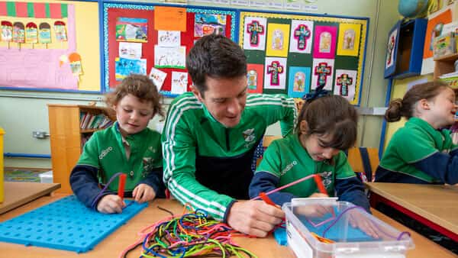

Goal 2: Strong, Inclusive and Respectful Organisational Culture (Continued)

Priority | Action | Performance Indicator | Target
(f) Build stronger relationships with other regional agencies to proactively address barriers to inclusion for marginalised individuals or groups | Expand FET to HE pathways for learner progression with MTU and UCC – unified tertiary education.  Continue the implementation of the ETBI Provision Mapping Programme in Kerry ETB Post Primary Schools.  Continue the rollout of the Belong To Q Mark in Post Primary Schools with Belong To Ireland.  Continue the rollout of the Yellow Flag for Inclusion in Post Primary Schools with the National Yellow Flag Programme. | Strengthen collaboration with UCC and MTU to expand FET to HE pathways, supporting unified tertiary education opportunities and enhancing progression routes for Kerry College learners.  Students with additional educational needs will receive a suite of holistic supports in the classroom and in small groups based on needs.  Kerry ETB schools are LGBTQ+ safe and supportive schools. Staff are equipped to support LGBTQ+ students.  Staff and students will have developed a whole school plan to address interculturalism, equality and diversity. | Secure approval for Tertiary Degree in Occupational Therapy and reinstate the Tertiary Degree in Animation for the 2025/26 academic year while reviewing additional tertiary provision for 2026/27.  8 post primary schools will have commenced Provision Mapping.  3 schools will have achieved the Belong To Q Mark and one new school commenced the process.  3 schools will have achieved the Yellow Flag for Inclusion and one new school commenced.
(g) Work to meet the needs arising from the Irish Refugee Protection Programme and provision for international protection applicants | Continue the REALT Programme and the Ukrainian and International Protection Co-ordination Team structures. | All Ukrainian and International Protection students will have a school placement and school transport where required. | REALT Team will place students in schools and organise transport within 5 working days.
(h) Create opportunities for students/learners and staff to  access equality, diversity and inclusion education and training opportunities | Develop a revised Charter of Dignity. | Completion of a comprehensive review and update of existing Charter of Dignity incorporating stakeholder input and alignment with relevant policies and procedures. | Secure formal approval and implement revised charter by Quarter 4 2025.

Goal 3: Opportunities for Greater Organisational Synergies

Priority | Action | Performance Indicator | Target
(a) Develop a structure to facilitate shared understanding across the organisation's three pillars | Continued embedding of the organisation 's communication framework to ensure consistent, transparent and effective communication across all teams. | Ongoing adoption and integration of the communication framework across all Schools/Centres/  Department teams. | Achieve ongoing adherence to the framework in communication policies and practices.
(b) Create opportunities for closer cross-pillar collaboration to strengthen synergies and promote shared objectives | Cross Pillar Forum in place. | Cross Pillar Staff Forum to meet twice annually to inform organisation direction, policy and priorities. | Achieve 90% attendance and active participation.
 | Address in a structured manner schools to FET pathways | Continue and expand rollout of the taster opportunities for Transition Year (TY) Students 2025 in Quarter 4.  Review Impact in Quarter 2 including expansion to include non-Kerry ETB post primary schools.  Conduct a mapping exercise to track progression of the first TY to FET learners to Kerry College. | Provide a showcase event in Quarter 4 where the 9 projects will be on display.  Encourage and support entries into the BT Young Scientist competition.  The collaboration with LMETB will be continued in 2025.  TY to FET programme to more non-Kerry ETB post-primary school and increase Kerry ETB school participation and map TY learner progression to Kerry College. Increased Diversity of offering to schools.
(c) Ensure greater integration of management and staff teams across the organisation | Establish cross departmental implementation groups to support the roll out and integration of key organisational plans including Public Sector Duty plan, Communications plan etc. | Active formation of cross departmental implementation groups e.g. Communications group, ensuring successful execution and alignment of each plan across departments. | Establish implementation groups e.g. Communications group for each plan Quarter 2 2025.

Goal 3: Opportunities for Greater Organisational Synergies (continued)

Priority | Action | Performance Indicator | Target
(c) Ensure greater integration of management and staff teams across the organisation (continued) | Two senior leadership in-service events, based on adaptive leadership approach. | Successful organisation of biannual senior leadership in-service events. | Two sessions to be held in 2025.
(d) Achieve excellence in the delivery of support services fully aligned to legislation | Focus on enhancing recruitment practices through interview training and procuring recruitment software. | Continued compliance with recruitment legislation and procurement of the necessary software to support recruitment efficiency and continued compliance. | Deliver interview training and procure recruitment software.
 | Develop and implement the Kerry ETB 2025/2026 Corporate Procurement Plan. | Finalise and implement the Kerry ETB 2025/2026 Corporate Procurement Plan. | Implementation commenced.
€ Establish a dedicated evidence- based research and development function to support decision- making | Work collaboratively with Mary Immaculate College (MIC) Limerick and University College Cork (UCC) to develop an approach to action research on agreed themes. | MOU in place with MIC and UCC.  Interagency working groups in place between Kerry ETB and both colleges. | Action Research on an approach to Universal Design for Learning (UDL) in primary post primary and FET will be completed.  Action Research on the complementarity between youth work and formal education and Training commenced.
(f) Establish more linkages for the integration of youth services with schools and FET | Cross-pillar collaborations plan for schools, FET, youth work, creating opportunities for deeper connections between the formal and informal provision.  Plan strategically for the provision of youth services in Kerry (Youth Work Development Plan 2023-  2027 publication). | Successful development and implementation of the Youth Work Development Plan 2023-2027 (KPIs outlined in Youth Work Plan). | Achieve 95% completion by the end of 2027.

Goal 3: Opportunities for Greater Organisational Synergies (continued)

Priority | Action | Performance Indicator | Target
(g) Create more opportunities to engage with all our stakeholders to better understand their needs and address specific requirements and expectations | Implementation of the Customer Charter Action Plan. | Formation of cross pillar Customer Charter implementation group ensuring successful execution and alignment across the ETB. | Establish Customer Charter implementation group Quarter 2 2025.

Goal 4: A Leader in Education and Training Provision

Priority | Action | Performance Indicator | Target
(a) Proactively expand the accessibility of the ETB’s support services to non-Kerry ETB schools and centres | Research and design a future-proof corporate staffing structure.  Review the OSD function’s structure to position the ETB strategically for future expansion of its remit. | Kerry ETB OSD Pillar will provide assistance to non-ETB schools, in relation to building works. This assistance is provided in line with Section 22 of the Education and Training Boards Act 2013. | Kerry ETB to complete large capital projects and new school builds on behalf of the Department of Education.  By 2027 Kerry ETB plans to have completed the construction of four new schools and two school extensions for non-ETB schools for the Department of Education.
 | Expand Community National Schools | A media campaign planned for Quarter 1 of 2025 including information to preschool parents, a radio Kerry interview with Parents in Quarter 1 and an information Webinar in Quarter 1. Continue engagement with school exploring the possibility of becoming a Community National School. | Community National School Principals are supported with a Principals Network and frequent meetings with Kerry ETB.  Kerry ETB will  follow up any enquiries in relation to transfers.

Goal 4: A Leader in Education and Training Provision (continued)

Priority | Action | Performance Indicator | Target
(b) Promote Kerry ETB as a key regional employer to prospective job applicants | Establish a permanent Kerry ETB Head Office in Tralee. | Continue engagement with the Department of Education and Department of Further and Higher Education Research Innovation and Science in relation to the ETB's proposals around consolidation of property and estate management in Tralee with regard to the MTU South Campus. | Advance to finalisation the proposal for the consolidation of the acquisition of the MTU south Campus which will incorporate a permanent Head Office for Kerry ETB.
 | Review and enhance the level of administration support in schools. | Finalise survey with school secretaries re role in Quarter 2. Consult with school secretaries in relation to responsibilities and workload. | A submission to ETBI recommending a review of the grading structure for school secretaries.
 | Design and implement recruitment campaigns aimed at underrepresented areas to broaden the applicant pool and promote greater inclusivity. | Successfully execute the recruitment campaigns increasing applications and enhancing the organisation's visibility as a regional employer. | Launch campaigns aimed at underrepresented areas to broaden the applicant pool and promote greater inclusivity.
(c) Demonstrate innovative leadership in identifying and delivering future local and national development skills in response to local and national labour trends | Re-structure and expand part-time evening provision across the county providing an extensive and flexible programme. | Where established either through Subject Matter Experts or industry representations, create new and innovative programmes that seek to meet existing and forecasted skills gaps. Enhance and revitalise existing provision to ensure relevance to changing market/employer demands. | Review existing provision/program offering ensuring relevance to changing market/employer demands.  Revalidate programmes in line with awarding bodies requirements.  Conduct Programme reviews to validate and substantiate existing provision.

Goal 4: A Leader in Education and Training Provision (continued)

Priority | Action | Performance Indicator | Target
(c) Demonstrate innovative leadership in identifying and delivering future local and national development skills in response to local and national labour trends. (continued) | Develop and deliver professional qualifications to external stakeholders, including teachers and youth work professionals as relevant, to empower the delivery of outdoor education and activities | Further development and expansion of the professional qualifications to include advanced certifications in outdoor education (OE), with a specific focus on environmental sustainability and innovative teaching practices for teachers and youth workers. Empower educators and youth professionals to integrate OE principles into their practice. | Work in progress - Astronomy and Commercial Scuba Diving is in review with QQI and further development of the programme is continuous with the QA department. Look to close out by the end of Quarter 2.
 | Establish a marine training campus in Cahersiveen to meet local, regional and national training needs. | Work in progress - Kerry College Killorglin Campus will deliver the 'Sustainability in the Community' course in Quarter 2 and Quarter 3. Further development of new programmes is underway, with a focus on conservation and rewilding, leveraging the expertise of Killorglin Campus staff and the extensive land resources available on campus. | Initiative to link Kerry College and Community Education and work to rewild designated areas under the Ecology programme with the possibility of involving CE schemes under consideration.
 | Exploring and creating rewilding, conservation, and ecology programmes to restore natural rainforest habitat | Kerry College Killorglin Campus will explore this initiative with a view to identifying appropriate land/lands on which this course work can take place.  SME are being identified to advise on natural rainforest habitat/rewilding, conservation | Initiative to link Kerry College and Community Education and work to rewild designated areas under the Ecology programme with the possibility of involving CE schemes under consideration

Goal 4: A Leader in Education and Training Provision (continued)

Priority | Action | Performance Indicator | Target
(d) Build stronger relationships with employers in the region through the establishment of a Kerry ETB Employers Forum | Host annual employer’s forum for Kerry. | Kerry College Business Support Unit to partner with various Chambers and professional industry alliances.  Kerry ETB to host employer/industry specific forms. | Kerry College Business Support Unit to attend regional trade specific forums.  Kerry College Business Support Unit to create industry/sector/  employer specific training/professional upskilling response to existing talent deficits.
 | Expansion of enterprise engagement with commercial organisations through the Business Support Unit. | Enhance listing and scheduling of programmes run under Skills to Advance. | Target specific programmes scheduled and run under Skills to Advance.  Ensure non-Skills to Advance Scheduled Programmes are available to learners under Skills to Advanced Dispersed.
(e) Publish the second Kerry ETB Sustainability Strategy 2023-2025 and  establish a sustainability support function to address sustainability matters | Achieve ETB Board approval of the Kerry ETB Climate Action Plan 2025.  Continue to work towards the five strategic goals outlined in the Sustainability Strategy 2024 - 2026 utilising the objectives detailed in the Kerry ETB Climate Action Plan. | Achieving the actions listed under each of the nine key objectives detailed in the Kerry ETB Climate Action Plan. Continued engagement with the SEAI's Climate Action Mandate Statement of Compliance, Monitoring and Reporting tool and Gap To Target tool. | Finalise and publish the Kerry ETB Climate Action Plan 2025 in Q1 2025.  Invest over €1 Million across the FET Estate under the Green Devolved Capital allocation.  Finalise the DoE Pathfinder Programme, completing the deep retrofit of Castleisland Community College and three other non-ETB schools.  Finalise the initial design and inclusion of Kerry College Monavalley Campus within the DFHERIS Pathfinder Programme.  Plant c.1.5 acres of native Irish trees on ETB owned lands.

Goal 4: A Leader in Education and Training Provision (continued)

Priority | Action | Performance Indicator | Target
(f) Build on existing relationships with the local Gaeltacht and non-Gaeltacht communities to support the use of Irish as a living language | Develop/Implement the Kerry ETB language Plan. | Completion of a further 10-week TEG course for 10 staff members beginning in Quarter 1.  TEG Level A2 exams take place in Quarter 2.  Kerry ETB as the lead agency in the support of the Language Planning Officer in Tralee with continue to support this role and work closely with Glor na nGael to achieve the plans objectives/goals.  Recruit Adult Educator to deliver Irish Language classes county wide. | Staff members successfully complete TEG exams.  Continue into Quarter 2 2025 once Irish language Adult Educator is appointed and expand into other public bodies (i.e. KCC).
(g) Foster and develop mainstream European and international opportunities for learners and staff | Develop the staff and learner mobility function throughout Kerry ETB via the EU Project Development office that was set up in 2024. | Continued development of the new EU Project Development Office. | Submit Erasmus funding applications for mobilities in Kerry ETB schools, FET and Youth.  Deliver mobilities in Kerry ETB.
(h) Strengthen existing and build new relationships with government departments, funders, ETBs, universities, community organisations and other education and training providers | Develop and sign third-party arrangements with relevant organisations and agencies, including regional Universities | Accredited Status Achieved for Erasmus Funding for FET. | Continue to develop and expand Staff and Learner mobilities with European colleges, universities and ancillary organisations.  MOU between Kerry ETB and Région Academique Occitanie to be developed in Q2 2025.

Goal 5: Communications, Brand Awareness and Shared Understanding of Kerry ETB

Priority | Action | Performance Indicator | Target
(a) Promote Kerry ETB as the first-choice education and training provider in Kerry | Promote FET as the "first choice" through effective branding and communications. | The Admissions Office to continue strengthening the position of FET as the 'First Choice' through targeted branding and communications campaigns, focusing on increased visibility and engagement across digital and traditional platforms. | Enhance the visibility of FET through effective branding and communication strategies, driving increased engagement across platforms and encouraging more applications.
 | Prioritise informal and formal events to celebrate learner achievements across the organisation. | Advanced Manufacturing project celebration in Quarter 4.  Increase Young Scientist participation Quarter 4.  STEAMfest hosted Causeway CS for all Kerry ETB schools in Quarter 1.  In celebration of learners and apprentice who successfully complete their chosen programme or apprenticeship, graduation ceremonies will be scheduled within the year. | Annual Students Awards ceremony to be held in Quarter 1, 2025.  Awards ceremonies and graduation events held annually across 4 Youthreach Centre to recognise learner achievements. Graduation Ceremonies to be scheduled in recognition of learner and apprentice success.
(b) Transition from a fragmented communications model to a fully resourced, dedicated Kerry ETB communications function | Implementation of the Communications Plan. | Formation of cross pillar Communications implementation group ensuring successful execution and alignment across the ETB. | Establish Communications implementation group Quarter 2 2025.

Goal 5: Communications, Brand Awareness and Shared Understanding of Kerry ETB (continued)

Priority | Action | Performance Indicator | Target
(c) Adopt and launch a new Kerry ETB brand to enhance awareness and highlight the range of education and training services available to all learner cohorts | Build on the launch of the new Kerry ETB brand by increasing its visibility and ensuring consistent use. | Increased awareness and recognition of new brand. | Brand consistency.
(d) Enhance communications with internal stakeholders in a structured manner | Implementation of the Communications Plan | Formation of cross pillar Communications implementation group ensuring successful execution and alignment across the ETB. | Establish Communications implementation group Quarter 2 2025
(e) Enhance communications with external stakeholders in a structured manner | Implement a plan aimed at communicating the ETBI Patron's Framework on Ethos to the wider public. | Develop our school communities understanding of our Ethos and make it more visual in our schools. ETB Day in Quarter 1. | Social Media campaigns in all schools to reference our Ethos and Core Values.  Ethos and Core Values to be highlighted during schools’ events, such as open days and awards.  School Ethos Day celebrated as part of ETBI Week Quarter 1.  Student and Staff Ethos Ambassadors in all schools.  All new Boards of Management will receive training on Kerry ETBs Ethos and Values in Quarter 1.
 | Ensure effective implementation of the Official Languages (Amendment) Act 2021. | Implement a monitoring system to ensure ongoing compliance with Section 10 of the Act, i.e. Advertising by Public Bodies). | Adherence to advertising provision, i.e. 20% of all advertising to be in Irish and 5% in Irish through Irish language media.

Goal 5: Communications, Brand Awareness and Shared Understanding of Kerry ETB (continued)

Priority | Action | Performance Indicator | Target
(f) Ensure all Kerry ETB materials publications are widely available, accessible and understood | Deliver training in the use of plain language and enhance accessibility of Kerry ETB website. | Successful implementation of plain language training and website accessibility improvements with measurable increases in user engagement and clarity in communication. | Training delivered and website accessibility increased.
(g) Maximise opportunities to communicate our culture and core values across internal and external audiences | Implementation of the Communications Plan. | Formation of cross pillar Communications implementation group ensuring successful execution and alignment across the ETB. | Establish Communications implementation group Quarter 2 2025.
(h) Support management and staff to become key communicators | Implementation of the Communications Plan. | Formation of cross pillar Communications implementation group ensuring successful execution and alignment across the ETB. | Establish Communications implementation group Quarter 2 2025.

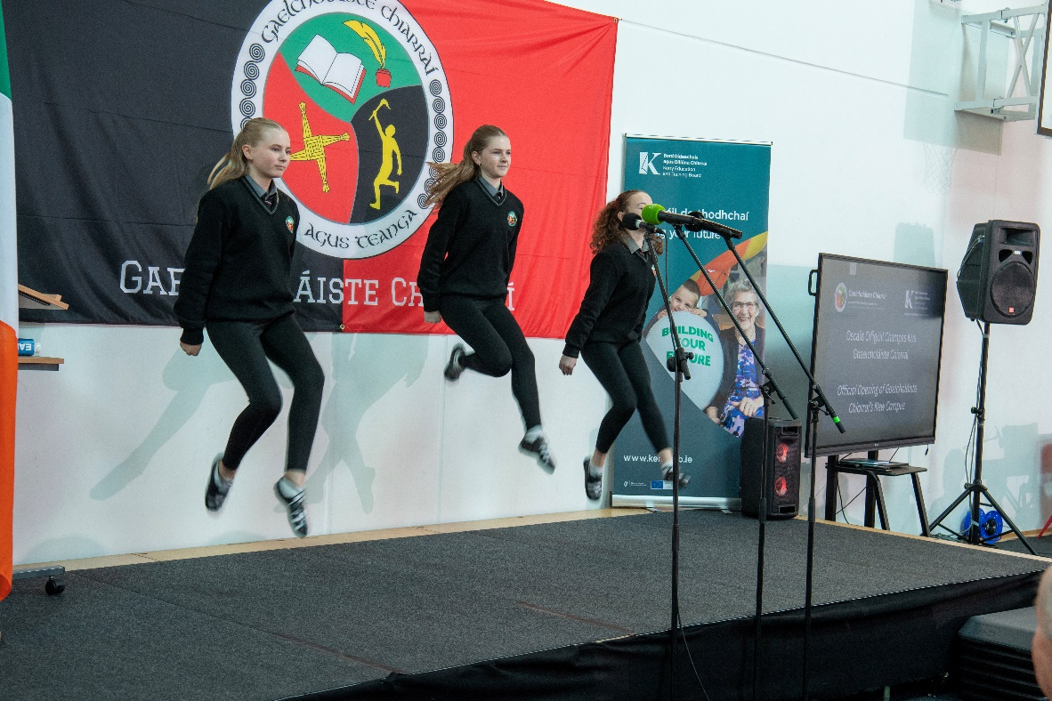

Appendix I: Projected Receipts and Expenditure

Projected Receipts and Expenditure
 | Year Ended  31/12/2025 | Year Ended  31/12/2024
 | (Estimate) | (Pre Audit)
 | Total | Total
RECEIPTS | € | €
Schools & Head Office Grants | €35,042,655 | €35,549,278
Primary School Grants | €48,657 | €142,986
Further Education and Training Grants | €49,762,145 | €50,353,757
Youth Services Grants | €1,394,787 | €1,512,132
Agencies & Self-Financing Projects | €2,747,719 | €2,794,131
Capital | €15,203,423 | €28,903,486
 | €104,199,385 | €119,255,771
PAYMENTS
Schools & Head Office | €35,042,655 | €35,124,790
Primary School | €48,657 | €71,224
Further Education and Training | €49,762,140 | €49,493,406
Youth Services | €1,394,787 | €1,277,110
Agencies & Self-Financing Projects | €2,396,379 | €2,500,841
Capital | €23,514,868 | €17,983,459
 | €112,159,486 | €106,450,830
Cash Surplus / (Deficit) For Period¹⁰ | -€7,960,100 | €12,804,941

¹⁰ * Please note that this figure does not include the opening cash balance of €15,314,133 as of 1st January 2025.

School and Head Office Payments
 | Year Ended 31/12/2025 | Year Ended 31/12/2024
 | (Estimate) | (Pre Audit)
 | Total | Total
 | € | €
PAY
Instruction | €28,300,942 | €27,886,370
Administration | €3,405,006 | €3,029,288
Maintenance | €726,034 | €668,814
 | €32,431,982 | €31,584,472
NON PAY
Non-Pay Expenditure | €1,935,075 | €1,919,790
ASSOCIATED PROGRAMMES
School Services Support Fund | €317,889 | €349,840
DEIS Grant & Home School Liaison (incl. Summer Programme) | €90,000 | €200,320
Book Grant | €0 | €69,982
Free Junior Cycle Schoolbooks Grant Incl Admin | €0 | €429,039
Junior Certificate School Programme | €17,880 | €55,398
Transition Year | €35,625 | €58,408
Leaving Cert Applied | €12,684 | €20,428
Traveller Capitation | €8,327 | €10,599
School Attendance Campaign | €0 | €14,933
Physics, Chemistry, and Science | €2,587 | €11,203
ICT Grant | €0 | €120,268
DoE approved special needs equipment grant | €0 | €34,548
Bus Escort Grant | €0 | €30,583
DoE - ESBS Project (Shared Services) | €0 | €23,011
Others (4 in total) | €201 | €3,448
 | €485,193 | €1,432,008
Creative Youth Programme | €190,405 | €188,520
Primary School
Capitation/Ancillary/ICT/Book Scheme/Standardised Testing | €48,657 | €71,224

Further Education and Training Payments
 | Year Ended 31/12/2025 | Year Ended 31/12/2024
 | (Estimate) | (Pre Audit)
 | Total | Total
Further Education | € | €
Core | €11,043,980 | €11,840,241
Workforce Skills Development/Transformation | €13,983,450 | €13,809,551
FET Pathways | €8,930,758 | €9,300,274
Apprenticeship Funding | €12,260,441 | €11,913,817
Discretionary Funding | €3,543,511 | €2,629,523
 | €49,762,140 | €49,493,406

Youth Services Payments
 | Year Ended 31/12/2025 | Year Ended 31/12/2024
 | (Estimate) | (Pre Audit)
 | Total | Total
 | € | €
UBU - Your Place Your Space - (SPY Grant) | €827,789 | €624,622
UBU - Resilience and Effectiveness Initiative | €20,000 | €8,000
Youth Work Act (Youth Work Development Plan) | €154,718 | €158,031
Youth Work Capital |  | €110
Youth Information | €132,091 | €130,053
Integration Fund | €132,982 | €254,255
Youth Club Grant Scheme | €67,207 | €65,706
Youth Employability Initiative | €60,000 | €36,333
 | €1,394,787 | €1,277,110



