


Public Sector Equality and Human Rights Duty
Action Plan 2024 - 2025

Contents
Introduction 3
Our Community 4
Identified Groups 5
Progress to Date: 6
Public Section Duty Action Plan 2024-2025 7
Our Access Officers 12
Board Approval 12
Appendix I Further Information 13
Appendix II Policy Assessment Tool 14
Appendix III Assessment of Equality and Human Rights Issues 15

Introduction
The Public Sector Equality and Human Rights Duty (PSD) requires all public bodies in Ireland, including Kerry ETB, to have regard to the need to eliminate discrimination, promote equality of opportunity, and protect human rights for learners, staff and stakeholders across all of the organisation’s functions. This legal obligation arises from Section 42 of the Irish Human Rights and Equality Commission Act, 2014, which provides for the following:
42 (1) A public body shall, in the performance of its functions, have regard to the need to:
- Eliminate discrimination;
- Promote equality of opportunity and treatment of its staff and the persons to whom it provides services; and
- Protect the human rights of its members, staff and the persons to whom it provides services.
Section 42.2 of the Act also sets out three key steps to be taken by public bodies. These include:
- In preparing strategic plans, public bodies must assess and identify the human rights and equality issues that are relevant to their functions. These issues must relate to all of its functions as an employer, policy maker, and service provider.
- Public bodies must identify the policies and practices that they have In place or that they plan to put in place to address these issues.
- In their annual report or equivalent documents, public bodies must report in a manner accessible to the public on their development and achievements in that regard.
Kerry ETB is committed to maintaining a culture of respect for equality and human rights among stakeholders, both internal and external.
A working group was established in December 2022 to support and drive the implementation of the PSD. The cross-pillar working group led the assessment of the human rights and equality issues relevant to its functions and identified the key actions, including policies and practices, that needed to be put in place to address these issues as they exist in Kerry and broader society.
Kerry ETB’s first PSD Assessment and Action Plan were developed in alignment with the organisation’s overarching Strategy Statement 2023-2027. This integrated approach reflects a commitment to fostering working and learning environments that actively champion human rights and equality. In the forthcoming reporting period, our unwavering dedication remains towards driving organisation-wide initiatives that regard the need to eliminate discrimination, promote equality of opportunity, and protect human rights for all.

Our Community
Kerry ETB is a leading provider of education and training in County Kerry, offering a comprehensive range of services to meet the diverse needs of our diverse local community. As one of the largest statutory providers in the region, we provide access to high-quality education and training to individuals of all ages, regardless of their background or circumstances.
With an extensive network of locations throughout the county, Kerry ETB ensures convenient access to education and training opportunities. We offer a wide array of services, including primary and post-primary education and further education and training. In addition, we also directly oversee and deliver comprehensive learner supports, youth and creative services, and outdoor education alongside services related to the Irish language and corporate support.
As a public sector organisation, Kerry ETB is committed to cultivating an organisational culture that embodies our fundamental values and fosters an inclusive and respectful environment for all individuals. We remain steadfast in our pursuit of promoting equality and human rights, guided always by our core values: Inclusion, Respect, Equality, Quality, and Excellence in Learning.
Kerry ETB also has designated charitable status (registered charity number: 20083243).

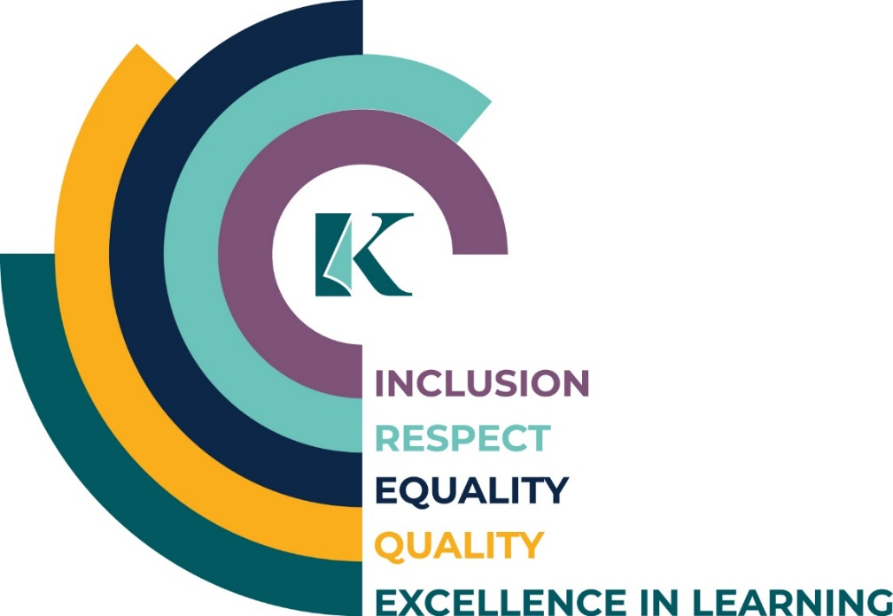

Identified Groups
The identified groups under the equality legislation are:
- Civil status
- Gender (encompassing gender identity, people transitioning to their true gender and gender expression)
- Family status (including lone parents and people with caring responsibilities)
- Age
- Disability (including mobility, sensory, and intellectual disabilities, mental health issues, and chronic illness)
- Sexual orientation
- Race (encompassing skin colour, nationality and ethnic origin)
- Religion
- Membership of the Traveller community
- Those at risk of, or experiencing, poverty and social exclusion.

Progress to Date:
Key existing Kerry ETB provisions include but are not limited to the following:
- Array of staff supports in place, including flexible working patterns and parental and paternal leave.
- Comprehensive special education needs and learner support programmes for learners and families.
- Community Education and Adult Literacy and Basic Education programmes.
- Learner counselling and psychological support services are available for all learners.
- One post-primary school has been awarded an LGBTQ+ Quality Mark for its commitment to LGBTQ+ inclusion.
- Comprehensive International Protection and Ukraine response programme in place.
- All delivery is multidenominational.
- Travel Education Support Programme in place for learners and their families.
- No fees are charged for the majority of courses.
- Staff can avail of breastfeeding breaks.
- All recruitment processes are carried out ethically, impartially, and in line with the Department of Education's circular letters
Key achievements in implementing the Duty from 2023 include (non-exhaustive):
- The delivery of PSD familiarisation session to the Senior Leadership team.
- Commenced the rollout of 'Dignity at Work' training with staff.
- Publication of the Gender Pay Gap 2022 report.
- All interview boards gave due consideration to gender balance.
- Staff were provided with accessible resources for their well-being, including the employee assistance programme and a financial well-being programme.
- Implemented a new Values Statement.
- Commenced a review of internal policies to include due consideration of the PSD.
- The Traveller education support programme expanded its scope to include a Transition Programme designed specifically for incoming first-year Traveller learners.
- Continued to collaborate with key local organisations in the coordination of the Adult Literacy for Life Strategy Collaboration and Innovation Fund.

Public Section Duty Action Plan 2024-2025

Objective | Action | Lead | Timeline
Employer | Continue to raise awareness of the PSD amongst staff |  | 2024-2025
Employer | Consult on and prioritise human rights and equality issues through Kerry ETB employment processes |  | 2024-2025
Employer | Rollout targeted training for staff* |  | 2024-2025
Employer | Rollout Dignity in the Workplace training for staff* |  | 2024-2025
Employer | Release all administration staff to complete the 3 modules (3 hours total) Public Sector Duty online eLearning course* |  | 2024-2025
Employer | Develop a PSD training module for staff |  | 2024-2025
Employer | Develop methods/systems to ensure our workforce reflects appropriate disability targets |  | 2025 +
Employer | Work with the Departments to facilitate the fulfilment of our commitment to employing a diverse workforce |  | 2024-2025
Employer | Ensure staff are fully aware of the process for making reasonable accommodation requests, including assistive technologies |  | 2024-2025
Employer | Provide information to staff about support services |  | 2024-2025
Employer | Include PSD as part of all inductions and training programmes |  | 2024-2025

Objective | Action | Lead | Timeline
Policy Maker | Reconstitute the new cross-pillar and cross-grade PSD Steering Group |  | 2024-2025
Policy Maker | Establish sub-groups of the PSD Steering Committee to examine structures and services in closer detail |  | 2024-2025
Policy Maker | Continue to engage* with and raise awareness of the Public Sector Equality and Human Rights Duty amongst learners and external stakeholders |  | 2024-2025
Policy Maker | Continue to raise awareness of disability issues amongst learners and external stakeholders |  | 2024-2025
Policy Maker | Raise awareness of the role of the Kerry ETB Access Officers amongst internal and external stakeholders |  | 2024-2025
Policy Maker | Publish publically core policies and procedures that relation to equality and human rights |  | 2024-2025
Policy Maker | Design and implement a strategic software module dedicated to monitoring PSD implementation |  | 2024-2025
Policy Maker | Establish a systematic approach for the planned review of organisational policies, procedures, and internal systems (see Appendix II) |  | 2024-2025
Policy Maker | Publish Gender Pay Gap 2023 report |  | 2024-2025
Policy Maker | Implement revised Customer Charter and Action Plan setting out shared commitments to providing accessible services (Disability Act 2005)* |  | 2024-2025
Policy Maker | Ensure 100% of new builds or upgrades are fully accessible |  | 2025 +
Policy Maker | Incorporate discussion about human rights and equality issues at the Board and management meetngs |  | 2024-2025
Policy Maker | Include the PSD as part of our communications plans |  | 2024-2025
Policy Maker | Include human rights and equality requirements in procurement processes, grants and service level agreements and capital projects |  | 2024-2025
Policy Maker | Carry out a human rights and equality assessment when drafting or reviewing strategies or plans |  | 2024-2025
Policy Maker | Compile a draft Assessment Report with the most up-to-date data and information and publish a new Action Plan (2026-2027) |  | 2025
Objective | Action | Lead | Timeline
Service Provider | Develop/review of services and programmes to ensure learners' needs and expectations are being met |  | 2024-2025
Service Provider | Include across all open days and promotional events/initiatives a focus on Duty and its relevance for prospective and current learners |  | 2024-2025
Service Provider | Organise events that celebrate diversity and human rights |  | 2024-2025
Service Provider | Continue to meet the needs arising from the Irish Refugee Protection Programme* |  | 2024-2025
Service Provider | Continue to roll out the Child Protection Monitoring Plan |  | 2024-2025
Service Provider | Develop a Traveller and Roma Education and Training Policy across FET and SY&M* |  | 2024-2025
Service Provider | Continue to rollout Schools’ and FET Universal Design for Learning Plan* |  | 2024-2025
Service Provider | Continue to explore how technology can be used to improve the service provided to our learners |  | 2024-2025
Service Provider | Develop methods to better evaluate outcomes of learners from identified groups |  | 2024-2025
Service Provider (Organisation Support and Development specific) | Establish an access and disability support function* |  | 2025 +
 | Ensure the www.kerryetb.ie website is accessible to all users |  | 2024-2025
 | Procure appropriate services for the use of Irish Sign Language and translation |  | 2024-2025
Service Provider (Schools, Youth and Music specific) | Support relevant staff to complete the AHEAD ARK Digital Accessibility Master Badge* |  | 2024-2025
Service Provider (Schools, Youth and Music specific) | Continue the delivery of the ‘Delivering Equality of Opportunity in Schools' programme, incorporating School Self-Evaluation planning* |  | 2024-2025
Service Provider (Schools, Youth and Music specific) | Achieve yellow flags for inclusion and Belong to Q Mark across all Kerry ETB schools* |  | 2024-2025
Service Provider (Schools, Youth and Music specific) | Continue the delivery of the ‘Traveller Education Support’ programme/role across Kerry schools* |  | 2024-2025
Service Provider (Schools, Youth and Music specific) | Continue to conduct special education needs mapping across all Kerry ETB schools |  | 2024
Service Provider (Schools, Youth and Music specific) | Continue engagement with the Young Social Innovators |  | 2024-2025
Service Provider (Schools, Youth and Music specific) | Continue to roll out the ETBI Patrons' Framework on Ethos across all Kerry ETB schools, including the patron’s curriculum* |  | 2024-2025
Service Provider (Schools, Youth and Music specific) | Continue to support Special Educational Needs Co-ordinator Community of Practice* |  | 2024-2025
Service Provider (Schools, Youth and Music specific) | Research a model of best practice between schools and youthwork |  | 2024
Service Provider (Schools, Youth and Music specific) | Culturally appropriate youthwork |  | 2024-2025
Service Provider (Further Education and Training specific) | Continue to roll out targeted FET programmes, including Youthreach, Adult Literacy and Basic Education, ESOL/EAL, etc. |  | 2024-2025
Service Provider (Further Education and Training specific) | Establish a Kerry ETB College of English Language for international/migrant learners* |  | 2025 +
Service Provider (Further Education and Training specific) | Transition to a fully integrated FET provision that helps to promote inclusivity and support learners with disabilities to achieve their full potential (move away from the legacy approaches)* |  | 2024-2025
Service Provider (Further Education and Training specific) | Adapt learner-focused information materials and supports, including the Learner Handbook, to include a focus on the PSD and its relevance for learners |  | 2024-2025
Service Provider (Further Education and Training specific) | Include PSD as part of Learner Forum meetings |  | 2024-2025
Service Provider (Further Education and Training specific) | Develop/review of learner-focused information and guidance materials |  | 2024-2025

*Actions identified in the Future Back Report.

Our Access Officers
Any stakeholder with a query relating to accessing services should contact our Access Officers as follows:

Address: Kerry ETB, Centrepoint, John Joe Sheehy Road, Tralee, Co. Kerry, V92 P2FE
E-mail: accessofficer@kerryetb.ie

Board Approval
The revised Public Sector Equality and Human Rights Duty Action Plan 2024 – 2025 was formally approved by the Board of Kerry ETB on 10th December 2024

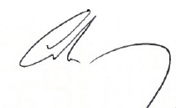

Colm Mc Evoy
Chief Executive

Appendix I Further Information
Relevant Legislation:
- Official Languages Act, 2003
- Irish Sign Language Act, 2017
- Equal Status Acts 2000 – 2015
- Irish Human Rights and Equality Commission Act 2014

Appendix II Policy Assessment Tool
Use the template to answer questions 1 to 3:
- Extract the equality and human rights issues relevant to this policy/procedure/plan from Kerry ETB’s assessment of equality and human rights issues. Note each relevant issue (from the assessment) in column 1 of the template.
- Examine the policy/procedure/plan to determine whether these relevant issues are addressed in the current draft and gaps in that regard. Note in column 2 whether each identified issue is fully, partially, or not addressed in the policy/procedure/plan.
- Identify whether and how these issues could be appropriately addressed in the policy/procedure/plan (column 3).
Additional questions to consider:
- Is there anything in the current policy/procedure/plan that could run counter to addressing the relevant equality and human rights issues (from the assessment)? If yes, how should this be addressed?
- Does the policy/procedure/plan align with the ambition set in Kerry ETB’s Values Statement?
Relevant equality and human rights issues (for this policy/plan) identified from the assessment | Is this issue addressed in the current draft of the policy/plan? (fully/ partially (gaps)/ no) | Relevant section(s)  of policy/plan | How this issue will be addressed in the policy/plan (suggested text/amendments)

Appendix III Assessment of Equality and Human Rights Issues
Link to Assessment of Equality and Human Rights Issues

Including Diversity Awareness, PSD Familarisation etc.

