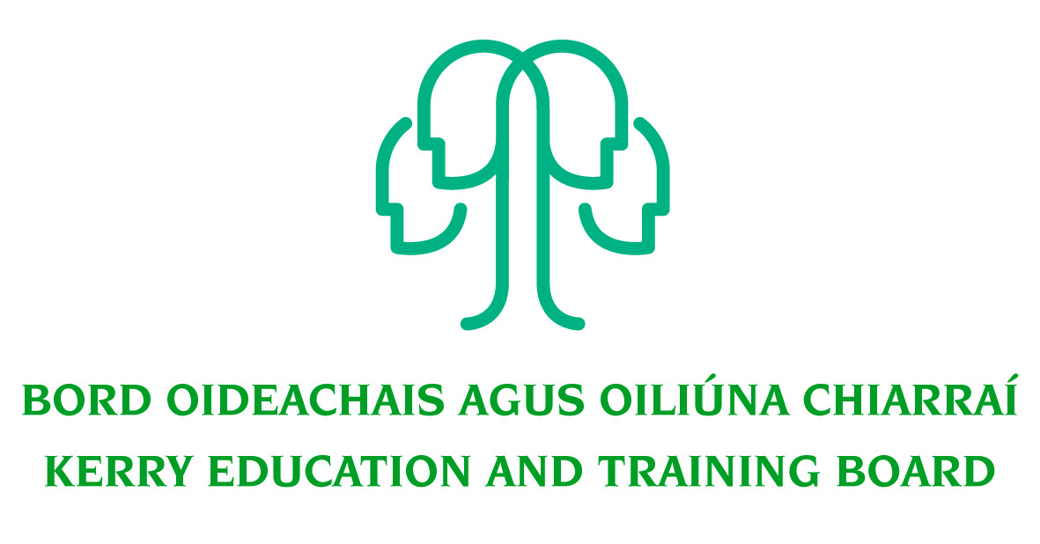
Kerry Education and Training Board
Tutor – Tattoo Artistry

Job Description

Job Title:
Tutor – Tattoo Artistry

Hours of Attendance:
Fixed Term position 8 Hours per week for the remainder of the 2020/21 academic year (maximum 60 hours).

Attendance shall be at such times as necessary for the delivery of the service including attendance outside of normal office hours as required.

Location:
Appointment is to the Scheme – Kerry ETB reserves the right to assign a staff member to any other location, as the service exigencies require.

Centres of first assignment will be Clash Campus (Kerry College)

Duration:
This post will be Fixed Term.

Reporting/Accountability Relationships:
The post holder will report to Principal Kerry College.

Salary Scale:
€40.57 per hour

Post Information:
This post requires flexibility as the tutor may be required to perform varied tasks at different locations.

He or she is not only involved in delivering tuition hours duties but also expected to operate as part of a team and contribute to the overall growth of Kerry ETB Further Education & Training Sector.

General Responsibilities:

The following list outlines the duties of tutors in order to present a standard framework to ensure good practice.

- To deliver such hours as are assigned by Principal/Centre Manager/Co-Ordinator on dates and times assigned.
- To develop a course plan and forward the details to Principal/Centre Manager/Co-Ordinator
- To maintain full and accurate records/registers as advised by Principal/Centre Manager/Co-Ordinator
- To be responsible for the property or equipment of Kerry ETB in your charge at any time.
- To achieve high professional standard of work practice and behavior.
- To comply with Kerry ETB Quality Assurance policy and procedures.
- To provide learners with information and access to information regarding progression, reasonable accommodation, assessment, appeals and malpractice.
- To ensure timetables/schedules are adhered to.
- To ensure that learner files/records are maintained detailing attendance, (and where relevant) assessment results, certification and progression.
- To record and ensure the return of teaching materials, resources and other equipment e.g. keys to the centre/school.
- To identify materials and equipment (including ICT) required for the delivery and support of the learning and teaching process.
- To review modes of delivery to support a ‘good fit’ between delivery methodologies and identified learner needs.
- To partake in online delivery when required and have content prepared to facilitate this
- To provide learners with constructive feedback on formative and summative assessment.
- To attend and engage in staff meetings, staff development and training.
- To assist Kerry ETB to identify progression pathways.
- To work as a team with other staff to coordinate the delivery of programmes.
- To carry out the lawful orders of the Chief Executive Officer, and to fulfill the rules and requirements of the Minister for Further and Higher Education Research Innovation and Science.
- Carry out any other duties appropriate to the grade which may be assigned from time to time.

The above list of accountabilities may be varied having regard to the changing needs of the Scheme and the terms of the post can include delivery of responses to unpredictable work demands as they arise.

Person Specification

Selection Criteria
Selection criteria outline the qualifications, skills, knowledge and/or experience that the successful candidate must demonstrate for successful discharge of the responsibilities of the post. Applications will be assessed on the basis of how well candidates satisfy these criteria.

Essential Criteria
- A qualified person (Verification of qualifications will take place prior to appointment) capable of delivering tuition in the following areas:
  - Tattoo Safety Precautions/Hygiene
  - Skin Anatomy/Skin Structure
  - Stencil Preparation & Application
  - Tattoo Machine & Equipment operation
  - Tattoo machine construction & adjustment
  - Use of various needle arrangements including magnums & single needle
  - Station set up with use of disposable equipment
  - Tattoo aftercare essentials
  - Needle disposal
- Minimum of 2 years’ experience in relevant discipline
- Experience of working with groups
- Excellent organisational and administration skills
- Experience of QQI assessment protocols and procedure

Desirable Criteria
- High level of interpersonal and communication skills
- Good time management skills and ability to work on own initiative
- Commitment to Kerry ETB core values: Respect, Quality, Equality, Inclusion and Learning.

Competencies Required
Kerry ETB Core Values of Respect, Quality, Equality, Inclusion and Learning are the guiding principles of the organisation and underpin the competencies required to fulfil this role.

Specialist Knowledge, Expertise & Self Development
- Clearly understands the role, objectives and targets and how they fit into the work of the organisation.
- Understands the boundaries of professional practice
- Develops the expertise necessary to carry out the role to a high standard and shares this with others
- Demonstrates knowledge of child protection policy and practice
- Understands and shows commitment to the purpose of Kerry Education and Training Board and to work within the values, policies and procedures of the organisation and in the context of current legislation and regulations
- Has expertise in his/her field that is recognised and utilised by colleagues

Administrative & Technical Skills
- Experience in Microsoft Office (Word, Excel, Access & PowerPoint etc.)
- Experience of communication via information technology
- Experience of maintaining accurate paper and electronic record systems
- Experience of working to multiple deadlines.

Delivery of Results
- Plans and prioritises work in terms of importance, timescales and other resource constraints, re-prioritising in light of challenging circumstances
- Assumes responsibility for and delivers on agreed objectives / goals
- Effectively manages multiple projects
- Ensures all outputs are delivered to a high standard and in an efficient manner
- Uses resources effectively, challenging processes to improve efficiencies.
- Is self-reliant and uses judgement on when to seek guidance and from whom.

Teamwork
- Experience of working effectively in a team environment
- Develops and maintains good working relationships with others, sharing information and knowledge, as appropriate
- Maximises the contribution of the team, encouraging ownership, providing support and working effectively with others
- Contributes to the development of policies in own area and the wider organisation

Interpersonal & Communication
- Communicates in a fluent, logical, clear and convincing manner verbally and in writing
- Is able to listen effectively and develop a two-way dialogue quickly
- Experience in motivating people
- Maintains a strong focus on meeting the needs of service users
- Effectively influences others to take action
- Works to establish mutual understanding to allow for collaborative working

Drive & Commitment
- Is self-motivated and shows a desire to continuously perform at a high level
- Must be flexible and prepared to work outside normal hours as required.
- Has the ability to think logically, use initiative and work with minimum supervision.
- Have a flexible approach to the work in response to organisational change, development and review of best practice
- Through leading by example, fosters high standards of ethics and integrity

