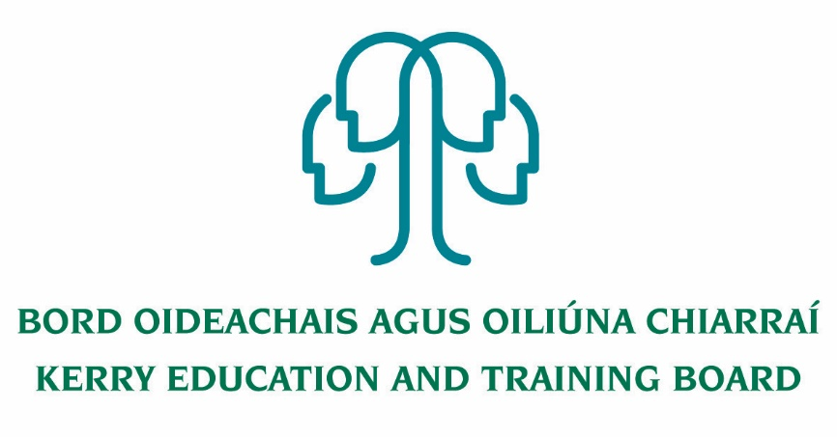

Person Specification – Principal
Kerry College Clash Road and Denny St. Campuses

To qualify for appointment candidates must have:
Essential Criteria:
- A recognised post-primary teaching qualification.
- A minimum of 5 years’ satisfactory teaching experience or equivalent.
- Registration in accordance with Section 30 of the Teaching Council Act 2001.
- Senior Management Experience

Desirable Criteria:
- Experience of leadership, management and administration at a sufficiently high level.
- A proven track record in Curriculum Leadership and Change Management.
- Evidence of commitment to the core values of Kerry Education and Training Board: respect, quality, equality, inclusion and learning.
- A proven track record in Course delivery and development in Further Education and Training or equivalent courses.
- A thorough understanding of FET Quality Assurance, Validation and Certification process for QQI and other Awarding and Professional Bodies.

Core Competencies Required:

Leadership Skills.
- Promotes the building of a College community in accordance with the values of the College’s mission statement.
- Focuses on improving instruction to enable teachers to teach at their best and students to learn at their utmost.
- Fosters a climate of trust that motivates and inspires others to commit to ongoing development that will support the educational goals/objectives of the College.
- Ensures that results are achieved in a caring and compassionate environment.
- Ability to encourage a shared sense of purpose.
- Ability to facilitate College development planning.
- Ability of lead effective curriculum planning.
- Ability to lead and manage change

Organisational Management and Administrative Skills.
- Uses a range of system supports and processes to establish a systematic course of action for self and/or others to ensure accomplishment of objectives.
- Sets priorities, goals and timetables to ensure effective use of time and all resources.
- Employs, monitors and maintains acceptable accounting procedures in the maintenance of all fiscal records.

- Strategic Development & Management Skills.
- Demonstrates the ability to take a broad and long term view of the needs of the College’s purpose and objectives.
- An ability to plan strategically
- Ability to manage change effectively.

- Self-awareness and Self-management Skills.
- The ability to accurately perform self-assessments on practice
- The ability to develop personally and professionally

- A Clear Vision for the development of Education and Training
- Understanding of current education and training needs locally and nationally.
- Strategy to respond to education and training needs.
- An understanding of the need to engage directly with employers, statutory agencies and
other providers

- Commitment to Professional Development.
- Commitment to continuous professional development. Participation in regular professional development, through in-service, reflective practice and membership of relevant subject association.
- Ability to assess and respond to staff professional development needs.

- Communication
- Set up excellent communication structures/policies and procedures with staff, learners, Kerry ETB, Governance Board and all partners and stakeholders
- Set a standard and code for communication in the college in terms of tone, response, methods and appropriateness.
- Set up good communication structures to the wider community from College and to ensure that the College has effective and positive public relations.
- Embrace modern methods of communication e.g. on line, bulletin boards, information technology systems social media and bloggers etc.

- Commitment to Kerry ETB Core Values
- Commitment to the Core Values of Kerry ETB of Respect, Quality, Equality, Inclusion and Learning.
- Commitment to inclusive teaching practices and to ensuring that the College prevents and combats discrimination.
- Create and maintain a climate of respect and fairness for all staff and students

The successful candidate will:
- Be a leader, committed to the highest standards of education and training provision, administration and governance
- Have a passion for education and training
- Have strong people management and organisation skills
- Be a visionary and have experience in delivering projects through teamwork
- Be community minded and conscious of the role the College plays in the local community
- Be dynamic, driven and capable of the development of a modern College of Further Education and Training to the highest standards

