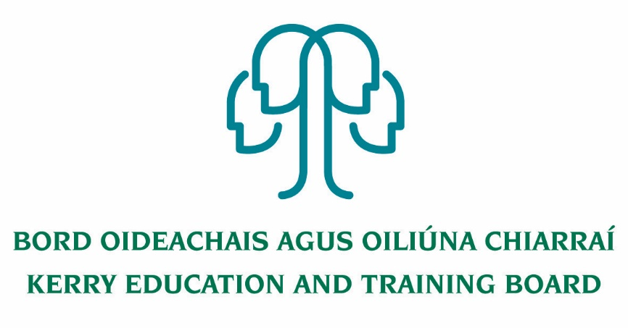

Job Description- Principal

Kerry College

Clash Road and Denny St. Campuses Tralee

Nature of Post
The post is whole-time and permanent.

Location
Centre of first assignment is Kerry College of Further Education and Training, Clash Road and Denny St. Campuses, Tralee.
The person appointed to this post may be transferred to another post under Kerry ETB, provided that in the opinion of Kerry ETB and the Minister for Further and Higher Education, Research, Innovation and Science, such other post is of similar status.

Commencement Date
Appointment to commence at the start of the 2020/2021 academic year

Remuneration
Category of Principal Allowance payable – XV (€39,079)

Profile
The successful candidate will:
- have a clear vision for the development and expansion of a modern College of Further Education and Training where all courses are delivered to the highest standards to meet learner needs in a flexible manner
- be a leader, committed to the highest standards of education and training provision, management, administration and governance
- have a passion for education and training
- have strong people management and organisation skills
- be a visionary and have experience in delivering projects through team work
- be community minded and conscious of the role the college plays in the local community and the wider ETB
- have significant experience of leading change and change management

Functional Relationships
- Staff and Learners – Partners in Education
- Chief Executive Officer, Director of Further Education and Training and Administrative Staff of Kerry Education & Training Board
- Governance Board of Kerry College of Further Education and Training
- Department of Further and Higher Education, Research, Innovation and Science/SOLAS/Other outside agencies e.g. National Educational Psychological Service, An Garda Siochána, Health Service Executive, Central Applications Office, local and national employers etc.
- The wider community

Reporting/Accountability Relationship
The Principal shall report to Director of Further Education and Training/Chief Executive Officer.

Key Areas of Responsibility
- To be responsible, under the Director of Further Education and Training for the organisation, discipline and administration of the College Campus

- To engage in teaching the number of hours per session specified by the Department of Further and Higher Education, Research, Innovation and Science

  - To comply with the lawful orders of the Board, and its Chief Executive Officer, and with the rules and requirements of the Minister for Further and Higher Education, Research, Innovation and Science

  - To effectively carry out the professional duties appropriate to a Principal Teacher as outlined in the Provisions of the Education Act 1998, Part V – which include

(a) be responsible for the day-to-day management of the College, including guidance and direction of the teachers and other staff of the school, and be accountable to the board for that management,
      - provide leadership to the teachers and other staff and the learners of the College
      - be responsible for the creation, together with the board and the teachers, of a College environment which is supportive of learning among the learners and which promotes the professional development of the teachers,
      - under the direction of the board and, in consultation with the teachers, to the extent appropriate to their age and experience, the learners, set objectives for the College and monitor the achievement of those objectives, and
      - encourage the involvement of learners in the College in the education of those learners and in the achievement of the objectives of the College

  - To carry out any other duties appropriate to the position.

  - To be responsible for the development and performance of staff in line with Kerry ETB Core Values and to foster a culture of continuous improvement and development.

Attendance of the Principal
Kerry College of Further Education and Training programmes are delivered throughout the entire year. The programmes delivered include, full time courses, part time courses and other forms of Further Education and Training courses as the need arises. The Principal will lead the development and delivery of all Further Education and Training courses and have responsibility to ensure that all courses delivered from the college are delivered to the highest standards in a quality assured environment. In addition, the Principal will lead the development and implementation of an extensive part time evening programme. The Principal’s responsibilities extend to the entire calendar year and all college staff including teaching, administration and support staff. The Principal’s responsibility to lead and manage staff extends to the full year including traditional learner holiday periods. The Principal will normally be required to be in attendance from 8:15 am to 5:00 pm each day and at other times as required by the Director of Further Education and Training/CEO/ Governance Board Kerry College.

Key Role:
Leader – Teaching and Learning
- Establish and promote high standards and expectations for all learners and staff or academic performance, engagement, learning, behaviour and social skills.
- Responsibility for leading change and change management.
- Effectively implement appropriate modern teaching and learning strategies to the benefit of learner achievement and college performance.
- Actively promotes their own continuous professional development and that of staff and ensures that it is in line with the overall goals, plans and targets of the college.
- Be responsible for the creation, together with the learners, Board /Kerry ETB and the teachers, of a college environment which is supportive of learning and high achievement among the learners.
- Continuously develop and prioritise, in conjunction with staff, a timetable, a curriculum, instructional methodologies and college plans that best meet the needs of the entire learner population and in accordance with Department of Further and Higher Education, Research, Innovation and Science and the relevant sector regulations and guidelines.
- Ensure that the education provided in the college is constantly supervised and evaluated.
- Ensure that strategies, measures, methodologies, improvement plans and targets are put in place to ensure best practice and standards of teaching and learning are being achieved.
- Develop and provide appropriate learning and curricular programmes to meet the needs of all learners in the college and ensure the diversity of the learner population is being catered for.
Leader – College Development
- Put in place a comprehensive college development Strategic/Education plan, following consultation with staff /Kerry ETB/ Governance Board of Kerry College of Further Education and Training and other relevant stakeholders.
- Develop, implement, evaluate and update procedures and systems for the operation and functioning of the college; ensuring compliance with legislation (Education, Employment Law, Child Protection), Department/SOLAS and relevant sector regulations, philosophy and values.
- Strategically develop the expertise and capability of the staff in line with the College Development Plans, College Vision and Culture.
- Establish structures in the college that
(a) facilitates excellence in teaching and learning
(b) which supports and cultivates a community of learning
(c) provide pastoral care and learner support
(d) facilitates development of a management tier devoted to the key objectives of the college
  - Implement the policies and decisions of the Kerry ETB, Governance Board, Minister for Further and Higher Education, Research, Innovation and Science / SOLAS in such a way as to enhance the college offering.
- Set a system for constant re-evaluation of the purpose, objectives and activities of the college in line with College Self Evaluation Guidelines from the Department of Further and Higher Education, Research, Innovation and Science
- Lead the review and development of Courses in conjunction with the wider Kerry ETB FET Services, Local employers, other ETB Training Providers and agencies.
- Develop and lead the establishment of an extensive programme of part-time evening programme (certified) to meet local and surrounding learner needs.
- Lead and implement a comprehensive learner enrolments system, including during traditional learner holiday periods
- Develop an extensive and detailed annual college promotion and learner recruitment plan for approval by the Governance Board each year
- Lead the staff in the establishment of relevant clubs and societies (including sporting) in the college to enhance the learner experience
- Implement a system for learner access to the college facilities during traditional learner holiday periods

Leader – People and Teams
- Lead, motivate and manage the teaching and ancillary staff in the college to achieve excellence in their work; through the use of good industrial relations, systems, planning and evaluation, team work/support, organisation and communications throughout the entire year.
- Set the highest standards of work and behaviour and to be actively involved in probation, performance management and appraisal of staff through the agreed systems.
- Actively manage difficult employment issues, following agreed procedures, using appropriate action, support and advice.
- Ensure adherence to child protection, health, safety and welfare for learners, staff and visitors.
- Foster and maintain excellent professional working relationships with all staff in the college, ensuring effective delegation and support.
- Establish strong organisation structures within the college with clearly defined roles and responsibility among the various categories of staff, in line with staff skills and talents.
Organisational Management and Administrative Skills
- Set an organisational timetable /calendar for the college regarding administrative matters such as Department/SOLAS/Kerry ETB returns.
- Set an organisational timetable /calendar for the college regarding Health and Safety drills, actions, checks and safety statement reviews.
- Control, manage and best use college/public funds and ensure all financial records are up to date and maintained according to good governance, regulations and guidelines.
- Consult with the Deputy Principal and the senior management team on matters related to the administration and management of the college as appropriate.
- Act as Secretary to the Governance Board, to assist and advise them on policy, professional, financial and administrative matters. Understand the role and function of the Governance Board and to work in cooperation and support of the Governance Board.
- Implement, manage and review effective data management systems such as learner records, teacher records, attendance, purchasing procedures, and timetables
- Ensure the facilities and assets of the college are maintained and managed to the highest standards.
- Put in place a calendar of maintenance to be conducted during the year and to ensure it is complied with. Lead the college in ensuring that all administrative matters are dealt with effectively and on time.
Self-Awareness and Self-Management
- Set a good standard of professional interactions and to ensure excellent relationship boundaries are in place.
- Be aware of own skill set and traits and to ensure to seek help and advice when required and to operate with an openness with the Governance Board and Kerry ETB.
- Upholds professional integrity at all times for example discretion, confidentiality, loyalty and trust.
- Seek to actively improve on skill sets through active networking, CPD and good interactive working relationships.
- Participate in reflective practice individually and with other principals

Communication
- Maintain effective relationships with the stakeholders involved including learners, local employers, other education and training bodies and agencies including representing Kerry ETB on Boards and Committees as appropriate.
- Set a standard and code for communications in the college in terms of tone, response, methods and appropriateness.
- Set up good communication structures to the wider community from the college and to ensure that the college has effective and positive public relations.
- Liaising with the College union representatives on matters relating to the College.
- Embrace modern methods of communication e.g. on line, bulletin boards, Information technology systems, social media and bloggers etc.

