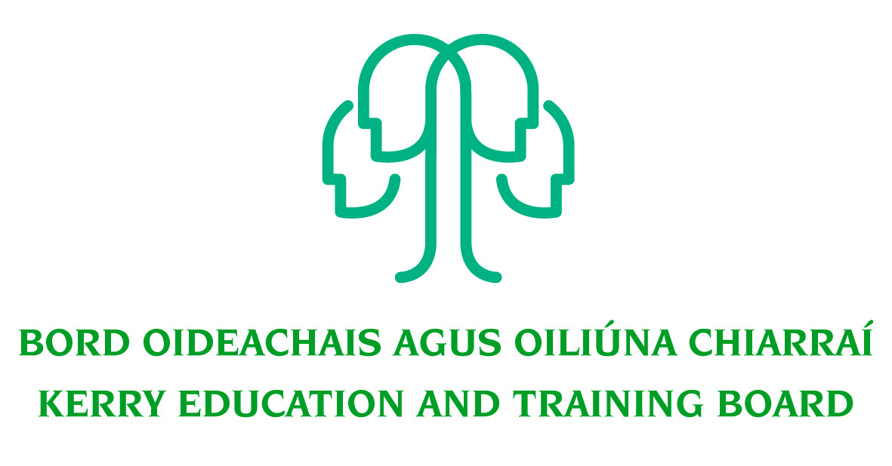
Kerry Education and Training Board
Further Education and Training Adult Educator (BTEI Programme)

Job Description

Job Title:
Further Education and Training Adult Educator Pool (BTEI programme)

Hours of Attendance:
Part time position (Between 5 – 12 Hours per week inclusive of delivery & admin)

Attendance shall be at such times as necessary for the delivery of the service including attendance outside of normal office hours as required. This post will include a combination of both tuition & administration duties.

Remuneration: The Adult Educator scale goes from €33,167 - €57,157.
Scale Rate per hour €15.75 - € 29.60.

Location:
Appointment is to the Scheme – Kerry ETB reserves the right to assign a staff member to any other location, as the service exigencies require.

Centres of first assignment will be O’Connell FET Centre, Cahersiveen and/or An Tóchar FET Centre, Causeway.

Duration:
This post will be Fixed Term for Spring Term 2021

Reporting/Accountability Relationships:
The post holder will report to the Centre Manager

Salary Scale:
€?? - €??

Salary will be paid in accordance with such rates as may be authorised by the Minister for Education and Skills from time to time for BTEI Adult Educators. Entry point to this scale will be determined in accordance with Circulars issued by the Department of Education and Skills. Rate of remuneration may be adjusted from time to time in line with Government Policy. For persons entering a recruitment grade for the first time, starting pay will be at the minimum of the new reduced scale and is not negotiable.

Post Information:
This post requires flexibility as the Adult Educator may be required to perform varied tasks at different locations.

Post Holder must be prepared to work evenings and/or weekends. As the work may require visits to various locations including various outreach locations where further education and training is delivered the post holder must have own transport and a full driving license. He or she is not only involved in delivering tuition hours duties but also expected to operate as part of a team and contribute to the overall growth of the Kerry ETB Adult & Further Education & Training Sector.

Initial Duties and Responsibilities:
- Responsible to the centre manager on a day to day basis for the delivery of the programme.
- Direct class contact in keeping with programme needs as required by Kerry ETB subject to a maximum of 20 hours per week.
- Administrative duties relevant to the post, subject to a maximum of 17 hours per week e.g. maintenance of in-house IT admin systems (PLSS/QBS/PTT/P2P etc.), learner contact, timetabling, recruitment of learners, course promotion, etc.
- Liaising with relevant stakeholders both within and outside of Kerry ETB.
- Curriculum development and delivery, implementation of certification procedures supervision of work experience and delivery of guidance and information as appropriate.
- Work with centre management in the planning, delivery and evaluation of appropriate responses to education and training needs, including the identification and implementation of indicators for education and training outcomes for learners.
- Development and monitoring of programmes.
- Assessment and monitoring of learner course work.
- Conducting interviews and/or assessment of learners.
- Provide locally agreed substitution cover for absent staff.
- To collect course fees where applicable.
- To comply with Kerry ETB Quality Assurance policy and procedures.
- To provide learners with information and access to information regarding progression, reasonable accommodation, assessment, appeals and malpractice.
- To ensure timetables/schedules are adhered to.
- To record and ensure the return of materials, resources and other equipment.
- To inform learners of the Code of Conduct and return the signed documents to the Centre Manager/Adult Education Officer.
- To inform learners of Kerry Education and Training Board ICT policy and procedures (where appropriate) and return the signed documents to the Centre Manager/Adult Education Officer.
- To identify materials and equipment (including ICT) required for the delivery and support of the learning/delivery process.
- To attend and engage in staff meetings, staff development and training.
- To obtain feedback from learners regarding course content, delivery and quality assurance and return Learner Evaluation forms and Learner Verification.
- To participate in appropriate continuous professional development and training as agreed with management.
- To maintain full and accurate records/registers as advised by the Adult Education Officer /Director of Further Education and Training
- To carry out the lawful orders of the Chief Executive Officer, and to fulfill the rules and requirements of the Minister for Further and Higher Education Research Innovation and Science.
- Carry out any other duties appropriate to the grade which may be assigned from time to time.

The above list of accountabilities may be varied having regard to the changing needs of the Scheme and the terms of the post can include delivery of responses to unpredictable work demands as they arise.

Person Specification

Selection Criteria
Selection criteria outline the qualifications, skills, knowledge and/or experience that the successful candidate must demonstrate for successful discharge of the responsibilities of the post. Applications will be assessed on the basis of how well candidates satisfy these criteria.

Essential Criteria
- Minimum QQI Level 6 Certification in the relevant discipline
- Minimum of 2 years’ experience in delivery of the relevant discipline
- Experience of working with groups
- Excellent organisational and administration skills
- Experience of QQI assessment protocols and procedure
- Excellent ICT skills/experience (including database, data analysis and spreadsheets, other MIS systems)
- Full clean driving Licence

Desirable Criteria
- High level of interpersonal and communication skills
- Good time management skills and ability to work on own initiative
- Commitment to Kerry ETB core values: Respect, Quality, Equality, Inclusion and Learning.

Competencies Required
Kerry ETB Core Values of Respect, Quality, Equality, Inclusion and Learning are the guiding principles of the organisation and underpin the competencies required to fulfil this role.

Specialist Knowledge, Expertise & Self Development
- Clearly understands the role, objectives and targets and how they fit into the work of the organisation.
- Understands the boundaries of professional practice
- Develops the expertise necessary to carry out the role to a high standard and shares this with others
- Demonstrates knowledge of child protection policy and practice
- Understands and shows commitment to the purpose of Kerry Education and Training Board and to work within the values, policies and procedures of the organisation and in the context of current legislation and regulations
- Has expertise in his/her field that is recognised and utilised by colleagues

Administrative & Technical Skills
- Experience in Microsoft Office (Word, Excel, Access & PowerPoint etc.)
- Experience of communication via information technology (MS Teams)
- Experience of maintaining accurate paper and electronic record systems
- Experience of working to multiple deadlines.

Delivery of Results
- Plans and prioritises work in terms of importance, timescales and other resource constraints, re-prioritising in light of challenging circumstances
- Assumes responsibility for and delivers on agreed objectives / goals
- Effectively manages multiple projects
- Ensures all outputs are delivered to a high standard and in an efficient manner
- Uses resources effectively, challenging processes to improve efficiencies.
- Is self-reliant and uses judgement on when to seek guidance and from whom.

Teamwork
- Experience of working effectively in a team environment
- Develops and maintains good working relationships with others, sharing information and knowledge, as appropriate
- Maximises the contribution of the team, encouraging ownership, providing support and working effectively with others
- Contributes to the development of policies in own area and the wider organisation

Interpersonal & Communication
- Communicates in a fluent, logical, clear and convincing manner verbally and in writing
- Is able to listen effectively and develop a two-way dialogue quickly
- Experience in motivating people
- Maintains a strong focus on meeting the needs of service users
- Effectively influences others to take action
- Works to establish mutual understanding to allow for collaborative working

Drive & Commitment
- Is self-motivated and shows a desire to continuously perform at a high level
- Must be flexible and prepared to work outside normal hours as required.
- Has the ability to think logically, use initiative and work with minimum supervision.
- Have a flexible approach to the work in response to organisational change, development and review of best practice
- Through leading by example, fosters high standards of ethics and integrity

