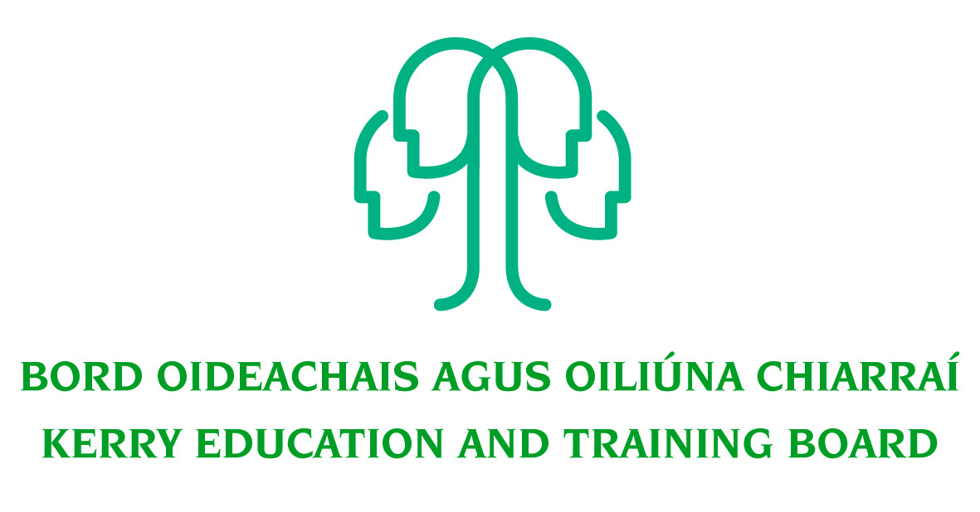 Job Description

Grade V – initial assignment to Stores

Nature of Post
Permanent full time position, 37 hours per week.
Location
Appointment is to the Scheme – Kerry ETB reserves the right to assign a staff member to any other location, as the service exigencies require. Your centre of first assignment will be Kerry College Monavalley Campus, Monavalley, Tralee, Co. Kerry

Reporting/Accountability Relationship
The Grade V reports to the Kerry College, Monavalley Campus Manager.

Post Summary/Purpose:
This role is Grade 5 post with initial assignment to stores. The applicant must have the ability to multitask, meet multiple deadlines, project manage developments and be able to maintain a high degree of accuracy and attention to detail in completing their work. They must have proven communication, administrative and organisational skills.

Key areas of responsibility
- Oversee the procurement process for all Kerry College Campuses ensuring that compliance of procurement procedures by all procurement officers.
- Responsible ensuring compliance with procurement frameworks both locally devised and OGP.
- Assist with auditory functions for both internal and external audits where required.
- All requests for purchase are processed in full compliance with Kerry ETB Procurement Guidelines and Departmental Guidelines.
- Comprehensive and real time up to date recording of all activities across either electronic or paper form.
- Compliance with OGP Regulations, DoES Circular Letters, Kerry ETB Procurement policies and procedures, and relevant legislation.
- All invoices are processed effectively and efficiently for payment.
- All aspects of Kerry College Stores are dealt with effectively.
- Positive relationship management of all external suppliers.
- Positive relationship management of all internal Kerry ETB stakeholders.
- Support the team effort in developing short / medium / long term planning in line with Kerry ETB needs.
- Support the team of Kerry College as required
- Identify opportunities for Business Process improvements.
- Support Kerry College Management to achieve key performance indicators and goals.
- Maintain a strong focus on self-development, seeking feedback, coaching and creating opportunities for self-development.
- Promote teamwork within the Department.
- Maintain an efficient and effective filing system.
- Plan and prioritise work in terms of importance, timescales and other resource constraints, reprioritising in light of changing circumstances for self and relevant staff teams.
- Carry out any other duties appropriate to the grade which may be assigned from time to time.
- Responsible for ensuring that all items purchases are recorded on the Kerry ETB Fixed Assed Register or the SAP system as appropriate.
- Ensuring that both registers (Kerry ETB Fixed Asset Resister and SAP) are kept up to date.
- Requirement to run timely reports from SAP as required by the Directors of FET and OS&D
The above list of accountabilities may be varied having regard to the changing needs of the Scheme and the terms of the post can include delivery of responses to unpredictable work demands as they arise.

ESSENTIAL REQUIREMENTS
As per Circular Letter 8/2017 candidates must:
- Have the requisite knowledge, skills and competencies to carry out the role. Competencies will be informed by best practice Public Appointment Service competency frameworks for the Irish Public Service;
- Be capable and competent of fulfilling the role to a high standard;
- Have obtained at least Grade D3 in five subjects in the Leaving Certificate Examination (higher, ordinary, applied or vocational programmes) or equivalent or have passed an examination at the appropriate level within the QQI qualifications framework which can be assessed as being of a comparable to Leaving Certificate standard or equivalent or higher or have appropriate relevant experience which encompasses equivalent skills and expertise;
DESIRABLE REQUIREMENTS
- Achieved or be at an advanced stage of working towards a Level 6 qualification or higher on the National Framework of Qualifications
- Significant experience in an administrative capacity in a busy office environment
- A high level of experience and knowledge of the designated area of work
- Excellent administrative and IT skills
- Experience of using the SAP system.

COMPETENCES REQUIRED
Kerry ETB Core Values of Respect, Quality, Equality, Inclusion and Learning are the guiding principles of the organisation and underpin the competencies required to fulfil this role. The person appointed to the above post will be required to show evidence of the following competences:
Specialist Knowledge, Expertise and Self Development
- Clearly understands the role, objectives and targets and how they fit into the work of the Organisation.
- Develops the expertise necessary to carry out the role to a high standard and has a thorough understanding of the Procurement Guidelines and protocols.
- Is proactive in keeping up to date on issues and key developments that may impact on the Department and/or wider ETB service
- Consistently reviews own performance and sets self-challenging goals and targets Leadership Potential
- Is flexible and willing to adapt, positively contributing to the implementation of change
- Contributes to the development of policies in the Department/Organisation
- Seeks to understand the implications of taking a particular position on issues and how interdependencies need to be addressed in a logical and consistent way
- Maximises the contribution of the team, encouraging ownership, providing support and working effectively with others
- Formulates a perspective on issues considered important and actively contributes across a range of settings
Analysis & Decision Making
- Is skilled in policy analysis and development, challenging the established wisdom and adopting an open-minded approach
- Quickly gets up to speed in a complex situation, rapidly absorbing all relevant information/data (written and oral)
- Uses numerical data skilfully to understand and evaluate service issues and adjudicating tenders.
- Identifies key themes and patterns in and across different sources of information, drawing sound and balanced conclusions
- Sees the logical implications of taking a particular position on an issue
Delivery of Results
- Assumes personal responsibility for and delivers on agreed objectives/goals
- Manages and progresses multiple work activities successfully
- Maintains a strong focus on meeting the needs of purchase requests in a timely manner
- Ensures all outputs are delivered to a high standard and in an efficient manner
- Use resources effectively, at all times challenging processes to improve efficiencies Interpersonal & Communication Skills
- Communicates in a fluent, logical, clear and convincing manner verbally and in writing
- Is able to listen effectively and develop a two-way dialogue quickly
- Maintains a strong focus on meeting the needs of internal and external customers
- Effectively influences others to take action
- Works to establish mutual understanding to allow for collaborative working
Drive & Commitment to Public Service Values
- Consistently strives to perform at a high level
- Maintains consistent effort under pressure and is resilient to criticism or setbacks at work
- Demonstrates high levels of initiative, taking ownership for projects and demonstrating self sufficiency
- Is personally trustworthy and can be relied upon

