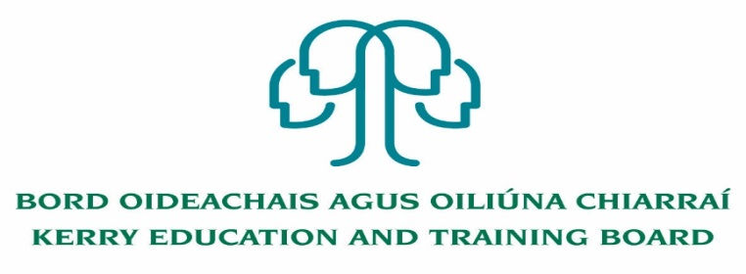

Principal (PWT)
Kerry College
Clash Road and Denny St. Campuses Tralee
Roll number: 76494H
Category XV

Kerry Education & Training Board (Kerry ETB) invites applications for the post of Principal for Kerry College, Clash Road and Denny St. Campuses, Tralee.

Kerry College is a fully integrated College of Further Education and Training. The College offers a full range of Further Education and Training opportunities for learners/students with courses for progression, employment and apprenticeships. Kerry College provides a dynamic and inclusive environment for learners/students to complete their chosen further education and training course. This leadership position offers the opportunity to join a dynamic team in leading a fully integrated College of Further Education and Training.

County Kerry is our Campus.
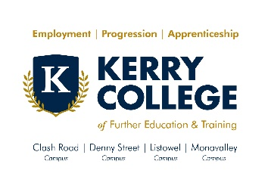

Kerry College currently has four campus locations across the county:
- Clash Road, Tralee
- Denny St., Tralee
- Monavalley, Tralee
- Listowel
For further details please visit www.kerrycollege.ie

This senior management post will afford the appointee an opportunity to lead the staff of Clash Road and Denny St. Campuses in the strategic development of Kerry College.

The appointee will lead in the delivery of quality assured Further Education and Training courses and contribute to the wider development and expansion of Further Education and Training Services in County Kerry, as a member of the Further Education and Training Senior Management Team of Kerry ETB.

-------------------------------------------------------------------------------------------------------------------------------

To qualify for appointment to this post candidates must have:
- A recognised post-primary teaching qualification
- A minimum of 5 years’ satisfactory teaching experience or equivalent
- Registration in accordance with Section 30 of the Teaching Council Act 2001
- Senior Management Experience

Conditions of Service, Terms of Appointment, Qualifications, Salary Scales and Allowances are in accordance with the regulations of the relevant Department.

Application form and full details may be obtained from www.kerryetb.ie/opportunities or contact the H.R. Department, Kerry ETB, Centrepoint, John Joe Sheehy Road, Tralee, Co. Kerry. Tel. 066-7121488

Please complete an application form and return by email only to jobs@kerryetb.ie. No C.V.’s, only official application form will be accepted. Applications must be received not later than 1 p.m. Wednesday 15th July 2020.

Kerry Education & Training Board services Gaeltacht areas.
Cuirfear fáilte roimh chomhfhreagras i nGaeilge.
Garda Vetting of successful candidates will take place prior to offer of employment.
Canvassing will automatically disqualify. Shortlisting of applicants may take place.

Kerry Education & Training Board is an equal opportunities employer.
“Creating a Learning Society in Kerry”
Colm Mc Evoy
Chief Executive Officer

